*New L293D motor shield, the input voltage DC4.5-25V,
*600mA OUTPUT CURRENT CAPABILITY PER CHANNEL
*1.2A PEAK OUTPUT CURRENT (non repetitive)PER CHANNEL
*ENABLE FACILITY
*OVERTEMPERATURE PROTECTION
*LOGICAL "0" INPUT VOLTAGE UP TO 1.5 V(HIGH NOISE IMMUNITY)
*INTERNAL CLAMP DIODES
DESCRIPTION
The Device is a monolithic integrated high voltage,high current four channel driver designed to accept standard DTL or TTL logic levels and drive inductive loads (such as relays solenoides, DC
and stepping motors) and switching power transistors .To simplify use as two bridges each pair of channels is equipped with an enable input. A separate supply input is provided for the logic, allowing operation at a lower voltage and internal clamp diodes are included. This device is suitable for use in switching applications at frequencies up to 5 kHz.

9-24V motor drive wiring
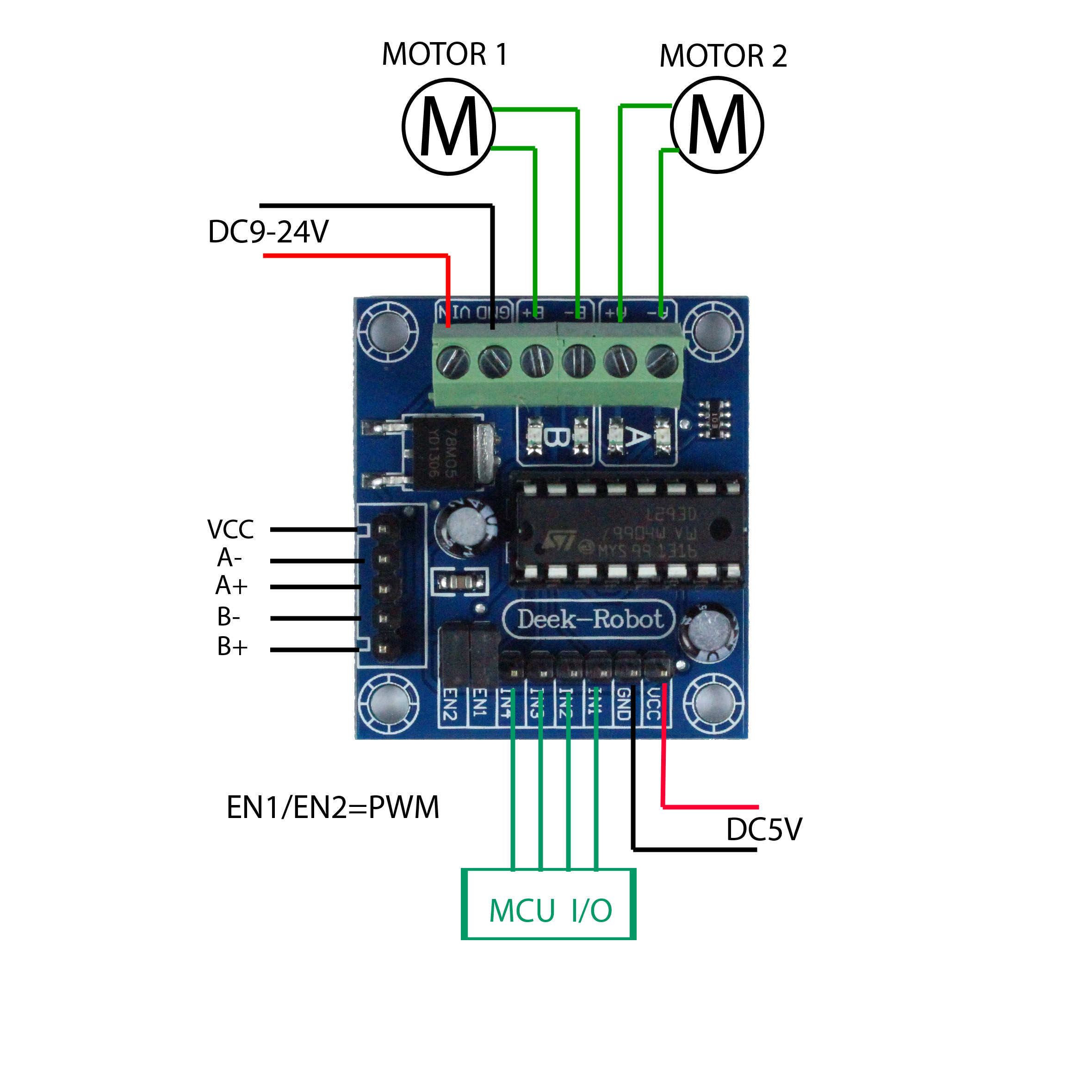
5V motor drive wiring
