ZTP – Zadanie 1

Możliwe wywołania:

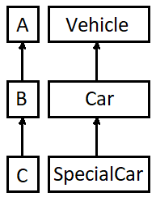**class Garage<Car>**

|  |  |  |  |
| --- | --- | --- | --- |
|  | **A** | **B** | **C** |
| void m(T arg) | - | + | + |
| void f(Y<T> arg) | - | + | - |
| void f(Y<? extends T> arg) | - | + | + |
| void f(Y<? super T> arg) | + | + | - |

**class X<B>**