TODOS proposals:

CRITICAL – Render Obor

HIGH – fix camera POV dacie

MEDIUM – WASD pe tot ce e randuit fara dacie

LOW – gandit tranzitie intre obor – pantelimon

LOW – arme pantelimoneze de hand to hand combat – telescopica,lant,box, robinet de chiuveta

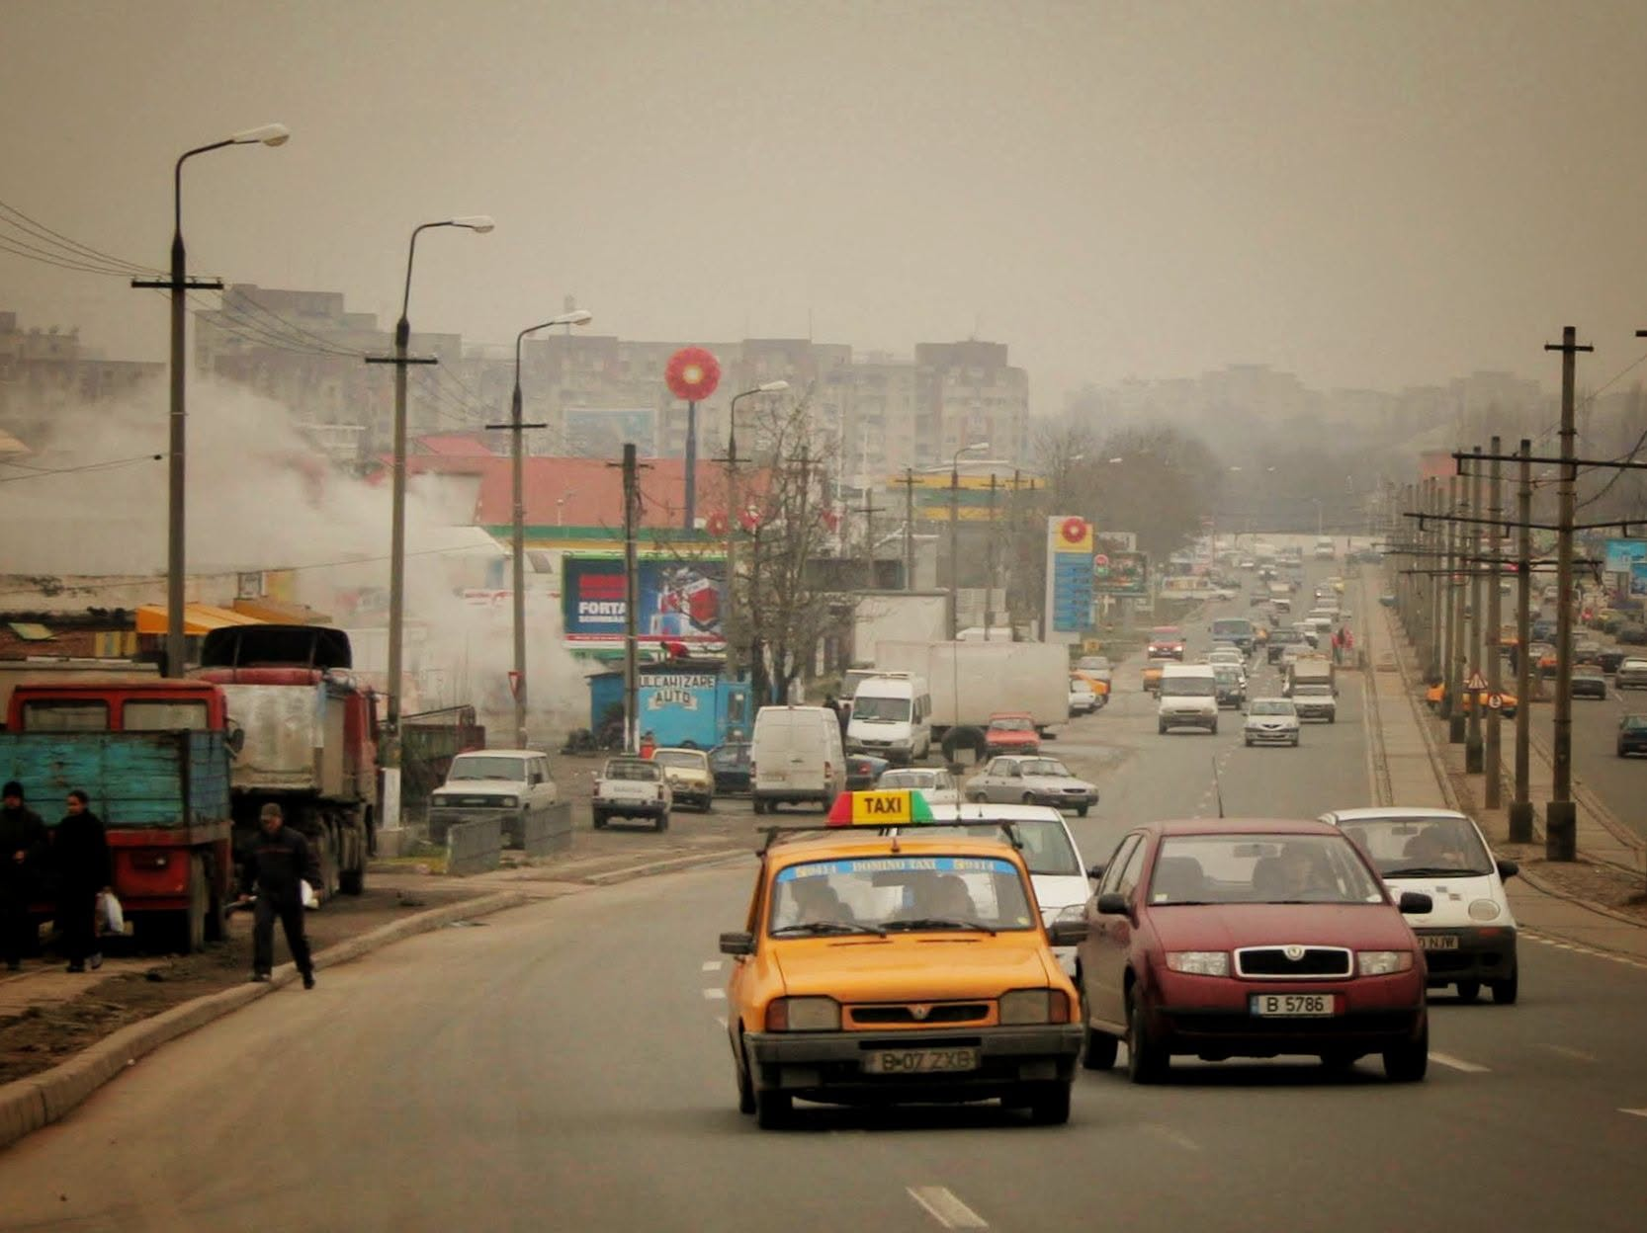
Inspiratie vizuala

