**Brief Description:**

* Loosely Based on Mine-Sweeper.
* User can jump mine between clouds.
* User must keep mine hidden in clouds.
* If the satellite finds the mine game is over.
* Game is side scrolling.
* User jumps mine between clouds.
* User could control multiple mines? And keep them all hidden?

**Neural Network Involvement:**

Neural Network competes against user:

* Tries to predict the cloud in which the mine is hiding. Cloud appearance changes, more drastically the longer the mine is hidden there this is noticeable to the neural network. User can send decoys which change clouds as if the mine is hidden there but not as drastically.
* User must keep moving the mine as the game is side scrolling to keep up.
* Neural network can send the satellite to it’s predicted cloud to uncover the mine and end the game.

**Difficulty level:**

* Neural network against user.
* Scroll speed can increase with time.
* Less clouds to hide in.

**Education value:**

* Instructions at start will explain Neural Network will identify clouds to predict where the mine is.
* Neural network will be against the user, as clouds change and computer gets closer to the catching the user, this gives a visualization of the neural network detecting changes.

[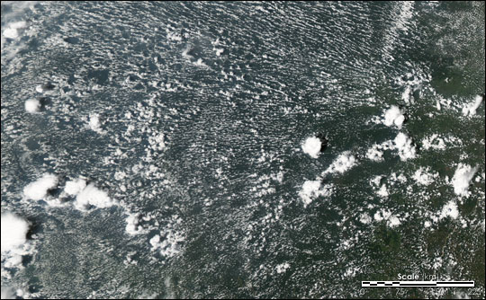](https://www.google.co.uk/url?sa=i&rct=j&q=&esrc=s&source=images&cd=&cad=rja&uact=8&ved=2ahUKEwjr59vRmq_eAhVJx4UKHW5xAYQQjRx6BAgBEAU&url=https%3A%2F%2Fearthobservatory.nasa.gov%2FFeatures%2FSmokeClouds&psig=AOvVaw35eCITQ1HJdGD4rJZaP30B&ust=1541024721364148)

Example of satellite image with multiple clouds for mine to hide in.