**Brief Description:**

* + Based on Pac-Man
  + User controls satellite
  + Satellite ‘collects’ items, that are identifiable by the neural network.
  + When an item is collected user score increases, until all items are collected, and next level commences.
  + The user must avoid enemy space ships(ghosts) and collect all items to proceed to next level.

**Neural Network Involvement:**

Neural Network competes against user

* + - Neural Network identifies items and can rank items(from appearance) based on score player will receive for that item, computer can also collect items and detract from the user score, neural network will prioritise what items to collect.
    - Pre-written scripts allow the neural network to chase down the user based on his location also.
    - Neural Network must prioritise resources between lowering the users points and catching the user to lower lives.

**Difficulty level:**

* Difficulty will increase with each level, computer will have access to more space ships to send after the user or to items.

**Education value:**

* Game shows neural network identifying items as well as distinguishing value of items(score gained)

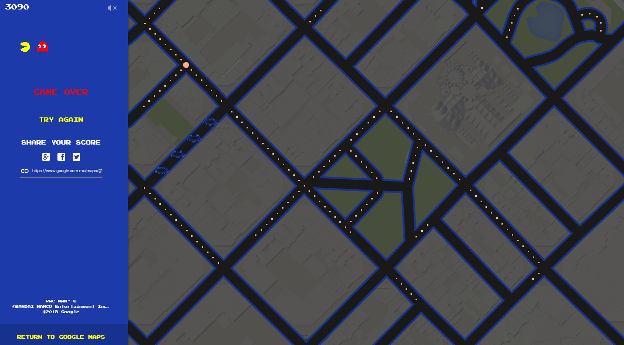

example of Pacman overlaying maps (similar to satellite imagery), items would have to be larger to be identifiable. (image from GoogleMaps).