**Digital Entertainment Systems B**



Android Mobile Flash Game

Aliencraft

Trevor Barker

Steve Bennett

Andrew Waterhouse

10219812

Table of Contents

During the development of the mobile flash game for Android devices, I will need to document my progress through the system life cycle of the product. Please use the contents page below as a guide to the work completed for this project.

1. Research 3

1.1 Main Menu 3

1.2 Gameplay 5

2. Development, Reflection and Testing 6

2.1 Reflection on Prototype 6

2.2 Test Log of Beta through to Final Game 6

3. Usability Study 7

3.1 Observations on BETA 7

3.2 Observations on the Final Game 8

4. Credits 9

4.2 Coding 11

4.3 Sounds 11

4.4 Original Content 11

5. Evaluation 12

5.1 Positives 12

5.2 Negatives 12

5.3 Conclusion 12

# 1. Research

## 1.1 Main Menu

The Space Invaders menu screen majorly influenced the starting screen of my Aliencraft game. I took influences from the 1980’s classic to include similar typography and menu interface so players would feel comfortable with the title.

Looking online at many Space Invaders image resources, I found there to be many different versions of the game. I particularly liked the aesthetics of the PlayStation 1 Space Invaders game where there was a simple space image as a background, with a menu enclosed inside a dark box.

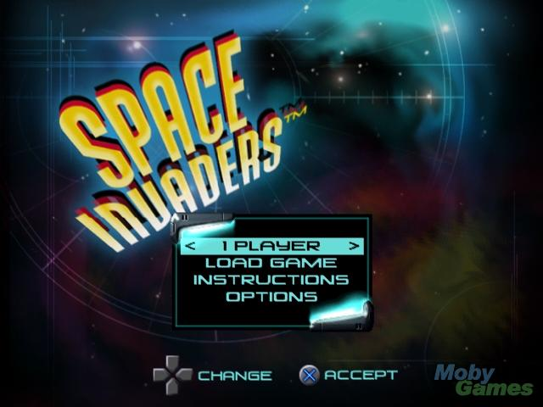I combined the two games of Space Invaders to create a final menu design that took the best aspects of each.

The finished menu for Aliencraft utilized a Space Invaders like style to subtly let the user know what genre of game they were about to play. The main menu typeface was selected to be reminiscent of the 1980’s with a classic design.

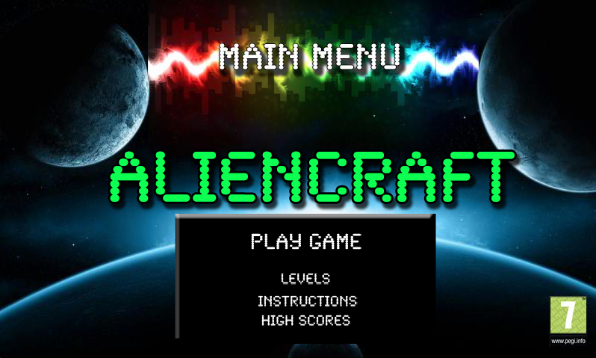Different sizes of text were used within the menu to direct the user to play the main game. However, later developments of the Flash based project allowed further options to be added, like selecting which level to play exactly, the instructions of the game and the current high scores.

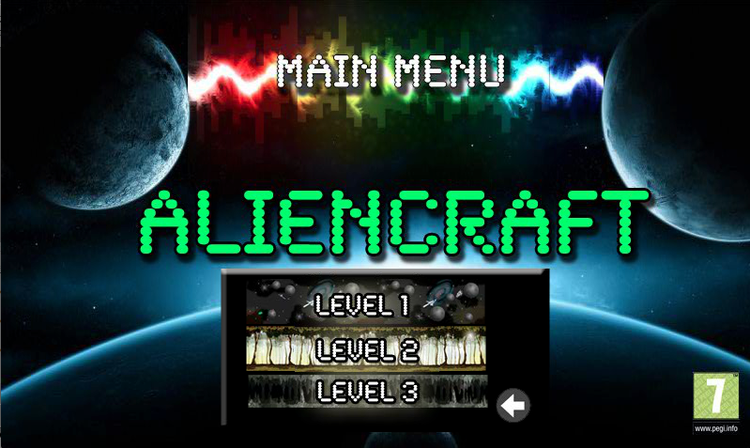The level design of the menu was created through imagination and the entire main content for this feature occurs inside the menu area.

Each level has an image to indicate which level the user is about to pick. The links of this part of the menu are the text to direct the user to the level they wish to play. The back button directs the user back to the main menu with a transition.

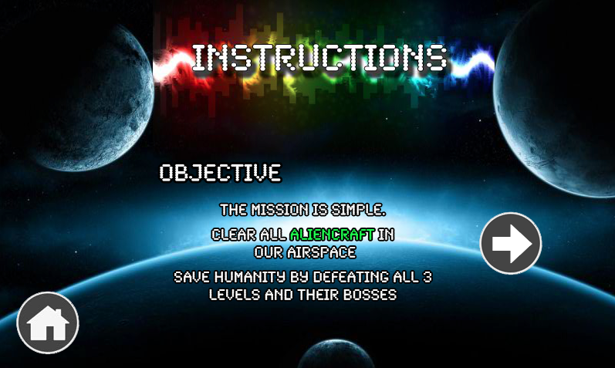The link from the main menu to the instructions takes the user to this pane. I wanted to encompass the style of instructions that was provided with the original Space Invaders game.

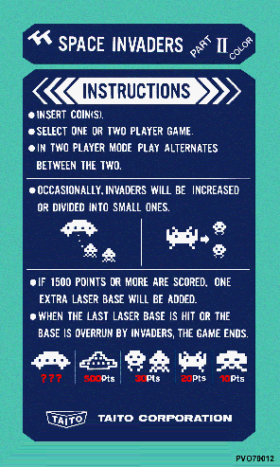

The instructions of the original game have a clear heading for the page the user is on. Each page of the Aliencraft game has a clear heading to indicate the page the user is currently viewing.

The instructions of the original game looked as though there would be different pages the user could view because of the arrow graphics at the top of the page.

In Aliencraft, the player can scroll different pages in the game using the provided arrow buttons. The user is able to view the objective and background to the game, rules and controls.

## 1.2 Gameplay

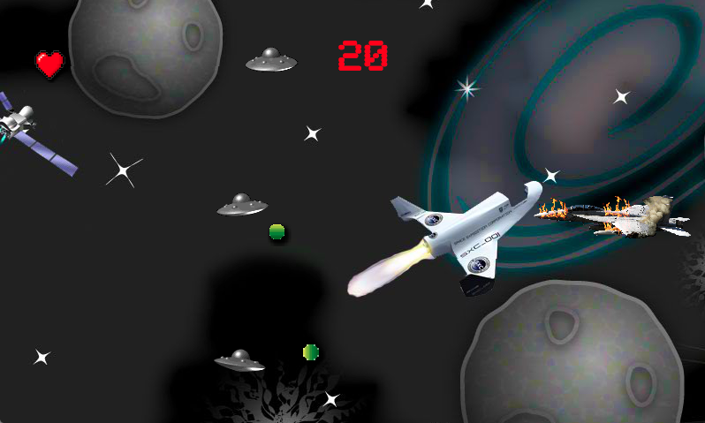

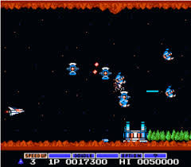The gameplay is set toward the brief for the assignment but had many similarities to Gradius (or Nemesis), a top selling game originally released in 1985. There are multiple levels to Aliencraft, much like Gradius, which has most recently been revamped in 2008.

Gaiares is a simple space shooter that has eight levels with different themes including bosses on each level like the Mermaid found in level two. Aliencraft also has similarities where on-screen display of score and lives are available on screen alongside the multiple themed levels and their respective bosses.

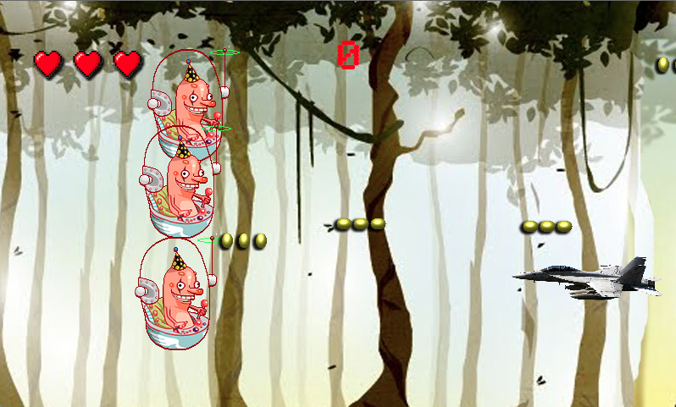

Multiple designed levels of the game were key to making the game fun as it always kept the player on its toes on what to expect next.

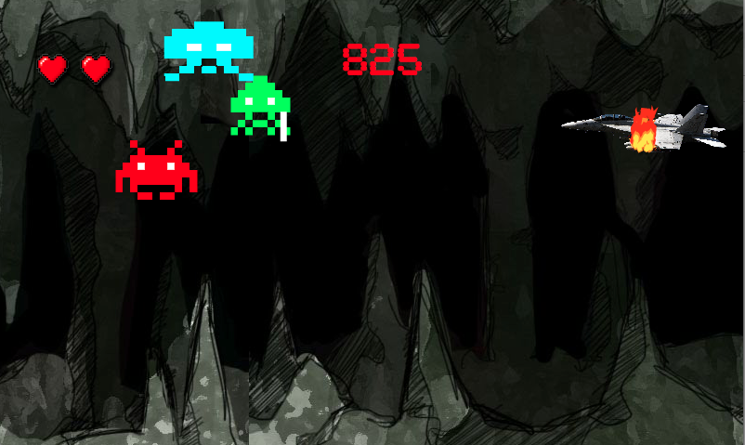Unique enemies with different movement patterns and shooting techniques culminated in a well-rounded game much like the Gaiares of the 1980’s.

# 2. Development, Reflection and Testing

## 2.1 Reflection on Prototype

The original prototype of the game was simply to test out that the basic functionality could work so I believe the initial prototype of Aliencraft did well in that regard.

## 2.2 Test Log of Beta through to Final Game

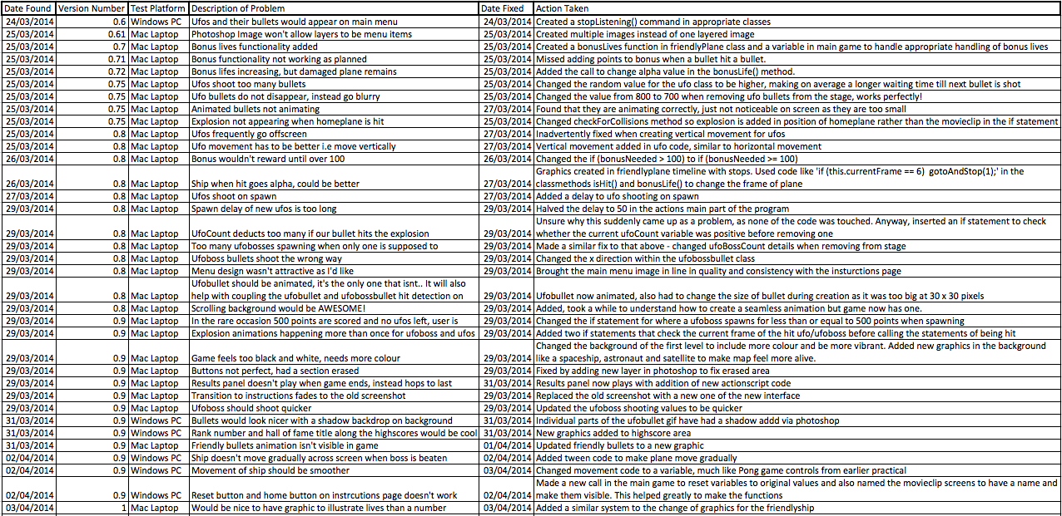

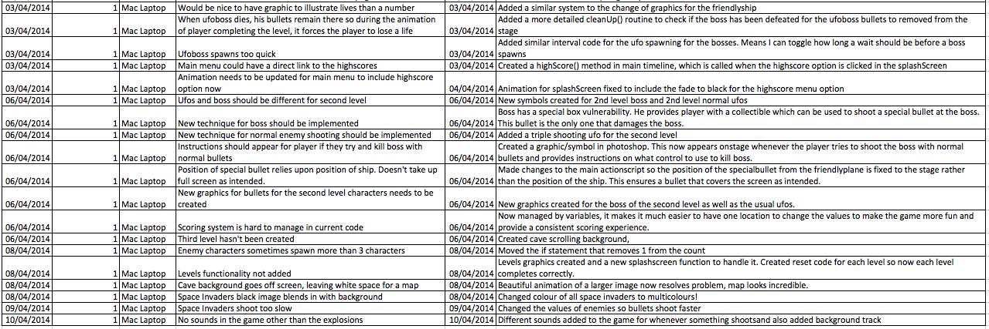

# 3. Usability Study

Due to the ethics rules at University of Hertfordshire, I will conduct the usability study of Aliencraft upon myself to determine where to progress the game from its BETA stage.

## 3.1 Observations on BETA

1. Can you shoot the alien on screen?

*I shot the alien on screen by holding down the Enter key, which I found to be unnatural to begin with. The bullets streamed out of the gun but didn’t look like the alien was hit at all as the bullets travelled off the screen.*

2. Can you control the friendly gun to avoid being hit?

*I can control my gun using the up and down arrows, but sometimes this leads to the gun being off screen. I feel like there should be a limit to keep the gun in the gaming area. When hit, the gun is so large that the explosion happens in a place that is away from where the bullet actually struck.*

3. Can you find a bug in this game?

*I could find many, like the gun being able to move off the screen, the unlimited supply of bullets for the gun and how the alien or gun didn't have any health or scoring.*

## 3.2 Observations on the Near-Final Version of the Game

1. Can you shoot the alien on screen?

*Easily shot the three on screen after going through the main menu. The explosions occur where the alien was struck and I enjoy how there is a delay to shooting rapidly.*

2. Can you control the friendly gun to avoid being hit?

*It was just as easy to control the friendly ship but the movement felt a lot smoother. I was unable to breach the limits of the screen to make the plane move outside of the playing arena.*

3. Can you find a bug in this game?

*After five or so run-throughs, I couldn’t see any bugs within this version of the game. I would like to hear more sound though.*

# 4. Credits

## 4.1 Image Credits

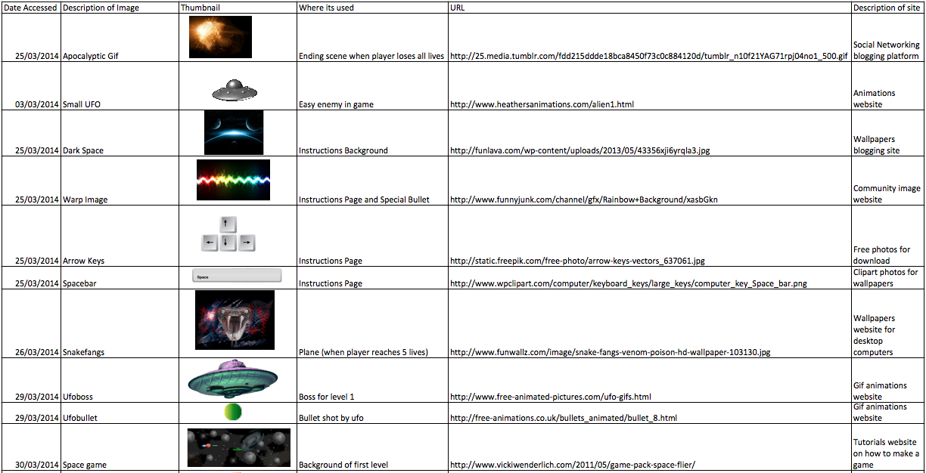

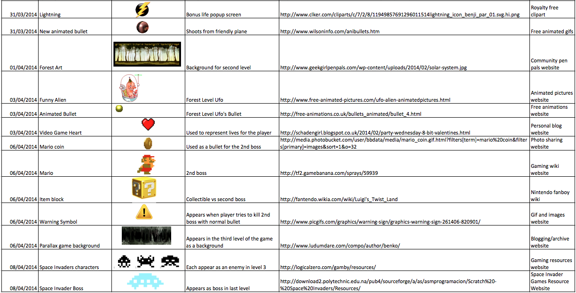

## 4.2 Coding

The majority of coding of Aliencraft was undertaken during the Digital Entertainment Systems B practicals at University of Hertfordshire. Practical lessons from Steve Bennett can be found at <http://www.studynet2.herts.ac.uk> where the basic functionality taught helped to inspire what to include throughout this project.

## 4.3 Sounds

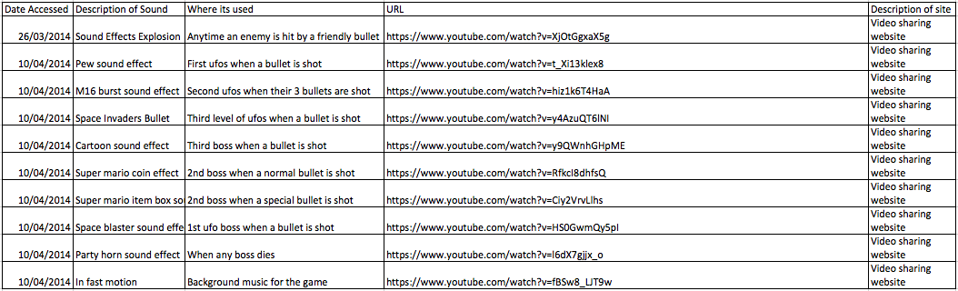

## 4.4 Original Content

All other attributes to Aliencraft not mentioned in the above credits have been created myself, using programs like Adobe PhotoShop and Audacity to manage the creation of such content. The raw files are included in the submission of the Aliencraft game as a variety of formats (including .psd) to verify these claims.

# 5. Evaluation

To evaluate my game Aliencraft, I will take a players point of view of the game to create a player-centric approach to the shooter. I will constructively criticize the game in a way that identifies the positives of how it currently stands and what could be improved.

## 5.1 Positives

* Attractive graphics for menu and gameplay
* Great levels option in the main menu
* Boss fights
* Good hit detection, no problem with unexpected numbers of enemies
* All functionality works as expected
* Amazing use of sound
* Keeps me on my toes with varied enemies

## 5.2 Negatives

* Would be nice for keyboard functionality on menu
* Animations could be touched up for when craft completes a level, works 95% of time
* End game screen could have better animations or graphics
* Mario boss could be clearer in how to defeat

## 5.3 Conclusion

I am really proud of the Aliencraft game I created for this project. I believe the graphics and sound quality alone set the shooter above the vast majority of side scrolling shooter games. One of the major factors that limited the number of fixes I could implement into the game was time. If I had an extra month or so, I would have been able to address the issues I had found when playing the game for myself. I enjoyed creating my first game and will look forward to further developing Aliencraft far beyond the coursework deadline.