SYNAPSE: Detection and Attribution of AI-Generated Synthetic Online Personas Using OSINT Techniques

SOFTWARE REQUIREMENTS SPECIFICATION (SRS)
1. PROJECT OBJECTIVE
Develop a complete system that:
- Collects OSINT data from X (Twitter)
- Detects whether a persona is *Human or AI-generated
- Identifies *linked synthetic personas (attribution)
- Provides results via *API + Dashboard
- Generates *forensic investigation reports

2. SYSTEM ARCHITECTURE OVERVIEW
The system must follow this pipeline:

Data Acquisition → Preprocessing → Feature Extraction → ML Detection → Attribution → API → Dashboard → Report Generation

3. SYSTEM MODULES & REQUIREMENTS
3.1 DATA ACQUISITION MODULE
Functional Requirements:
A. X (Twitter) Data Collection
- Use *snscrape* (no official API required)
- Input: username
* Output:
* username
* tweet text
* timestamp

B. AI Persona Generator
- Generate synthetic users with:
- unique usernames
- 50+ tweets per persona
- varied tone (casual, tech, student, etc.)
- realistic timestamps

C. Dataset Storage
- Store data in CSV or database
* Format:

username | post_text | timestamp | label

Labels:

* human
* ai

3.2 DATA PREPROCESSING MODULE
Functional Requirements:
- Convert text to lowercase

- Remove:
- URLs
- mentions (@user)
- special characters
- Normalize whitespace
- Tokenize text into words

Output:
* Cleaned text column (clean_text)
3.3 FEATURE EXTRACTION MODULE
Functional Requirements:
A. Stylometric Features
- word_count
- avg_word_length
- unique_word_count
- vocabulary richness
B. Behavioral Features
- posts_per_day
- time_between_posts
- hour_of_post
- night_activity_ratio

C. Text Vectorization
- Implement *TF-IDF*
- Max features: configurable (e.g., 300–500)

D. Feature Combination
- Merge:
- TF-IDF vectors
- stylometric features
- behavioral features

Output:
* Feature matrix X
* Labels y

3.4 MACHINE LEARNING MODULE (DETECTION ENGINE)
Functional Requirements:
A. Model Training
Implement and train:
1. Random Forest
2. Support Vector Machine (SVM)
3. XGBoost
B. Model Evaluation
- Accuracy
- Precision
- Recall
- F1-score

C. Confusion Matrix
- Generate and display
D. Feature Importance
- Extract feature importance (especially for Random Forest / XGBoost)
E. Model Selection
- Select best-performing model automatically or manually
F. Model Persistence
- Save model as .pkl
- Load model for inference

3.5 ATTRIBUTION ENGINE (CLUSTERING)
Functional Requirements:
A. Filter AI Accounts
- Only process accounts classified as AI
B. Similarity Calculation
- Cosine similarity on feature vectors
- Include:
- stylometric similarity
- behavioral similarity
C. Clustering
- Use *DBSCAN*

- Configurable parameters:
- eps
- min_samples

D. Cluster Assignment

- Assign cluster IDs
- Identify:
- grouped personas
- isolated personas (noise)
E. Graph Visualization
- Use *NetworkX*
- Nodes: personas
- Edges: similarity above threshold
3.6 API MODULE (BACKEND)
Technology:

* FastAPI
Endpoint:
GET /analyze?username=<username>
Processing Flow:
1. Fetch user data (snscrape)
2. Preprocess text
3. Extract features
4. Run ML model
5. Run attribution engine
6. Return results

3.7 DASHBOARD MODULE (FRONTEND)
Technology:
* Streamlit
Features:
Input:

* Username field
Output Display:
1. Detection Result
* AI / Human
* Synthetic Score

2. Behavioral Insights
- Activity timeline
- Posting patterns

3. Stylometric Insights
- vocabulary richness
- word statistics

4. Attribution Results
- Cluster ID
- Linked accounts

5. Visualizations
- Graph (NetworkX)
- Charts (matplotlib/plotly)
3.8 REPORT GENERATION MODULE
Functional Requirements:
- Generate downloadable *PDF report*
- Include:

* detection result
* feature insights
* cluster analysis
* visual graphs

4. NON-FUNCTIONAL REQUIREMENTS
Performance:
- System should handle multiple users sequentially
- Response time < 10 seconds per analysis
Usability:
- Simple UI (non-technical users can operate)
Scalability:
- Modular architecture (easy to extend)
Security:
- Only public OSINT data
- No private data access

5. TECHNOLOGY STACK

| Component | Technology |
7. FINAL DELIVERABLES
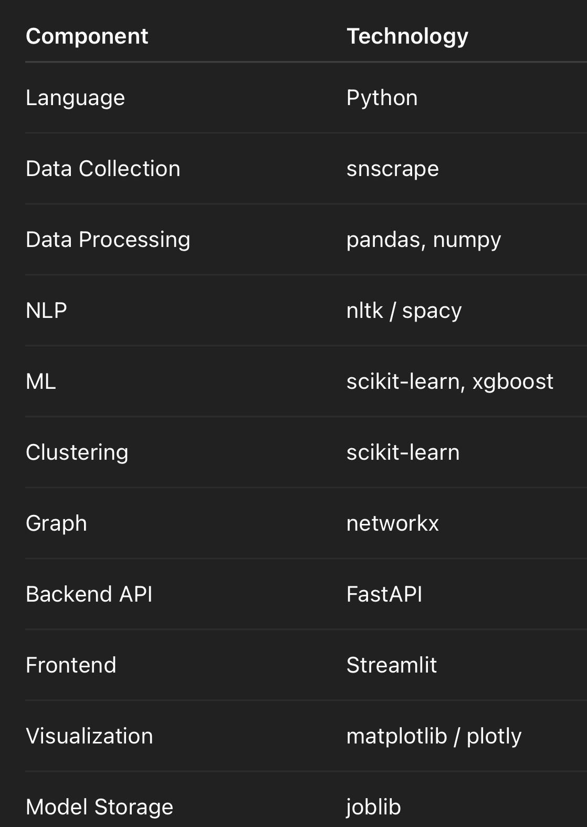
Developer must deliver:

- Complete source code
- Trained ML model file
- API backend
- Streamlit dashboard
- Dataset samples
- Visualization outputs
- PDF report generation
- Documentation

8. SUCCESS CRITERIA
The system is considered complete when:
* User inputs a username
* System fetches data
* Detects AI vs Human
* Identifies linked personas
* Displays results on dashboard
* Provides downloadable report
REFERENCE PICTURE OF UI:
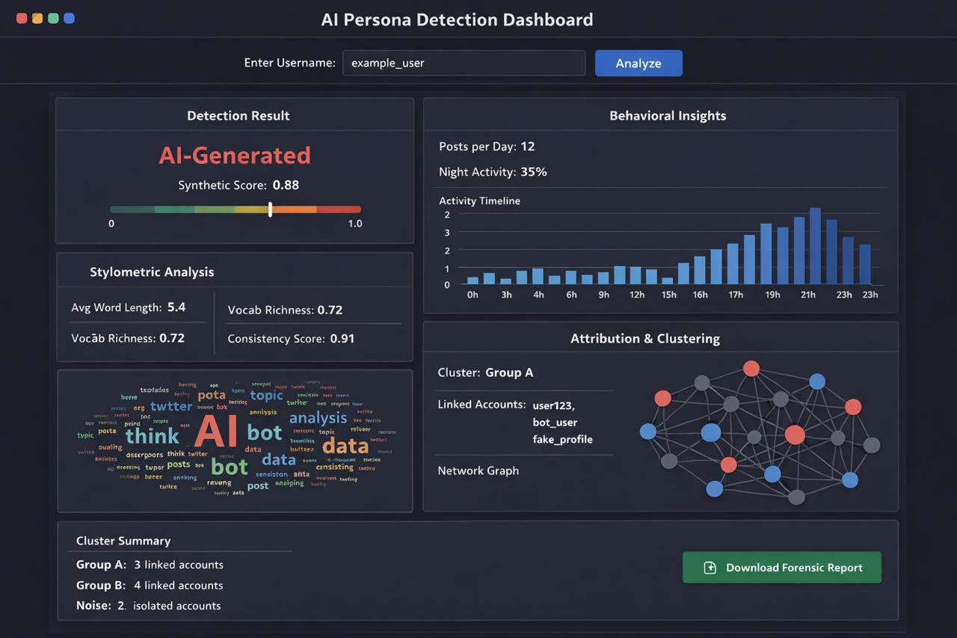
- More interactive and improved version of dashboard interface would be appreciated
- Add dark/light mode option too

