# CS 340 README

## About the Project/Project Title

The Grazioso Salvare Animal Locator is a database filtering software. It allows a user to filter, sort, and locate animals within a database. The software also gives you details on each animal such as breed, age, health, etc. The project was built using Python.

## Motivation

This project was designed to filter and search a database for animals that can assist with emergency response situations.

**Tools Used**

As stated above, the project was built using Python code and the database that was used was MongoDB. MongoDB is a free, open source, NoSQL database, meaning that no money was needed to develop the software.

Python code was used in tandem with MongoDB due to the Python library pymongo, making this duo the optimal choice.

The Dash framework was used to create the web application.

## Getting Started

You will need to download a current copy of the CRUD python module to work in tandem with the Animal Locator software. The current version of the software was designed for use with the database MongoDB.

## Usage

### Code Example

Upon start-up the dashboard will be unfiltered, showing every animal and their corresponding details.

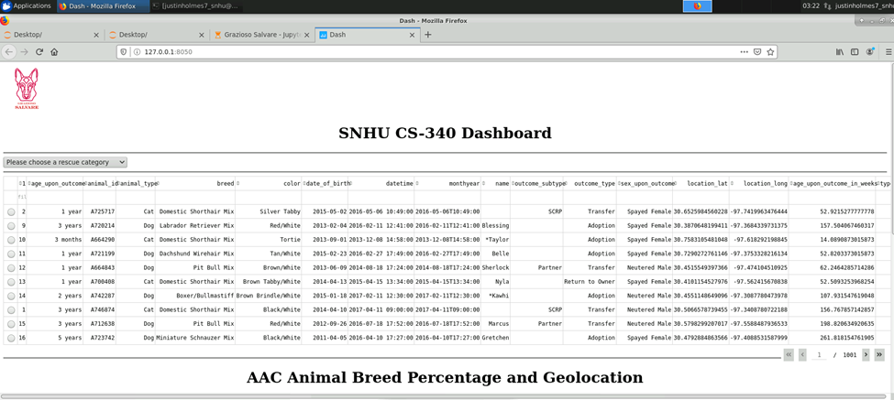

Below the dashboard you will see the Animal Breed Percentage pie chart which shows every breed and the percentage of that breed that is within the database. You will also see a map that, on start-up, shows the location of the Austin Animal Center.

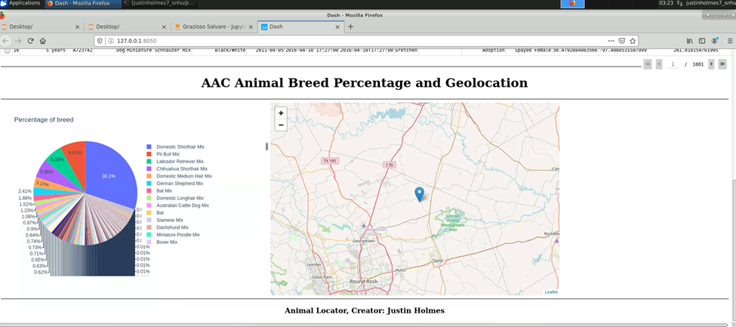

In the top left corner of the dashboard there is a dropdown list showing the different categories of emergency response encounters. Each of these emergency response encounters has specific dog breeds that can be crucial to success.

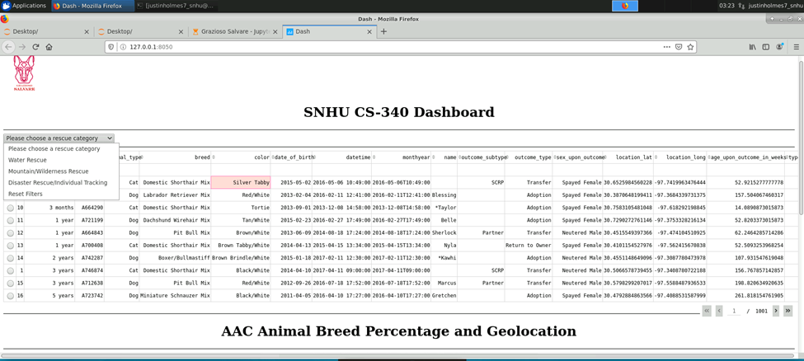

By clicking these options, the dashboard will be filtered to just the breeds of dogs for that specific emergency response, and will, again, show the breeds and percentages of those breeds that are inside the database.

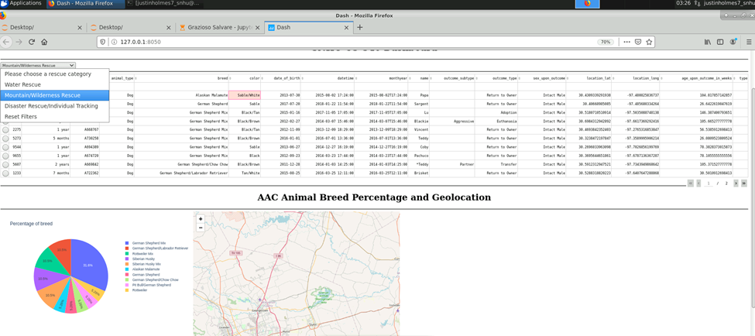

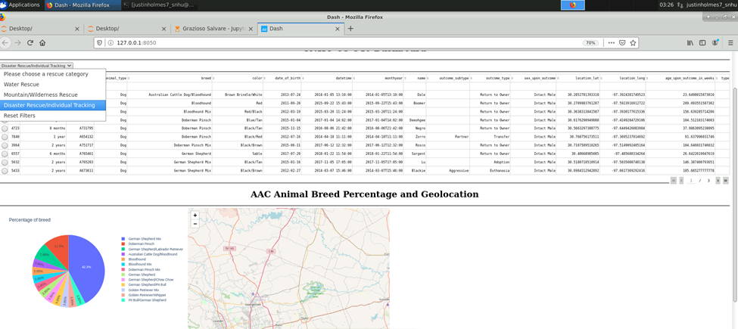

Once the category is decided, you can select the radio button next to the animal of your choice, and it will display the marker location on the map with the breed of the animal and their name.

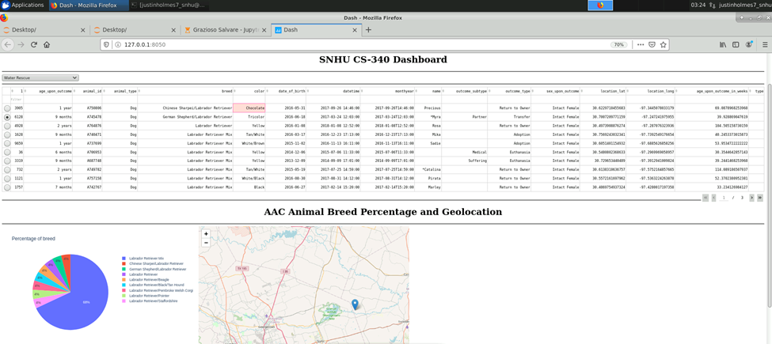

There is also a feature to reset the dashboard back to the full database in the drop-down menu.

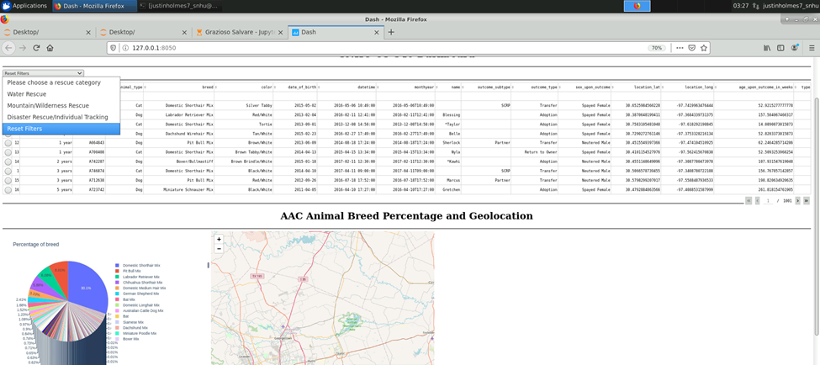

## Roadmap/Features

* Additional filter options
  + Cats
  + Dogs
  + Birds
  + Etc.

## Contact

Justin Holmes

Justin.holmes7@snhu.edu