**Reverse test plan**

|  |  |  |  |  |
| --- | --- | --- | --- | --- |
| Test No. | Input | Reason | Expected | Actual |
| Test 1:  Single digit | First Selection: 1 | Test selecting 1 shows that user is not able to progress | Value 1 input  Program outputs  “Your input is invalid, please try again” | “Your input is invalid, please try again”  See fig. 1 for screenshot |
| Test 2:  11 digits | First Selection: 12345678910 | Test selecting a number 11 or larger shows that user is unable to progress. | Value 12345678910 input  Program outputs  “Your input is invalid, please try again” | “Your input is invalid, please try again”  See fig. 2 for screenshot |
| Test 3:  Non integer | First Selection: “test” | Test selecting a string value, shows that user is unable to progress. | Value “test” input  Program outputs  “Your input is invalid, please try again” | “Your input is invalid, please try again”  See fig. 3 for screenshot |
| Test 4:  Negative integer | First Selection:  -13 | Test selecting a negative integer, shows that user is unable to progress. | Value -13 input  Program outputs  “Your input is invalid, please try again” | “Your input is invalid, please try again”  See fig. 4 for screenshot |
| Test 5:  Float | First Selection: 5.5 | Test selecting a float value, shows that user is unable to progress. | Value 5.5 input  Program outputs  “Your input is invalid, please try again” | “Your input is invalid, please try again”  See fig. 5 for screenshot |
| Test 6:  Correct input | First Selection:  456789 | Test selecting a valid input, showing that the input is correctly reversed | Value 456789 is input  The reversed value is displayed to user: 987654 | Reverse of the provided number is 987654  See Fig. 6 for screenshot |

**Fig. 1** – Single Digit

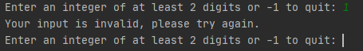

**Fig. 2** – 11 Digits

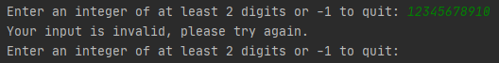

**Fig. 3** – String Input

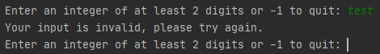

**Fig. 4** – Negative Integer

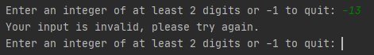

**Fig. 5** – Float

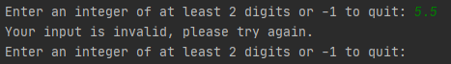

**Fig. 6** – Correct

