**resilience_gui**

**Developed by Craig Robson**

**Newcastle University**

**16 January 2015**

**Table of Contents**

**1** **Introduction** 2

**1.1** **Dependencies** 2

**1.2** **Further reference material** 2

**2** **Using the interface** 3

**2.1** **User Interface** 3

**2.2** **Building a network** 3

**2.3** **Calculating metrics and simple visualisation** 4

**2.5** **Simple failure simulations** 6

**2.6** **Complex failure simulations** 6

**2.7** **Further settings** 7

**2.7.1** **Metrics** 7

**2.7.2** **Config files** 7

# **Introduction**

This library provides a user interface for the python library ‘resilience’ along with added visual aspects to improve the user experience and range of analytics available to a user. Through the developed user interface the tool aims to provide the same level of flexibility as available natively through the resilience library thus allowing users to run a multitude of failure simulations. The functionality of the tool also extends from this to offer the ability to compute a range of common graph metrics, a selectin of those available in the NetworkX library. The library also provides the tool, and the user, with the ability to generate networks using some common graph generators. Finally, the tool utilises a range of drawing functions available in NetworkX to offer the user the ability to visualise a network during perturbations or not.

## **Dependencies**

The developed tool relies on a number of other libraries for which without the tool may not run or will suffer from reduced functionality.

* Python 2.7+
* NetworkX 1.7+
* PyQt4
* resilience 1+

## **Further reference material**

* NetworkX - <https://networkx.github.io/>

# **Using the interface**

## **User Interface**

The user interface has three main portions; (i) input network settings, (ii) failure analysis settings and (iii) the control buttons/menu’s. These are indicated in Figure 1 below.

An error message may appear on the initial loading of the tool about not being able to find/load the ‘nx_pgnet’ module. The location of this, if downloaded and required for the users objectives, can be specified in the ‘View Options’ option in the ‘Edit’ menu.



Figure : Diagram of interface with main aspects highlighted.

## **Building a network**

There are number of options available to build a network:

|  |  |
| --- | --- |
| * Graph generator * CSV * List * Database | Figure 2: Highlighting the input options to build a network. |

Before any analysis can be selected to be run the network build method should be selected and the parameters (file or values) entered to allow the network to be built. For the first option, using a graph generator algorithm, as available in the NetworkX library, help is available by hovering over the input boxes which are not shaded out for the network.

The CSV option requires the user to provide a CSV which contains a list of nodes and edges on consecutive lines in a text file.

The list option requires a list of nodes and a list of edges to be entered manually.

The database option allows users who have access to a database using the nx_pgnet schema to build a network from this, which opens the option for visualising the network geographically as well. This requires the database connection parameters and the name of the network to be loaded.

## **Calculating metrics and simple visualisation**

To calculate a metric over a network options are available in the ‘Metric’ (Figure 3) drop down menu. These allow the computation of a number of metrics using algorithms available in the NetworkX library. Results are returned in a window. There are options available for the computation of multiple metrics simultaneously, again with the results returned in a window.

Visualisations of networks can be quickly obtained through the ‘Draw’ button, which then gives options specific to the network build method, Figure 4 (when built from the database this allows a geographic visualisation). The visualisation can be customised using the ‘Edit’ menu and the ‘View Options’ item, Figure 5, which allows the colouring and size of nodes/edges to be changed, including having the size based on a metric value, for which there a small number of options. The results of any visualisation can be saved in a range of formats using the toolbar available in the visualisation window, Figure 6.

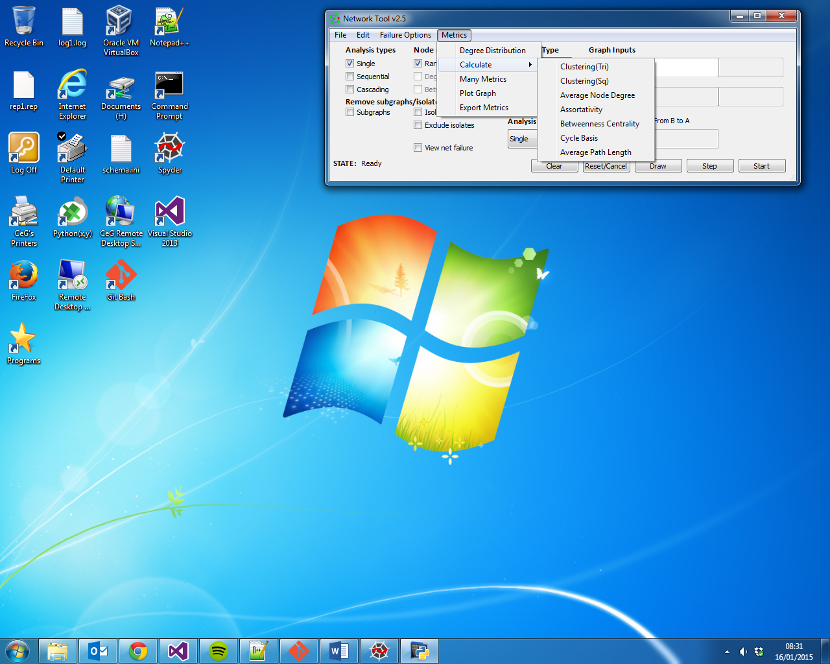

Figure : Showing the 'Metrics' menu and the available calculation options.

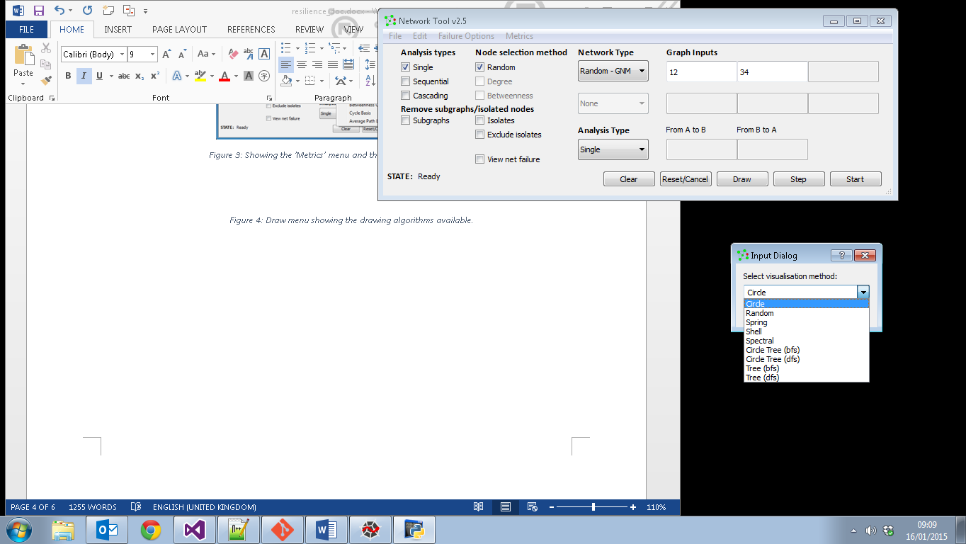

Figure : Draw menu showing the drawing algorithms available.

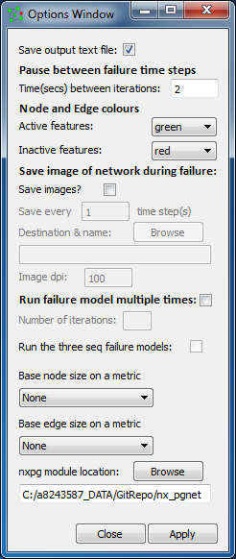

Figure : The Options menu.

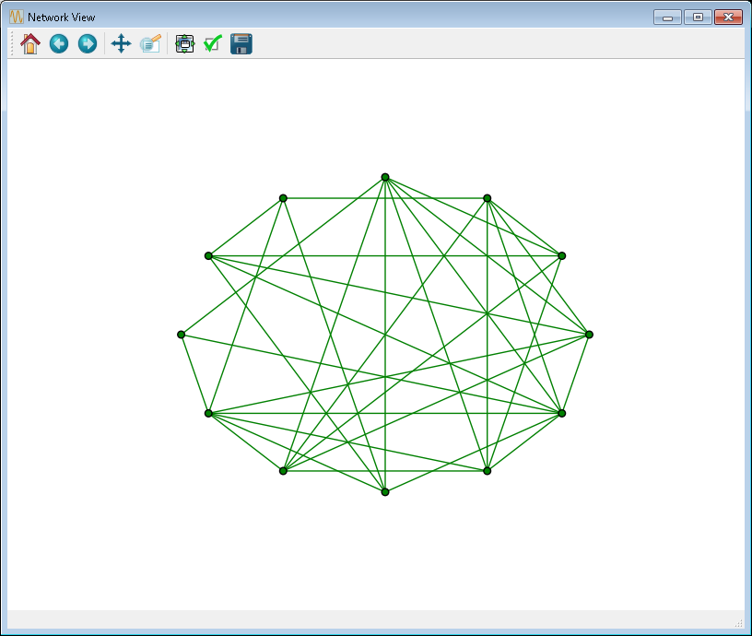

Figure : Showing the visualisation window, with the save button in blue on the top toolbar..

## **Simple failure simulations**

To run a failure simulation first select the ‘network type’ and then enter the parameters required to build the specific network. Following this select one of the ‘analysis types’ and then one of the ‘node selection method’s’. If you click run ‘Start’ now the simulation will run. However if you select the ‘View net failure’ option before clicking ‘Start’ a visualisation window will appear and the failure can be seen. Upon clicking start a window will open asking for a file to write the results to, using a simple text format. A pause time is used to slow the simulation down so the visualisation is readable, this along with many other options are available from the ‘Edit – View Options’ window (Figure 5) (some further advanced options are available through the ‘Options’ option in the ‘Failure Options’ menu). Further options are available on the user interface which allow for the customisation of how the simulation handles subgraphs and isolated nodes (under the ‘Remove subgraphs/isolated nodes’ heading).

While a simulation is running the ‘Pause’ button can be pressed at any time with the simulation stopping at the end of the current iteration. This allows for a more detailed analysis of the graph in the visualisation window. To resume, press the ‘Start’ button again. Rather than the simulation running one go, via the ‘Step’ button, one step can be run at a time. At any time during the simulation the ‘Start’ button can be pressed and the simulation will run automatically until the end.

At the end of a simulation there is the option to view the metrics which have been computed throughout the analysis on two plots (to change the metrics for the next simulation see the following section). Simply select a metric from each of the drop down menus and the plots should be updated automatically, allowing for comparisons to be made between metrics and this the behaviour of the network analysed. At any time the plots can be saved using the save button in the tool bar across the top of the window.

## **Complex failure simulations**

The tool and the underlying resilience module facilitates the ability to analyse dependencies between networks, using the same failure options as for the single network analysis. Where dependency is concerned, the network which is the ‘parent’ is the one subjected to the failures. The settings/parameters for the second network can be set by changing the ‘Analysis Type’ drop down menu to ‘dependency’ (Figure 7), which should then enable a second network to be crated. The dependency links can be created randomly (‘Failure Options’ – ‘Random Dependency Edges’ (Figure 8)) or entered in the input box titled ‘From A to B’. these should be in the form of a list of tuples. As with the analysis of a single network, clicking the ‘Start’ button commences the analysis. It should be noted when doing dependency analysis the simulation cannot be visualised.

It is also possible to run interdependency analysis in a similar fashion to the dependency analysis.

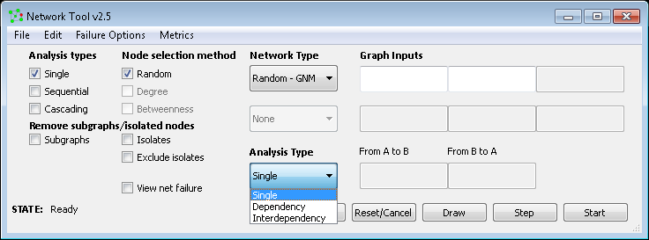

Figure : List of the different Analysis Types available, including dependency and interdependency.

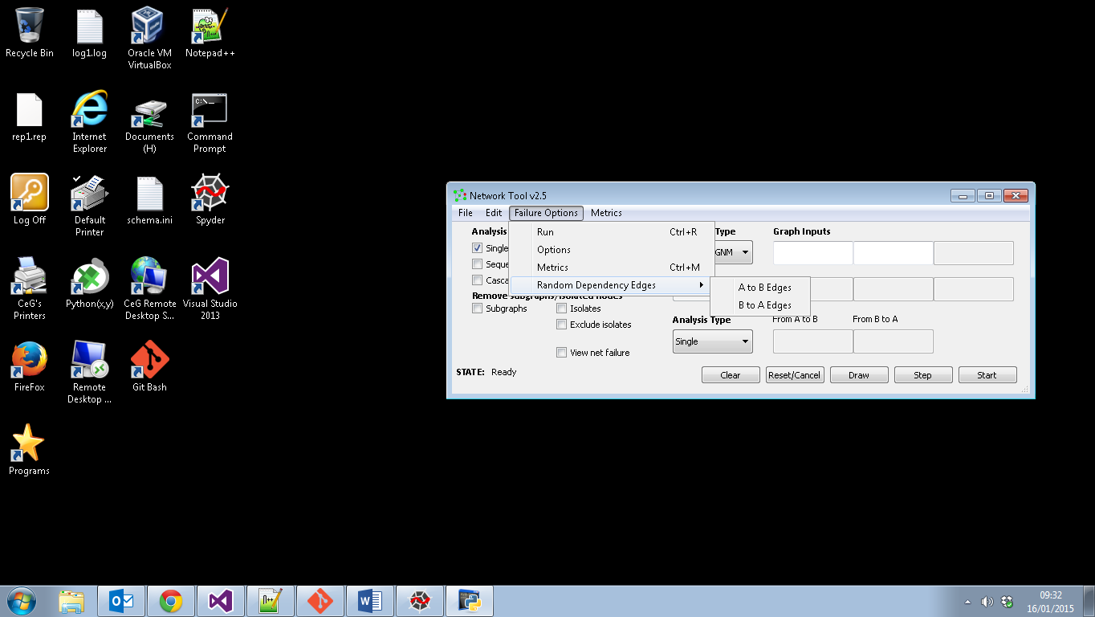

Figure : Showing the Failure Options menu and the option to create random dependency links.

## **Further settings**

### **Metrics**

A default set of metrics are calculated during a simulation at each time step, however for each simulation the metrics computed can be changed going to the ‘Failure Options’ – ‘Metrics’ window (Figure 9). Those included, if possible, will also be listed in the visualisation at the end of a simulation.

### **Config files**

Configuration files can be saved and re-loaded so where a user sets up the gui to run a simulation, the settings can be re-loaded when the gui is next opened, as well as allowing for the settings to be reviewed outside of the gui from the text file directly. This is done through the ‘Edit’ menu.

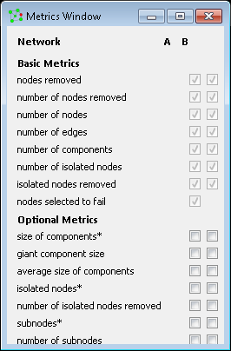

Figure : A snapshot of the 'Metrics' window and the possible metrics (note that this shows less than half of the available optional metrics).