Craig Ssemakula

Internetworking

11th November,2025

Spanning Tree Protocol (STP) Lab Synopsis

Key Learnings

1. STP Port States & Root Bridge Selection
- STP elects a root bridge based on the lowest bridge ID
- Port states: Forwarding (FWD) allows traffic; Blocking (BLK) prevents loops
- One port is blocked in redundant topologies to create a loop-free logical path
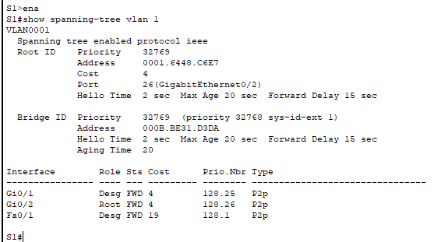

2. Loop Prevention Mechanism
- STP blocks redundant paths to prevent broadcast storms and MAC table instability
- Orange link lights in Packet Tracer indicate blocked ports
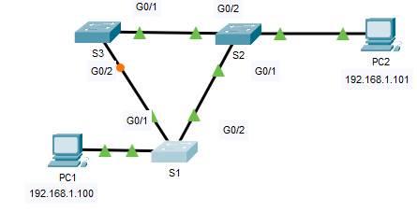

3. STP Convergence Process
- When a link fails, STP recalculates and transitions blocked ports through states: BLK → LIS → LRN → FWD
After 30-50 seconds, theconnectivity is restored through alternate paths.
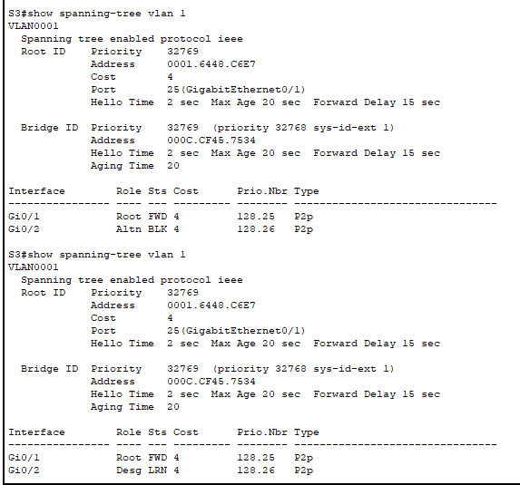

Conclusion
This lab demonstrated how STP is essential for network stability in redundant topologies. By blocking ports and recalculating paths during failures, STP ensures both loop prevention and high availability.

