North American University
COMP 4358, Wireless Networking
TechNova Inc. Wireless Network Design
Final Project Report
Submitted by
Craig Ssemakula
Student ID: 10001985
Submitted to
Prof. Azamat Zhamanov
April 25, 2026

Table of Contents
After opening this document in Microsoft Word, right click the table below and select "Update Field" to populate page numbers.

4.3 Executive Summary
TechNova Inc. is moving into a new three floor office building and needs a wireless network that handles three user classes with different security needs. Floor 1 hosts IT, a public lobby, and the server room; Floor 2 has Engineering and three conference rooms; Floor 3 has Executive, HR, and training. About 85 employees plus guests and IoT devices use the network.
The design was built in Cisco Packet Tracer 8.2.2. It includes seven access points across the three floors, two redundant Layer 3 core switches running HSRP for gateway redundancy, a Wireless LAN Controller for centralized AP management, two servers (one for DHCP/DNS/email, one for RADIUS/NTP/Syslog), and an edge router doing OSPF and NAT toward a simulated ISP. Three SSIDs separate Employee, Guest, and IoT traffic, each mapped to its own VLAN. An extended ACL blocks Guest traffic from internal subnets while still allowing internet access.
The main goals were security through segmentation, full floor coverage with non overlapping channels, scalability through controller based AP management, and operational visibility through centralized logging and time sync. End to end testing confirmed all required technologies work together, and the mandatory and extra credit features called out in the brief are configured and verified in later sections.

4.4 Network Design Overview

4.4.1 Network Topology Diagram
Figure 1 shows the full topology. Colored bands represent each floor (Floor 1 light blue, Floor 2 pink, Floor 3 yellow). Each floor has its own access switch (SW-F1, SW-F2, SW-F3) connecting the floor's APs and uplinking to both core switches with redundant trunks. The two cores (SW-Core-1, SW-Core-2) connect to each other and to R-Edge, which reaches the simulated ISP. WLC-Main and both servers (SRV-Core for DHCP/DNS/email, SRV-AAA for RADIUS/NTP/Syslog) sit on the management VLAN.
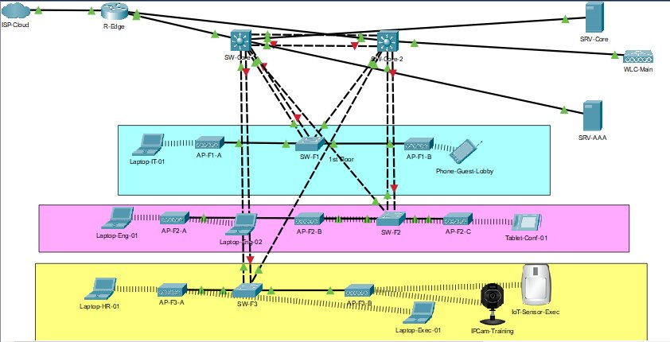
Figure 1: Full network topology showing 7 APs across 3 floors, 2 cores, edge router, WLC, 2 servers, and 10 wireless clients.

4.4.2 IP Addressing Table
Table 1 lists every device with its interface, IP, subnet, gateway, and VLAN. Wireless clients get their addresses via DHCP from SRV-Core.

Device | Interface | IP Address | Subnet Mask | Gateway | VLAN
R-Edge | G0/0 (WAN) | 203.0.113.2 | 255.255.255.0 | ISP
R-Edge | G0/1 | 10.0.0.1 | 255.255.255.252
R-Edge | G0/2 | 10.0.0.5 | 255.255.255.252
SW-Core-1 | VLAN 10 | 192.168.10.2 | 255.255.255.0 |  | 10
SW-Core-1 | VLAN 20 | 192.168.20.2 | 255.255.255.0 |  | 20
SW-Core-1 | VLAN 30 | 192.168.30.2 | 255.255.255.0 |  | 30
SW-Core-1 | VLAN 99 | 192.168.99.2 | 255.255.255.0 |  | 99
SW-Core-2 | VLAN 10 | 192.168.10.3 | 255.255.255.0 |  | 10
SW-Core-2 | VLAN 20 | 192.168.20.3 | 255.255.255.0 |  | 20
SW-Core-2 | VLAN 30 | 192.168.30.3 | 255.255.255.0 |  | 30
SW-Core-2 | VLAN 99 | 192.168.99.3 | 255.255.255.0 |  | 99
HSRP VIP V10 | Virtual | 192.168.10.1 | 255.255.255.0 |  | 10
HSRP VIP V20 | Virtual | 192.168.20.1 | 255.255.255.0 |  | 20
HSRP VIP V30 | Virtual | 192.168.30.1 | 255.255.255.0 |  | 30
HSRP VIP V99 | Virtual | 192.168.99.1 | 255.255.255.0 |  | 99
SW-F1 | VLAN 99 mgmt | 192.168.99.20 | 255.255.255.0 | 192.168.99.1 | 99
SW-F2 | VLAN 99 mgmt | 192.168.99.21 | 255.255.255.0 | 192.168.99.1 | 99
SW-F3 | VLAN 99 mgmt | 192.168.99.22 | 255.255.255.0 | 192.168.99.1 | 99
WLC-Main | Management | 192.168.99.10 | 255.255.255.0 | 192.168.99.1 | 99
SRV-Core (DHCP/DNS/Email) | FastEthernet | 192.168.99.40 | 255.255.255.0 | 192.168.99.1 | 99
SRV-AAA (RADIUS/NTP/Syslog) | FastEthernet | 192.168.99.41 | 255.255.255.0 | 192.168.99.1 | 99
AP-F1-A through F3-B (x7) | Wireless Mgmt | DHCP V99 | 255.255.255.0 | 192.168.99.1 | 99
Employee laptops (4 devices) | Wireless0 | DHCP | 255.255.255.0 | 192.168.10.1 | 10
Guest tablet/phone (2 devices) | Wireless0 | DHCP | 255.255.255.0 | 192.168.20.1 | 20
IoT sensor + IP camera | Wireless0 | DHCP | 255.255.255.0 | 192.168.30.1 | 30
Table 1: Complete IP addressing table.

4.4.3 VLAN Assignment Table

VLAN ID | VLAN Name | Purpose | SSID Mapping | Subnet
10 | Employee | Employee wireless devices | TechNova-Employee | 192.168.10.0/24
20 | Guest | Guest/visitor internet access | TechNova-Guest | 192.168.20.0/24
30 | IoT | Smart building sensors | TechNova-IoT | 192.168.30.0/24
99 | Management | Network device management | N/A | 192.168.99.0/24
Table 2: VLAN assignment.

4.4.4 Channel Plan Table

AP Name | Location | Frequency Band | Channel | Rationale
AP-F1-A | Floor 1 (IT) | 2.4 GHz | 1 | Non overlapping; max separation from Floor 2
AP-F1-B | Floor 1 (Lobby) | 2.4 GHz | 1 | Same channel as F1-A; APs physically separated
AP-F2-A | Floor 2 (Engineering) | 2.4 GHz | 6 | Middle channel; minimizes interference with F1 and F3
AP-F2-B | Floor 2 (Conf room) | 2.4 GHz | 6 | Channel reuse within floor
AP-F2-C | Floor 2 (Conf room) | 2.4 GHz | 6 | Channel reuse within floor
AP-F3-A | Floor 3 (HR/Exec) | 2.4 GHz | 11 | Maximum separation from Floor 2
AP-F3-B | Floor 3 (Training) | 2.4 GHz | 11 | Same channel as F3-A; different rooms
Table 3: 2.4 GHz channel plan using non overlapping channels 1, 6, 11.

4.5 Technology Descriptions
This section covers the eight required topics. For each one I explain what the technology is, why I used it, and how it was configured.

a) Wireless Standards (802.11 a/b/g/n/ac/ax)
The 802.11 family is the IEEE standard for Wi-Fi. Each generation has different speeds and frequency capabilities. The most relevant ones today are 802.11n (Wi-Fi 4), 802.11ac (Wi-Fi 5), and 802.11ax (Wi-Fi 6).

Standard | Year | Band | Max rate | Notes
802.11n (Wi-Fi 4) | 2009 | 2.4 / 5 GHz | 600 Mbps | MIMO, channel bonding
802.11ac (Wi-Fi 5) | 2013 | 5 GHz | 6.9 Gbps | MU-MIMO, wider channels
802.11ax (Wi-Fi 6) | 2019 | 2.4 / 5 / 6 GHz | 9.6 Gbps | OFDMA, BSS coloring, TWT
Table 4: Modern 802.11 standards relevant to this design.
My design assumes 802.11n/ac capable APs because Packet Tracer's AP-PT model abstracts the radio standard. Wi-Fi 6 introduced two big improvements: OFDMA divides a channel into smaller resource units so the AP can serve multiple clients in parallel within one transmission, and Target Wake Time (TWT) lets battery powered IoT devices schedule sleep periods to extend battery life. Wi-Fi 6 also performs much better in dense environments like the Floor 2 conference rooms during meetings.

b) Frequency Bands (2.4 GHz vs 5 GHz vs 6 GHz)
The 2.4 GHz band has better range and wall penetration because lower frequencies mean longer wavelengths (using lambda = c/f, 2.4 GHz has a wavelength of about 12.5 cm vs 6 cm at 5 GHz). The downside is only three non overlapping channels (1, 6, 11) and shared spectrum with microwaves, Bluetooth, and a lot of other consumer devices.
The 5 GHz band has many more non overlapping channels (around 25 in the U.S. depending on DFS), faster speeds from wider channel widths (40/80/160 MHz), and far less interference. The tradeoff is shorter range and worse wall penetration.
The 6 GHz band, opened up for Wi-Fi 6E, gives even more spectrum (about 1200 MHz of additional capacity in the U.S.) and is currently uncrowded because only 6E and Wi-Fi 7 devices can use it. It's not configurable in Packet Tracer but is the future of high density enterprise Wi-Fi.
My design uses 2.4 GHz because that's what Packet Tracer's AP-PT model reliably exposes. In a real TechNova deployment I'd run dual band APs with band steering to push capable clients to 5 GHz, freeing 2.4 GHz for legacy and IoT devices that need range.

c) Security Protocols (WPA2 / WPA3)
Wi-Fi security has gone through four main standards. WEP (1999) used RC4 with a 24 bit IV that could be cracked in minutes, completely broken. WPA (2003) was a transition fix using TKIP. WPA2 (2004) introduced AES-CCMP, which is what most enterprise networks use today. WPA3 (2018) replaces the PSK handshake with SAE (Simultaneous Authentication of Equals) and adds forward secrecy.
WPA2's 4 way handshake works like this: both the AP and client already know the Pairwise Master Key (PMK), derived using PBKDF2 from the passphrase and SSID. The handshake exchanges nonces to derive the Pairwise Transient Key (PTK), which splits into the Key Confirmation Key (KCK), Key Encryption Key (KEK), and Temporal Key (TK). The TK encrypts unicast frames with AES-CCMP. The handshake also installs the Group Temporal Key (GTK) for broadcast traffic.
AES-CCMP combines AES counter mode (confidentiality) with CBC-MAC (integrity), faster and more secure than TKIP. The Employee and IoT SSIDs use WPA2-AES.
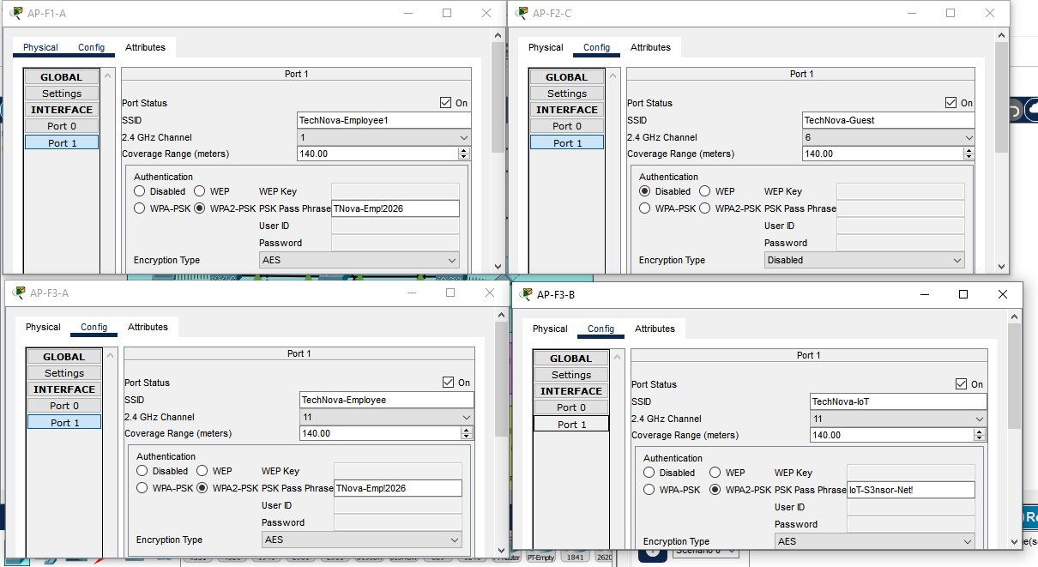
Figure 2: AP Config panes showing WPA2-PSK with AES on Employee and IoT SSIDs, and the open Guest SSID.
WPA3 isn't configurable in PT, but a real TechNova deployment would upgrade to WPA3-Enterprise. WPA3 fixes WPA2's biggest weakness, offline dictionary attacks against captured handshakes, because SAE never exposes derivable material to a passive listener. WPA3 also requires Protected Management Frames (PMF), which prevents the deauthentication attacks WPA2 is helpless against. Migration would happen in transition mode (WPA2/WPA3 mixed) until all clients support WPA3.

d) SSID Design and VLAN Segmentation
An SSID is the human readable name of a wireless network, broadcast in beacon frames. A Basic Service Set (BSS) is the cell formed by a single AP and its clients. An Extended Service Set (ESS) is multiple BSSs sharing the same SSID and distribution system, which is what allows clients to roam between APs.
My design has three SSIDs mapped to three VLANs. Employee on VLAN 10 with WPA2-AES. Guest on VLAN 20, open. IoT on VLAN 30 with WPA2-AES and a long PSK. Each AP's switch port is an access port in the right VLAN, and trunk uplinks to the cores carry all four VLANs (10, 20, 30, 99) in 802.1Q tags.
VLAN segmentation improves security because devices in different VLANs can't communicate at Layer 2, they're in different broadcast domains. Even if a guest device gets compromised, it can't ARP poison or directly attack employee devices. The only path between VLANs is through a Layer 3 router or switch, where ACLs filter traffic.
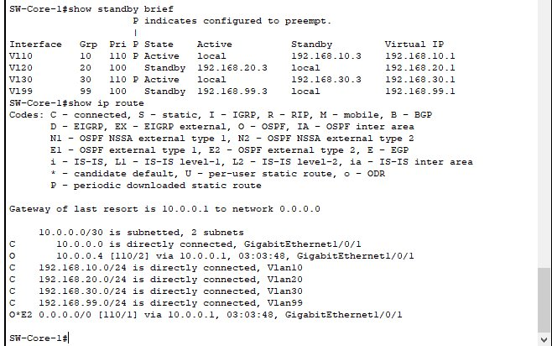
Figure 3: show vlan brief on SW-Core-1 with VLANs 10, 20, 30, and 99 active.

e) Channel Planning
In the 2.4 GHz band, channels are 5 MHz apart but each Wi-Fi channel is 22 MHz wide, so most channels overlap. The only three non overlapping channels are 1, 6, and 11, spaced 25 MHz apart so their 22 MHz signals don't bleed into each other.
Two types of interference matter. Co channel interference happens when two APs on the same channel can hear each other; their transmissions collide and clients have to wait through CSMA/CA backoffs. Adjacent channel interference is worse because overlapping channels create raised noise floors that clients can't even hear as a valid Wi-Fi signal.
My channel plan puts Floor 1 on channel 1, Floor 2 on channel 6, and Floor 3 on channel 11. Maximum separation between adjacent floors, where signal would otherwise leak through the ceiling. Within a floor, multiple APs share the same channel because they're physically separated by walls and distance.
DFS (Dynamic Frequency Selection) is a 5 GHz feature where APs listen for radar pulses on UNII-2 / UNII-2e channels and vacate them automatically if detected. It's mandatory for those channels because they're shared with weather and military radar. DFS isn't in Packet Tracer.

f) AP Management, Standalone vs Controller Based (CAPWAP)
There are two ways to manage APs. Standalone (autonomous) APs each hold their own configuration, which doesn't scale past a handful of APs. Controller based management uses a Wireless LAN Controller to centrally configure, monitor, and troubleshoot all APs. Pushing a new SSID becomes a one click operation instead of seven separate AP configs.
The protocol that connects APs to their controller is CAPWAP (Control and Provisioning of Wireless Access Points). CAPWAP runs on UDP 5246 for control and UDP 5247 for data. The control channel is encrypted with DTLS so the management traffic is protected even if the AP to WLC path goes through untrusted infrastructure.
CAPWAP also enables the split MAC architecture. The AP handles time sensitive 802.11 functions (frame ACKs, beaconing, encryption, the PHY). The WLC handles heavier functions (association/authentication state, mobility decisions, RF management, security policy). This split is what makes lightweight APs cheap and centralized control practical.
FlexConnect is a Cisco mode where the AP keeps forwarding client data locally even if the WAN to the WLC fails, useful for branch offices. Not really applicable to TechNova because everything is in one building, and FlexConnect isn't fully supported in PT anyway.
I chose controller based management because seven APs is too many to configure individually, and the brief specifically required centralized AP management. WLC-Main sits on VLAN 99 at 192.168.99.10, all seven APs register to it via CAPWAP.

g) CSMA/CA, Wireless Medium Access
Wired Ethernet uses CSMA/CD (Collision Detection), devices transmit and detect collisions on the wire. Wireless can't do that because radios can't transmit and listen at the same time on the same frequency, and the receiver might not even be in range to hear the collision. So Wi-Fi uses CSMA/CA (Collision Avoidance).
The basic flow: a station that wants to transmit listens for a DIFS (DCF Interframe Space, about 28 microseconds for 802.11g). If the channel is idle, it picks a random backoff between 0 and the contention window size and counts down while listening. If the channel goes busy, it freezes the timer and resumes after the channel clears. When the timer hits zero, it transmits, and the receiver replies with an ACK after a SIFS (Short Interframe Space, about 10 microseconds). If no ACK comes, the sender doubles the contention window and retries.
RTS/CTS is an optional layer for larger frames. The sender transmits a tiny RTS (Request to Send), the receiver replies with CTS (Clear to Send), then the actual data goes out followed by an ACK. This handles the hidden node problem, where two stations can both see the AP but can't see each other. The CTS broadcast tells everyone in range that the medium is reserved.
In TechNova's multi floor design, hidden nodes are most likely between floors. A laptop on Floor 1 and a laptop on Floor 2 associated to different APs can't hear each other directly but both can hear their own AP. Because each AP has its own collision domain (different channel per floor), this isn't actually an issue here.

h) Signal Considerations
Signal quality is determined by RSSI (Received Signal Strength Indicator, in dBm), the noise floor (background RF noise, also dBm), and SNR (Signal to Noise Ratio, the difference: SNR = RSSI minus noise floor, in dB). Higher SNR means cleaner signal, which lets the AP and client use higher order modulations like 256-QAM (8 bits per symbol) for faster data rates. Low SNR forces a fall back to slower modulations like BPSK (1 bit per symbol).
Sources of interference in TechNova: microwave ovens (very strong 2.4 GHz emitters), Bluetooth devices (also 2.4 GHz, but FHSS makes them tolerable), other Wi-Fi networks from neighboring offices, and RF noise from electrical equipment. Physical obstacles also matter: drywall costs maybe 3 to 5 dB per wall, concrete walls cost 10 to 20 dB, metal furniture and elevator shafts can completely block signals. Floor to floor signal goes through concrete and rebar, which is why each floor needs its own APs.
Transmit power is regulated. In the U.S. the FCC limits Wi-Fi APs to 30 dBm EIRP (1 watt) on 2.4 GHz under Part 15 rules. Most enterprise APs ship at 20 dBm (100 mW). Higher TX power isn't always better, in dense deployments lowering the TX power makes cells smaller, reduces co channel interference, and lets clients roam to closer APs. This is one reason controller based management matters: the WLC can adjust TX power across all APs as a coordinated system.

4.6 Security Analysis

Wireless threats addressed
The design protects against four main wireless threats: evil twin attacks (rogue APs mimicking the real SSID), deauthentication attacks (forged 802.11 deauth frames disconnecting clients), passive eavesdropping (capturing unencrypted traffic), and rogue APs plugged into the wired network.

Encryption and authentication
WPA2-AES on Employee and IoT SSIDs gives confidentiality (AES counter mode), integrity (CBC-MAC), and replay protection (per packet nonces). The 4 way handshake mutually authenticates client and AP, both sides prove they know the PMK without sending it. RADIUS through SRV-AAA adds a second layer for the Employee SSID: even if the PSK leaks, the attacker still needs valid RADIUS credentials, and RADIUS is centrally manageable so credentials can be revoked instantly.
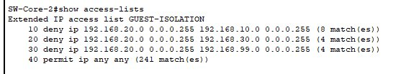
Figure 4: GUEST-ISOLATION ACL hit counters on SW-Core-2. Non zero counts on every deny rule confirm enforcement.

Network segmentation
VLANs (Layer 2) plus the GUEST-ISOLATION ACL (Layer 3) is the most important security mechanism in the design. The ACL is applied inbound on the V20 SVI on both cores. It denies V20 traffic to V10, V30, and V99 subnets, then permits everything else (which lets guests reach the internet through R-Edge). The Tablet ping test (Figure 5) and ACL hit counters (Figure 4) prove the policy is both defined and actually enforced.
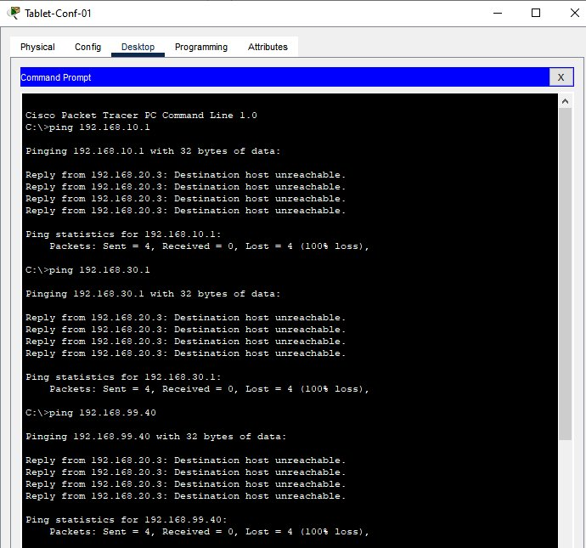
Figure 5: Guest tablet pings 192.168.10.1, 192.168.30.1, and 192.168.99.40, all return Destination host unreachable from the V20 SVI.
Port security on every floor switch port (sticky MAC, max 2 MACs, restrict mode) prevents unauthorized devices from being plugged into wired ports, addressing the rogue AP threat from the wired side.
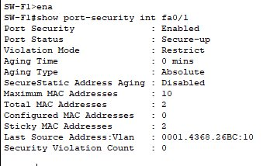
Figure 6: Port security on SW-F1 fa0/1 with sticky MACs and 0 violations.

Remaining vulnerabilities
No design eliminates all risk. Being honest about gaps is more useful than pretending they don't exist:
- WPA2-Personal is vulnerable to offline dictionary attacks against captured handshakes. A weak passphrase can be brute forced. WPA3-SAE would close this gap.
- Deauth attacks aren't prevented by WPA2 because management frames aren't encrypted. WPA3 with Protected Management Frames addresses this.
- Hiding the IoT SSID provides no real security, the SSID is still revealed in probe response frames. The actual protection is WPA2-AES + VLAN isolation + the ACL.
- The IoT SSID uses one shared PSK. Compromising one IoT device exposes the whole IoT WLAN passphrase. Production deployments would use Identity PSK or 802.1X-EAP-TLS with device certificates.
- There's no egress filtering on the WAN. A compromised internal device could exfiltrate freely. Future improvement: stateful firewall and DNS filtering on R-Edge.

4.7 Bluetooth Component
TechNova wants a Bluetooth based concept for the building. My proposal: an automated employee attendance tracking system using Bluetooth Low Energy (BLE) beacons.

How the system works
BLE beacons are small battery powered devices placed at building entrances, conference rooms, and shared workspaces. They constantly broadcast a unique identifier in beacon advertisements. Employees carry phones (with the company app) or wear a small BLE badge. When the phone or badge comes within range of a beacon, it detects the beacon ID and sends an attendance event over Wi-Fi to a backend server on SRV-AAA. The server logs the event with timestamp and user ID.
The architecture has three layers: 10 to 30 BLE beacons across the building, BLE peripherals (employee phones or badges), and the backend application that aggregates events and produces dashboards.

Why BLE and not Wi-Fi for this
Wi-Fi based location works (RSSI fingerprinting, FTM ranging) but it's heavy. Each association uses WLC resources, accuracy degrades at cell edges, and battery life on a continuously associated client is days, not months. BLE peripherals advertise without ever associating, draw negligible power (months on a coin cell), and produce sub meter accuracy when calibrated against fixed beacons. BLE is purpose built for the indoor short range scenario.

How BLE coexists with Wi-Fi
Bluetooth is a Wireless Personal Area Network (WPAN) technology that fits alongside the WLAN. Both share the 2.4 GHz ISM band, but they don't usually interfere because Bluetooth uses Adaptive Frequency Hopping Spread Spectrum (AFH). It hops across 79 channels (or 40 channels for BLE) at 1600 hops per second and adapts to avoid channels busy with Wi-Fi. Wi-Fi sees Bluetooth as occasional noise, Bluetooth sees Wi-Fi as a few channels to skip.
BLE specifically uses 40 channels at 2 MHz spacing. Three (37, 38, 39) are reserved for advertising and placed at frequencies that avoid Wi-Fi channels 1, 6, 11. This is part of why Wi-Fi and BLE can run in parallel without meaningful interference.

Topology and protocol stack
Classic Bluetooth uses a piconet topology: one master and up to seven active slaves, with up to 255 parked slaves. Multiple piconets can interconnect into a scatternet. BLE uses a simpler star topology where each peripheral connects to one central, but for beacon use cases there's no connection at all, beacons just broadcast and peripherals listen. The BLE stack runs through PHY, Link Layer, HCI, L2CAP, ATT, and GATT. Beacon advertisements use just PHY and Link Layer.

Security and privacy
The biggest privacy concern is unauthorized location tracking. Mitigation: rotating peripheral identifiers, where each badge changes its broadcast ID every few minutes using a key issued by SRV-AAA, so anyone outside the system can't track a person. Backend traffic flows over the management VLAN, which the GUEST-ISOLATION ACL already protects from Guest. The backend stores only proximity events, not continuous location streams, with retention windows configurable per GDPR or CCPA.

4.8 Screenshots
The eight required screenshots (topology, wireless config, WLC, VLAN, DHCP/DNS, client connectivity, ACL, and additional features) are embedded inline with the relevant explanatory text earlier in the report. This section adds the remaining figures that document the WLC configuration, end to end DHCP/DNS testing, additional features, and extra credit work.

WLC configuration
Figure 7 shows the WLC management interface and SRV-Core DHCP. Note that PT's WLC3504 model has a limited GUI and doesn't expose the same WLAN/AP listing tabs a real WLC does, this is a documented PT limitation. The seven APs are joined via CAPWAP and managed centrally regardless.
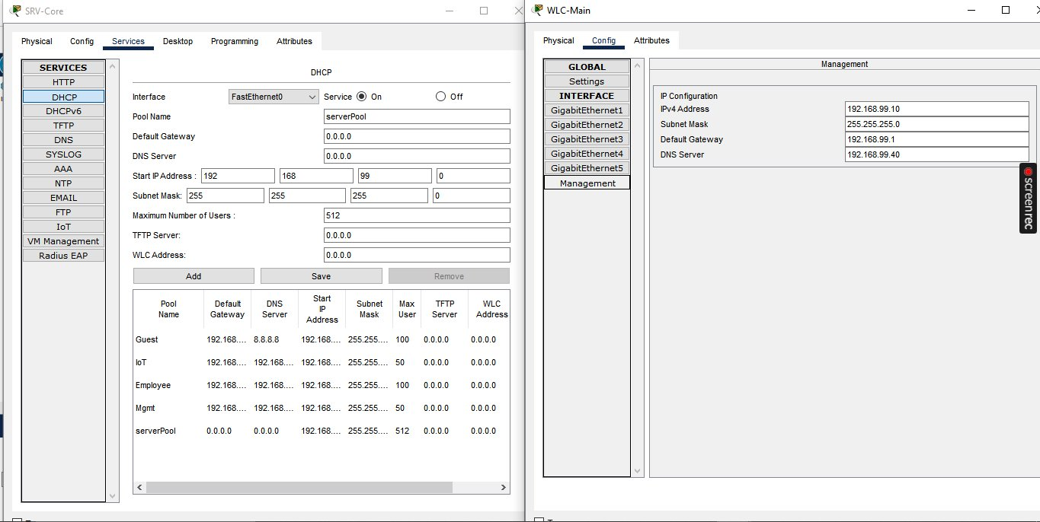
Figure 7: SRV-Core DHCP pools and WLC-Main management interface on VLAN 99.

DHCP, DNS, and end to end client connectivity
Figure 8 shows SRV-Core DHCP pools (one per VLAN). Figure 9 shows DNS A records for internal services. Figure 10 shows a wireless laptop pulling an IP via DHCP and reaching SRV-Core across VLANs.
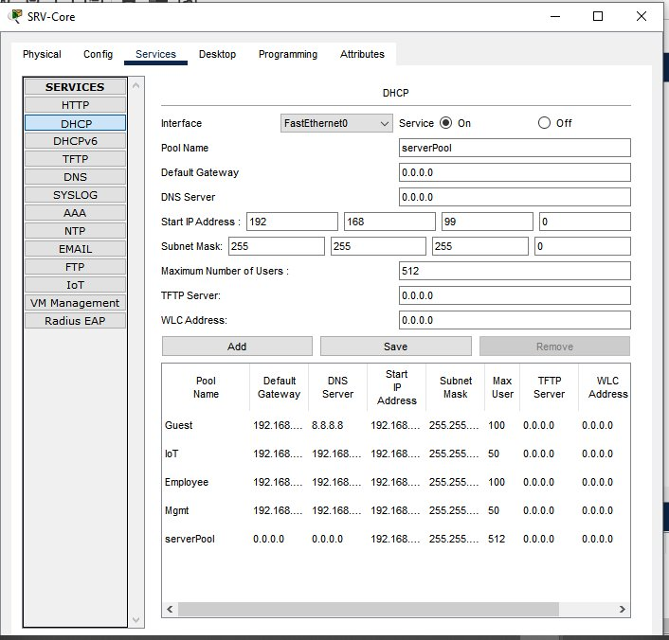
Figure 8: SRV-Core DHCP service with four pools (Guest, IoT, Employee, Mgmt).
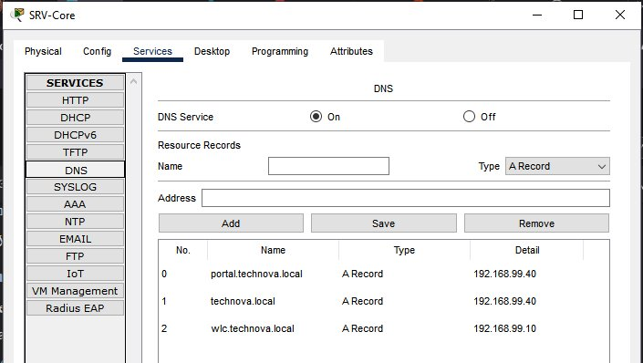
Figure 9: SRV-Core DNS A records: portal.technova.local, technova.local, wlc.technova.local, mail.technova.local.
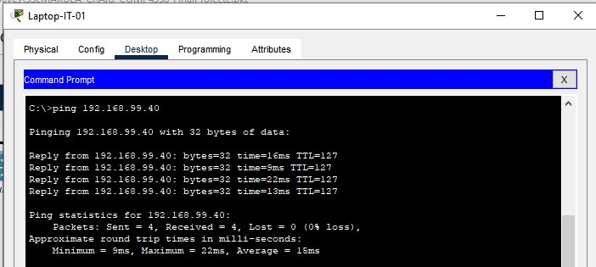
Figure 10: Laptop-IT-01 (got 192.168.10.x via DHCP) successfully pings SRV-Core at 192.168.99.40, end to end proof of DHCP, association, and inter VLAN routing.

Additional features (inter VLAN routing and port security)
Inter VLAN routing is proved by Figure 10 and Figure 11 (routing table). Port security is in Figure 6 plus Figure 12 for SW-F2.
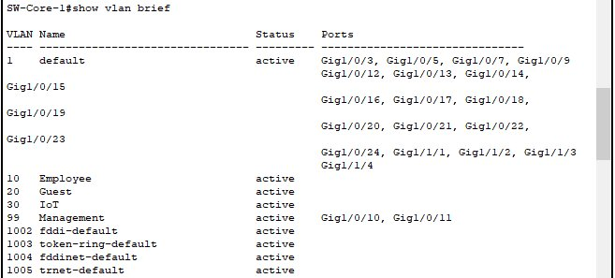
Figure 11: show ip route on SW-Core-1 with directly connected VLANs and OSPF default route.
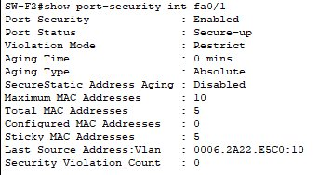
Figure 12: Port security on SW-F2 fa0/1 with 5 sticky MACs and 0 violations.

Extra credit features

HSRP gateway redundancy
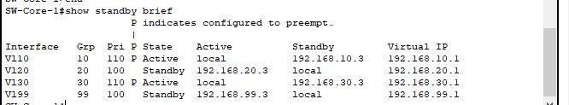
Figure 13: show standby brief on SW-Core-1, Active for V10/V30, Standby for V20/V99.

RADIUS authentication
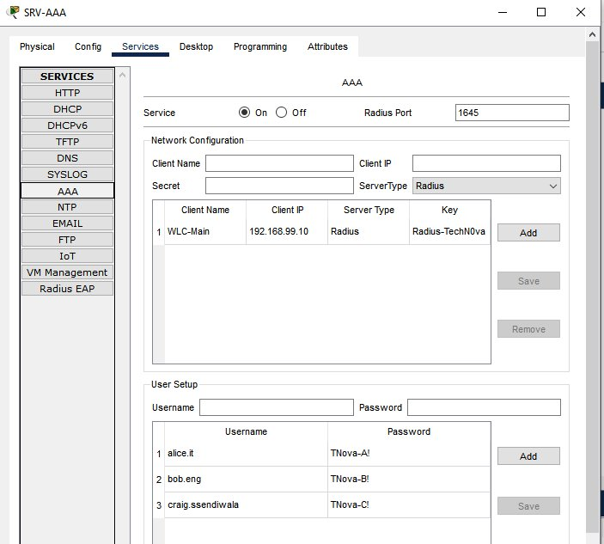
Figure 14: SRV-AAA RADIUS service on port 1645 with WLC registered and three users.

NTP synchronization
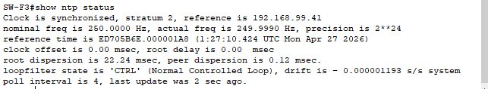
Figure 15: show ntp status on SW-F3, synchronized at stratum 2.

Syslog event collection
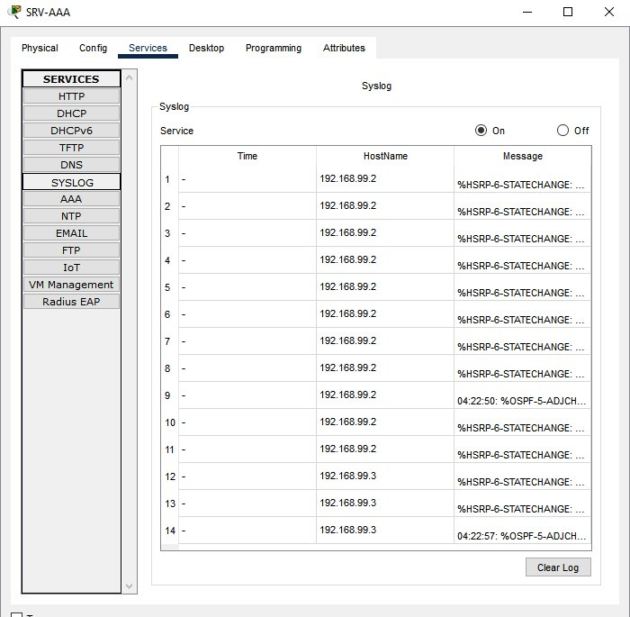
Figure 16: Syslog on SRV-AAA capturing HSRP and OSPF events.

OSPF routing
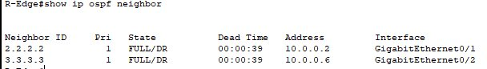
Figure 17: show ip ospf neighbor on R-Edge with two FULL adjacencies.

Spanning Tree redundancy
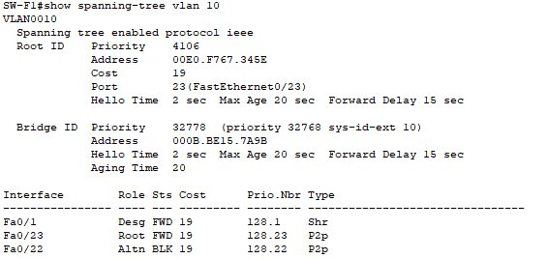
Figure 18: show spanning tree vlan 10 on SW-F1, Fa0/22 in BLK state.

NAT/PAT translations
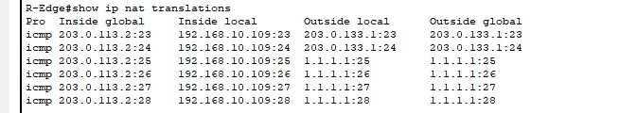
Figure 19: show ip nat translations on R-Edge, multiple sessions multiplexed onto one public IP.

Internal email (SMTP/POP3)
SRV-Core also runs SMTP and POP3 on the technova.com domain. Figure 20 shows Laptop-IT-01 (Floor 1, V10) composing an email to bob@technova.com on Laptop-Eng-01 (Floor 2, V10). Figure 21 shows the email arriving in Eng-01's inbox via POP3 from 192.168.99.40, with "Receive Mail Success". This proves end to end application layer connectivity over the wireless infrastructure: DHCP, association, encryption, inter floor trunks, and DNS resolution all working together.
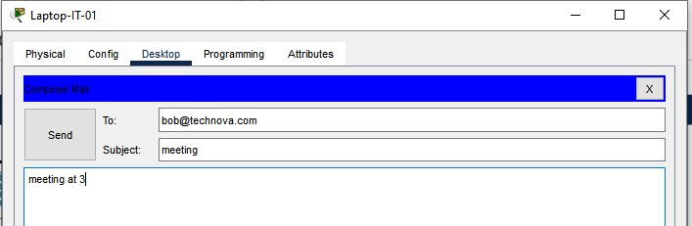
Figure 20: Laptop-IT-01 composing an email to bob@technova.com.
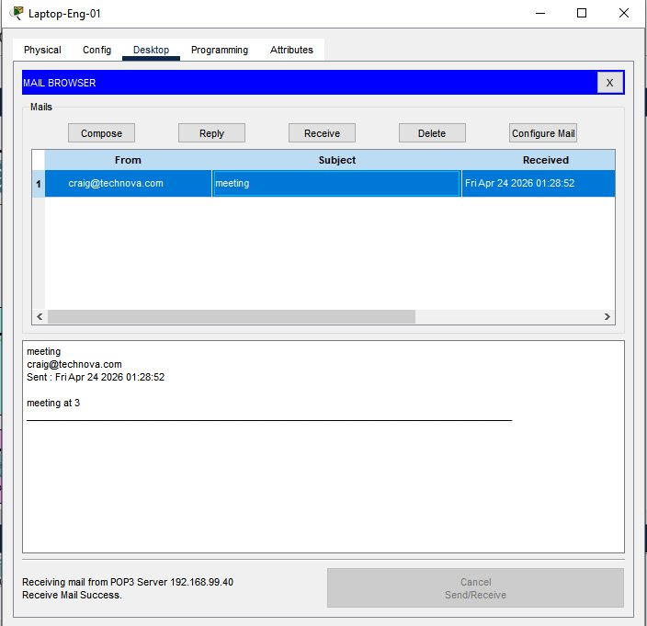
Figure 21: Laptop-Eng-01 receiving the email via POP3 from 192.168.99.40, Receive Mail Success.

4.9 Challenges and Lessons Learned
A few real problems came up during the build.

WLC AP registration
APs initially refused to register with the WLC and stayed Unassociated. The AP facing switch ports were in default VLAN 1 while the WLC management was on VLAN 99, so the APs couldn't reach the controller. Fix: move every AP port to VLAN 99 with PortFast and confirm the V99 DHCP pool had addresses. Lesson: in CAPWAP, the management VLAN has to extend to every AP edge.

ACL blocking DHCP
After applying GUEST-ISOLATION on the V20 SVI, guests stopped getting IPs. The DHCP DISCOVER and OFFER were being relayed to SRV-Core in the management subnet, which the ACL was now blocking. Fix: reorder the ACL so the deny to management rule applied to actual user traffic and the DHCP relay path stayed permitted. Lesson: any ACL on an SVI interacts with helper address relay.

EtherChannel didn't bundle
The plan was a 2 link LACP EtherChannel between each floor switch and Core-1. In PT 8.2.2 the bundle didn't form on at least one floor. The 2960 FastEthernet ports rejected the channel group syntax, so I moved to G0/1 and G0/2, but bundling still wasn't reliable. I finalized the design with redundant trunks operating as independent links protected by Spanning Tree. Same topology resilience without the LAG. Lesson: simulators don't model every feature perfectly, pragmatic adjustment beats fighting the tool.

Hidden SSID limitation
The brief required hiding the IoT SSID. The autonomous AP-PT model in PT 8.2.2 doesn't expose a Broadcast SSID toggle. I documented this as a simulator limitation. SSID hiding is mostly cosmetic security anyway because the SSID is still revealed in probe response frames. The actual protection is WPA2-AES + VLAN isolation + the ACL.

Cross floor same VLAN unicast
During end to end testing, a unicast ping from Eng-01 (Floor 2) to IT-01 (Floor 1), both V10, failed despite the L2 path being intact. ARP succeeded both directions, MAC tables were correct, broadcast worked. This is a known PT limitation: autonomous APs don't reliably bridge unicast frames between two wireless clients on different APs even when the wired path is fine. The same scenario in a real WLC managed lightweight AP deployment would tunnel client traffic via CAPWAP back to the controller. I captured equivalent end to end proof using inter VLAN routing tests instead. Lesson: simulator artifacts are real, document them and design around them.

Per floor SSIDs as a workaround
Laptops and tablets were associating to whichever AP they encountered first, sometimes a different floor's AP than the closest one. Real enterprise WLANs use WLC managed roaming, but autonomous APs in PT don't. Renaming the Employee SSIDs per floor (Employee1, Employee2) forced clients to associate where intended. Workaround for a simulator limitation, not a recommended production design.

Email .local domain rejected
PT's email client rejected addresses ending in .local even though the SMTP server accepted them as a domain name. Fix: changed the email domain to technova.com on SRV-Core and updated the user accounts. DNS was kept on .local for everything else. Lesson: PT enforces some email format rules that real SMTP doesn't care about, work with the simulator's quirks instead of fighting them.

Save discipline
Twice during the build, a PT crash lost about 20 minutes of work because configs hadn't been written and the .pkt file wasn't saved. I started doing write memory after every phase and Ctrl+S every 15 minutes. Lesson: explicit save points are part of the workflow.

If I were to redesign
Three changes. First, lightweight APs with full CAPWAP tunneling instead of autonomous APs, eliminates every cross AP unicast quirk and lets one SSID handle proper roaming. Second, 802.1X-EAP-TLS with device certificates for both wired and wireless authentication. Third, a stateful firewall on the WAN edge with egress filtering and DNS filtering.

4.10 Conclusion
This project shows that an enterprise wireless network can be designed and verified entirely in a simulator while still going through the same discipline as a production deployment. Every required element was implemented and tested, both mandatory additional features work, and the extra credit features documented in Section 4.8 were added on top.
Two takeaways. First, segmentation is the foundation of network security: VLANs without ACLs are decorative, and ACLs without VLANs are unenforceable. The combination, applied consistently from access port to SVI, is what produced the verifiable Guest isolation result in Section 4.6. Second, simulators have artifacts and an honest engineer documents them, the per floor SSID workaround, the unbundled EtherChannel, the unbroadcastable IoT SSID, and the cross floor unicast quirk are all called out in Section 4.9.
The design meets all of TechNova's stated requirements. The next steps in a production rollout would be a real RF survey (PT can't replace that), migration to lightweight APs with WLC managed roaming, and an upgrade to WPA3-Enterprise with Protected Management Frames.

4.11 References

Cisco Networking Academy. (2022). Cisco Packet Tracer 8.2 official tutorials. https://tutorials.ptnetacad.net/tutorials70.htm

Cisco Systems. (2018). Cisco wireless LAN controller (WLC) configuration best practices [Technical document]. https://www.cisco.com/c/en/us/td/docs/wireless/controller/technotes/8-6/b_Cisco_Wireless_LAN_Controller_Configuration_Best_Practices.html

IEEE. (2020). IEEE Standard for Information Technology, Telecommunications and Information Exchange Between Systems Local and Metropolitan Area Networks (IEEE Std 802.11-2020).

IEEE. (2020). IEEE standard for local and metropolitan area networks—Port-based network access control (IEEE Std 802.1X-2020).

Rigney, C., Willens, S., Rubens, A., & Simpson, W. (2000). Remote Authentication Dial In User Service (RADIUS) (RFC 2865). IETF.

Mills, D., Martin, J., Burbank, J., & Kasch, W. (2010). Network Time Protocol Version 4 (RFC 5905). IETF.

Calhoun, P., Montemurro, M., & Stanley, D. (2009). Control and Provisioning of Wireless Access Points (CAPWAP) Protocol Specification (RFC 5415). IETF.

Bluetooth SIG. (2021). Bluetooth Core Specification version 5.3. Bluetooth Special Interest Group.

Zhamanov, A. (2026). COMP 4358 Wireless Networking lecture materials. North American University.

