Energuides Report
By Craig Venhuis

Contents
Current Expenditures Per Year 2
Potential Savings Per Year 3
House with Highest Current Energy Consumption 4
House with Lowest Current Energy Consumption 5
Five House with Greatest Potential Savings from New Furnace 6

Figure 1: Current Spending 2
Figure 2: Potential Savings 3
Figure 3: Highest Energy Used 4
Figure 4: Lowest Energy Used 5
Figure 5: Highest Potential Savings from Furnace 6

Current Expenditures Per Year
Currently $2,274 a year are being spent on space heating.
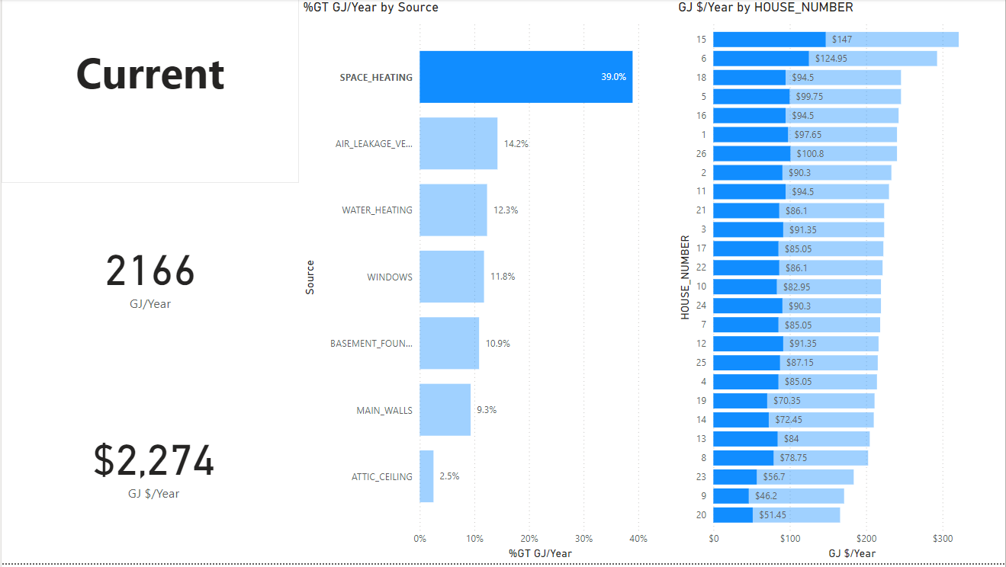
Figure 1: Current Spending

Potential Savings Per Year
If all 26 houses were to get new furnaces $1,374 will be saved per year.
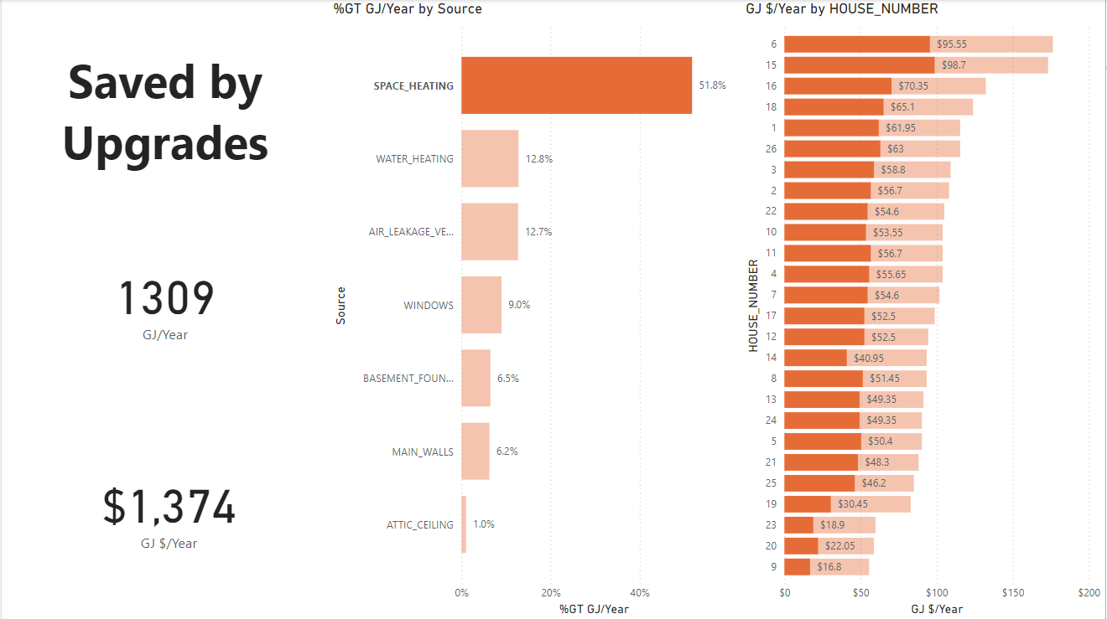
Figure 2: Potential Savings

House with Highest Current Energy Consumption
House 15 is currently using the most energy at 306 GJ/Year and spending the most money at $321 per year.
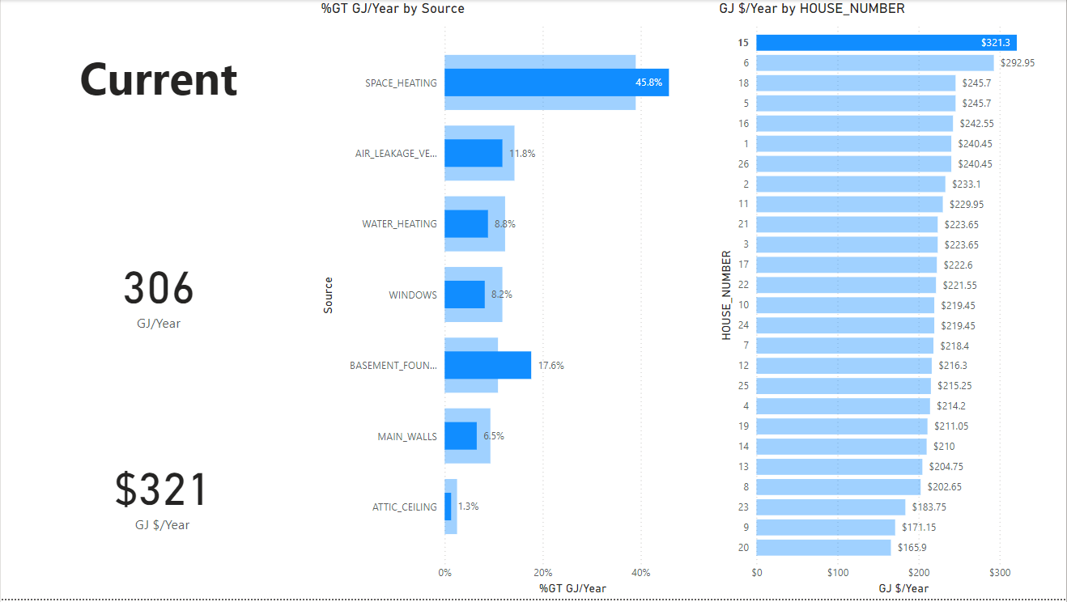
Figure 3: Highest Energy Used

House with Lowest Current Energy Consumption
House 20 is currently using the least energy at 158 GJ/Year and spending the least money at $166 Per Year.
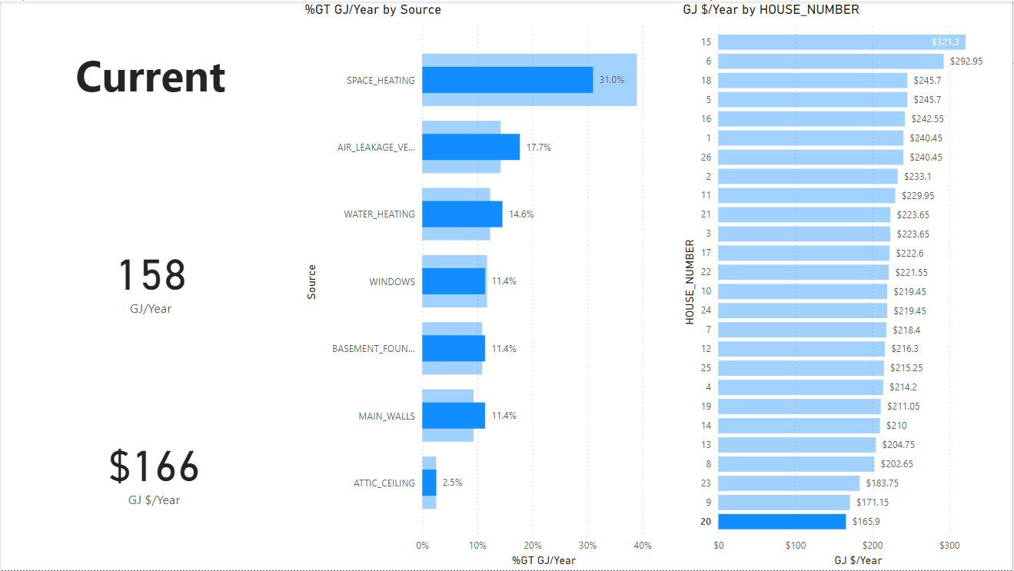
Figure 4: Lowest Energy Used

Five House with Greatest Potential Savings from New Furnace
Houses 15, 6, 16, 18, and 26 will save the most money by installing a new furnace. 15 will save the most at around $98.70 and 26 will save the fifth most at around $63.00.
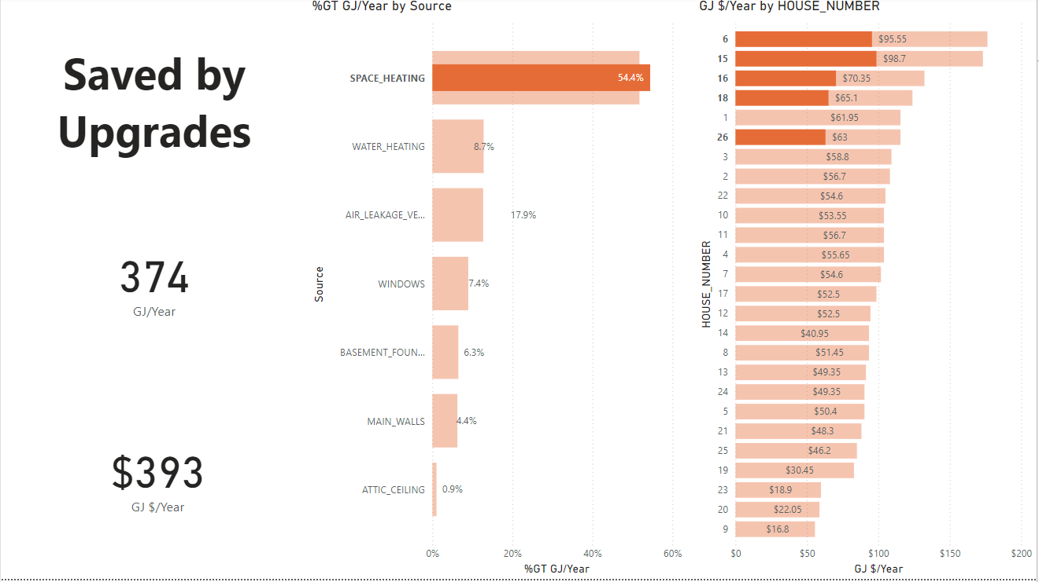
Figure 5: Highest Potential Savings from Furnace

