Process to Flash the open Hub 6 device

Setup You need:-

* HUB 6 Device connected to you alarm panel (so that it is powered i.e. red light showing)
* Ethernet cable which you will connect from your laptop LAN port to the HUB 6 port.
* Tooth pick or pin for when hard resetting the hub in step 5

1. Download the openhub6 firmware provided by William on to your laptop

(filename OpenHUB6-DSC-R1-20220206.bin)

1. Set computer to an IP address 192.168.255.2 (see appendix A how to do this)
2. Connect the laptop to the hub 6 via an ethernet cable
3. Watch William’s video on how to reset the original HUB 6 so that the firmware can be update (<https://www.youtube.com/watch?v=kn8yNztC2cw>) Video titled “Safe by HUB6 OpenWRT Installation”.
4. Type 192.168.255.1 in your browser and upload the firmware from your laptop to the Hub 6.

(filename OpenHUB6-DSC-R1-20220206.bin downloaded in step 1)

1. Download the “pushover: app to your android or ios device

Register an account

Logon to pushover

<https://pushover.net/login>

create an API  
Note down the your pushover “UserKey” and “API token”

1. Connect the Hub 6 to your Home WIFI by going

With the laptop connected to the hub 6 via ethernet

192.168.255.1

Once in OPEN HUB 6

Login

i)Go to wifi

(see below link to get an idea)  
<https://openwrt.org/docs/guide-user/network/wifi/connect_client_wifi>

ii) Go to pushover and add your pushover “UserKey” and “API token” (from step 5)

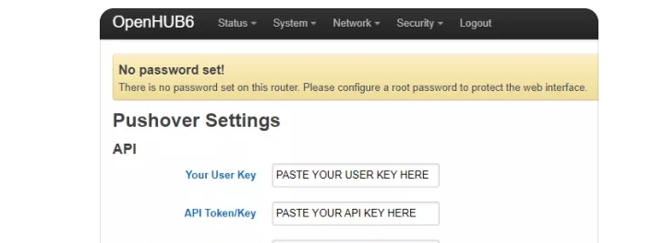

1. If your router does not see the Hub 6 you need to add it manually via MAC address

See video below  
<https://www.youtube.com/watch?v=Osl_RQIzzIA>

Note : -

Do not forget to save and changes made to the open hub 6 interface

Any changes to the openHUB6 interface must be done as per step 1 and step7 (i.e. with ethernet and laptop and not via WIFI)

**Appendix A :- Set IP 192.168.255.2 (windows 10)**

Control Panel -🡪Network & Internet🡪network and sharing center

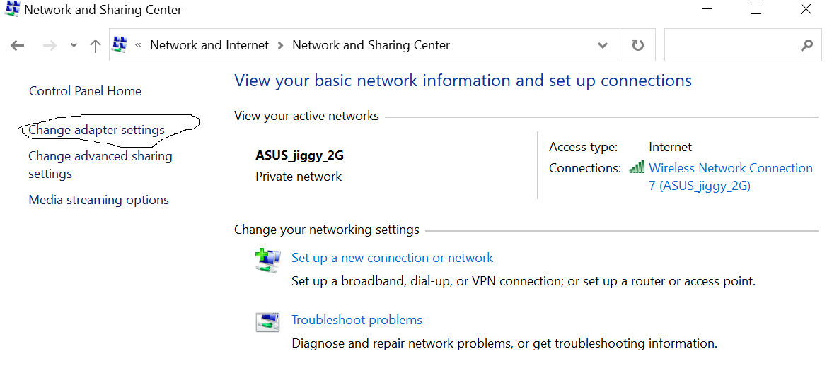

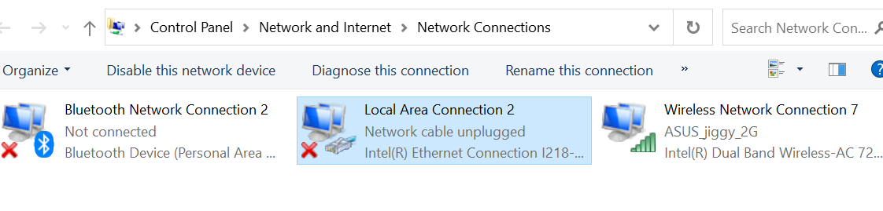

Right click on the LAN and choose properties and highlight internet protocol version 4 (TCL/IPv4) properties and set the ip address to 192.168.255.2 and apply

