Craig Hulsebus

CSC 137-03

Project 1: Design a 2-bit CLA adder

Spring 2018

Block Diagram

Design & Outputs

2-bit CLA adder

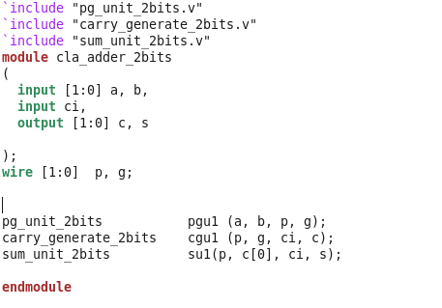

PGU

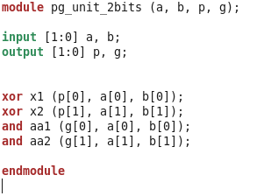

CGU

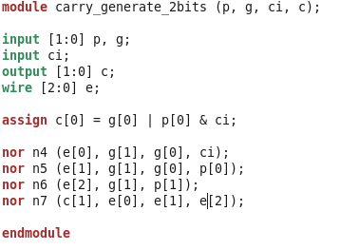

SU

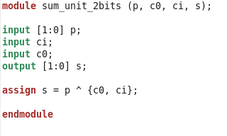

Analysis of Results

Test Bench

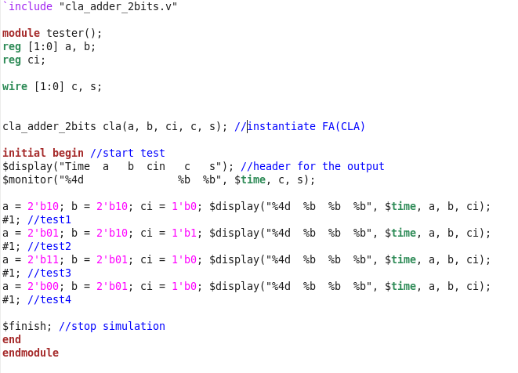

Test Cases Done by Hand

SIMV

