**Growth Model Dynamics using growth increment approach**

Uses a VB (linear increment) approach

$$L_{t}=L_{inf}\left(1-e^{-Kt}\right)$$

*K* and *Linf* are generated as lognormal random deviates each fish *y* is assigned its own growth path as specified by *Ky*  and *Linfy*

Derivation of *K* ~ (lognormal) assumes K comes from a lognormal distribution with mean = *K* and variance = *v* = (*K*\*cv)2. In log space log(k) come from a normal distribution with mean = 'u' and standard deviation 's' calculated as follows:

$$u=log\left(K^{2}/\sqrt{v+K^{2}}\right)$$

$$s=\sqrt{log\left(\frac{v}{K^{2}}+1\right)}$$

Likewise *log(Linf)~(Normal)*

The expected growth increment for a fish of length L with growth path Ky and Linfy over unit time t is given by the linear increment formulation of the vB (Francis 1988)



Where

$∆L$ = change in length (increment) over unit time t for a fish of given length $L_{1}$

m = rate of change of *L* ($\frac{dL}{dt})= (1-e^{-Kt})$

c = increment for a fish of length = 0 the intercept of $∆L$ = $-mL_{inf}$

The change in length (i.e. increment) for a fish of length $L_{1}$ over $∆t$ is given by

$∆L_{∆t}=(1-e^{-K∆t})L_{1}+c$

Francis, R.I.C.C. (1988) Are growth parameters estimated from tagging and age-length data comparable?

*Canadian Journal of Fisheries and Aquatic Sciences* 45, 936 – 942

**Test of the code**

1000 random growth paths drawn with lognormal error with cv = 0.2

*K* = 0.1

*Linf* = 60

**Run 1 1 annual season i.e. $∆t=1$**

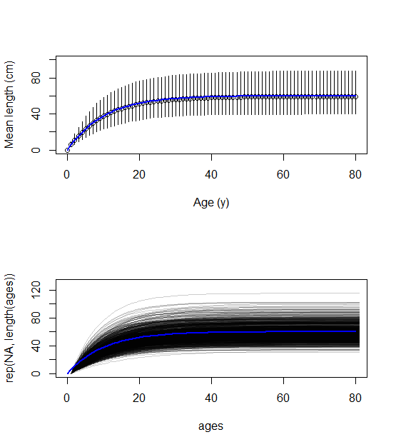

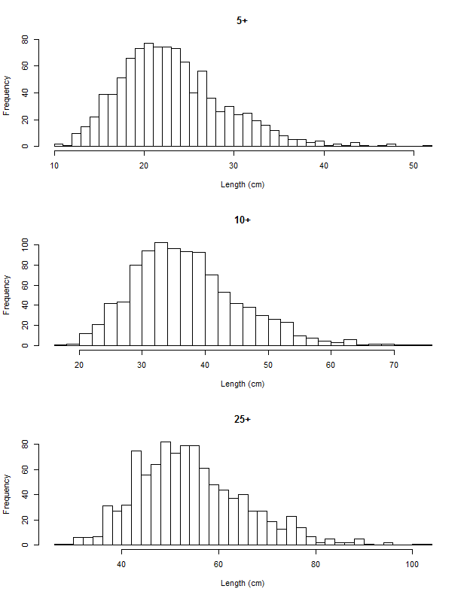

**Run 2 4 annual seasons i.e. $∆t=0.25$**

