**Species Spatial Exploratory Analysis (Black Bears)**

DATA 589 Project

Craig Adlam, Kulaphong Jitareerat, Nijiati Abulizi

**Introduction**

The Ursus americanus Pallas (North American black bear, or black bear) is a ubiquitous large mammal that resides mostly in North America with the focus of this study on occurrences within the British Columbia (BC) province of Canada. Their presence shapes the ecological landscape of the province, but human activity and habitat alteration are significant concerns. Both Provincial and National Parks across BC are dispersed across many protected areas, which “are important for ecological conservation while simultaneously supporting culturally and economically valuable tourism”.[1] There are 4,331 black bear sightings across Canada with approximately 44% occurring within BC. This study utilizes data on black bear occurrences in BC to delve into their spatial distribution patterns across the province. In addition, there are four complementary datasets for the province of BC that include measurements of elevation, forest coverage percentages, an index representing the human footprint impact, as well as proximity distance measurements with respect to water locations. Finally, spatial data for the distribution of parks will be incorporated for a comprehensive analysis to further explore and understand black bear occurrences in the province of BC.

In-depth spatial statistics are used to analyze and shed light on black bear habitat preferences and potential human-wildlife interactions (HWI). Ultimately, there are three preliminary questions of interest that can be explored using this dataset, which could help support and improve understanding of the final question about HWI concerns.

* Habitat Selection: Do black bears exhibit preferences for specific elevations and/or forest cover within their range in BC?
* Human Footprint: Is there a correlation between the human footprint index (HFI) and black bear occurrences?
* Water Proximity: Does the distance from water sources influence black bear distribution?
* Park Locations: Is there a relationship between the spatial distribution of park locations and black bear occurrences? If so, is this relationship significant?

Understanding these relationships is critical for informing conservation strategies for black bears in BC as well as helping structure guidelines for humans cohabitating in areas of high HWI occurrences. By analyzing these spatial patterns, we can gain valuable insights into how to maintain healthy black bear populations alongside a growing human presence.

**Methods**

***Data Preprocessing***

For this study, data preprocessing was important in making sure the quality and accuracy of the dataset for analyzing black bear occurrences in British Columbia (BC). Initially, the dataset was filtered to focus mainly on black bear records within BC. To address data completeness, any records lacking essential geographic coordinates (longitude and latitude) were removed. Additionally, occurrences that were misclassified or located outside of the BC’s geographic boundaries as well as duplicate records were removed from the dataset. A specific buffer zone was implemented along the south-western coastal edge to include relevant occurrences while excluding three specific records misidentified as being BC but actually located on the east coast.

***First Moment Analysis***

The first moment analysis examined the location of black bear occurrences in BC. This involved using a Point Pattern object to visualize occurrences and applying quadrat counts to assess their homogeneity and intensity, which included a Chi-squared test for complete spatial randomness (CSR). Kernel Density Estimation (KDE) helped create a smooth map of occurrences intensity, with optimal bandwidth. Hotspot Analysis identified areas with statistically significant concentration of occurrences. The study area was also divided by covariates like habitat, facilitating a comparative analysis of occurrence frequencies, and the relationship between occurrences and covariates was quantified by using the nonparametric rhohat method.

***Second Moment Analysis***

The second moment analysis focused on the spatial interactions between black bear occurrences in BC, assessing patterns of attraction or inhibition across various distances. Due to the failure to meet the assumption of homogeneity, the Morisita’s Index was deemed unreliable. Instead, spatial correlations were analyzed using an inhomogeneous version of Ripley’s K-function (Kinhom), identifying deviations from random distributions. The g-function (pcfinhom) provided an alternative assessment of clustering or regularity. The statistical significance of these spatial metrics was evaluated using bootstrapped simulations to generate confidence intervals for the observed values.

***Modeling Black Bear Occurrences***

Before modeling, the NA’s and nan values were removed to ensure that the residual plot functioned properly. This is because there are no data values for HFI over water locations. The modeling phase developed a statistical model to predict black bear occurrences in BC, using a correlation matrix to assess multicollinearity among spatial covariates. Based on the insights from first and second moment analysis, the chosen point process model accounted for spatial trends, interpoint interactions, and covariate impacts. A null model without spatial or covariate effect was used to validate the effectiveness of the fitted model. Model coefficients were visualized with other variables at median values to show their effects on occurrence probabilities. The model's goodness-of-fit was confirmed using tests like Chi-square or envelope test, verifying its capability to represent the data.

**Results**

**Data Preprocessing**

The initial black bear occurrences data (4,331) underwent a multi-step cleaning process to ensure data quality for further analysis. Filtering for a specific area (likely British Columbia) reduced the data by 2,415 occurrences. Subsequently, data cleaning addressed missing coordinates (31 removed), misclassified data (3 removed), and duplicates (159 removed). Notably, 114 points were excluded during the initial filtering step for falling outside the designated window. This cleaning process resulted in a final dataset of 1,723 high-quality black bear occurrences within the specified area for further analysis.

**First Moment Analysis**

***Homogeneity and Intensity***

There are approximately 0.0018 black bear occurrences per square kilometer in the province of BC. This value represents the average number of black bears expected to be found in any given square kilometer if black bears were spread uniformly throughout the province. The estimated density is likely biased and misrepresents the actual distribution of black bears. This is because the assumption of homogeneity is unlikely to be true as shown in Figure 1.

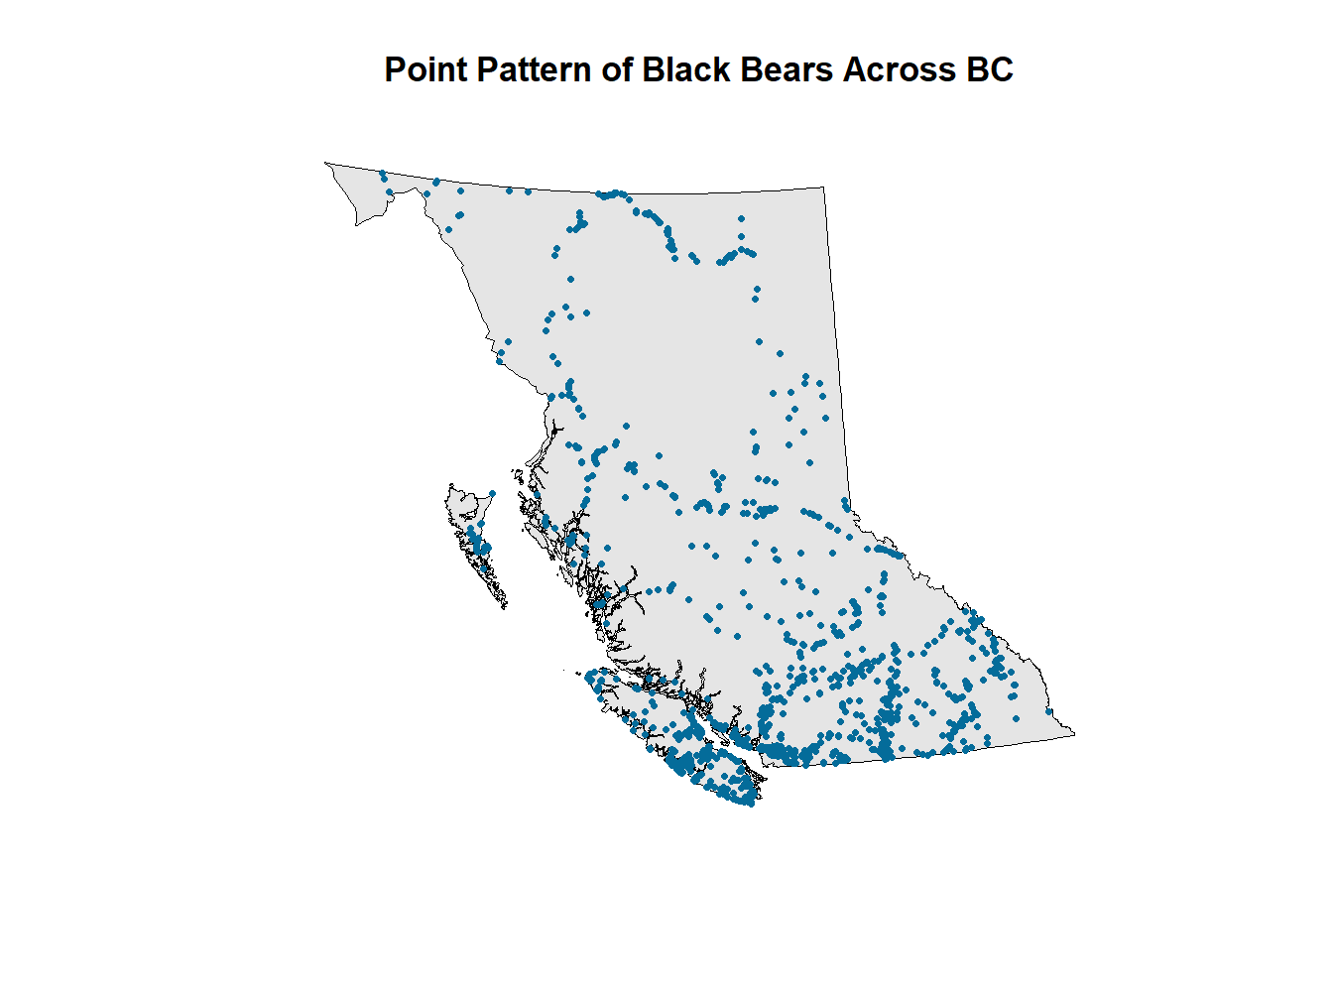

***Figure 1 Point Pattern Plot. This figure presents the observation window of interest that includes the spatial distribution of black bear sightings that occurred in BC highlighting the varying nature of their locations.***

***Quadrat Counts and Kernel Densities***

Although the quadrat count plot in Figure 2 and corresponding histogram in Figure 3 both suggest spatially varying intensities, point patterns are stochastic and some variation is expected. To objectively test for spatial homogeneity, a Chi-squared test of significant deviations from CSR using the quadrat counts was conducted. A large Chi-squared value of 7432.4 and low, significant p-value of 2.2e-16 suggests substantial deviations from CSR and the null hypothesis of CSR is rejected.

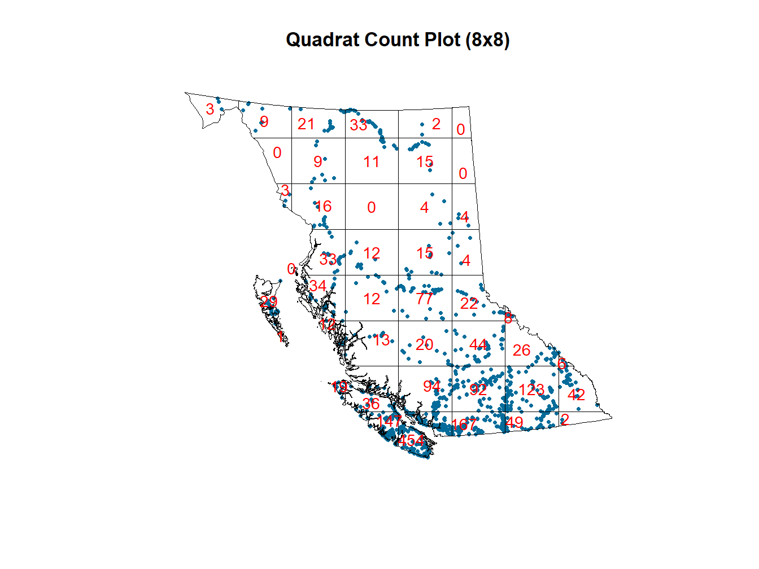

***Figure 2 Quadrat Count Plot. This figure presents the number of black bear occurrences within each quadrat, in which the observation window has been divided roughly into 8 rows and 8 columns for a total of approximately 64 potential quadrats. This plot highlights further support of inhomogeneity and spatially varying number of black bear occurrences across BC.***

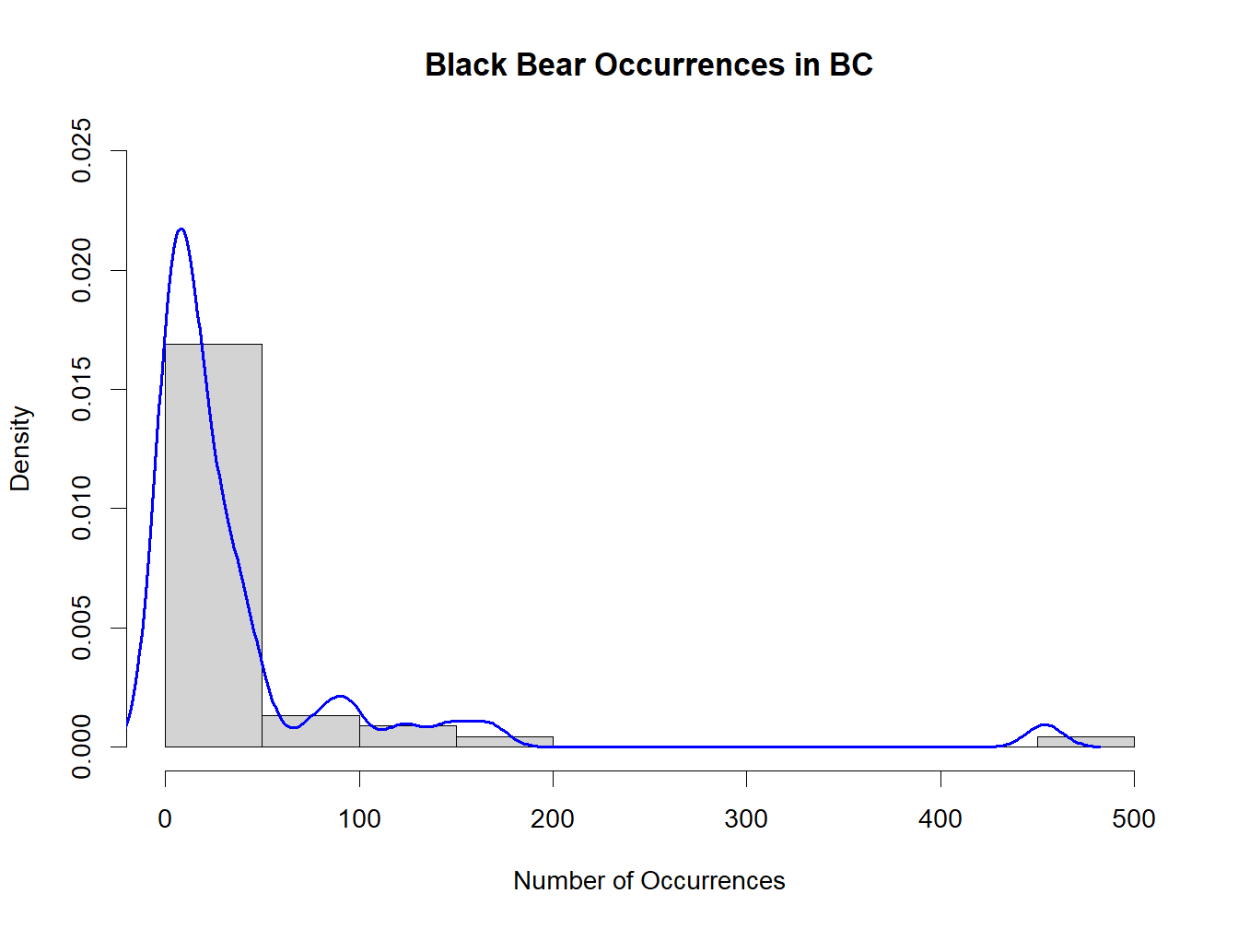

***Figure 3 Quadrat Count Histogram and Density Curve. This figure presents the approximate number of black bear occurrences and corresponding density further suggesting inhomogeneity among the spatial distribution.***

***Hotspots***

The first objective test for CSR was rejected using the Chi-squared test, which indicated a homogeneous point pattern. The second objective test to determine whether the areas of interest - or “hotspot analysis” - observed in both the quadrat plots and kernel density plots are significant is conducted using the likelihood ratio test (LRT) to determine p-values. As seen in Figure 4, there are multiple “hotspots” with a p-value that falls below 0.2 and approaches close to zero, which indicates that there are statistically significant areas with more black bear occurrences than others.

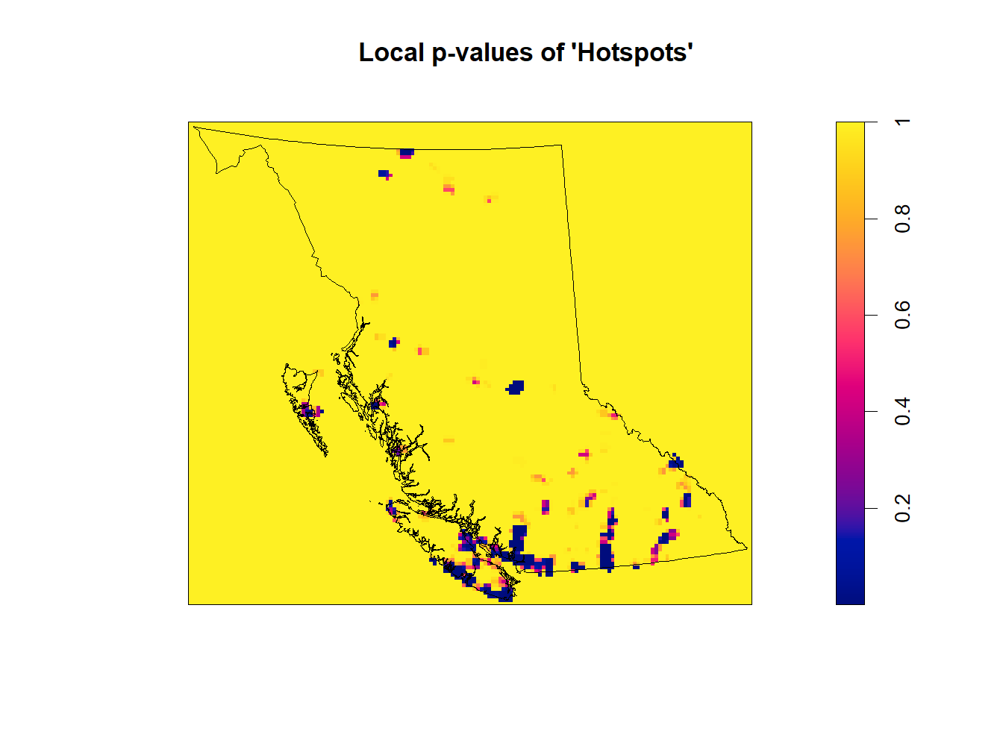

***Figure 4 P-values Plot. This figure presents the varying p-values across the province of BC with respect to the number of black bear sightings that occurred in each respective area. This plot highlights areas of interest, known as “hotspots” which indicate that the number of black bears in that particular area is statistically significant (dark blue).***

***Non-parametric Intensity-Covariate Relationship (rhohat)***

There are four spatial covariates of interest: level of elevation (m), percentage of forest coverage, human footprint index (HFI), and distance from water (m). As shown in Figure 5, there is considerable overlap in their distribution densities and at areas with black bear occurrences.

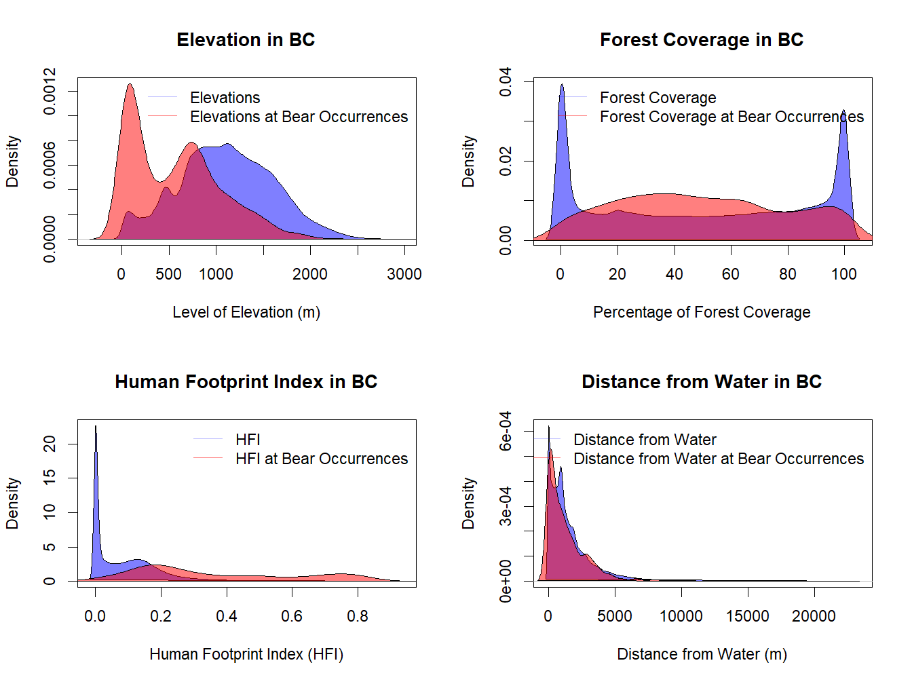

***Figure 5 Kernel Density Estimate Plots. This figure presents the approximate density curves of the four covariates (elevation, forest coverage, HFI, and distance from water) and areas in which black bear sightings occur with respect to each covariate. These curves illustrate the spatial distribution of bear occurrences across different elevations, levels of forest coverage, HFI, and distances from water and highlights their respective spatial patterns and potential relationships with each covariate.***

Finally, the most efficient approach to check for a relationship between intensity and spatial covariates is typically through the use of quadrat counts, however, due to the varying nature of covariates’ measurements (e.g., only elevation is visually distinct for analysis), the specific quadrat counts of black bear occurrences in Table 1 are more effective than a visualization at those levels (for supplementary details, see Appendix A). As shown in Figure 6, there are potential relationships between black bear occurrences and each covariate. There appears to be a negative relationship between black bears and elevation as elevation increases; apparent association of black bears and moderate forest coverage; significant number of black bear sightings occur more frequently where there is a larger human footprint index; and nearly twice as many black bears being sighted within the closest proximity to water.

|  | **Very Low** | **Low** | **High** | **Very High** |
| --- | --- | --- | --- | --- |
| **Elevation** | 1145 | 327 | 168 | 83 |
| **Forest** | 168 | 720 | 572 | 257 |
| **HFI** | 21 | 81 | 249 | 1371 |
| **Dist_Water** | 659 | 321 | 355 | 375 |

***Table 1 Quadrat Counts for Spatial Covariates. This table presents the number of black bear occurrences in each of the 4 quadrats and highlights the potential relationships between each covariate and the number of black bear sightings that occurred at those corresponding levels or measurements (e.g., low elevation to high; low forest coverage to high, etc.).***

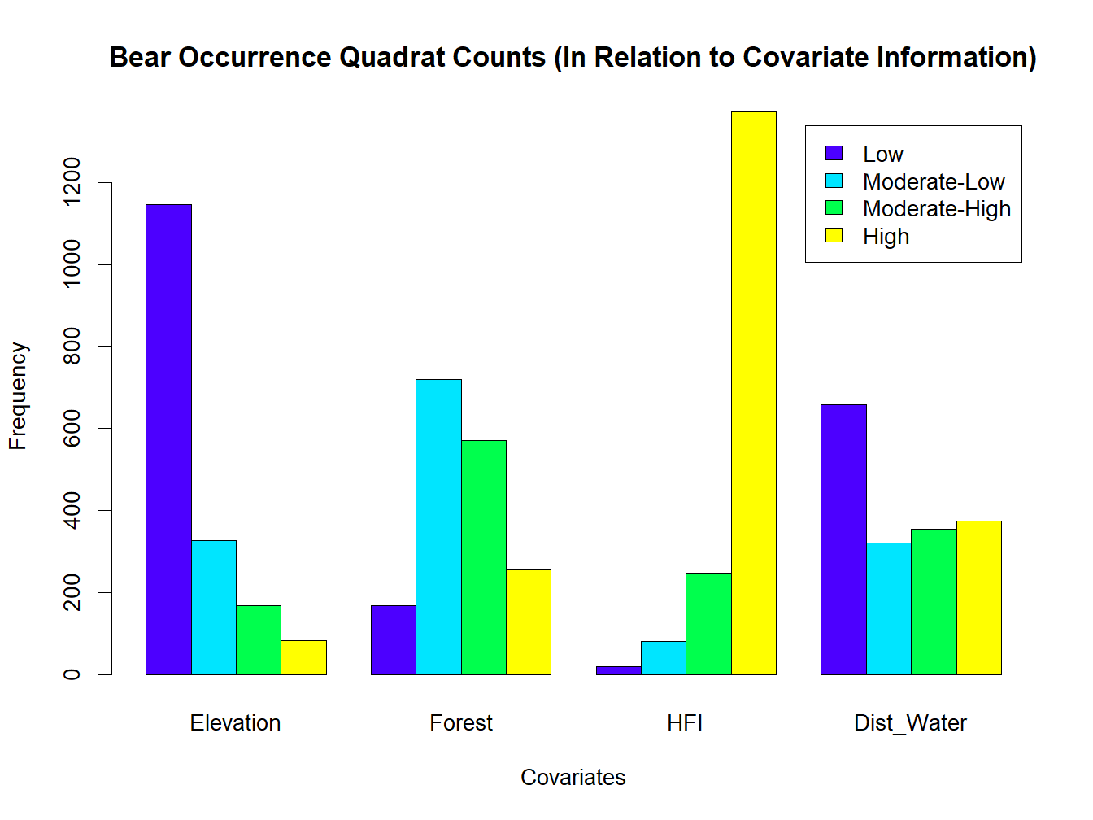

***Figure 6 Bar Plot of Covariate Quadrat Counts. This figure presents the distribution of each covariate’s respective measurement into 4 quadrats that represents the approximate distribution of values. This chart highlights the visual relationships between each covariate and the number of black bear sightings that occurred at those corresponding levels or measurements (e.g., low elevation to high; low forest coverage to high, etc.).***

More formally, the relative distribution estimates for the above can be obtained via kernel estimation and visualized in a rho plot. As shown in Figure 7, the intensity of black bear occurrences decreases with increasing elevation. At lower elevations (i.e., 10m), intensity is highest, exceeding the average by 962%. There is a negative relationship as the number of black bear occurrences decrease with respect to elevation increase and begin to disperse around 825m. As elevation climbs to 2500m, the intensity drops significantly, reaching 94% below the average. A slight increase in intensity (approximately 20% above average) is observed at 2800m. However, this finding is likely unreliable due to the limited data point (single occurrence) and wider confidence interval.

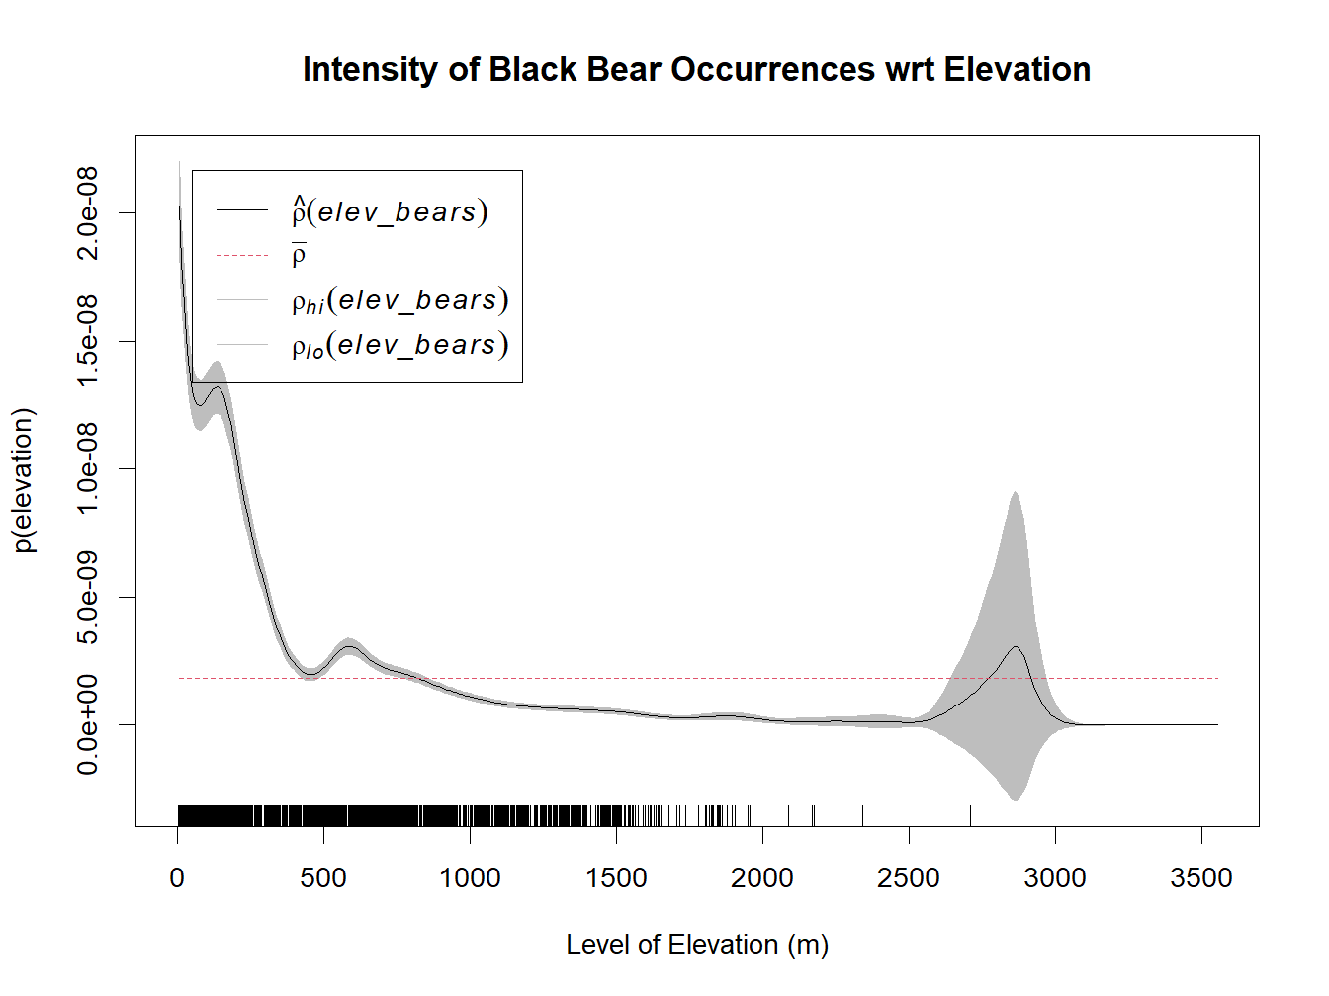

***Figure 7 Non-parametric Rho Plot. This figure presents the spatial autocorrelation between the black bear occurrences and elevation across the observation window. This plot highlights the non-linear relationship between the intensity of black bear occurrences and elevation as there are a greater number of black bear occurrences at lower levels of elevation and decrease as elevation increases.***

As shown in Figure 8, the intensity of black bear occurrences increases with increasing forest density, with a peak at moderate densities (around 40% density). At this point, intensity is 106% higher than the average. Black bear occurrences are less frequent at both ends of the forest density spectrum. At low densities (around 1%), the intensity drops significantly, reaching 88% below the average. Interestingly, at very high densities (around 99%), intensity also decreases, reaching 78% below the average.

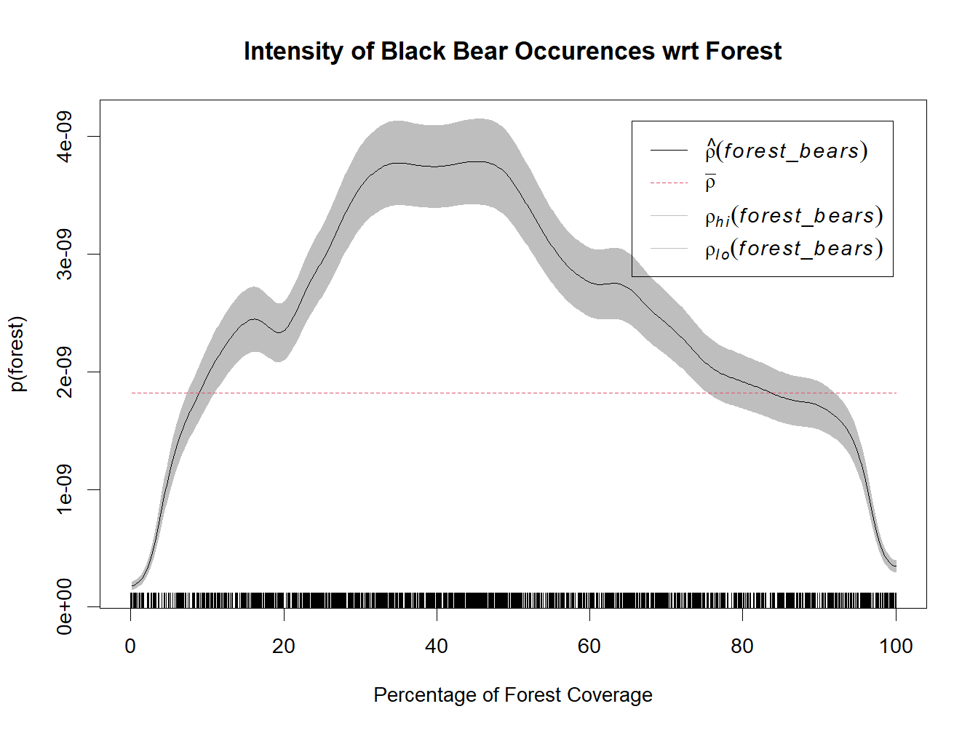

***Figure 8 Non-parametric Rho Plot. This figure presents the spatial autocorrelation between the black bear occurrences and forest coverage across the observation window. This plot highlights the non-linear relationship between the intensity of black bear occurrences and forest coverage as the intensity increases with forest coverage with the highest intensity at moderate levels of forest coverage, after which the intensity decreases.***

As shown in Figure 9, the intensity of black bear occurrences increases dramatically with increasing HFI. At low HFI values (around 0.01), intensity is very low, reaching 94% below the average. Conversely, at high HFI values (around 0.5), intensity is significantly higher than the average, reaching 904% more. Even at the highest HFI values (around 0.99), intensity continues to rise, reaching a staggering 3190% above the average.

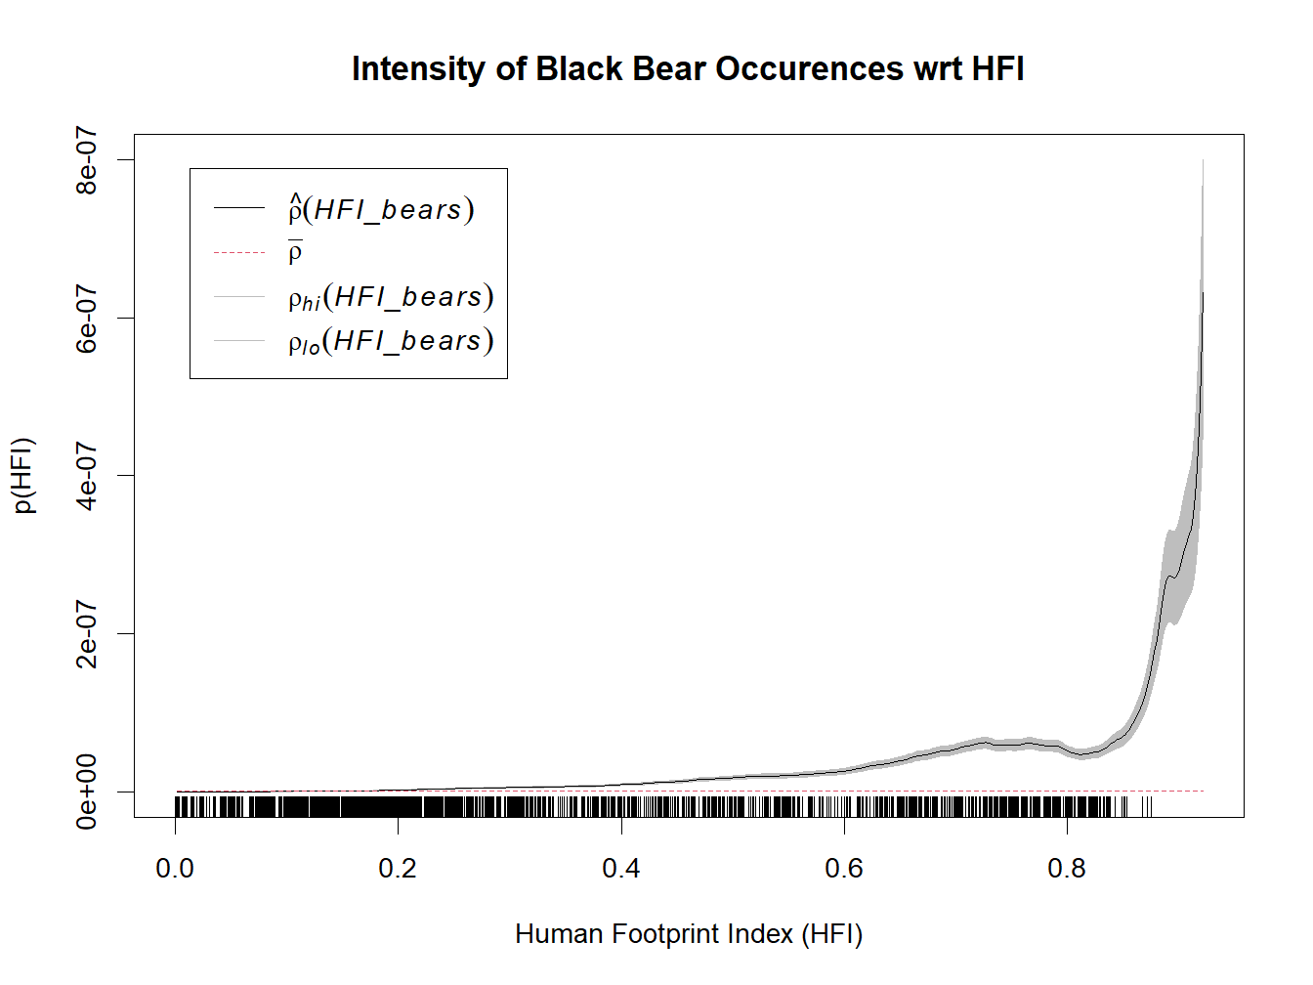

***Figure 9 Non-parametric Rho Plot. This figure presents the spatial autocorrelation between the black bear occurrences and the human footprint index (HFI) across the observation window. This plot highlights the non-linear relationship between the intensity of black bear occurrences and HFI as intensity increases as HFI increases with the highest intensity approaching 1.0 on the HFI.***

As shown in Figure 10, the intensity of black bear occurrences is generally slightly higher closer to water bodies. At distances between 1 meter and 75 meters, intensity is close to the average, ranging from 2% to 14% below the average. As distance from water increases beyond 75 meters, intensity fluctuates within a narrow range, with a maximum increase of approximately 37% observed at 250 meters and 3250 meters. At a distance of approximately 10,000 meters from the water, a significant decrease in intensity is observed, reaching two times below the average.

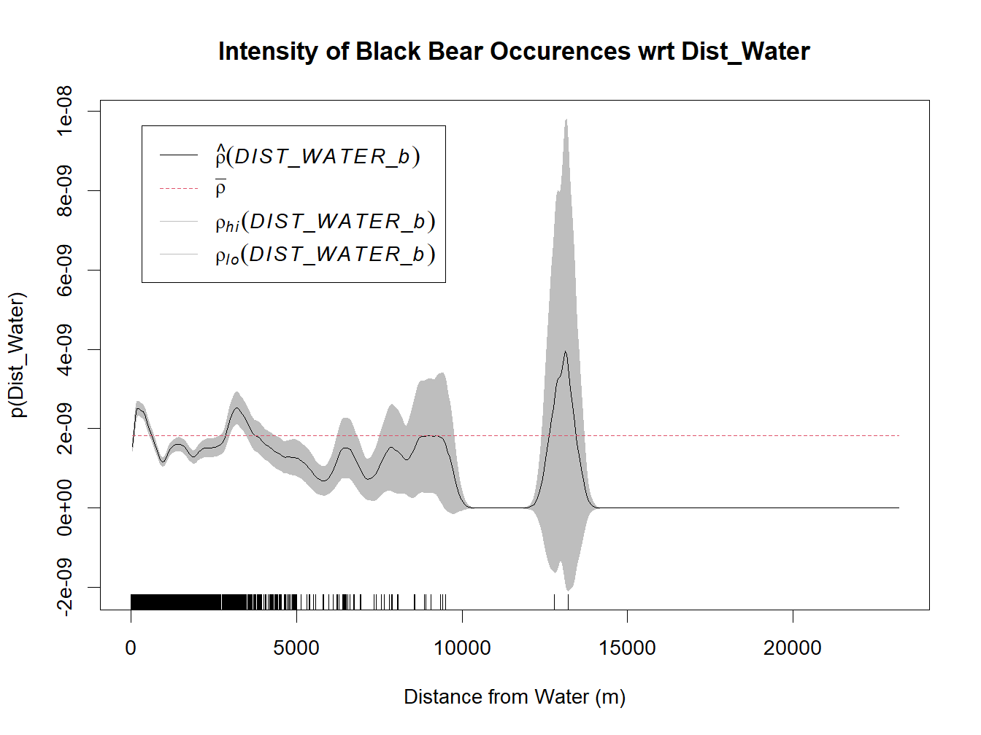

***Figure 10 Non-parametric Rho Plot. This figure presents the spatial autocorrelation between the black bear occurrences and the distance from water across the observation window. This plot highlights the non-linear relationship between the intensity of black bear occurrences and HFI as intensity increases as HFI increases with the highest intensity approaching 1.0 on the HFI.***

**Second Moment Analysis**

Based on the first moment analysis indicating that the distribution of black bear occurrences is not homogenous, Morisita’s index may not be well defined, and therefore cannot confidently infer an interpretation (see Appendix B). As shown in Figure 11, the K-function values deviate significantly from the confidence envelope at distances below 40,000 meters radius. This indicates a strong positive spatial correlation, suggesting that black bear occurrences are clustered within this range. Beyond 40,000 meters radius, the K-function values fall within the confidence envelope. This implies a lack of spatial correlation, suggesting that black bear occurrences are randomly distributed at these larger distances.

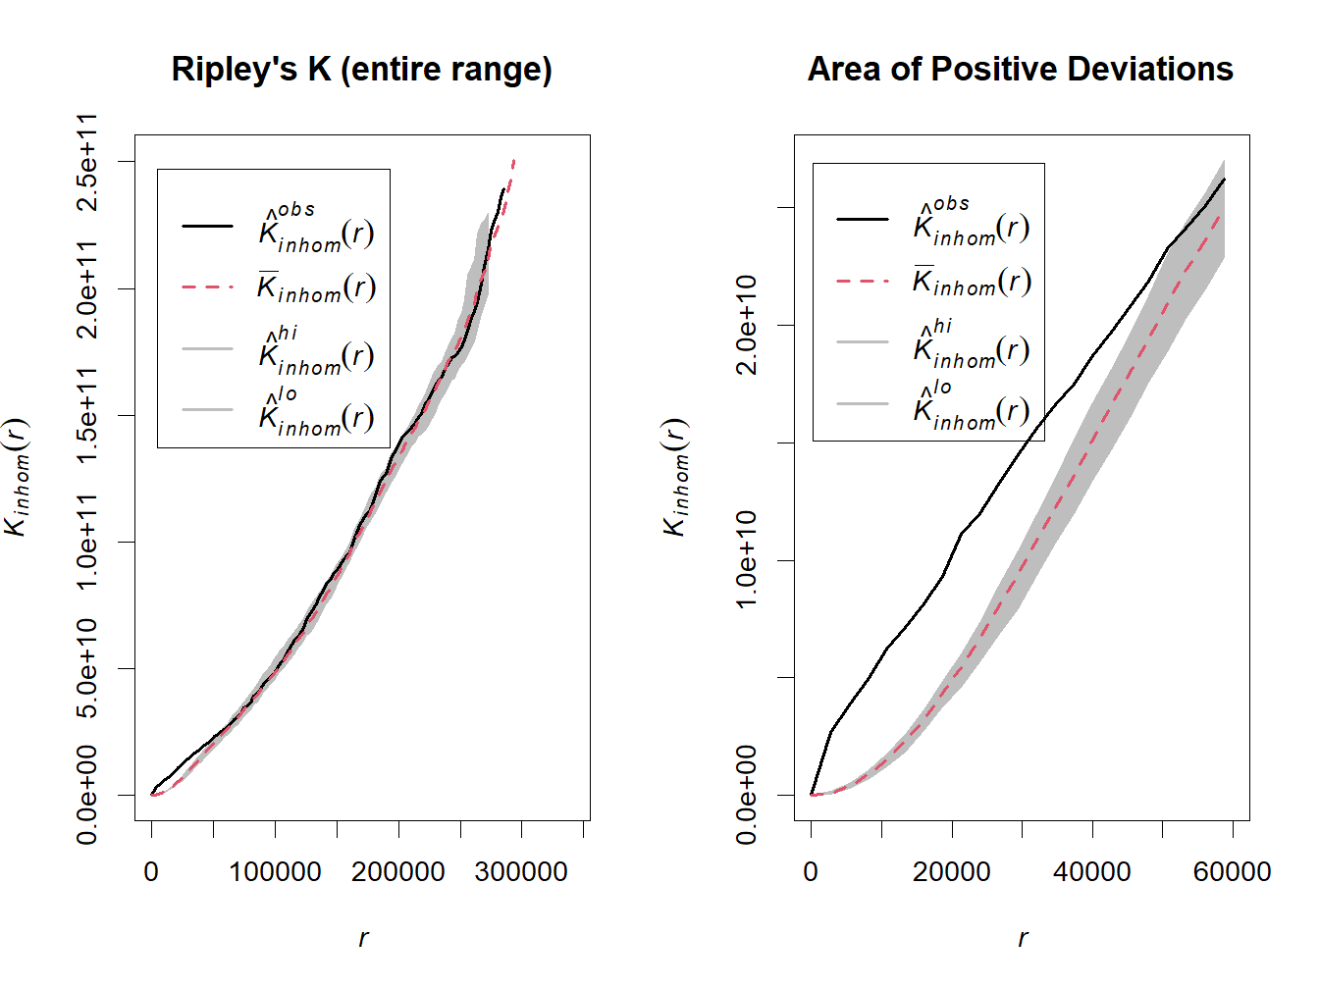

***Figure 11 Ripley’s K Function Plots. This figure presents the spatial distribution of points with the observed K-function curve displayed alongside the upper and lower bounds of the confidence band (i.e., hi, lo), allowing for the assessment of spatial clustering or dispersion. These plots highlight the range in which there are positive deviations from the confidence band indicating that there is a higher amount of black bear occurrences than expected under CSR at those distances, which suggests clustering.***

As shown in Figure 12, the pairs correlation function (or g-function) reveals that the g-function values deviate significantly from the confidence envelope in the first area of interest at distances below 20,000 meters radius. This indicates a strong positive spatial correlation, suggesting that black bear occurrences are clustered within this range. Beyond 20,000 meters radius the g-function values fall reasonably well within the confidence envelope with the exception of a second area in which there is a slight positive deviation around 250,000 meters radius and two additional areas in which there are slight negative deviations from the lower bound (for supplementary details, see Appendix C). However, this also depends on the results of the simulated confidence intervals. Ultimately, this implies a lack of spatial correlation, suggesting that the distribution of black bear occurrences are displaying CSR at these larger distances.

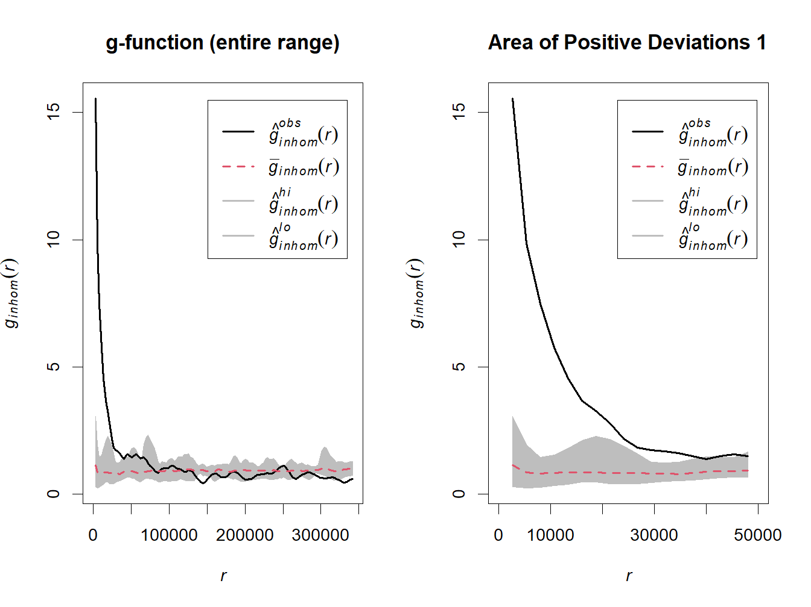

***Figure 12 Pairs Correlation Function (or g-function) Plots. This figure presents the spatial dependence of point pairs within a given distance range, as measured by the Pairs Correlation Function (g-function). The observed g-function curve is depicted alongside the upper and lower bounds of the confidence band, facilitating the assessment of spatial clustering or dispersion in point pair interactions. These plots highlight the ranges in which there are positive deviations from the confidence band (right) indicating spatial clustering of black bear occurrences, and negative deviations (see*** ***Appendix C******) indicating spatial dispersion of black bear occurrences.***

***Relationship between Park Locations and Black Bear Occurrences***

After thoroughly analyzing the point pattern of black bear occurrences, spatial covariates of elevation, forest coverage, HFI, and distance from water; the relationship between black bear occurrences and park locations is an interesting consideration that extends beyond the analysis thus far. As shown in Figure 13, there appears to be a potential relationship between the number of black bear sightings that occur near park locations in BC.

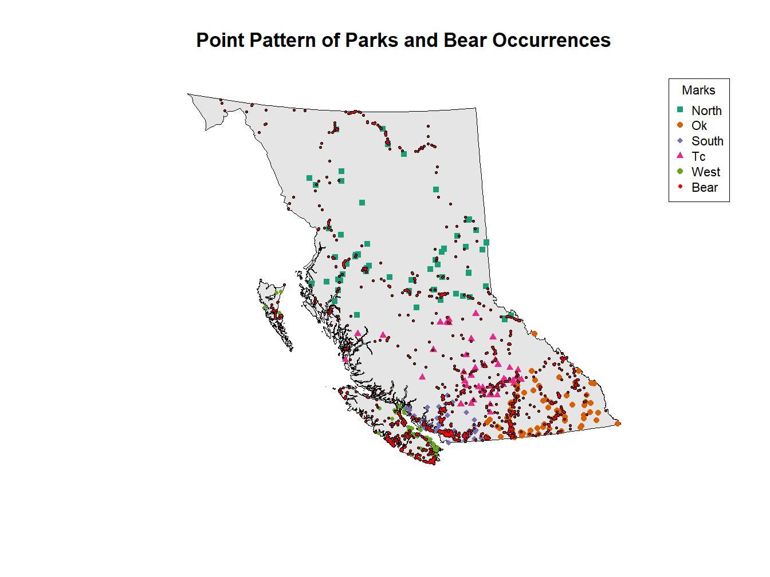

***Figure 13 Point Pattern Plot. This figure presents the observation window of interest that now includes the spatial distribution of black bear sightings that occurred in BC as well as the park locations. This plot highlights the potential relationship between park locations and black bear occurrences.***

It is worthy to note that in Figure 14, the spatial intensities of black bear occurrences and park locations show similarities when comparing 8x8 quadrat plots, suggesting that there could be a spatial association between the two point pattern and is also evident with kernel estimates and hotspot analysis (for supplementary details, see Appendix D). Furthermore, Figure 15 shows the respective density plots of both bear occurrences and park locations with respect to elevation as well as forest coverage and there is considerable overlap in the distributions. This may indicate that certain elevation ranges or forest coverages offer favorable habitat conditions or ecological features that attract both bears and the establishment of parks.

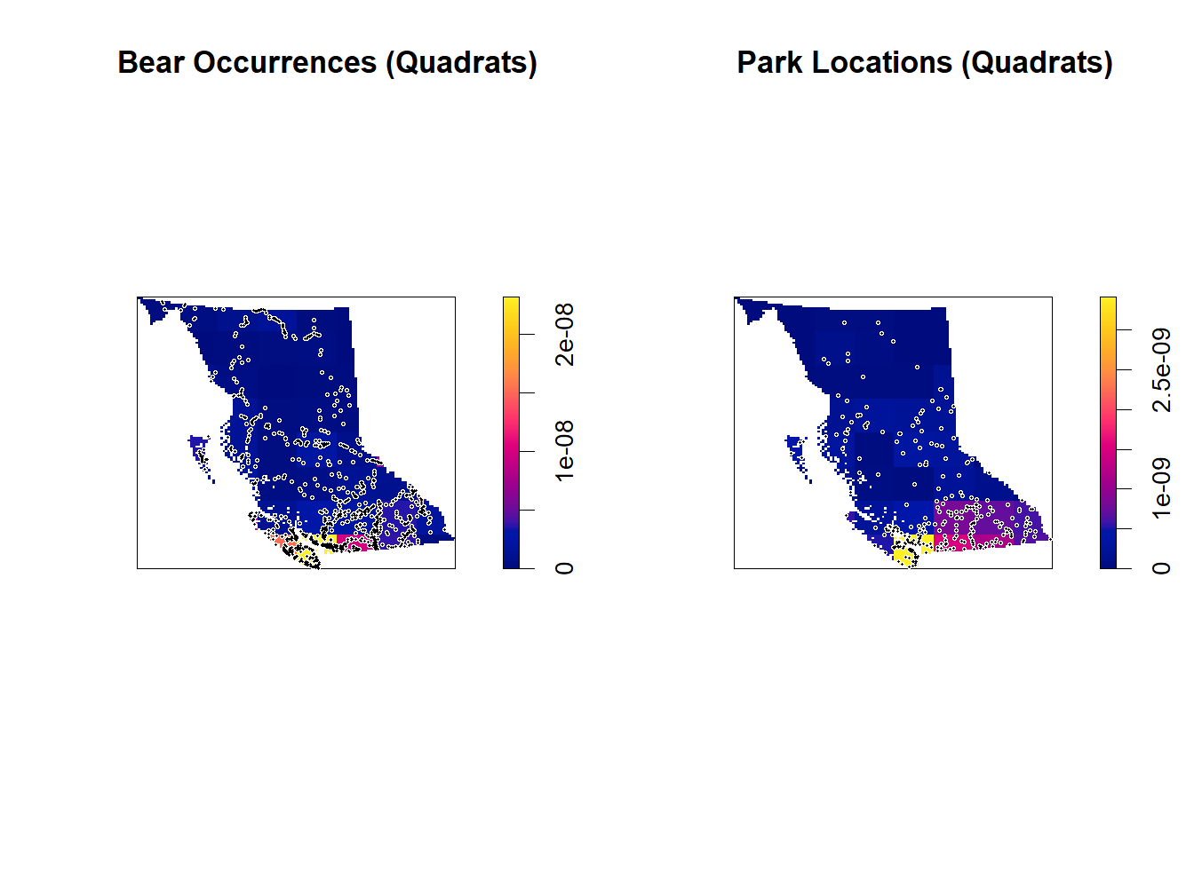

***Figure 14 Quadrat Count Comparative Plots. This figure presents the approximate number of black bear occurrences (left) and approximate number of park locations (right) in each quadrat. This plot highlights the areas of similar counts throughout, but most specifically in yellow and pink areas.***

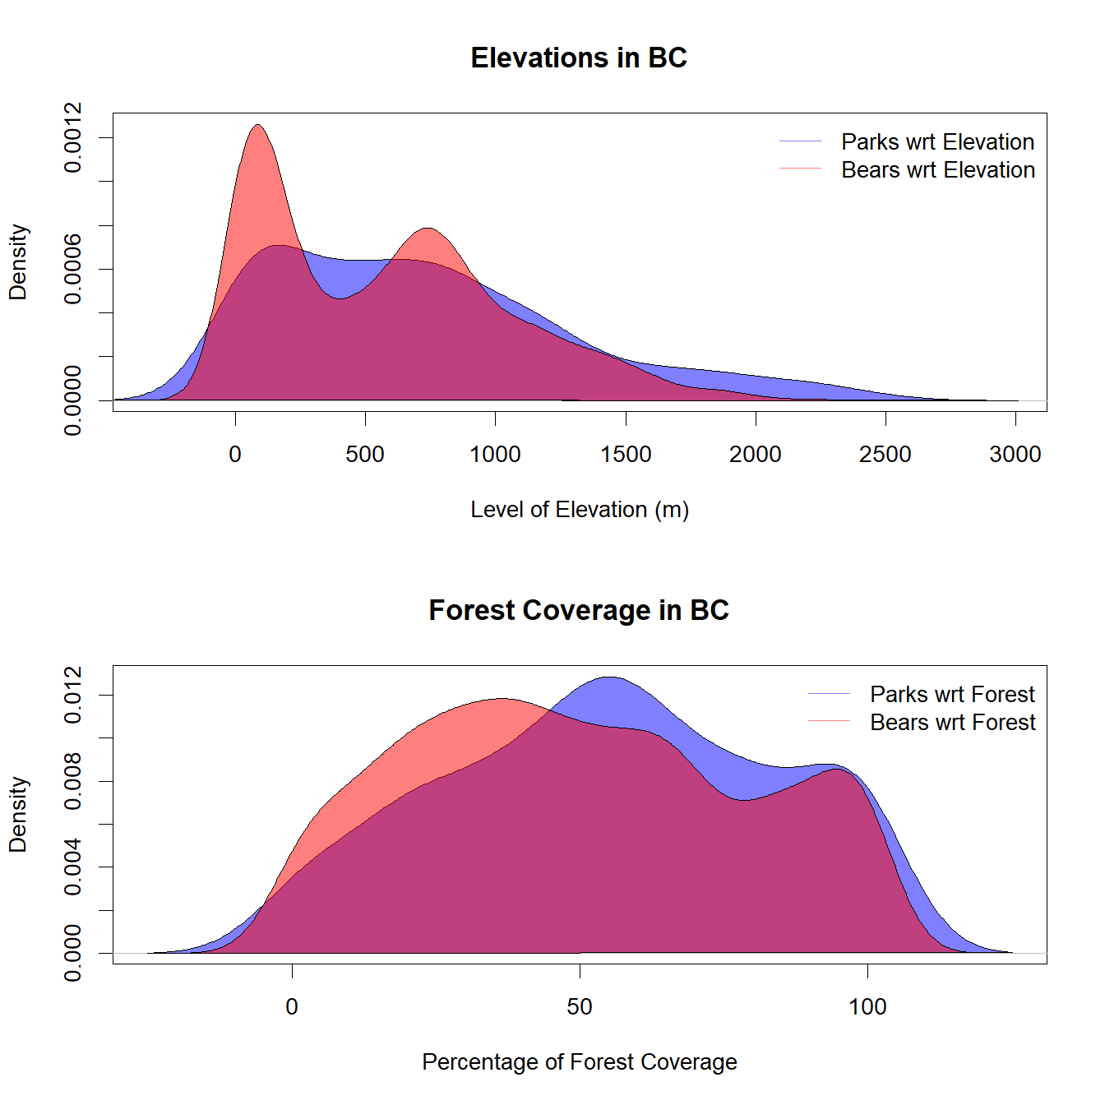

***Figure 15 Kernel Density Estimate Plots. This figure presents the approximate density curves of park locations and bear occurrences at certain elevations and forest coverage levels. These curves illustrate the spatial distribution of park locations and bear occurrences across different elevations and levels of forest coverage, providing insights into their respective spatial patterns and potential relationships.***

As shown in Figure 16, there is significant overlap with multiple density contours in the bottom right-hand section of the bivariate KDE plot suggesting a region of high spatial density where both point patterns, represented by the contours, coincide. This overlap indicates areas where both types of points (e.g., bears and parks) are concentrated together, further indicating a potential spatial association or correlation between the two point patterns.

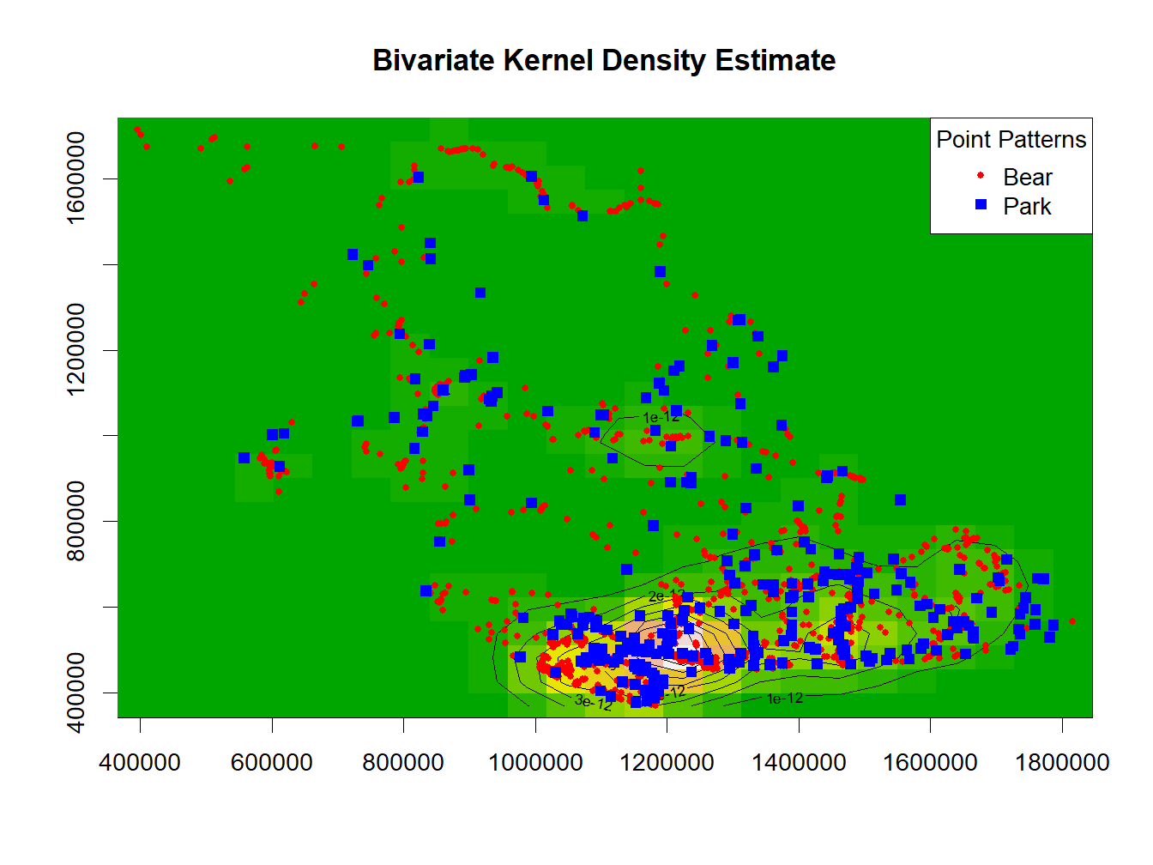

***Figure 16 Bivariate Kernel Density Estimate Plot. This figure displays contour densities representing the spatial distribution of black bear occurrences and park locations in BC. The contours represent areas of varying intensity, with higher contour densities indicating regions where both bear occurrences and park locations are concentrated. This plot provides insights into potential spatial relationships between black bear occurrences and park locations in BC, highlighting areas of overlap or concentration.***

Although the quadrat plots, kernel estimate plots, density plots, and Bivariate Kernel Density Estimate plots all point towards a relationship, in order to objectively test if there is a correlation between black bear occurrences and park locations, the distances between points are calculated and then tested using Pearson’s product-moment correlation. The statistical analysis indicates a strong positive correlation (Pearson's correlation coefficient 𝑟 = 0.926) between the distances of black bear occurrences and park locations in BC. The computed p-value is highly significant (𝑝 < 2.2𝑒−16), suggesting that the observed correlation is unlikely to have occurred by random chance alone. Additionally, the 95% confidence interval for the correlation coefficient (0.919, 0.933) indicates a high degree of precision in estimating the true correlation. Therefore, the evidence strongly supports the presence of a significant spatial relationship between black bear occurrences and park locations in BC.

**Modeling Black Bear Occurrences**

First moment descriptive analysis was used to explore the black bear occurrences data and determined that the point process was inhomogeneous, which was corrected for when determining what factors were involved in the relationships between points and spatial covariates. These metrics are correlative in nature and do not confirm our assumptions or explain why the relationship(s) exists and therefore, a Poisson point process model must be used to fully understand the black bear occurrences point process.

To begin with, Figure 17 displays the correlation matrix plot between all four spatial covariates with all the coefficients being of relatively weak strength, which suggests that there is limited concern for multicollinearity. Nonetheless, elevation exhibits a weak negative correlation with both Forest (-0.26) and HFI (-0.27), suggesting that areas of higher elevation tend to have slightly lower forest cover and human footprint and the remaining correlations are negligible.

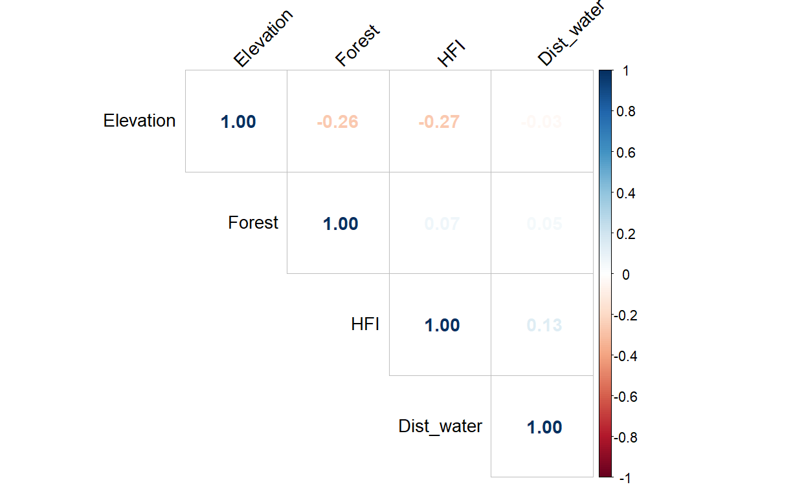

***Figure 17 Correlation Matrix Plot. This figure represents the correlation coefficient between two spatial covariates, with values ranging from -1 to 1. Positive values indicate a positive correlation, negative values indicate a negative correlation, and values close to zero indicate little to no correlation. This plot helps visualize the relationships between different covariates and provides insights into potential multicollinearity issues in the analysis.***

The fitted equation of the Poisson point process model with all four spatial covariates is:

Where is Elevation, is Forest, is Human Footprint Index, and is Distance from Water.

To compare the full-fitted model above with a model fit using only the intercept (i.e., null model), calculating the Akaike Information Criterion (AIC) as an estimator of prediction error can show the relative quality of the fitted model. The AIC value for the full model (68543.22) is lower than that of the null model (72802.45), indicating that the full model provides a better fit to the black bear occurrences data. The absolute difference (i.e., Delta) of the AIC values is 4259.235 and suggests that the full model is substantially better than the null model, as a Delta AIC value greater than 4 is considered strong evidence in favor of the model with the lower AIC.[2]

Furthermore, utilizing an analysis of variance (ANOVA) test to compare the models resulted in a large negative Deviance value for the full model (-4487.8) and the very small p-value (𝑝 < 2.2𝑒−16), which indicates that the full model fits the black bear occurrences data significantly better than the null model. These results suggest that the predictors included in this model contribute significantly to explaining the variability in the response variable (i.e., number of black bear occurrences).

Figure 18 is a visualization of the full-fitted model, which shows very few black bear occurrences being over-predicted (in the darker regions) and appears to include a reasonable amount of accurate black bear occurrences in the higher-predicted intensity areas (in the lighter regions). However, the residual plot of the full-fitted model in Figure 19 highlights exactly where these deviations occur. It appears that the model performs fairly well with low residuals throughout the province of BC with the exception of the hotspot at the southern tip that was identified earlier in the analysis.

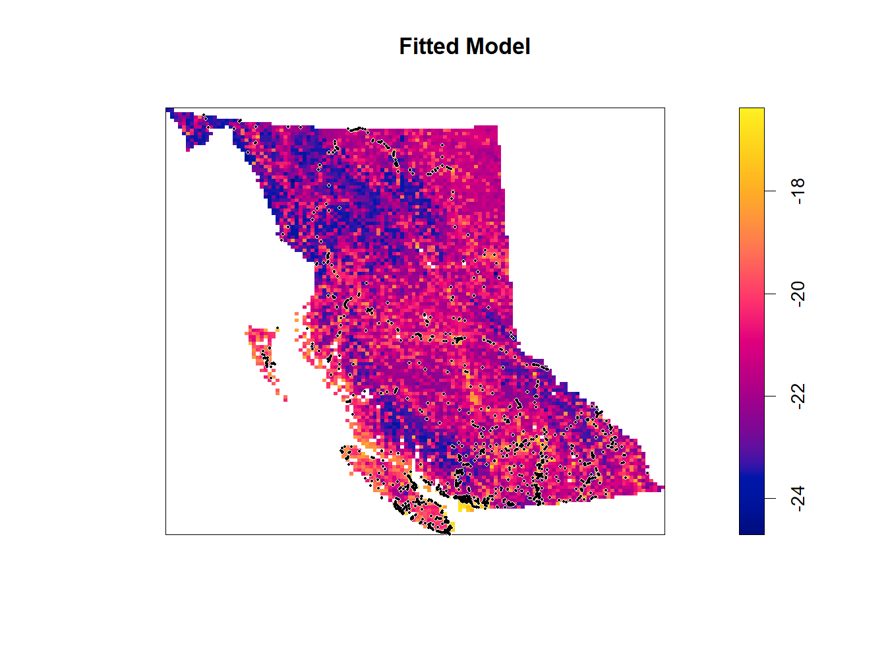

***Figure 18 Fitted Model Plot. This figure presents the spatially estimated intensity of black bear occurrences based on a fitted model incorporating four spatial covariates: elevation, forest coverage, human footprint index (HFI), and distance from water. The intensity values have been log-scaled for visualization purposes. The plot illustrates how the estimated intensity varies across BC, with areas of higher predicted bear occurrence intensity indicated by lighter shades, while darker shades correspond to lower predicted intensity.***

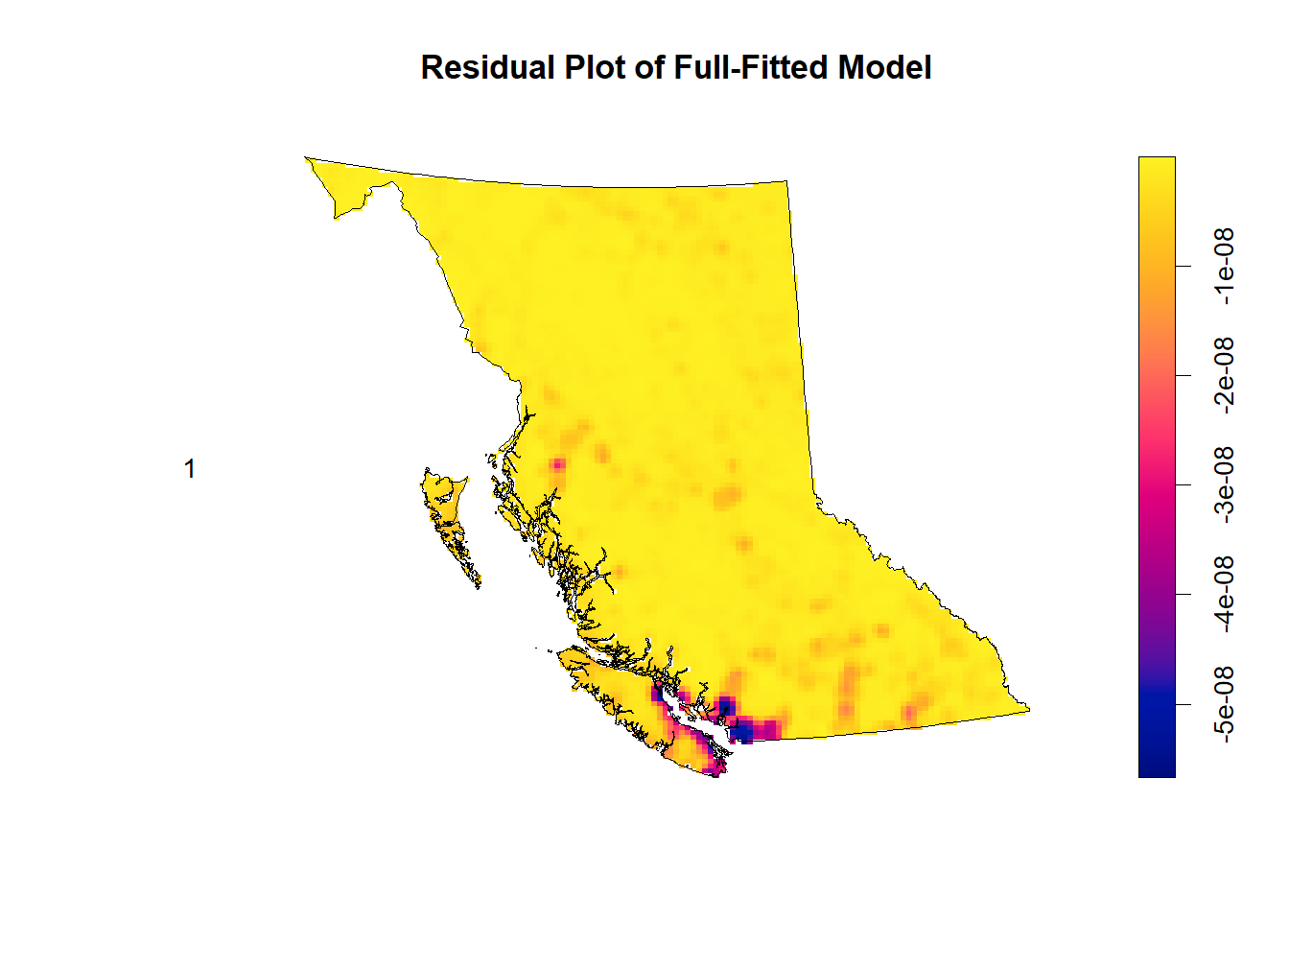

***Figure 19 Fitted Model Residual Plot. This figure presents the residuals of a full-fitted model predicting black bear occurrences using four covariates: level of elevation, forest coverage, human footprint index (HFI), and distance from water. The plot visualizes the differences between the observed black bear occurrences and the predictions made by the model. It allows for the assessment of model adequacy and identifies any systematic patterns or trends that may indicate model misspecification.***

To support these visualizations of the fitted model, the partial residuals of each covariate with respect to the full-fitted model is displayed in Figure 20 and indicates that the use of quadratic terms on each covariate during the Poisson point process model fitting stage was effective. Although it does not capture the increased intensity of black bear occurrences at higher levels of elevation, this area is not reliable as there is only a single data point that artificially inflates the estimate and enlarges the confidence interval. The main area of concern would be after the HFI exceeds approximately 0.7 and resides outside the confidence interval. However, for the given dataset of black bear occurrences, this is a fairly reasonable fit without increasing the complexity of the model.

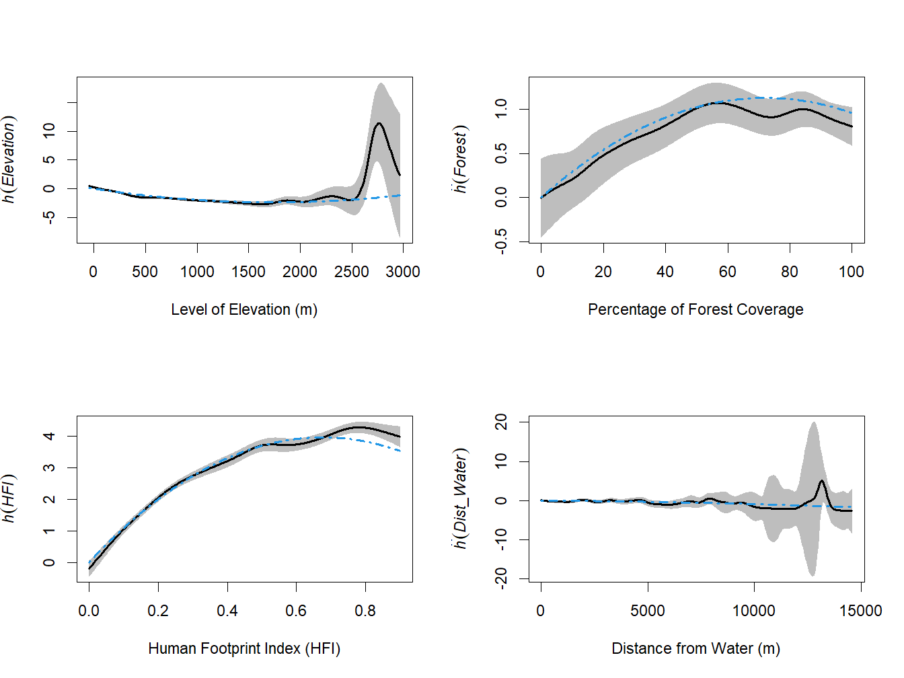

***Figure 20 Partial Residuals Plot. This figure presents the partial residuals of each spatial covariate (level of elevation, percentage of forest coverage, human footprint index (HFI), and distance from water) with respect to the fitted model of black bear occurrences. The partial residuals represent the difference between the observed response variable (black bear occurrences) and the predicted response variable from the model, after accounting for the effect of all other covariates. These plots highlight the effectiveness in applying quadratic terms to each covariate in the Poisson point process model fitting stage that resulted in a relatively accurate fit.***

**Discussion**

This study investigated the spatial distribution of black bear occurrences within the province of British Columbia, Canada, using various spatial data and statistical analyses. The key findings are summarized below, addressing the questions raised:

***Habitat Selection***

Black bear occurrences exhibited a negative relationship with elevation. Kernel density estimates showed a higher intensity of black bears at lower elevations, with a decrease in intensity as elevation increased. This suggests black bears prefer lower-elevation habitats within British Columbia.

Black bears showed a non-linear relationship with forest cover. The highest intensity of black bears occurred in areas with moderate forest cover (around 40%). Both very low and very high forest cover areas had lower black bear occurrences.

***Human Footprint***

A strong positive correlation was observed between black bear occurrences and the Human Footprint Index (HFI). This indicates that black bears are more frequently sighted in areas with a higher human footprint, which may be due to factors like access to food sources (e.g., garbage, agricultural crops) or artificial habitat fragmentation.

***Water Proximity***

Black bear occurrences showed a weak positive relationship with water proximity. The intensity of black bears was slightly higher closer to water bodies (within 75 meters) but fluctuated with increasing distance. A significant decrease in intensity was observed at distances exceeding 10,000 meters from water.

***Park Locations***

A significant spatial relationship was identified between black bear occurrences and park locations. This suggests that black bears are more likely to be found in areas near parks. This may be due to factors like overlapping habitat suitability (e.g., elevation, forest cover) or potential food sources within parks.

Overall, black bears in British Columbia exhibit preferences for specific habitat characteristics. They seem to favor lower elevations with moderate forest cover. Interestingly, the study found a positive correlation with human footprint and a weak positive association with water proximity. Finally, a significant spatial relationship was observed between black bear occurrences and park locations.

**References**

Greenwood, M.C. (2022). Intermediate Statistics with R. Version 3.1. Published Fall 2022.

Retrieved from

<https://greenwood-stat.github.io/GreenwoodBookHTML/chapter8.html#section8-13>

Weststrate, D. K., Chhen, A., Mezzini, S., Safford, K., & Noonan, M. J. (2024). How climate

change and population growth will shape attendance and human-wildlife interactions at

British Columbia parks. *Journal of Sustainable Tourism*, 1–15.

<https://doi.org/10.1080/09669582.2024.2331228>

Github: <https://github.com/CraigAdlam/BC_bears_spatial_statistics>

# Appendix A

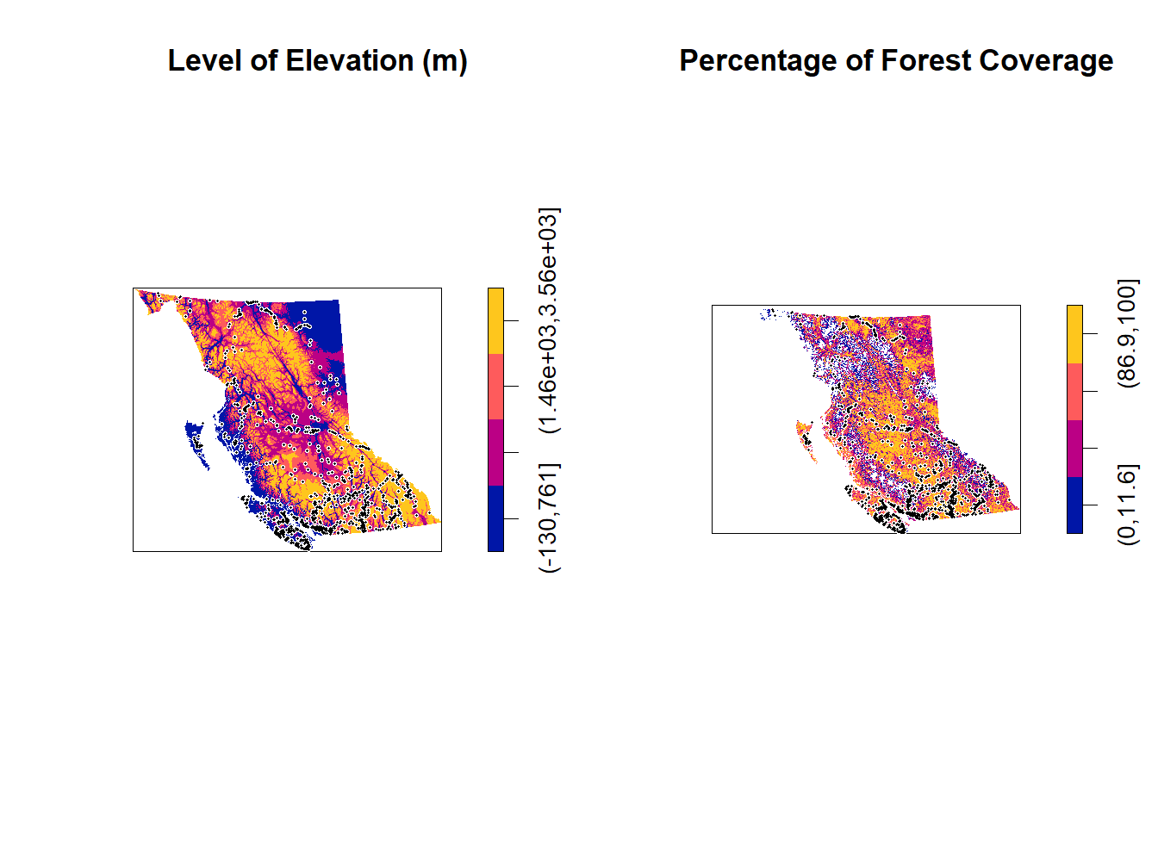

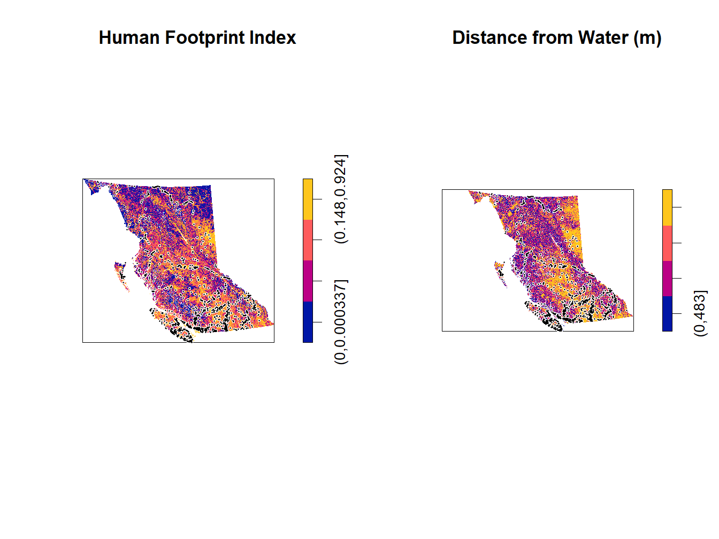

# Appendix B

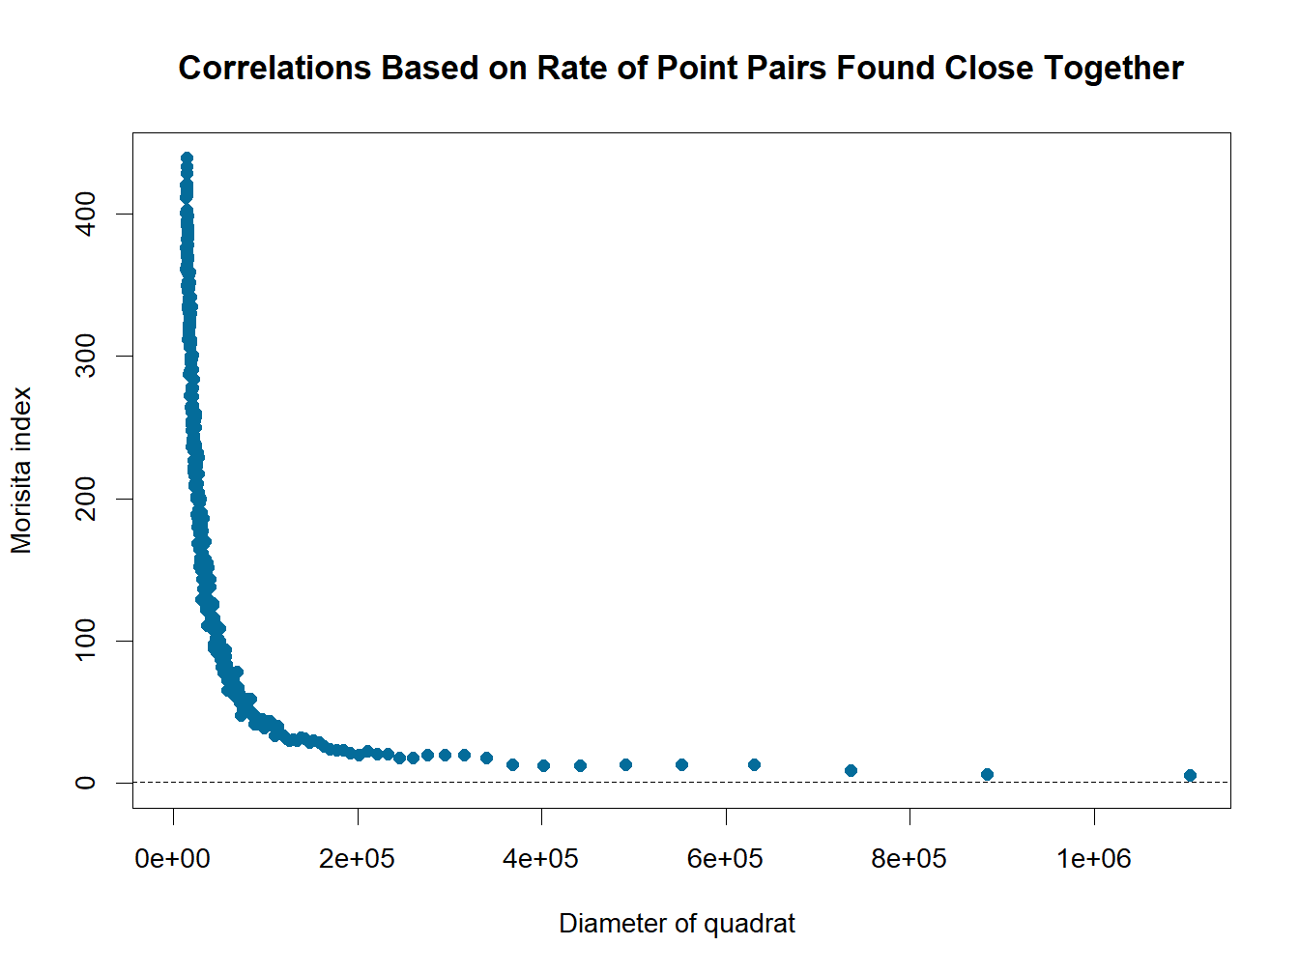

# Appendix C

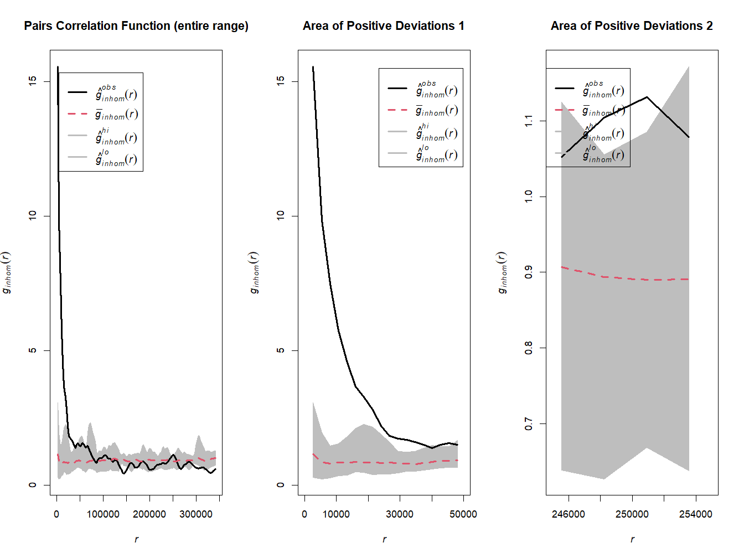

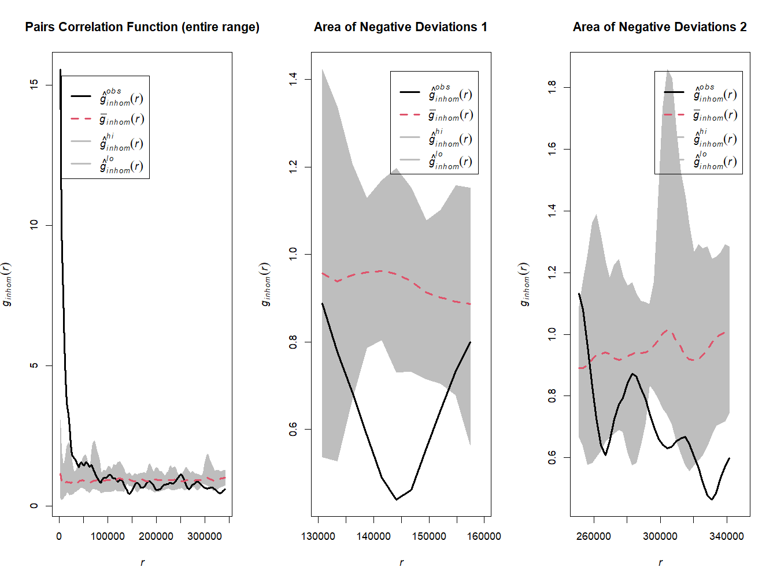

# Appendix D

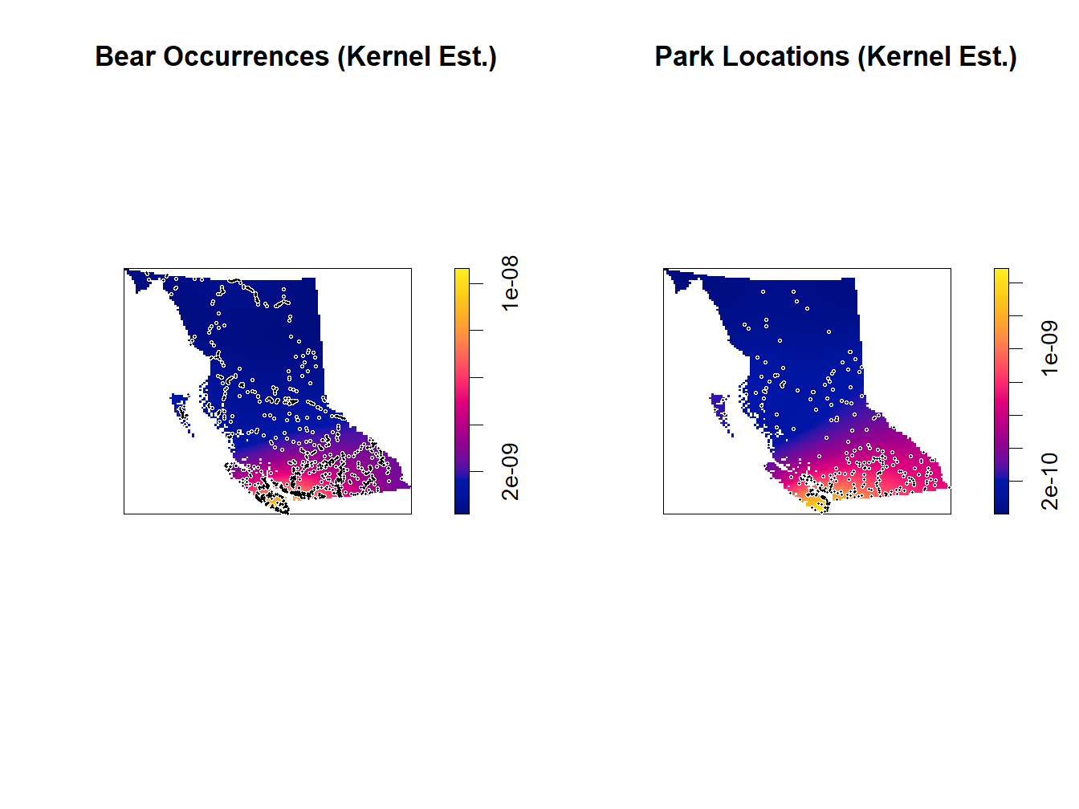

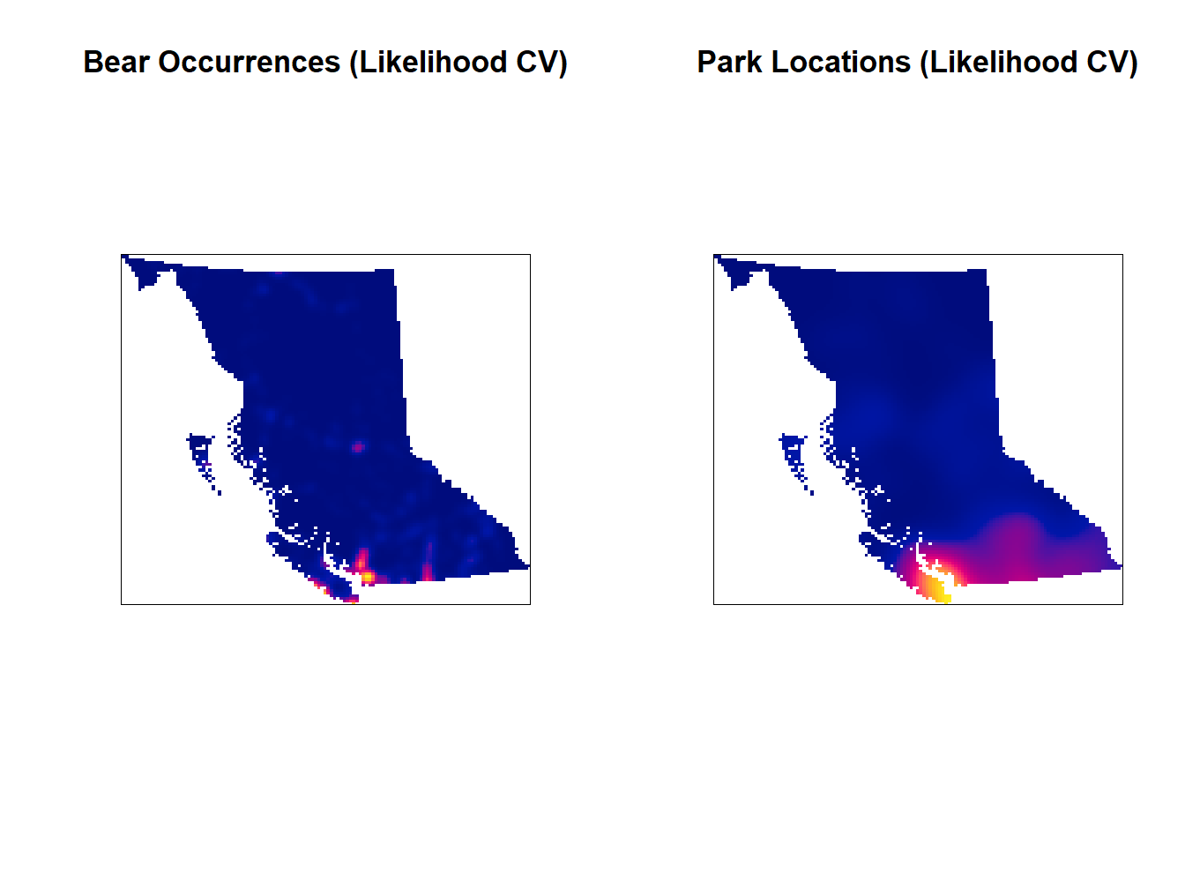

1. Weststrate, D. K., Chhen, A., Mezzini, S., Safford, K., & Noonan, M. J. (2024)
2. Greenwood, M.C. (2022)