**Automatic Update Information**

**Primary Host - X10Hosting.**

[www.x10hosting.com](http://www.x10hosting.com)

Registration = [x10host@bionicbone.plus.com](mailto:x10host@bionicbone.plus.com) Password = Normal

Website Name = APMLogAnaylser

* **Website Address:** [http://apmloganalyser.x10host.com](http://apmloganalyser.x10host.com/" \t "_blank)
* **Document Root:** ~/public\_html

Added the Updater FTP account

* **Server Hostname:** ftp.apmloganalyser.x10host.com
* **Server Port:** 21
* **FTPS (Secure):** Yes − We recommend using FTP via SSL/TLS.
* **Account Username:**updater@apmloganalyser.x10host.com
* **Account Password:** *1234567890*

This work for this account:

<http://apmloganalyser.x10host.com/Versions.txt>

or

<http://apmloganalyser.x10host.com/Upgrade/UpdaterProgram.exe>

It is possible to use the standard Visual Studio Settings with this service to update a deployment.

Auto Update Setting for Visual Studio:

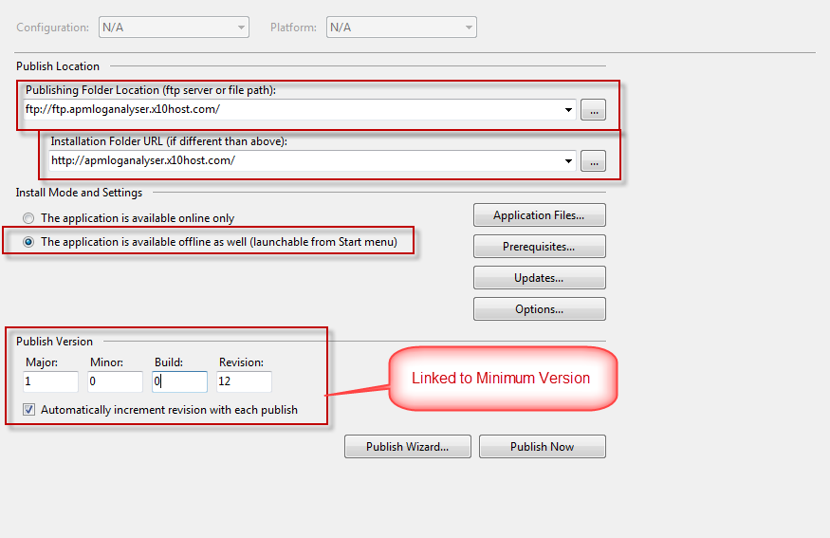

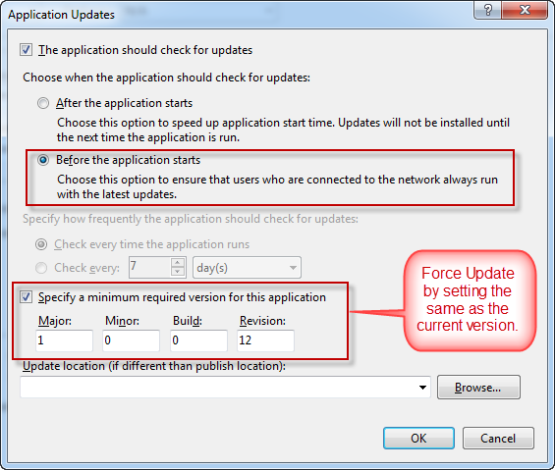

**Secondary Host – 000webhost.com**

[www.000webhost.com](http://www.000webhost.com)

Registration = [000webhost@bionicbone.plus.com](mailto:000webhost@bionicbone.plus.com) Password = Normal

Website Name = APMLogAnalyser

Website Address = www. APMLogAnalyser.net63.net

FTP Account

|  |  |
| --- | --- |
| FTP host name | apmloganalyser.net63.net |
| FTP user name | a9046792 |
| FTP password | \*\*\*\*\*\* |
| Folder to upload files | public\_html |
| Forgot FTP password? | [Change account password](http://members.000webhost.com/panel/change_account_password.php?accountID=18505962&login_hash=HdcfFaDQ3MwaIzEs) |
| Recommended FTP clients | [SmartFTP](http://www.smartftp.com/download/) or [FileZilla](http://filezilla-project.org/download.php?type=client) |

This account does not work as I cannot download using http the standard way of http://apmloganalyser.net63.net/Versions.txt

This is because we site does not allow downloads of .exe or .txt files, along with many others.

The only we to get round this is to change the extension on the server, once downloaded change it back. This would be a PITA though ☹

Need to find a better site…

After many attempts at trying to find a site that does what I need then I have decided that it may be better to use the encryption / decryption code to alter the extension of each file.

X10Hosting.com – OK

000WebHost.com – No

Trying AwardSpace

[**awardspace@bionicbone.plus.com**](mailto:awardspace@bionicbone.plus.com) **usual password**

Client ID: **1851537**