**README for Web Development**

**The Beginning**

The first order of business for the websites creation was deciding how I wanted it to look. I looked around on other websites to see if I could get some inspiration or ideas. I noticed some elements of certain websites that remained consistent, and from there it was a matter of putting my own ideas down on paper, as well as code.

I used the following websites for inspiration:

<http://joel.sh/>

<http://www.youtube.com/>

<http://www.facebook.com/>

<http://nile.northampton.ac.uk/>

**Designs**

Using what limited creative and artistic skills I had at my disposal, I created some very quick images to visualise what I wanted to create on my website:

Logo

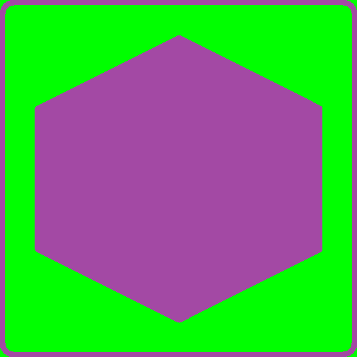 - I started with the logo as I have noticed that almost all websites use a logo at the top of the page to navigate back to the home page. My website will be no different, as I consider website navigation to be one of the more important factors of website creation (and I have had some bad experiences with previous websites not knowing how to get where)!

Navigation Bar

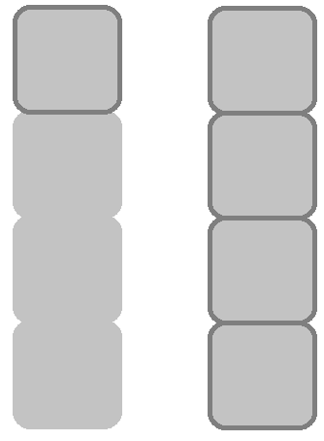 - The navigation bar I felt was very important; it had to be easy to locate and not hidden away. The nav bar would contain four buttons, and when hovering over those buttons I wanted them to darken around the button border, as you can see from the images. I have noticed a lot of websites use nav bar at the side, and so I felt that since people are familiar with this it would be wise to do the same, however some websites have navigation bars at the top. Of the two I prefer the side navigation bar, so I went with that. From top to bottom the nav bar contains buttons leading to; the home page, then the bio, then the CV page, and lastly the contact page.

Home page

Below is an image of what I roughly wanted the home page to look like. I kept it very simple and clean, to not overwhelm anyone with so much on screen at once. I made the home page serve as an introduction to myself, and nothing more.

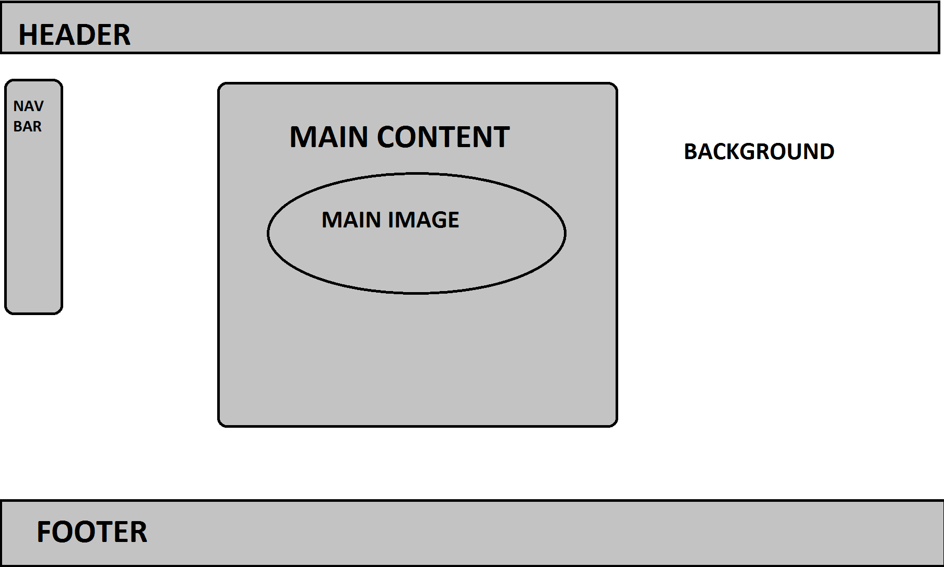

Bio/CV/Contact Page

As I decided to keep my website simple I chose to not change up the other pages too much or at all. The content they display will of course be different, but in terms of the placement of certain elements they will remain the same. It also keeps the website pages consistent.

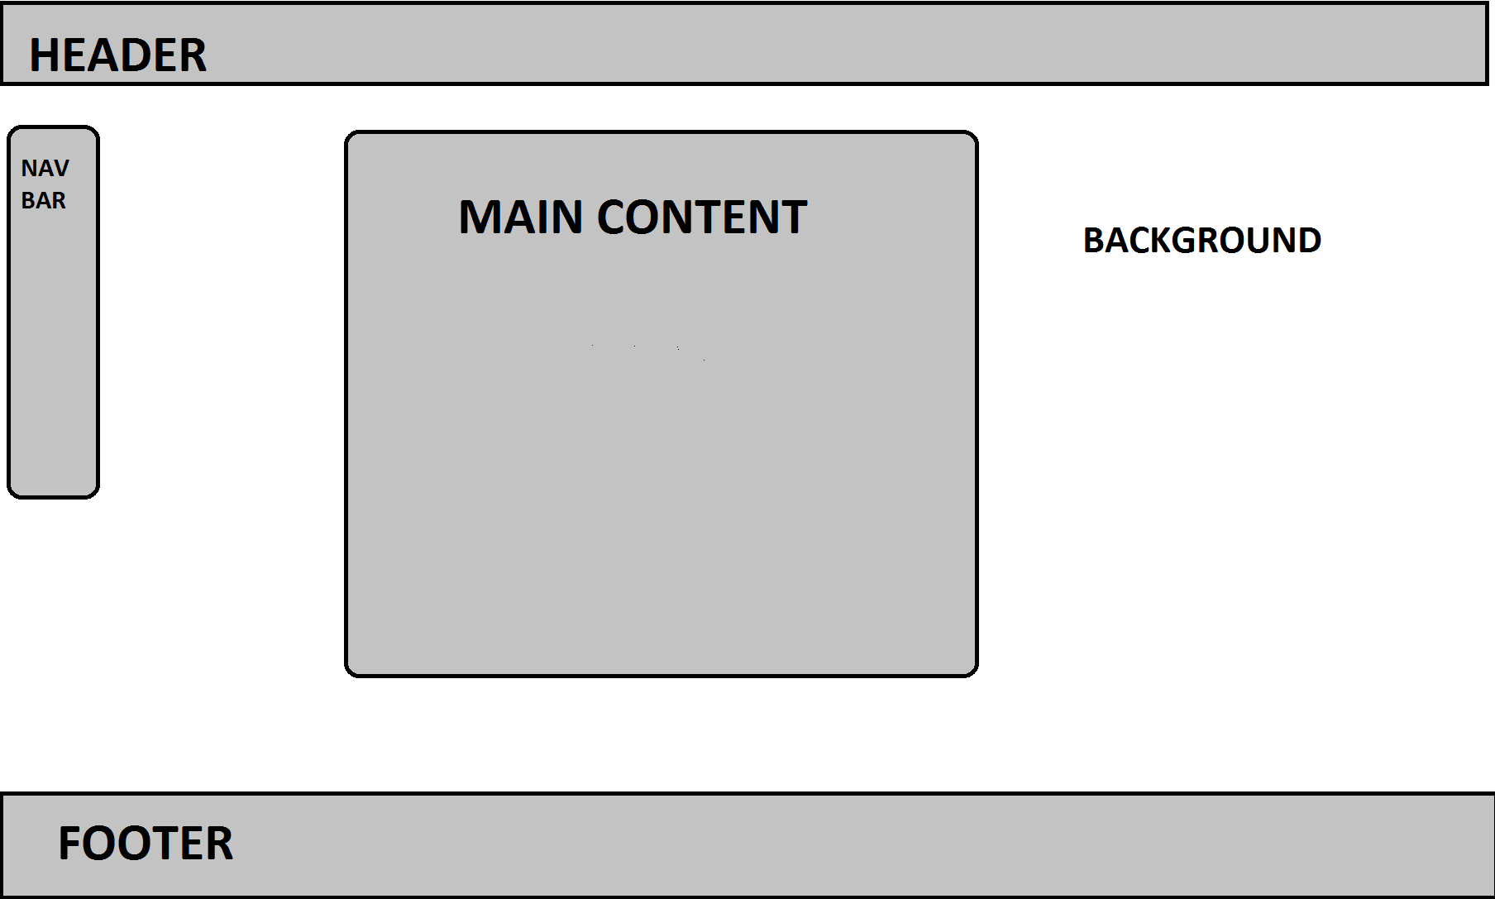

**Development of the Website**

The initial commit and first update did not involve any website creation at all, as they were for the creation of the GitHub repository, and then the first test commit to ensure I can commit correctly.

Second version

For the first viewable version of the website, I felt it was important to establish a way of navigating through all the pages. This meant creating relative URL’s inside a heading. This was of course a placeholder, but it would allow me to navigate the website while testing it out. An image of myself was also added to the biography page.

Third version

This is the version of the website where things began to take shape. A google web font was added to give the text a more unique look. Some parts were moved or changed, such as the image of myself. I felt it was better to put it on the index page, as people will immediately be able to put a face to who they are reading about.

I was also able to create a side navigation bar to place my URL’s into. This was important because it was part of the original design. This version was also the beginning of using applying CSS rules, so that I can structure the website how I want to. While here I made a rule that causes the nav buttons to change colour when hovering over them.

Fourth version

This is where I began to create headers and footers for all pages. I was also able to edit some CSS rules that allowed the main content box in the middle to stay in the middle, so that when the user changes the size of their window, the content box will adjust itself so that it stays in the middle. There were however, some parts of code that were unused, so they were erased for the time being.

Fifth version

This version of the website is where I could finally add some substance to the pages. The bio and cv pages were at last filled in with information that tells the user something about me. Some CSS rules were also edited slightly. Another important note is that I added another image to the relevant folder – a logo.

Sixth version

In this version, I revised the names of a lot of classes and elements. I moved the headers and footers outside of the main content box, where they would be more useful. I then included a phone number into the footer along with an email address, so the user will always be able to find out how they can contact me. In terms of the main contact page, I added a form to the contact page, where the user can send me a more detailed message.

Disclaimer Note: The form added to the contact page was not created by me. It was made by Thomas Rose on CodePen. I have slightly changed some of the code and removed other parts, but overall the code was not written by me.

Seventh version

This version is where I inserted the logo I added before, into the header. I also started writing some rules for the headers and footers in the CSS file. I added an extra contact detail to the footer as well, and changed around a lot of the CSS rules to make it easier to find the right classes.

Eighth version

In this version, I made some critical changes to only a few things. I first optimised all the images that were used on the site, as they were taking up far too much space when they did not need to. This will also speed up browsing and loading times. Another change I made is within the CSS rules; I changed every rule that used the pixel measurement, and changed them to “em”.

Final version

The final version of the website has not changed much at all in terms of appearance, however various comments were added in to help describe what each part of the code does. The unoptimized versions of the images were also removed from the folder.

**Additional Notes**

* I have discussed the assignment with Ryan Mitchell and Viktor Djambov.
* I have spent approximately 25-30 hours attempting this assignment. This does not include time spent in class.
* As stated before within the document, a piece of code that is not my own has been used for this assignment. I am referring to the static form created by Thomas Rose on CodePen. I have used this code and made some changes to it, you can find the source at http://codepen.io/collection/DPGozy/#