Vanier College

User Guide

420-411-VA Ecommerce section 00001

Professor: Michel Paquette

Team Name: Beavers

Team Members:

Alihan Djamankulov

Craig Justin Balibalos

Alexandra Vovc

Date: 16-12-2022

**As a customer, I can Register**

Step 1 – Fill out the fields

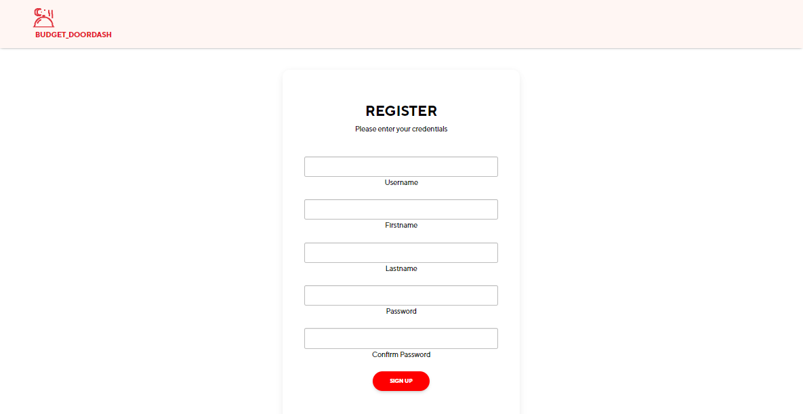

Step 2 – Pick a security question

Step 3 – Provide an answer for your chosen security question

**As a customer, I can Login**

Step 1 – Fill out the fields below with the info you inputted when you registered

Step 2 – Scan the QR-code and enter the 6-digit code to Setup 2 fa

**As a customer, I can Change my password if I forget**

Step 1 – Enter your username to find your chosen security question

Step 2 – Enter the answer you provided when you registered

Step 3 – Enter your new password

**As a customer, I can Look through Menu**

Step 1 – Pick a menu you want to browse and click the name

**As a customer, I can List the menu by price**

Step 1 – Used the buttons (Circled below) to sort food by price.

Left button is for lowest to highest and right button is for highest to lowest.

**As a customer, I can Search for a specific product**

Step – Type the name of the food you want to search and Click on the search icon

**As a customer, I can Favorite a specific food on the menu and add it to my favorite food list**

Step 1 – Click the “Add to favorite” button to favorite the food

**As a customer, I can remove a specific food on my favorite food list**

Step 1 – Click the “Remove from favorite” button to remove food from favorite food list

**To view favorite food list**

Step – 1 Click the “Account” button on the top right

Step 2 – Click the heart icon under Check favorite foods to see your favorites

**As a customer, I can Check my account and/or change my information**

Step 1 - Step – 1 Click the “Account” button on the top right

Step 2 – Click the pencil icon under “Hey there (username of user)”

Step 3 – Make the changes and click the “Save changes” button to save the new info

**As a customer, I can** **View the food description and leave a rating and a comment**

Step 1 – Click the “View details” hyperlink to view food details

Step 2 – Click the “Add a review” hyperlink to add your review

Step 3 – Choose a rating and write your comment then click the “Post review” button to post your review

**As a customer, I can delete my review**

Step 1 – Click the “Remove review” hyperlink

**As a customer, I can add a food to my cart**

Step 1 – Click the “Add to cart” button on the food that you want to add

(If there is no cart, the first click will create cart, so you need to navigate back to food list and click the “Add to cart” button a second time to add food to cart)

**As a customer, I can remove a food from my cart**

Step 1 – Click the “Remove from cart” hyperlink on the food that you want to remove

**As a customer, I can Checkout my order**

Step 1 – Click the “Cart” button on the top right to view your cart

Step 2 – Click the “Pay checkout” button to checkout you order

**As an admin, I can Add a menu**

Step 1 – Click the “Add menu” button on the top right, fill out the fields and click the “Create menu” button to create a new menu

**As an admin, I can Update a menu**

Step 1 – Click the “edit” hyperlink of the menu you want to edit, do the changes, and click the “Save changes” button to save the changes you did

**As an admin, I can Delete a menu**

Step 1 – Click the “delete” hyperlink of the menu you want to delete

**As an admin, I can Add a food**

Step 1 – Navigate to “All products”, click the “Add food” button, fill out the fields and choose a picture and click the “Create” button to create the food.

**As an admin, I can Update a food**

Step 1 – Click the “edit” hyperlink of the food you want to edit, do the changes, and click the “Save” button to save the changes you did

**As an admin, I can Delete a food**

Step 1 – Click the “delete” hyperlink of the food you want to delete

