Vanier College

Deliverable 2

  Client: Opeq, Simon

System Development Section 01

Team Orange:

Jiamin Yuan

Dinal Patel

Craig Justin Balibalos

Alihan Djamankulov

Ibrahim Awad

Submission Date:

Monday September 19, 2021

I, (Jiamin Yuan), student ID# (2055624), certify that I have contributed to this deliverable, (signature – this can be a scanned image, or an electronic signature).



I, (Dinal Patel), student ID# (2042827), certify that I have contributed to this deliverable, (signature – this can be a scanned image, or an electronic signature).



I, (Craig Justin Balibalos), student ID# (2069192), certify that I have contributed to this deliverable, (signature – this can be a scanned image, or an electronic signature).



I, (Alihan Djamankulov), student ID# (2033628), certify that I have contributed to this deliverable, (signature – this can be a scanned image, or an electronic signature).



I, (Ibrahim Awad), student ID# (2032818), certify that I have contributed to this deliverable, (signature – this can be a scanned image, or an electronic signature).



**Table of contents**

Statement ------------------------------------------------------ **4**

Executive Overview ------------------------------------------------------ **4**

Business Domain ------------------------------------------------------ **4**

Business Environment ------------------------------------------------------ **5**

Client Description ------------------------------------------------------ **6**

Business Problem ------------------------------------------------------ **6**

Open Questions ------------------------------------------------------ **6**

Questionnaire ------------------------------------------------------ **7-8**

Bibliography ------------------------------------------------------ **9**

**Previous Work Statement**

Our team will focus on creating the application from scratch using C# language. Some requirements for the application are that it must be downloadable on PC, and it must be able to connect to a web database. We will use the ideas that we learned from Application Development 1 in the previous semester. We will not use any previous code, but we will use the knowledge that we learned from before.

**Executive Overview**

In this deliverable, we needed more information about our client’s business and how our client wants the application to function, for example where does our client want to store the data and aesthetics. We did some research on what our client’s business does and the business environment.

In the last section of this document, we wrote the questions that we wanted to ask our client about the application and the client’s answer to those questions. There is also a drawing design of how the application should look like and a Bibliography that contains the sources that we used.

**Business Domain**

OPEQ is a non-profit organization that encourages social integration, re-employment, and eco-responsible recycling. OPEQ has been created in 1998 to manage the computers for school programs in Québec. Computers for Schools is a national program that refurbishes devices donated by governments, private businesses, and individuals for use by schools, libraries, registered not-for-profit organizations, Indigenous communities, and eligible low-income individuals. Their mission is to give or sell powerful computer systems at minimal cost to Quebec private and public schools and libraries as well as other Quebec non-profit organizations such as non-profit day-care centers (CPE) and learning centers. (“OPEQ - Ordinateurs pour les écoles du Québec - Home”) Their sorting centers receive computing equipment from private enterprises and ministries. Employees sort and test the devices to segregate the ones that meet our criteria against the ones who do not. Satisfactory items of good quality are then shipped to their technical workshops for an upgrade while the remainder is shipped to responsible recycling partners. Sorting centers participate in several social programs in association with carrefours jeunesse-emploi (CJE), with centers promoting professional and social insertion and with specialized schools and colleges. OPEQ have received and given: Several million sorted equipment including computers, servers, cell phones, mice, keyboards, projectors, etc. More than 270,000 computers and laptops were donated to schools and non-profit organizations. (“OPEQ - To know more on the organization”) More than 50,000 computers are recovered per year by OPEQ and over 18,000 tons of eco-friendly recycled material were recovered (April 1st, 2018).

**Business Environment**

Covering the whole province of Québec, OPEQ (Computers for Schools – Quebec) has two sorting centers (Montreal and Quebec), six workshops (Bellechasse, Gatineau, Montreal, Quebec, Saguenay, and Sherbrooke) and an administrative center. (“OPEQ - To know more on the organization”) This structure enables OPEQ to process rapid requests to pick-up as well as to provision schools and NPO with computers, laptops, and other refurbished devices. At the sorting centers, all types of devices are received (computers, laptops servers, hard drives, smart phones, old phones and even sometimes video games consoles. Before sending them to the workshops, people make sure that the devices are not outdated (decided by the company), hard drives capacities are at least 500 gigabytes or more or else they are recycled. The workshops only receive hard drives, computers, monitors, smart phones, and laptops after being sorted. When it comes to the computers, they go through what they call a “burn-in test” which consists of testing the computer components for fifteen minutes by default (can be changed to any duration), if the test is successful, the computers are ready for a potential order for a customer, when that happens, they install hard drives and make sure all the necessary components are there. There are a lot of other competitors that are in various parts of Canada such as Computer for schools in Manitoba (<https://www.c4smb.ca/>), in Yukon (<https://cfsy.ca/>), in Alberta (<https://recycle.ab.ca/envirobusiness/alberta-computers-for-schools/>), in Nova Scotia (<https://trp.ednet.ns.ca/accept_equip.shtml>), and a lot of other provinces of Canada.

Photo of OPEQ located in Montreal:

**Client Description**

  The client’s full name is Simon Provencher; he is a supervisor at a company named OPEQ, Dinal and Ibrahim’s former manager. He deals with computer components like hard drives, motherboards, RAM etc. The client is remarkably familiar with computers, so he is very skilled and has decent literacy, for example, he is quite familiar with Microsoft Office 365 apps like word, excel, etc. He is also familiar with databases as we used databases for items during the internship.

**Business Problem**

The problem that our client told us is that they are having a tough time recording the information of the customers, that calls them. They use an excel sheet to record the information but it takes a while to do it so some information might get mixed up with the others or forgotten completely. The solution that our client proposed is to make a desktop application that will make recording customer information fast and easy and it will also make the viewing of the records more organized.

**Open Questions**

We believe that developing a desktop application is a better solution to the time-consuming excel sheet because; It will present the information in a clearer and more structured visual while maintaining all the features of the client's current excel. We think that the client would want a login page for security reasons. The structure of the application we are not quite sure of but we do know that there will be at least 2 pages, one for adding data and one for viewing data. We would like to know if the client would also like a modify data option to update any information. We'll use a database to keep track of callers' details in real time. However, we do not know how the client intends to maintain the database or if a backup is necessary. Based on the customer's existing data, whether he wants to start fresh or store it all in the database, etc.

**Questionnaire**

Ask the questions you want to ask our client:

1. How do you want us to organize the database table? - Local database

-> Wants to save on google drive if possible if not a local database

1. Would you like to have a stored back up database in case of corruption?

-> If on google drive it will be saved if on local database still wants it saved

1. Do you want us to store the past information in the database (from excel)?

-> No, wants to start from scratch

1. Do you want to use buttons or a Filter to view different views?

-> Mix of both (look at drawing design)

1. Do you want a Login page?

-> Yes, just a name that will automatically be added to the database

1. Would you like to be an Admin there?

-> No, not needed, there is no special case

1. How many people are going to be using the application?

-> 1 Person, maximum 2 people

1. Do you want multiple languages (i.e., French and English)?

-> Yes, ask on the login page

1. Do you want pop ups for different views, or would you like them to show up on one page?

-> 1 Page, with buttons on the side for different options (look at drawing design)

1. How do you want the application to look like? (What kind of design, colors)

-> Blue, green, orange, grey (the Opeq colors)

1. Would you like a prototype to try/test the application? (Mid Oct)

-> Yes

More information will be in the drawing design because it will look clearer.

Rough sketch of what the application will look like:

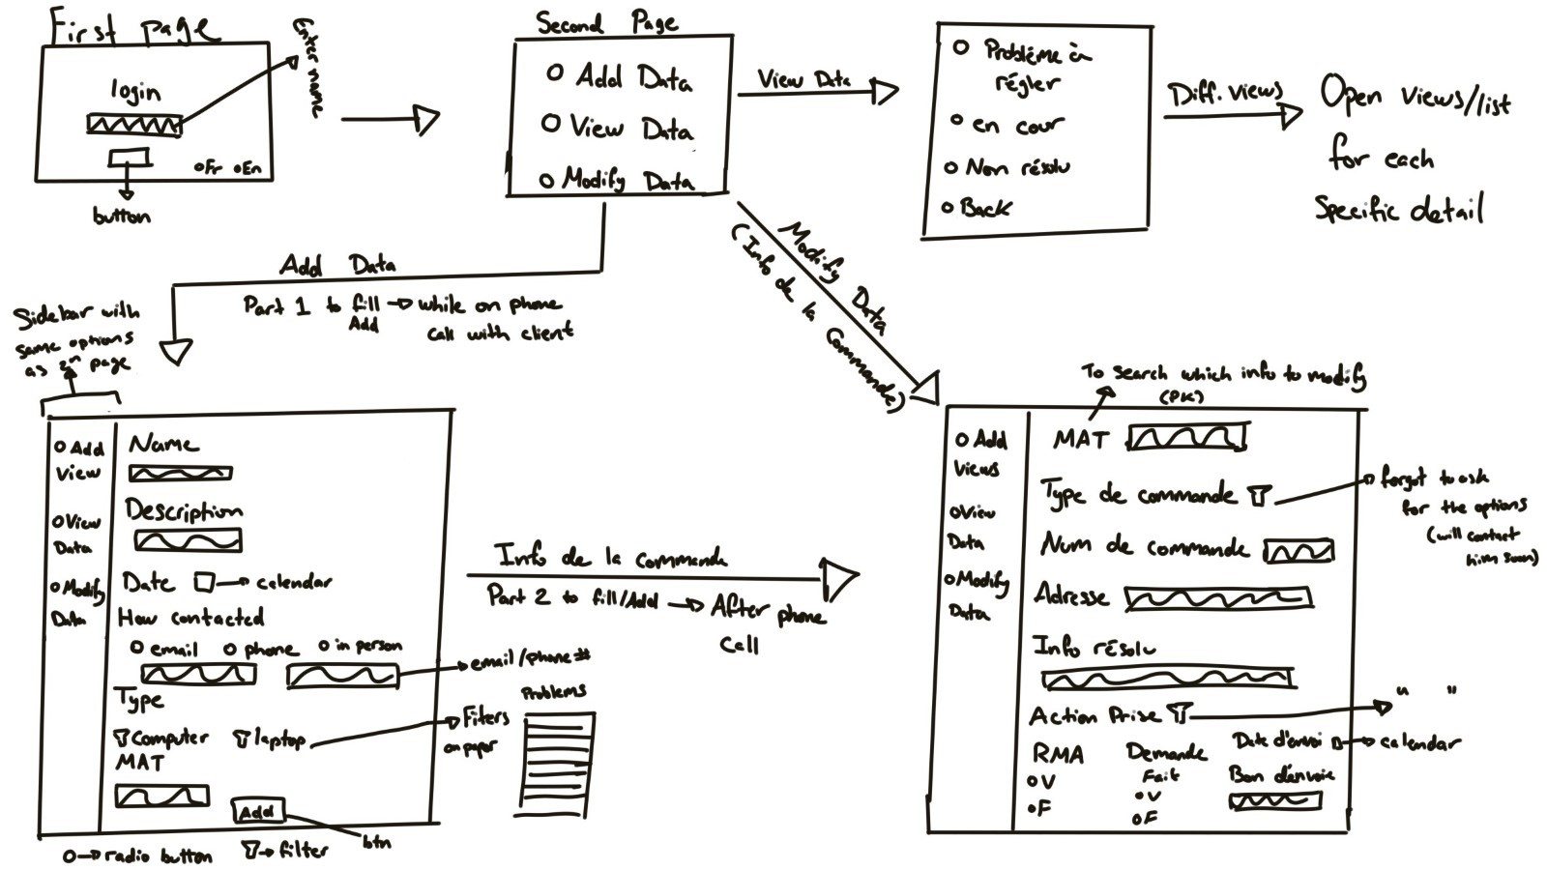

**Bibliography**

*OPEQ - To know more on the organization*. (n.d.). Retrieved from https://www.opeq.qc.ca/en/discover/organization/