Supplementary information for:

Submitted to: Integrative and Comparative Biology

Title: Ethomics for Ecotoxicology: Automated Tracking Reveals Diverse Effects of Insecticides on Bumble Bee Foraging and In-Nest Behavior

Authors: Anupreksha Jain, Acacia Tsz So Tang, James Crall (University of Wisconsin-Madison)

Supplementary Figures

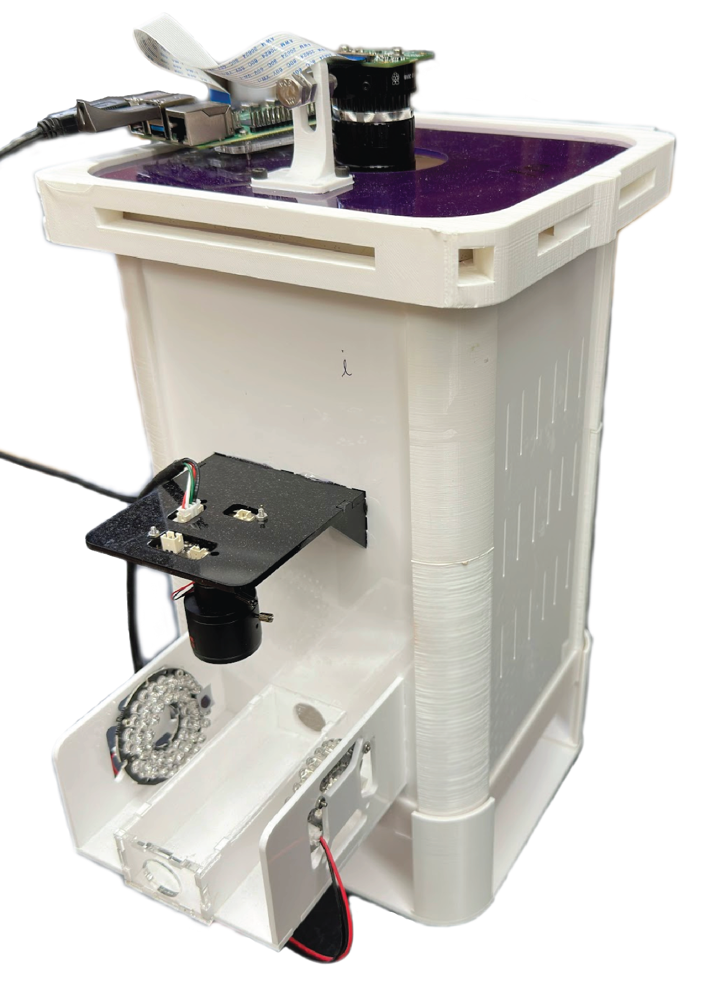
Figure S1 Modified BumbleBox setup for tracking within-nest behavior and foraging activity.

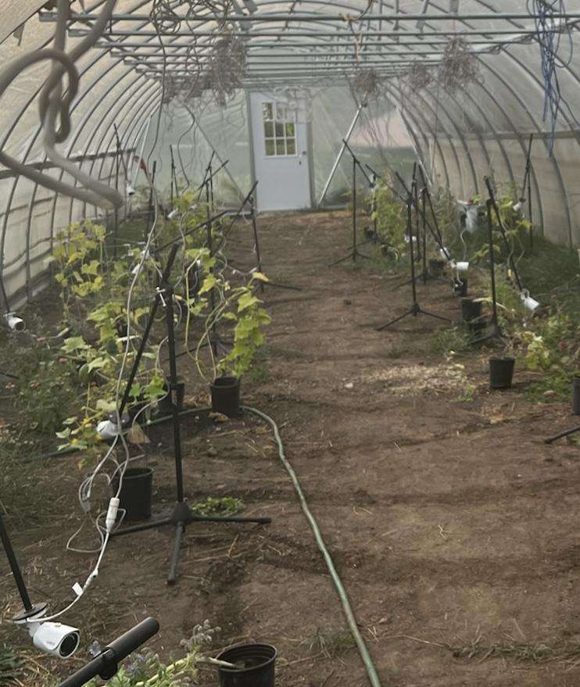
Figure S2 Flowering plants and cameras setup in the hoophouse.

Figure S3 BumbleBox nest chamber placed outside the hoophouse in a plastic container and further shaded. The nest chamber was connected to the hoophouse using plastic tubing (⅝” ID).

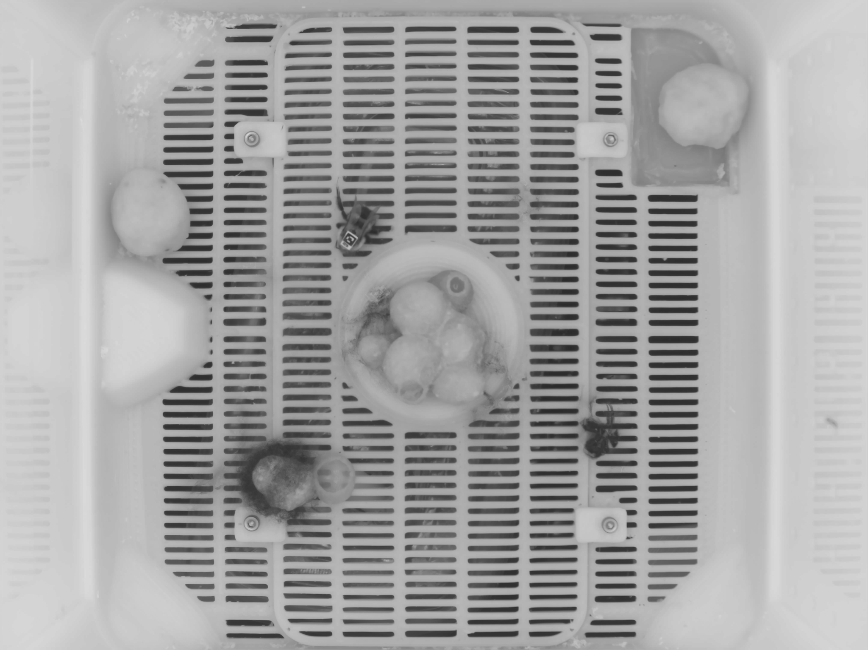
Figure S4 Example estimated background image (via median background estimation across videos). Visible bees were immobile during the entire day of data recording (dead bees), and the dark blur (e.g., in the bottom left) represents high-activity regions of brood care.

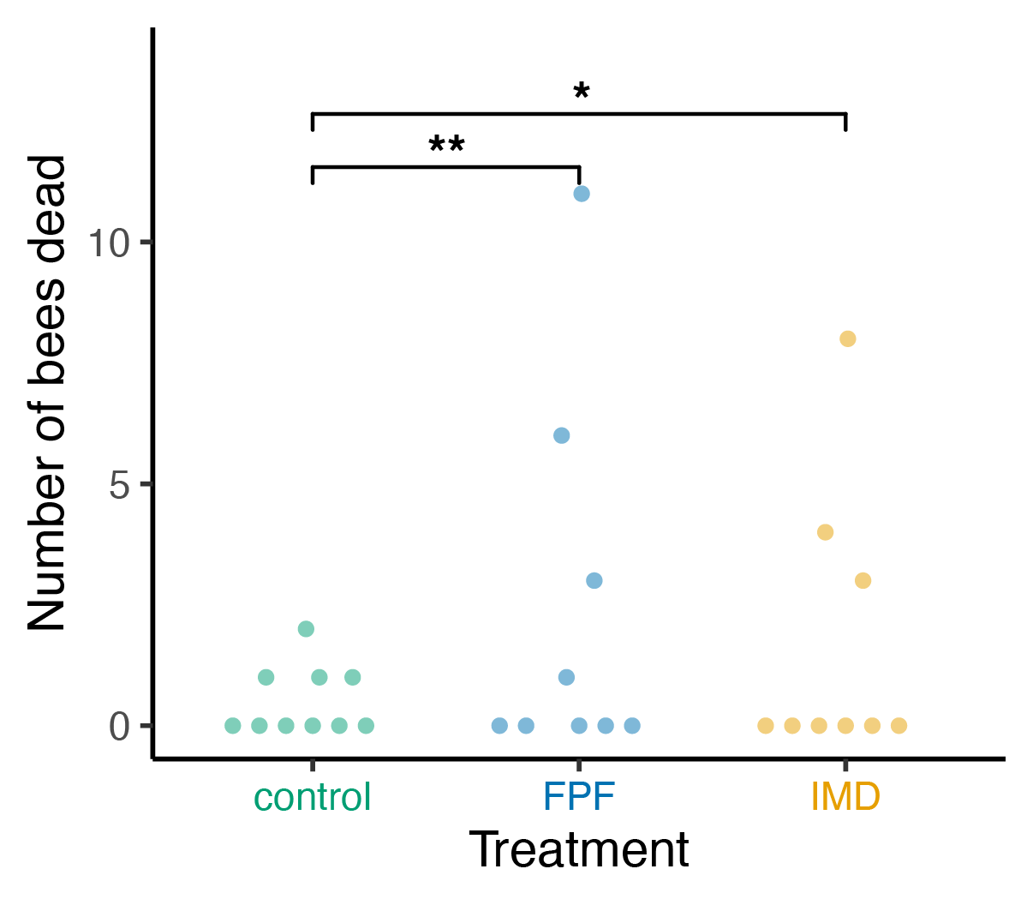
Figure S5 Number of bees found dead in microcolonies under the three insecticide treatments after one day of exposure (n = 10 [control], n = 9 [FPF], n = 9 [IMD] ). Each point represents a single microcolony. Asterisks denote level of evidence (** P < 0.01, * P < 0.05) from a zero-inflated negative binomial GLMM (Table S2).

Supplementary Tables

Table S1 Loading values of spatial metrics on Principal Component 1 of nest behavior (spatial centrality).
Variable | PC1 loading
log10(Distance to social center) | -0.484
log10(Mean distance to other bees) | -0.484
log10(Median minimum distance to other bees) | -0.372
log10(Mean distance to brood) | -0.493
log10(Median distance to closest brood) | -0.388

Table S2 Mortality model: glmmTMB (num_dead~treatment + (1|round), ziformula = ~1, family = nbinom2)
 | Estimate | Std. Error | z value | Pr(>|z|)
(Intercept) | -0.127 | 0.545 | -0.232 | 0.816
treatment(flupyradifurone) | 1.751 | 0.632 | 2.77 | 0.0056
treatment(imidacloprid) | 1.673 | 0.668 | 2.505 | 0.0123

Table S3 Spatial centrality model: lmer( pc1_mean~treatment*day_or_night + (1|round/microcolony/bee_ID) )
 | Estimate | Std. Error | df | t value | Pr(>|t|)
(Intercept) | -0.186 | 0.256 | 17.802 | -0.726 | 0.477
treatment(flupyradifurone) | 0.582 | 0.258 | 11.302 | 2.254 | 0.045
treatment(imidacloprid) | -0.186 | 0.275 | 11.409 | -0.675 | 0.513
day_or_night(night) | 0.008 | 0.094 | 353.865 | 0.085 | 0.932
treatment(flupyradifurone): day_or_night(night) | 0.051 | 0.122 | 351.801 | 0.415 | 0.678
treatment(imidacloprid): day_or_night(night) | -0.131 | 0.131 | 352.696 | -0.994 | 0.321

Table S4 Spatial centrality post-hoc comparisons (estimated marginal means with Tukey adjustment).
day_or_night | contrast | estimate | SE | df | t.ratio | p.value
day | control - flupyradifurone | -0.582 | 0.265 | 13.1 | -2.192 | 0.110
day | control - imidacloprid | 0.186 | 0.283 | 13.2 | 0.655 | 0.793
day | flupyradifurone - imidacloprid | 0.767 | 0.240 | 12.3 | 3.194 | 0.019
night | control - flupyradifurone | -0.632 | 0.267 | 13.3 | -2.372 | 0.080
night | control - imidacloprid | 0.316 | 0.285 | 13.5 | 1.111 | 0.524
night | flupyradifurone - imidacloprid | 0.949 | 0.241 | 12.4 | 3.938 | 0.0049

Table S5 Mean activity model: glmmTMB( mean_meanAct~treatment*day_or_night + (1|round/microcolony/bee_ID), family = beta_family() )
 | Estimate | Std. Error | z value | Pr(>|z|)
(Intercept) | 1.047 | 0.231 | 4.526 | < 0.0001
treatment(flupyradifurone) | 0.148 | 0.273 | 0.543 | 0.587
treatment(imidacloprid) | -1.761 | 0.290 | -6.064 | < 0.0001
day_or_night(night) | -0.677 | 0.094 | -7.216 | < 0.0001
treatment(flupyradifurone): day_or_night(night) | -0.036 | 0.125 | -0.292 | 0.770
treatment(imidacloprid): day_or_night(night) | -0.435 | 0.138 | -3.147 | 0.0016

Table S6 Mean activity post-hoc comparisons (estimated marginal means with Tukey adjustment).
day_or_night | contrast | odds.ratio | SE | df | null | z.ratio | p.value
day | control / flupyradifurone | 0.862 | 0.236 | Inf | 1 | -0.543 | 0.850
day | control / imidacloprid | 5.820 | 1.69 | Inf | 1 | 6.064 | < 0.0001
day | flupyradifurone / imidacloprid | 6.751 | 1.76 | Inf | 1 | 7.306 | < 0.0001
night | control / flupyradifurone | 0.894 | 0.243 | Inf | 1 | -0.412 | 0.911
night | control / imidacloprid | 8.990 | 2.64 | Inf | 1 | 7.477 | < 0.0001
night | flupyradifurone / imidacloprid | 10.053 | 2.64 | Inf | 1 | 8.774 | < 0.0001

Table S7 Activity IQR model: glmmTMB(act_IQR ~ treatment*day_or_night + (1|round/microcolony/bee_ID), data = tmp, family = beta_family())
 | Estimate | Std. Error | z value | Pr(>|z|)
(Intercept) | 0.020 | 0.175 | 0.117 | 0.906
treatment(flupyradifurone) | -0.632 | 0.221 | -2.857 | 0.0043
treatment(imidacloprid) | 0.069 | 0.237 | 0.291 | 0.771
day_or_night(night) | 0.339 | 0.176 | 1.927 | 0.054
treatment(flupyradifurone): day_or_night(night) | 0.007 | 0.228 | 0.031 | 0.975
treatment(imidacloprid): day_or_night(night) | -2.171 | 0.251 | -8.650 | < 0.0001

Table S8 Activity IQR post-hoc comparisons (estimated marginal means with Tukey adjustment).
day_or_night | contrast | odds.ratio | SE | df | null | z.ratio | p.value
day | control / flupyradifurone | 1.882 | 0.417 | Inf | 1 | 2.857 | 0.012
day | control / imidacloprid | 0.933 | 0.222 | Inf | 1 | -0.291 | 0.954
day | flupyradifurone / imidacloprid | 0.496 | 0.107 | Inf | 1 | -3.250 | 0.0033
night | control / flupyradifurone | 1.869 | 0.414 | Inf | 1 | 2.822 | 0.0133
night | control / imidacloprid | 8.182 | 2.010 | Inf | 1 | 8.552 | < 0.0001
night | flupyradifurone / imidacloprid | 4.378 | 0.968 | Inf | 1 | 6.681 | < 0.0001

Table S9 Mean speed model: lmer(log₁₀(mean_meanSpeed) ~ treatment*day_or_night + (1|round/microcolony/bee_ID) )
 | Estimate | Std. Error | df | t value | Pr(>|t|)
(Intercept) | 1.459 | 0.0415 | 20.984 | 35.176 | < 0.0001
treatment(flupyradifurone) | 0.065 | 0.052 | 16.496 | 1.245 | 0.230
treatment(imidacloprid) | 0.033 | 0.055 | 17.267 | 0.602 | 0.555
day_or_night(night) | -0.126 | 0.023 | 336.890 | -5.428 | < 0.0001
treatment(flupyradifurone): day_or_night(night) | 0.006 | 0.030 | 333.604 | 0.191 | 0.848
treatment(imidacloprid): day_or_night(night) | -0.124 | 0.033 | 340.067 | -3.773 | 0.00019

Table S10 Mean speed post-hoc comparisons (estimated marginal means with Tukey adjustment).
day_or_night | contrast | ratio | SE | df | null | t.ratio | p.value
day | control / flupyradifurone | 0.862 | 0.106 | 16.1 | 1 | -1.207 | 0.466
day | control / imidacloprid | 0.926 | 0.122 | 16.9 | 1 | -0.579 | 0.833
day | flupyradifurone / imidacloprid | 1.075 | 0.125 | 14.4 | 1 | 0.622 | 0.811
night | control / flupyradifurone | 0.850 | 0.105 | 16.4 | 1 | -1.308 | 0.411
night | control / imidacloprid | 1.233 | 0.164 | 17.5 | 1 | 1.570 | 0.284
night | flupyradifurone / imidacloprid | 1.449 | 0.169 | 14.8 | 1 | 3.175 | 0.016

Table S11 Foraging activity model: glmmTMB (bouts_per_24h~treatment + (1|round/microcolony), family = nbinom2, ziformula = ~1)
 | Estimate | Std. Error | z value | Pr(>|z|)
(Intercept) | 1.381 | 0.305 | 4.521 | < 0.0001
treatment(flupyradifurone) | 0.201 | 0.327 | 0.614 | 0.5395
treatment(imidacloprid) | -0.738 | 0.370 | -1.994 | 0.0462

Table S12 Total flower visitation model: glmmTMB(log1p(total_visits) ~ treatment + (1|round/microcolony) )
 | Estimate | Std. Error | z value | Pr(>|z|)
(Intercept) | 1.554 | 0.149 | 10.443 | < 0.0001
treatment(flupyradifurone) | -0.115 | 0.226 | -0.509 | 0.611
treatment(imidacloprid) | -0.052 | 0.195 | -0.265 | 0.791

Table S13 Flower visitation by plant species model: glmmTMB(log1p(visits) ~ treatment*species + (1|round/microcolony) )
 | Estimate | Std. Error | z value | Pr(>|z|)
(Intercept) | 1.740 | 0.147 | 11.864 | < 0.0001
treatment(flupyradifurone) | -0.749 | 0.211 | -3.550 | 0.0004
treatment(imidacloprid) | -0.562 | 0.192 | -2.933 | 0.0034
species(cucumber) | -0.628 | 0.164 | -3.817 | 0.00014
species(zinnia) | -0.679 | 0.179 | -3.793 | 0.00015
treatment(flupyradifurone):species(cucumber) | 0.836 | 0.249 | 3.356 | 0.0008
treatment(imidacloprid):species(cucumber) | 0.687 | 0.215 | 3.200 | 0.0014
treatment(flupyradifurone):species(zinnia) | 0.578 | 0.297 | 1.943 | 0.0521
treatment(imidacloprid):species(zinnia) | 0.622 | 0.235 | 2.647 | 0.0081

Table S14 Post-hoc comparisons of flower visitation by plant species (estimated marginal means with Tukey adjustment).
species | contrast | estimate | SE | df | t.ratio | p.value
borage | control - flupyradifurone | 0.749 | 0.211 | 230 | 3.550 | 0.0014
borage | control - imidacloprid | 0.562 | 0.192 | 230 | 2.933 | 0.0103
borage | flupyradifurone - imidacloprid | -0.186 | 0.196 | 230 | -0.948 | 0.610
cucumber | control - flupyradifurone | -0.087 | 0.179 | 230 | -0.488 | 0.877
cucumber | control - imidacloprid | -0.125 | 0.153 | 230 | -0.817 | 0.693
cucumber | flupyradifurone - imidacloprid | -0.037 | 0.167 | 230 | -0.226 | 0.972
zinnia | control - flupyradifurone | 0.171 | 0.238 | 230 | 0.717 | 0.754
zinnia | control - imidacloprid | -0.059 | 0.179 | 230 | -0.330 | 0.942
zinnia | flupyradifurone - imidacloprid | -0.230 | 0.224 | 230 | -1.026 | 0.561

