Inventory

The inventory structure is shown in the following picture:

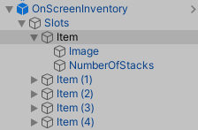

*OnScreenInventory* is the object that reacts to user input for navigating through the slots, it shows and hides the slots and uses/equips the selected item. The number of slots is changed by adding new Item elements in the hierarchy or removing them.

Each *Item* element consists of an image of the item and the number of stacks. It also needs to have the Slot script attached. That script will display the necessary information in the slot, remove an item from it and determine how to use it depending on whether the item is a simple item or a puzzle item or a piece of equipment.

The *Item* slots can be populated by objects that have the Item script or a class derived from the Item class (such as PuzzleItem and Equipment). Equipment items have to be children of the player’s WeaponContainer. PuzzleItems have to be children of the PuzzleSlotMatching game object.