

Functional Safety Concept Lane Assistance

**Document Version: [Version]**

**Template Version 1.0, Released on 2017-06-21**



# Document history

**[Instructions: Fill in the date, version and description fields. You can fill out the Editor field with your name if you want to do so. Keep track of your editing as if this were a real world project.**

**For example, if this were your first draft or first submission, you might say version 1.0. If this is a second submission attempt, then you'd add a second line with a new date and version 2.0]**

|  |  |  |  |
| --- | --- | --- | --- |
| Date | Version | Editor | Description |
| 7/20/2018 | 1.0 | Yafei Qin | First submission |
|  |  |  |  |
|  |  |  |  |
|  |  |  |  |
|  |  |  |  |

# Table of Contents

**[Instructions: We have provided a table of contents. If you change the document structure, please update the table of contents accordingly. The table of contents should show each section of the document and page numbers or links. Most word processors can do this for you. In** [**Google Docs**](https://support.google.com/docs/answer/116338?co=GENIE.Platform%3DDesktop&hl=en)**, you can use headings for each section and then go to Insert > Table of Contents.** [**Microsoft Word**](https://support.microsoft.com/en-us/help/285059/how-to-create-a-table-of-contents-by-marking-text-in-word) **has similar capabilities]**

Document history

Table of Contents

Purpose of the Functional Safety Concept

Inputs to the Functional Safety Analysis

Safety goals from the Hazard Analysis and Risk Assessment

Preliminary Architecture

Description of architecture elements

Functional Safety Concept

Functional Safety Analysis

Functional Safety Requirements

Refinement of the System Architecture

Allocation of Functional Safety Requirements to Architecture Elements

Warning and Degradation Concept

# Purpose of the Functional Safety Concept

**[Instructions: Answer what is the purpose of a functional safety concept?]**

On the Functional Safety Concept documents the system high level requirements are identified. These requirements are allocated to different parts of the item architecture. Technical safety requirements will be derived from these safety concepts. Instruction on how to validate and verify the requirements are presented as well.

# Inputs to the Functional Safety Concept

## Safety goals from the Hazard Analysis and Risk Assessment

**[Instructions:**

**REQUIRED:**

**Provide the lane departure warning and lane keeping assistance safety goals as discussed in the lessons and derived in the hazard analysis and risk assessment.**

**OPTIONAL:**

**If you expanded the hazard analysis and risk assessment to include other safety goals, include them here.**

**]**

|  |  |
| --- | --- |
| **ID** | **Safety Goal** |
| Safety_Goal_01 | The oscillating steering torque from the Lane Departure Warning function shall be limited. |
| Safety_Goal_02 | The Lane Keeping Assistance function shall be time limited, and additional steering torque shall end after a given time interval so the driver cannot misuse the system for autonomous driving. |
| Safety_Goal_03 | The Lane Departure Warning function shall be deactivated when the camera sensor stop working. |
| Safety_Goal_04 | The Lane Keeping Assistance function shall be deactivated when the camera sensor stop working. |

## Preliminary Architecture

**[Instructions: Provide a preliminary architecture for the lane assistance item. Hint: See Lesson 3: Item Definition]**

The following figure shows the Lane Assistance item architecture:

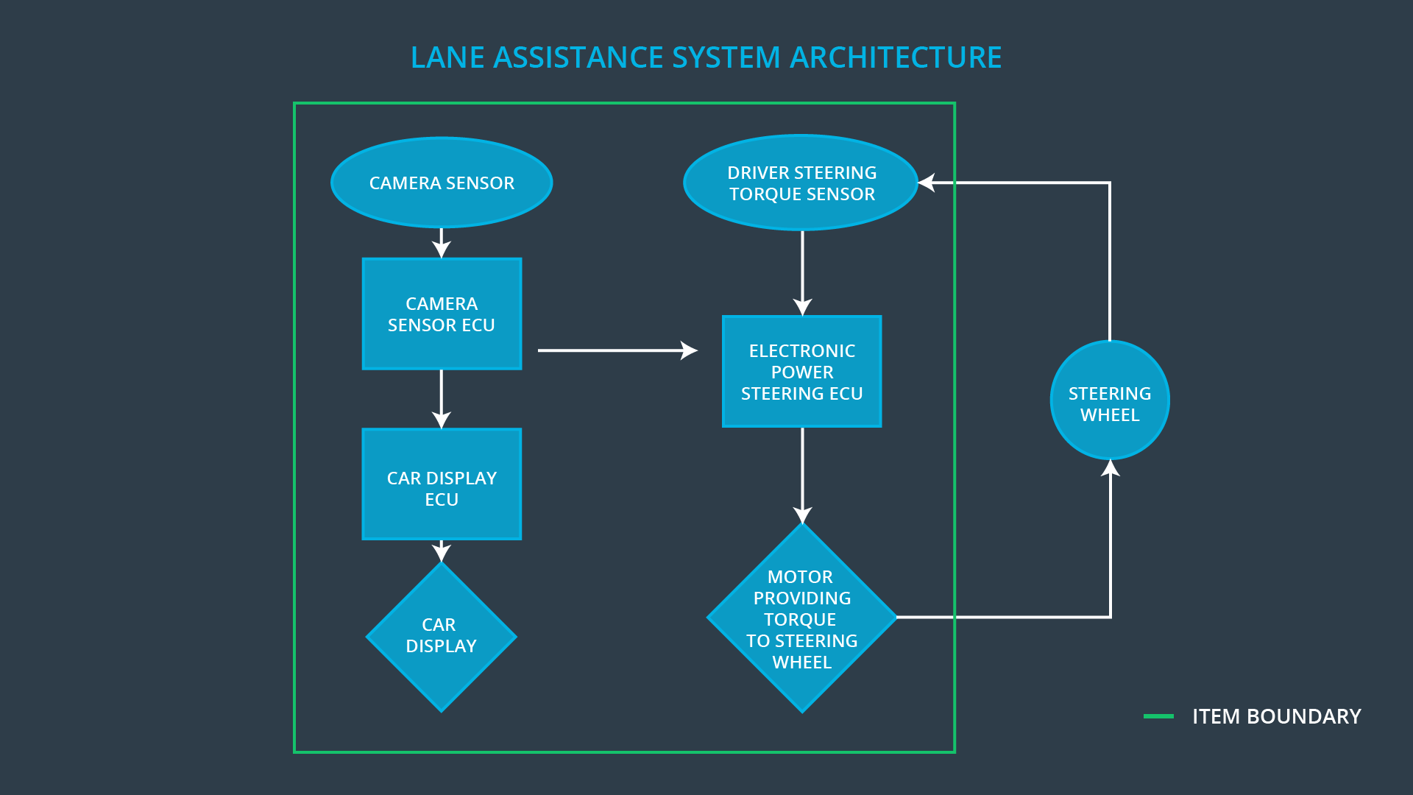

### Description of architecture elements

**[Instructions: Provide a description for each of the item elements; what is each element's purpose in the lane assistance item? ]**

|  |  |
| --- | --- |
| **Element** | **Description** |
| Camera Sensor | Capture road images and provide them to the Camera Sensor ECU. |
| Camera Sensor ECU | Analyze provided images to calculate the car position on the road respect to the road lanes. |
| Car Display | Provide feedback to the driver displaying warnings and the Lane Departure Assistance status. |
| Car Display ECU | Drive the Car Display component to show the Lane Keeping Assistance warning and Lane Departure Assistance status. |
| Driver Steering Torque Sensor | Measure the torque applied to the steering wheel by the driver. |
| Electronic Power Steering ECU | Use the information received from the Driver Steering Torque Sensor and the torque requested by the Lane Keeping Assistance and Lane Warning and requests the necessary torque to be applied by the Motor actuator. |
| Motor | Applies the torque indicated by the Electronic Power Steering ECU to the steering wheel. |

# Functional Safety Concept

The functional safety concept consists of:

* Functional safety analysis
* Functional safety requirements
* Functional safety architecture
* Warning and degradation concept

## Functional Safety Analysis

**[Instructions: Fill in the functional safety analysis table below.]**

|  |  |  |  |
| --- | --- | --- | --- |
| **Malfunction ID** | **Main Function of the Item Related to Safety Goal Violations** | **Guidewords (NO, WRONG, EARLY, LATE, MORE, LESS)** | **Resulting Malfunction** |
| Malfunction_01 | Lane Departure Warning (LDW) function shall apply an oscillating steering torque to provide the driver a haptic feedback | MORE | The Lane Departure Warning function applies an oscillating torque with very high torque amplitude (above limit) |
| Malfunction_02 | Lane Departure Warning (LDW) function shall apply an oscillating steering torque to provide the driver a haptic feedback | MORE | The Lane Departure Warning function applies an oscillating torque with very high torque frequency (above limit) |
| Malfunction_03 | Lane Keeping Assistance (LKA) function shall apply the steering torque when active in order to stay in ego lane | NO | The Lane Keeping Assistance function is not limited in time duration which lead to misuse as an autonomous driving function. |

## Functional Safety Requirements

**[Instructions: Fill in the functional safety requirements for the lane departure warning ]**

Lane Departure Warning (LDW) Requirements:

|  |  |  |  |  |
| --- | --- | --- | --- | --- |
| **ID** | **Functional Safety Requirement** | **ASIL** | **Fault Tolerant Time Interval** | **Safe State** |
| Functional  Safety  Requirement  01-01 | The Lane Departure Warning item shall ensure that the lane departure oscillating torque amplitude is below Max_Torque_Amplitude. | C | 50 ms | Vibration torque amplitude below Max_Torque_Amplitude. |
| Functional  Safety  Requirement  01-02 | The Lane Departure Warning item shall ensure that the lane departure oscillating torque frequency is below Max_Torque_Frequency. | C | 50 ms | Vibration frequency is below Max_Torque_Frequency. |
| Functional Safety Requirement  01-03 | The Lane Departure Warning function shall be deactivated when the camera sensor stop working. | C | 10 ms | Function is deactivated. |

Lane Departure Warning (LDW) Verification and Validation Acceptance Criteria:

|  |  |  |
| --- | --- | --- |
| **ID** | **Validation Acceptance**  **Criteria and Method** | **Verification Acceptance**  **Criteria and Method** |
| Functional  Safety  Requirement  01-01 | Validate Max_Torque_Amplitude chosen is high enough to be detected by a driver while low enough not to cause loss of steering | Verify the system does turn off if the Lane Departure Warning exceeded Max_Torque_Amplitude. |
| Functional  Safety  Requirement  01-02 | Validate Max_Torque_Frequency chosen is adequate to be detected by the driver and not cause the loss of steering. | Verify the system does turn off if the Lane Departure Warning exceeded Max_Torque_Frequency. |
| Functional Safety Requirement 01-03 | Validate Lane Departure Warning is off when the camera sensor is not working. | Verify the Lane Departure Warning is never on when the camera sensor is not working. |

**[Instructions: Fill in the functional safety requirements for the lane keeping assistance]**

Lane Keeping Assistance (LKA) Requirements:

|  |  |  |  |  |
| --- | --- | --- | --- | --- |
| **ID** | **Functional Safety Requirement** | **ASIL** | **Fault Tolerant Time Interval** | **Safe State** |
| Functional  Safety  Requirement  02-01 | The electronic power steering ECU shall ensure that the Lane Keeping Assistance torque is applied only Max_Duration. | B | 500 ms | Lane Keeping Assistance torque is zero. |
| Functional Safety Requirement 02-02 | The Lane Keeping assistance shall be deactivated when the electronic power steering ECU detects the camera sensor is not working. | C | 10 ms | Function is deactivated. |

Lane Keeping Assistance (LKA) Verification and Validation Acceptance Criteria:

|  |  |  |
| --- | --- | --- |
| **ID** | **Validation Acceptance**  **Criteria and Method** | **Verification Acceptance**  **Criteria and Method** |
| Functional  Safety  Requirement  02-01 | Validate the Max_Duration chosen not allow the driver to use the car as self-driving car. | Verify the system does deactivate if the Lane Keeping Assistance torque application exceeded Max_Duration. |
| Functional Safety Requirement 02-02 | Validate the Lane Keeping assistance shall be deactivated when the camera sensor stop working. | Verify the system does deactivate the Lane Keeping Assistance if the camera sensor is not working. |

## Refinement of the System Architecture

**[Instructions: Include the refined system architecture. Hint: The refined system architecture should include the system architecture from the end of the functional safety lesson including all of the ASIL labels.]**

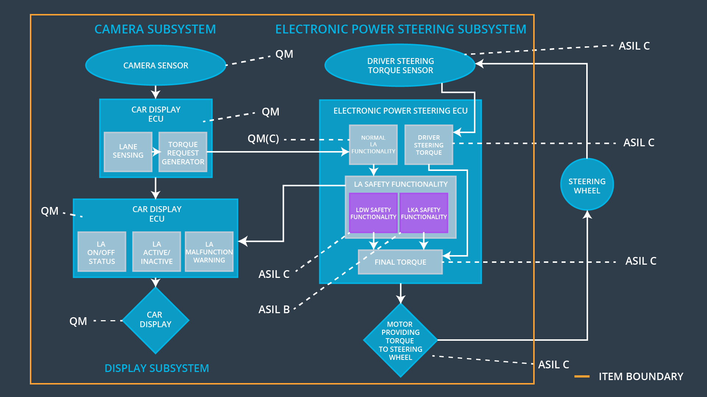

## Allocation of Functional Safety Requirements to Architecture Elements

**[Instructions: Mark which element or elements are responsible for meeting the functional safety requirement. Hint: Only one ECU is responsible for meeting all of the requirements.]**

|  |  |  |  |  |
| --- | --- | --- | --- | --- |
| **ID** | **Functional Safety Requirement** | **Electronic Power Steering ECU** | **Camera ECU** | **Car Display ECU** |
| Functional  Safety  Requirement  01-01 | The Lane Departure Warning item shall ensure that the lane departure oscillating torque amplitude is below Max_Torque_Amplitude. | **X** |  |  |
| Functional  Safety  Requirement  01-02 | The Lane Departure Warning item shall ensure that the lane departure oscillating torque frequency is below Max_Torque_Frequency. | **X** |  |  |
| Functional Safety Requirement 01-03 | The Lane Departure Warning function shall be deactivated when the camera sensor stop working. | **X** |  |  |
| Functional  Safety  Requirement  02-01 | The electronic power steering ECU shall ensure that the Lane Keeping Assistance torque is applied only Max_Duration. | **X** |  |  |
| Functional Safety Requirement 02-02 | The Lane Keeping assistance shall be deactivated when the electronic power steering ECU detects the camera sensor is not working. | **X** |  |  |

## Warning and Degradation Concept

**[Instructions: Fill in the warning and degradation concept.]**

|  |  |  |  |  |
| --- | --- | --- | --- | --- |
| **ID** | **Degradation Mode** | **Trigger for Degradation Mode** | **Safe State invoked?** | **Driver Warning** |
| WDC-01 | Turn off Lane Departure Warning functionality | Malfunction_01,  Malfunction_02,  Malfunction_04 | Yes | Lane Departure Warning Malfunction Warning on Car Display |
| WDC-02 | Turn off Lane Keeping Assistance functionality | Malfunction_03,  Malfunction_05 | Yes | Lane Keeping Assistance Malfunction Warning on Car Display |