* City: Nhà của trainer, nhà của Tiến sĩ, trung tâm pokemon

+ Nhà tiến sĩ: chọn 1 trong 3 pokemon khởi đầu

+ Trung tâm pokemon: mua item, hồi máu

+ Nhà của trainer: khởi đầu

* Route 1: bụi cỏ, hồ (mewth, Eevee, Vulpix, Growlithe, Pikachu, Electrike, Voltorb, Poliwag, Feebas, Taillow, Pidgey, )

+ cắm bảng level – pokemon theo level < 5

+ hồ nước – pokemon 1 => 5

* City 2: Trung tâm pokemon, NPC trainer

+ Trung tâm pokemon: hồi máu, mua item, NPC đổi/bán pokemon

* Cave, Lake: pokemon 5 =>10

+ Cave:, lửa, normal, điện

+ Lake: nước, cỏ, bay

* Route 2: 6 hệ 10 => 15
* Victory road: NPC trainer and Champion House: Tứ đại thiên vương + Champion

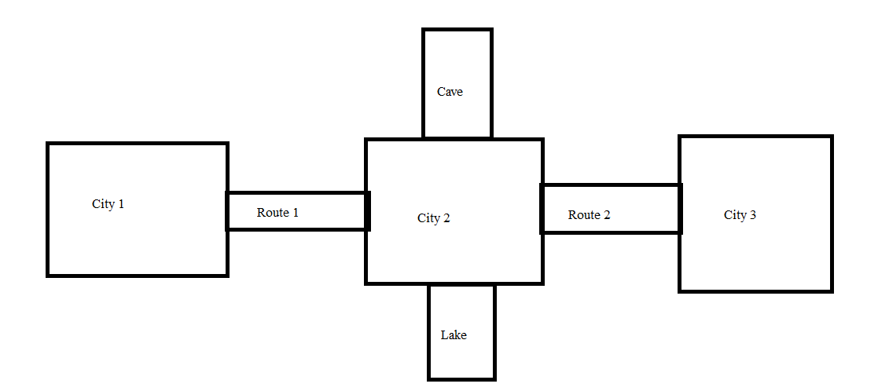

Trainer:

- Chọn nam nữ

- Chứa 6 pokemon

- 3 loại item:

+ đá tiến hóa 3 loại: điện, lửa, nước, cỏ

+ item hồi máu pokemon: 25, 50, 100%.

+ item hồi sinh: 50%, 100%

+ item hồi pp: 10, 100%

Pokemon 7 hệ: thường, rồng, 5 hệ khắc chế lửa, điện, cỏ, nước, bay

Rồng:

* Dragonair lv 20 => Dragonite
* Salamence
* Haxorus (Garchomp)

Thường:

* Snorlax
* Meowth
* Eevee

Lửa:

* Charmender lv 10 => Charmelon + đá lửa + lv 15 => Charizard
* Vulpix + đá lửa => Ninetales
* Entei
* Growlithe + lv15 => Arcanine
* Eevee + đá lứa => Flareon

Điện:

* Pikachu ­+ đá điện => Raichu
* Raikou
* Eevee + đá điện => Jolteon
* Electrike lv 15 => Manetric
* Voltorb lv 10 => Electrode

Nước:

* Squirtle lv 10 => Wartortle + đá nước + 15 => Blastoise
* Eevee + đá nước => Vaporeon
* Poliwag lv 10 =>Poliwhirl lv 15 + đá nước => Poliwarth
* Suicune
* Feebas lv 12 => Milotic
* Greninja lv18 + đá => ash-Greninja

Cỏ:

* Eevee + đá cỏ => Leafeon
* Chikorita lv 10 => Bayleef + đá cỏ + lv 15 => Meganium
* Shaymin lv 15 => Skymine
* Celebi

Bay:

* Taillow lv 13 => Swellow
* Pidgey lv 10 => Pidgeotto lv15 =>Pidgeot
* Farfetch’d
* Beautifly

Pokemon Level: pokemon khởi đầu: lv 5

Thanh exp: + theo cấp poke đánh bại, đánh npc x2 exp theo cấp pokemon của npc

Lên Level: level khởi đầu = 2exp(+2exp mỗi cấp).