[ AppDelegate.cpp ]

연습

glview = GLViewImpl::createWithRect("ResolutionEx", Rect(0, 0, 550, 320));

실제

glview = GLViewImpl::create("ResolutionEx");

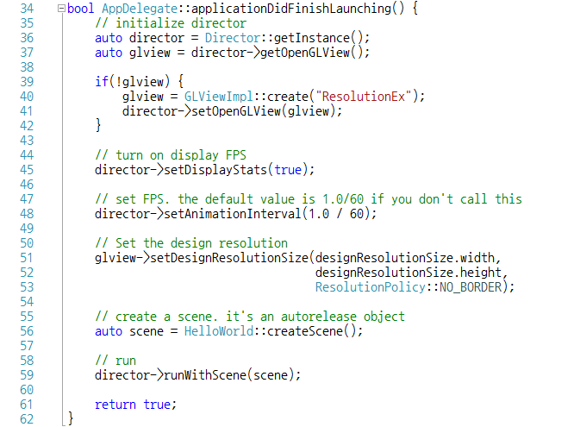

[ HelloWorld.h ]

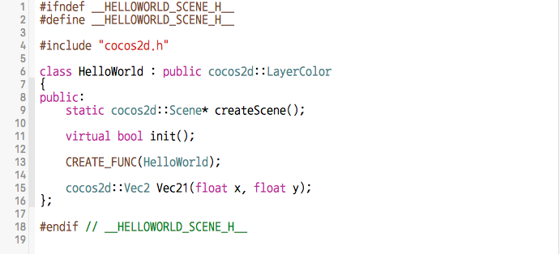

[ HelloWorld.cpp ]

