Contents
SWAP TWO VARIABLE 3
OUTPUT 3
USER INPUT 4
OUTPUT 4
GUI INPUT 6
OUTPUT 7
MATH CLASS 7
Example 7
RANDOM VALUES 9
OUTPUT 9
SWITCH CASE 10
OUTPUT 10
LOGICAL OPERATOR 11
OUTPUT 11
WHILE LOOP 12
DO WHILE LOOP 12
OUTPUT 12
FOR LOOP 13
OUTPUT 13
JAVA ARRAY 14
OUTPUT 14
JAVA 3D ARRAY 16
OUTPUT 16
JAVA STRING METHOD 17
OUTPUT 17
JAVA ARRAYLIST 18
OUTPUT 18
JAVA 2D ARRAYLIST 19
OUTPUT 19
FOREACH LOOP 20
OUTPUT 20
JAVA METHOD 21
OUTPUT 21
JAVA OVERLOADED METHOD 22
OUTPUT 22

SWAP TWO VARIABLE
package src;

public class Main{
public static void main(String args[]) {
String x = "Water";
String y = "Sand";
String temp;

temp = x;
x=y;
y=temp;

System.out.println("x: "+x);
System.out.println("y: "+y);

}

}

OUTPUT
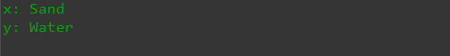
- On the above code, while we use x=y then the output of both x and y be Sand and for y=x, the output of x and y be Water.
- Therefore, to solve this issue we use a temporary variable name temp in order to set the value temporarily and use it when needed.

USER INPUT
package src;

import java.util.Scanner;

public class Main {

public static void main(String args[]) {
Scanner scan = new Scanner(System.in);

System.out.println();
System.out.println("What is your name?");
String name = scan.nextLine();

System.out.println("How old are you?");
int age = scan.nextInt();
scan.nextLine();

System.out.println("What is your favourite food?");
String food = scan.nextLine();

System.out.println("Hello, "+name);
System.out.println("Age: "+age);
System.out.println("Favourite Food: "+food);
}
}

OUTPUT
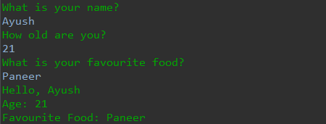
- On the below code, we take an input from the user and display it on the console.
- Whenever we take integer input, it skip the next input and show the result so to solve this problem we use scan.nextLine();

GUI INPUT
int age = JOptionPane.showInputDialog("What is your age?");
JOptionPane.showMessageDialog(null,"Your age is "+age);

- Whenever we take input using Dialog Box, we receive message as ‘String’.
- Therefore, when we use int for input, we must use Integer.parseInt() in order to convert the String value into Integer value

import javax.swing.JOptionPane;

public class Main{

public static void main(String args[]) {
String name = JOptionPane.showInputDialog("What is your name?");
JOptionPane.showMessageDialog(null,"Hello, "+name);

int age = Integer.parseInt(JOptionPane.showInputDialog("What is your age?"));
JOptionPane.showMessageDialog(null,"Your age is "+age);

String address = JOptionPane.showInputDialog("Where do you live?");
JOptionPane.showMessageDialog(null,"You live in "+address);

double height = Double.parseDouble(JOptionPane.showInputDialog("What is your height?"));
JOptionPane.showMessageDialog(null,"Your height is "+height+" cm.");

float marks = Float.parseFloat(JOptionPane.showInputDialog("What is your marks?"));
JOptionPane.showMessageDialog(null,"Your marks is "+marks+"%.");
}
}

OUTPUT

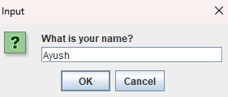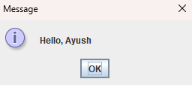
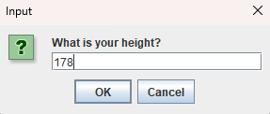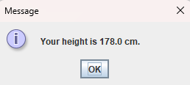

MATH CLASS
public class Main{
public static void main(String agrs[]){
double x = 5.6;
double y = -8;

double z = Math.round(x);

System.out.println("The result is "+z);
}
}

- So we can use more math classes like abs (absolute value), floor(round a floating-point number down to the nearest integer), ceil(round a floating-point number up to the nearest integer), sqrt(square root), min(minimum value), max(maximum value),etc.

Example
import java.util.Scanner;
public class Main{
public static void main(String agrs[]){
Scanner scan = new Scanner(System.in);

System.out.println("Enter the value of Perpendicular: ");
double p = scan.nextDouble();
System.out.println("Enter the value of Base: ");
double b = scan.nextDouble();

double z = Math.sqrt((p*p)+(b*b));

System.out.println("The value of Hypotenuse is "+z);

scan.close();

}
}

RANDOM VALUES
import java.util.Random;

public class Main{
public static void main(String args []) {

Random random = new Random();

int x = random.nextInt();
double y = random.nextDouble();
boolean z = random.nextBoolean();

System.out.println(x);
System.out.println(y);
System.out.println(z);

}
}

- Above code shows the random number or values.
- For the limited no of random values, we use code written below.
int x = random.nextInt(6)+1;
- The limited no. of the above code is 6 from 0 to 5. Therefore, while we roll for dice we need value from 1-6 hence we added +1 at the last.

OUTPUT

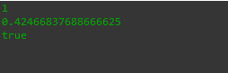

SWITCH CASE
public class Main{
public static void main(String args []) {

String day = "Wednesday";

switch(day) {

case "Sunday" : System.out.println("It is Sunday.");
break;

case "Monday" : System.out.println("It is Monday.");
break;

case "Tuesday" : System.out.println("It is Tuesday.");
break;

case "Wednesday" : System.out.println("It is Wednesday.");
break;

case "Thursday" : System.out.println("It is Thursday.");
break;

case "Friday" : System.out.println("It is Friday.");
break;

case "Saturday" : System.out.println("It is Saturday.");
break;

default : System.out.println("That is not a day.");
}
}
}

- If we do not use break after each case then then it prints the matched case along with upcoming cases.

OUTPUT
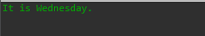

LOGICAL OPERATOR
import java.util.Scanner;

class Main
{
public static void main(String args [])
{
Scanner scan = new Scanner(System.in);

System.out.println("You are plaing a game. Press q or Q to quit.");
String response = scan.next();

if(response.equals("q") || response.equals("Q"))
{
System.out.println("You quit the game.");
}
else
{
System.out.println("You are still playing the game.");
}
}

}

- Here, the entry from the user is compared and if the condition is true then it executes the code written inside the if condition.
- Logical Operators are && (AND Operator), || (OR Operator) and ! (NOT Operator)

OUTPUT
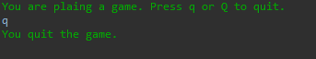

WHILE LOOP
import java.util.Scanner;

class Main
{
public static void main(String args [])
{
Scanner scan = new Scanner(System.in);
String response = "";

while(response.isBlank())
{
System.out.println("Enter your name: ");
response = scan.nextLine();
}
System.out.println("Hello, " + response);
}

}

DO WHILE LOOP
do
{
System.out.println("Enter your name: ");
response = scan.nextLine();
}while(response.isBlank());

OUTPUT
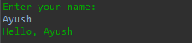

FOR LOOP
import java.util.Scanner;

class Main
{
public static void main(String args [])
{
Scanner scan = new Scanner(System.in);

for(int i=5 ; i>0 ; i--) {
System.out.println(i);
}
System.out.println("Happy Birthday.");
}

}

OUTPUT
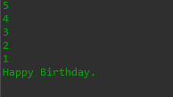

JAVA ARRAY
import java.util.Scanner;

class Main
{
public static void main(String args [])
{
String[] fruits = {"Apple" , "Banana" , "Mango" , "Orange"};
fruits[0] = "Grapes";
for(int i=0; i<fruits.length ; i++) {

System.out.println(fruits[i]);

}
}

}

- Arrays can be declared using following way as well.
String[] fruits = new String[4];
fruits[0] = "Grapes";
fruits[1] = "Banana";
fruits[2] = "Mango";
fruits[3] = "Orange";

OUTPUT
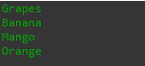

JAVA 3D ARRAY
public class Main {

public static void main(String[] args) {
String[][] cars = {
{"Camaro","Corvette","Silverado"},
{"Mustang","Ranger","F-150"},
{"Ferrari","Lambo","Tesla"}};
/*
String[][] = new String[3][3];
cars[0][0] = "Camaro";
cars[0][1] = "Corvette";
cars[0][2] = "Silverado";
cars[1][0] = "Mustang";
cars[1][1] = "Ranger";
cars[1][2] = "F-150";
cars[2][0] = "Ferrari";
cars[2][1] = "Lambo";
cars[2][2] = "Tesla";
*/
for(int i=0; i<cars.length; i++) {
System.out.println();
for(int j=0; j<cars[i].length; j++) {
System.out.print(cars[i][j]+" ");
}
}
}
}

OUTPUT

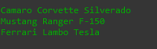

JAVA STRING METHOD
public class Main {

public static void main(String[] args) {
String name1 = "Ayush";
String name2 = " Ayush ";
boolean result1 = name1.equals("ayush");
boolean result2 = name1.equalsIgnoreCase("ayush");
//It shows the character lies on the specified index.
char result3 = name1.charAt(2);
//If unknown character is send then it give -1 as result.
int result4 = name1.indexOf("h");
boolean result5 = name1.isEmpty();
String result6 =name1.toUpperCase();
String result7 =name1.toLowerCase();
String result8 =name2.trim();
String result9 =name1.replace('s','S');
System.out.println(result1);
System.out.println(result2);
System.out.println(result3);
System.out.println(result4);
System.out.println(result5);
System.out.println(result6);
System.out.println(result7);
System.out.println(result8);
System.out.println(result9);
}
}

OUTPUT
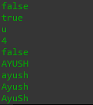

JAVA ARRAYLIST
import java.util.ArrayList;
public class Main {

public static void main(String[] args) {
ArrayList<String> food = new ArrayList<String>();
food.add("Pizza");
food.add("Momo");
food.add("Burger");
food.add("Paneer");

// below method is used to replace the Array Element on the specified index
// food.set(1, "Chicken Curry");
// below method is used to remove or delete the Array Element of the specified index
// food.remove(3);
// below method is used to remove or delete all the Array Elements from the Array List
// food.clear();
for(int i=0 ; i<food.size() ; i++) {
System.out.println(food.get(i));
}
}
}

OUTPUT

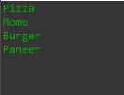

JAVA 2D ARRAYLIST
import java.util.ArrayList;
public class Main {

public static void main(String[] args) {
ArrayList<ArrayList<String>> electronicDevice = new ArrayList<ArrayList<String>>();
ArrayList<String> laptop = new ArrayList<String>();
laptop.add("Dell Inspiron 3565");
laptop.add("Acer Nitro 5");
laptop.add("Lenovo Legion");
ArrayList<String> headphone = new ArrayList<String>();
headphone.add("Sony");
headphone.add("boAt");
headphone.add("JBL");
ArrayList<String> keyboard = new ArrayList<String>();
keyboard.add("Ajazz");
keyboard.add("FanTech");
keyboard.add("Razer");
electronicDevice.add(laptop);
electronicDevice.add(headphone);
electronicDevice.add(keyboard);
System.out.println(electronicDevice.get(0).get(2));
}
}

OUTPUT

FOREACH LOOP
package src;

//import java.util.ArrayList;

public class Main{
public static void main(String args []) {
String[] animals = {"Dog", "Cat", "Rat", "Snake" };

// ArrayList<String> animals = new ArrayList<String>();
// animals.add("Dog");
// animals.add("Cat");
// animals.add("Cow");
// animals.add("Ox");

for(String i:animals) {
System.out.println(i);
}
}
}

OUTPUT
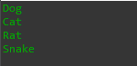

JAVA METHOD
public class Main {

public static void main(String[] args) {
// method = a block of code that is executed whenever it is called upon
int x = 3;
int y = 4;
int z = add(x,y);

System.out.println(z);
}

static int add(int x, int y) {
int z = x + y;
return z;
}
}

- Since, we are trying to call non-static method add(int x, int y) from the static method main() so we must use static keyword in front of the method named add(int x, int y).
- Note:[void doesn’t return the value.]

OUTPUT

JAVA OVERLOADED METHOD
public class Main {

public static void main(String[] args) {
// overloaded methods = methods that share the same name but have different parameters
// method name + parameters = method signature
double x = add(1.0,2.0,3.0,4.0);
System.out.println(x);
}

static int add(int a, int b) {
System.out.println("This is overloaded method #1");
return a + b;
}

static int add(int a, int b, int c) {
System.out.println("This is overloaded method #2");
return a + b + c;
}

static int add(int a, int b, int c, int d) {
System.out.println("This is overloaded method #3");
return a + b + c + d;
}

static double add(double a, double b) {
System.out.println("This is overloaded method #4");
return a + b;
}

static double add(double a, double b, double c) {
System.out.println("This is overloaded method #5");
return a + b + c;
}

static double add(double a, double b, double c, double d) {
System.out.println("This is overloaded method #6");
return a + b + c + d;
}
}

OUTPUT
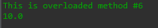

JAVA printf
public class Main {

public static void main(String[] args) {

// printf() = an optional method to control, format, and display text to the console window
// two arguments = format string + (object/variable/value)
// % [flags] [precision] [width] [conversion-character]

boolean myBoolean = true;
char myChar = '@';
String myString = "Bro";
int myInt = 50;
double myDouble = 1000;

// [conversion-character]
System.out.printf("%b\n",myBoolean);
System.out.printf("%c\n",myChar);
System.out.printf("%s\n",myString);
System.out.printf("%d\n",myInt);
System.out.printf("%f\n",myDouble);

//[width]
// minimum number of characters to be written as output
System.out.printf("Hello %10s\n",myString);

//[precision]
// sets number of digits of precision when outputting floating-point values
System.out.printf("You have this much money %.1f\n",myDouble);

// [flags]
// adds an effect to output based on the flag added to format specifier
// - : left-justify
// + : output a plus ( + ) or minus ( - ) sign for a numeric value
// 0 : numeric values are zero-padded
// , : comma grouping separator if numbers > 1000

System.out.printf("You have this much money %,f\n",myDouble);
}
}

OUTPUT
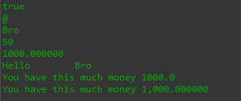

JAVA FINAL KEYWORD
public class Main {

public static void main(String[] args) {

final int num1 = 50;
// num1 = 55;
System.out.println(num1);
}
}

- Final keyword is used to initialize the variable permanently.

JAVA OBJECTS (OOP)
Main Class
public class Main {

public static void main(String[] args) {
Car myCar1 = new Car();
Car myCar2 = new Car();

System.out.println(myCar1.make);
System.out.println(myCar1.model);

System.out.println();
System.out.println(myCar1.make);
System.out.println(myCar1.model);

System.out.println();
myCar1.drive();
myCar1.brake();
}
}

Car Class
public class Car {

String make = "Chevrolet";
String model = "Corvette";
int year = 2020;
String color = "blue";
double price = 50000.00;

void drive() {
System.out.println("You drive the car");
}

void brake() {
System.out.println("You step on the brakes");
}
}

OUTPUT
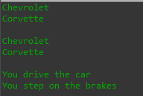

JAVA CONSTRUCTOR
Main Class
public class Main {

public static void main(String[] args) {
Human human1 = new Human("Ayush",21,68.5);
Human human2 = new Human("Muskan",12,55.5);
human1.eat();
human2.drink();
}
}

Human Class
public class Human {

String name;
int age;
double weight;
Human(String name, int age, double weight){
this.name = name;
this.age = age;
this.weight = weight;
}
void eat(){
System.out.println(this.name + " is eating Pizza.");
}
void drink() {
System.out.println(this.name + " is not allowed to drink Alcohol as his age is " + this.age);
}
}

OUTPUT
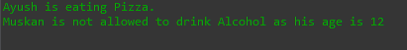

LOCAL AND GLOBAL VARIABLE

Main Class
public class Main {

public static void main(String[] args) {
//local = declared inside a method
// visible only to that method
//global = declared outside a method, but within a class
// visible to all parts of a class
DiceRoller diceRoller = new DiceRoller();
}
}

DiceRoller Class
import java.util.Random;

public class DiceRoller {
Random random;
int number;
DiceRoller(){
random = new Random();
roll();
}
void roll() {
number = random.nextInt(6)+1;
System.out.printf("The obtained rolled point is %d.",number);
}
}

OUTPUT

JAVA OVERLOADED CONSTRUCTOR
Main Class
public class Main {

public static void main(String[] args) {
Pizza pizza = new Pizza("thick crust","tomato","mozzerella","paneer");
System.out.println("Here are the ingredients of your pizza: ");
System.out.println(pizza.bread);
System.out.println(pizza.sauce);
System.out.println(pizza.cheese);
System.out.println(pizza.toppings);
}
}

Pizza Class
public class Pizza{
String bread;
String sauce;
String cheese;
String toppings;
Pizza(){
}
Pizza(String bread){
this.bread= bread;
}
Pizza(String bread, String sauce){
this.bread = bread;
this.sauce = sauce;
}
Pizza(String bread, String sauce, String cheese){
this.bread = bread;
this.sauce = sauce;
this.cheese = cheese;
}
Pizza(String bread, String sauce, String cheese, String toppings){
this.bread = bread;
this.sauce = sauce;
this.cheese = cheese;
this.toppings = toppings;
}
}

- On the above code, the output will be given according to the no. of arguments passed.

OUTPUT
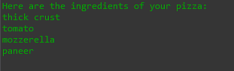

JAVA toString METHOD
Main Class
public class Main {

public static void main(String[] args) {
Laptop laptop = new Laptop("Dell","Inspiron 3565","512GB NVMe",75000.5);
System.out.println(laptop);
}
}

Laptop Class
public class Laptop{
String brand;
String model;
String storage;
double price;
public Laptop(String brand, String model, String storage, double price) {
this.brand = brand;
this.model = model;
this.storage = storage;
this.price = price;
}
public String toString(){
return "Brand : " + brand + "\nModel : " + model + "\nStorage : " + storage + "\nPrice : "+ price;
}
}

OUTPUT
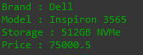

JAVA ARRAY OF OBJECTS
Main Class
// Note: Commented lines is alternative way to declare the array of objects
public class Main {

public static void main(String[] args) {
// Food[] lunchbox = new Food[3];
Food food1 = new Food("Daal");
Food food2 = new Food("Vaat");
Food food3 = new Food("Tarkari");

Food[] lunchbox = {food1,food2,food3};

// lunchbox[0] = food1;
// lunchbox[1] = food2;
// lunchbox[2] = food3;

System.out.println(lunchbox[0].name);
System.out.println(lunchbox[1].name);
System.out.println(lunchbox[2].name);
}
}

Food Class
public class Food{
String name;
public Food(String name) {
this.name = name;
}
}

OUTPUT
