ASSIGNMENT 3
(SCHEDULING)
- First Come First Serve Scheduling
CODE

Name: Pawan Gangwar
Roll No: 2301410024
Course: BTech CSE (Cyber
Security)

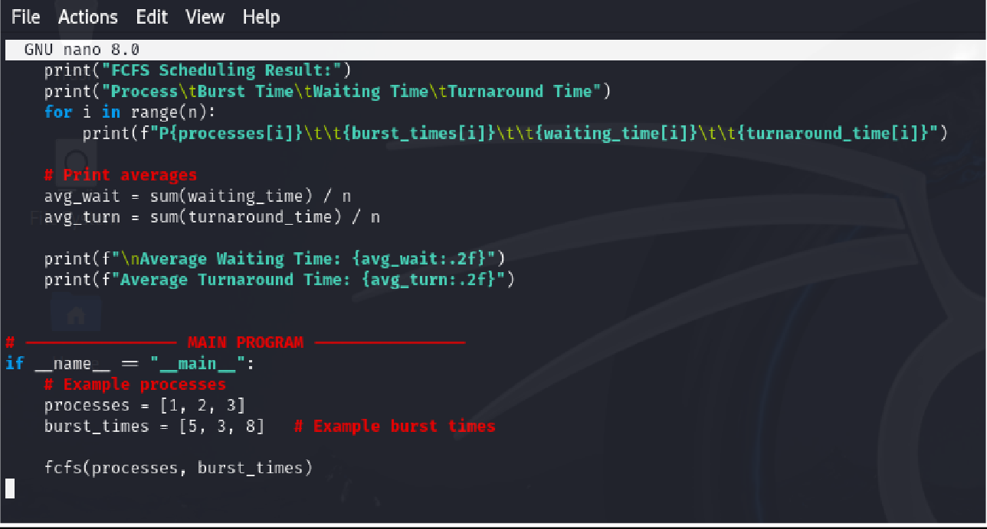

OUTPUT

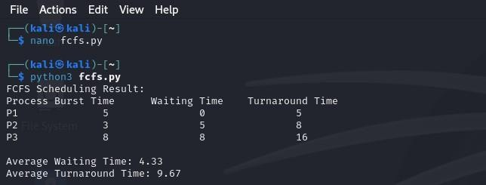
- SJF (Shortest Job First)
CODE

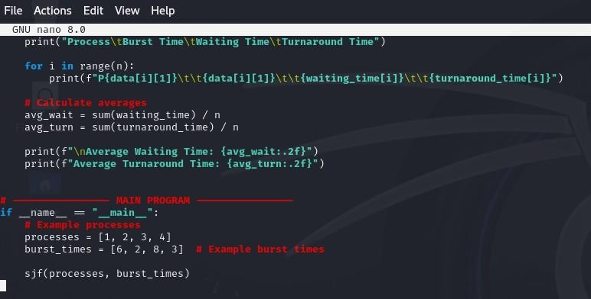

OUTPUT

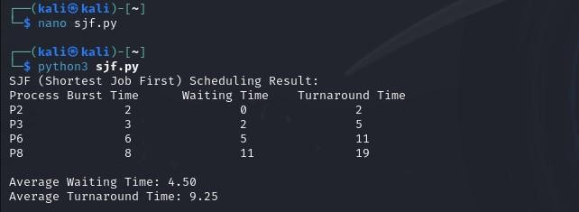
- Robin Round
CODE

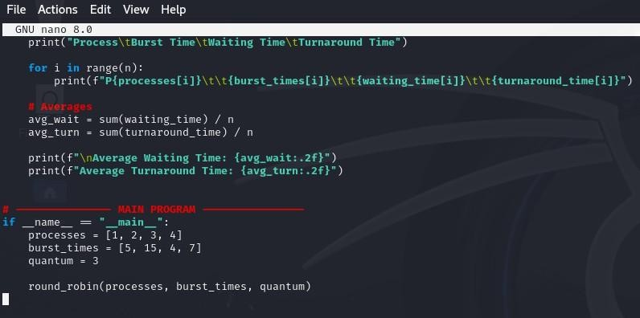

OUTPUT

