A System-Level EMC Simulation Platform for Vehicle-Mounted LEO Satellite Communications with Worst-Case Interference Search
SCI-style manuscript draft (author names, affiliations, and funding information to be completed)
Author information to be completed
Note: This manuscript is organized from archived engineering outputs. The structure, figures, and numerical results have been adapted to a journal-style format, while author, affiliation, funding, and data-sharing statements can be completed before submission.

Abstract
LEO satellite communications are becoming an important infrastructure option for wide-area vehicular coverage and integrated space-air-ground networking. However, most existing studies treat link budgeting, spectral coexistence, or interference recognition separately and do not provide an engineering-oriented platform that jointly covers scenario construction, joint-link evaluation, EMC criteria, worst-case search, and diagnostic outputs. This paper develops a system-level EMC simulation platform for vehicle-mounted LEO satellite communications. Using satelliteScenario as the geometric and orbital engine, the platform integrates downlink/uplink power precomputation, end-to-end routing and delay estimation, EMC threshold checking, worst-case interference search based on InfoGAN and a genetic algorithm, and an auxiliary interference-identification branch based on STFT and LeNet. A case study with a 1200 km, 53 deg, 12x8 constellation and six jammers is simulated over one orbital period (109.33 min) with a 10 s step. In the Baseline scenario, the mean end-to-end throughput is 73.99 Mbps with zero outage. In the Worst-case scenario, the mean end-to-end throughput drops to 50.57 Mbps, corresponding to a 31.66% reduction, while the outage ratio increases to 21.65%. The uplink is notably more sensitive than the downlink: its mean throughput decreases from 75.69 Mbps to 52.62 Mbps and its outage ratio reaches 20.73%, compared with 4.42% on the downlink. The results show that the platform can jointly expose communication performance, EMC thresholds, and interference interpretation within one unified results chain, thereby supporting design studies, parameter sweeps, worst-case pre-assessment, and laboratory validation planning.
Keywords: LEO satellite communications; vehicle-mounted terminal; electromagnetic compatibility; worst-case search; interference identification; system-level simulation

1 Introduction
Low Earth Orbit (LEO) satellite communications are becoming a key enabler for wide-area vehicular access and integrated space-air-ground networking because of their lower propagation delay, broad coverage, and compatibility with future non-terrestrial networks (NTNs).[1],[2] Compared with conventional geostationary systems, however, NGSO/LEO systems exhibit substantially higher complexity in time-varying geometry, inter-satellite topology, handover management, and spectrum coexistence. Consequently, static link-budget analysis alone is no longer sufficient for engineering validation.[1],[2]
Existing studies are largely distributed across three separate streams. The first stream focuses on LEO/NGSO architectures, access mechanisms, and system-level modeling, including comprehensive NGSO surveys and LEO access network studies for 6G.[1],[2] The second stream centers on coexistence and interference mitigation, such as NGSO-GSO coexistence, L/S-band cochannel interference, and uplink interference suppression strategies.[4]-[6],[8] The third stream investigates interference recognition and intelligent diagnosis using deep learning over spectrograms or RF fingerprints.[10]-[12] Yet these efforts usually target one problem at a time and rarely provide an engineering-oriented platform that covers the full chain from orbital scenario generation to EMC-oriented reporting.
For vehicle-mounted terminals, dynamic geometry, antenna pointing variation, asymmetric degradation between downlink and uplink, and worst-case assessment are particularly important. A platform that reports only average performance, but cannot identify the most critical outage windows, the dominant vulnerable link, or threshold violations over time, has limited value for laboratory validation and engineering iteration. Therefore, this paper deliberately emphasizes a unified platform and reproducible engineering outputs rather than over-claiming any individual algorithmic component as the sole novelty.
This work develops a system-level EMC simulation platform for vehicle-mounted LEO satellite communications. The platform integrates orbital and geometric scenario modeling, downlink/uplink power precomputation, end-to-end routing and delay estimation, EMC threshold checking, worst-case interference search based on InfoGAN and a genetic algorithm (GA), and an auxiliary interference-identification branch based on STFT and LeNet. The main contributions are fourfold: (1) a unified DL/UL/E2E evaluation framework for vehicular LEO scenarios; (2) a data-driven worst-case search mechanism that couples structured jammer-envelope generation with GA-based optimization; (3) a lightweight time-frequency classification branch that provides interpretable interference labels for abnormal link conditions; and (4) an engineering output chain that directly produces summary tables, compliance rows, and publication-ready visualizations.

2 Related Work

2.1 LEO/NGSO scenarios and system-level simulation
Al-Hraishawi et al. provided a comprehensive survey of NGSO communications and highlighted low propagation delay, resource management, and coexistence constraints as core issues for next-generation satellite Internet systems.[1] Xiao et al. discussed LEO satellite access networks (LEO-SAN) from the viewpoint of 6G architecture, coverage, and interference management.[2] Ma et al. proposed a connected-vehicle-oriented LEO communication simulation framework that couples satellite mobility, vehicular mobility, and network simulators for feasibility evaluation.[3] In addition, Yang et al. addressed routing in large LEO constellations and showed the importance of balancing inter-satellite forwarding with delay performance.[7] These studies provide the background for the scenario settings, routing assumptions, and vehicular application context used in this paper.
Nevertheless, the above efforts mainly target networking, access, or routing issues and do not integrate EMC constraints, worst-case interference search, and diagnostic branches into a single deliverable platform. Accordingly, this paper does not attempt to reinvent an isolated simulator; instead, it emphasizes engineering integration of geometry, power, compliance, and diagnosis for vehicle-mounted LEO communications.

2.2 Interference coexistence and EMC evaluation
Spectral coexistence between NGSO and GSO systems, EPFD limits, and cross-system interference risk remain central issues for practical deployment.[4] Pastukh et al. showed that coexistence constraints in the L- and S-bands can strongly restrict direct-to-cellular NTN deployment in bands already occupied by incumbent mobile-satellite services.[5] Zhang et al. further analyzed NTN-to-terrestrial interference in the S-band and demonstrated that the interference level strongly depends on relative geometry and separation distance.[6] From the uplink perspective, Moya Caceres et al. proposed robust null-shaping under interferer-location uncertainty, illustrating how sensitive the satellite receive side can be to external interference.[8]
Taken together, these studies suggest that an engineering-useful platform should jointly expose communication performance and EMC risk, rather than reporting only a single communications indicator. The present platform therefore links signal power, cochannel interference (CCI), jammer power, noise, SINR, throughput, outage ratio, and threshold checking into one unified results chain.

2.3 Worst-case search and interference identification
InfoGAN learns interpretable latent representations by maximizing the mutual information between latent codes and generated observations, which makes it a reasonable prior for structured jammer-envelope generation in the present platform.[9] LeNet is a classical lightweight convolutional neural network and remains an appropriate baseline when low complexity and stable deployment are preferred over model size escalation.[10] In the context of satellite interference recognition, Ujan et al. demonstrated that intelligent classifiers can jointly characterize modulation and interference type in Satcom scenarios.[11] Ozturk et al. further showed that spectrogram-based CNNs are advantageous under low-SNR conditions when compared with simpler time-series image representations.[12]
Importantly, this paper does not position InfoGAN or STFT+LeNet as standalone end goals. Instead, they are treated as platform enhancement modules: the former generates more destructive stress-test inputs, while the latter provides interpretable labels for the dominant interference pattern at critical time instants. This positioning is more appropriate for an engineering platform paper.

3 Platform Architecture and System Model

3.1 Overall platform architecture
The proposed platform is organized as a pipeline of configuration, modeling, simulation, search, identification, and compliance reporting. A unified configuration module first specifies orbital, link, jammer, threshold, and search parameters. The platform then builds the constellation scenario, precomputes downlink and uplink power terms, runs the DL/UL/E2E joint simulation, invokes InfoGAN+GA to generate a worst-case jammer envelope and rerun the scenario, and finally applies STFT+LeNet to identify interference patterns at critical time instants. The overall architecture is shown in Figure 1.
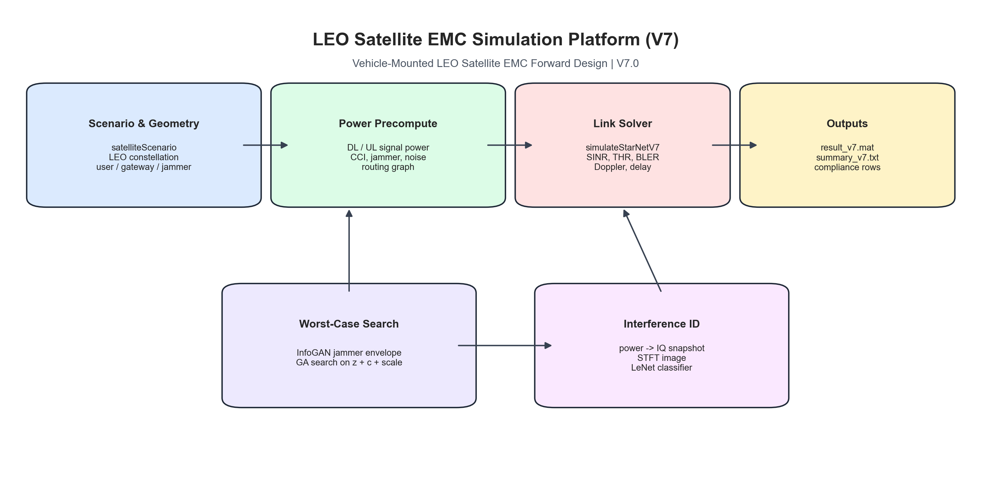
Figure 1. Overall architecture of the proposed system-level EMC simulation platform for vehicle-mounted LEO satellite communications.
This organization offers two advantages. First, the main link solver remains physically interpretable, which makes it possible to explain how each metric emerges from geometry and power evolution. Second, the worst-case search and identification modules are introduced as plug-in branches that enhance, rather than disrupt, the reproducibility and stability of the core simulation framework.

3.2 Scenario and geometry modeling
The case study adopts a Walker-type constellation at an altitude of 1200 km and an inclination of 53 deg, with 12 orbital planes and 8 satellites per plane, for a total of 96 satellites. The frequency reuse factor is 4, the number of jammers is 6, and the user and gateway ground stations are located at (36.06 deg, 120.38 deg) and (39.90 deg, 116.40 deg), respectively. The simulation step is 10 s, and the total duration spans one orbital period, approximately 109.33 min. A unified time grid drives the updates of user-visible satellites, gateway-visible satellites, and end-to-end route status so that geometric variation directly propagates into the communication metrics. Table 1 summarizes the main scenario and system parameters.

Table 1. Scenario and system parameters.
Parameter | Value
Constellation altitude | 1200 km
Orbital inclination | 53 deg
Number of orbital planes | 12
Satellites per plane | 8
Total satellites | 96
Frequency reuse factor | 4
Number of jammers | 6
User-station location | (36.06 deg, 120.38 deg)
Gateway-station location | (39.90 deg, 116.40 deg)
Sampling interval | 10 s
Simulation duration | One orbital period ≈ 109.33 min
Downlink center frequency / bandwidth | 1.5 GHz / 20 MHz
Uplink center frequency / bandwidth | 1.6 GHz / 20 MHz
Base jammer EIRP | 88 dBm
Anti-jam null depth | 40 dB

At each time step, the platform determines the visible satellite sets for the user and the gateway, and then selects the serving and gateway satellites according to visibility and link conditions. For the end-to-end path, the platform additionally estimates propagation delay from the user-to-satellite, satellite-to-gateway, and inter-satellite path lengths, so that the delay metric reflects not only the RF hop but also the geometric cost of in-orbit forwarding.

3.3 Link and EMC model
The downlink and uplink are configured with Fc=1.5 GHz and BW=20 MHz, and Fc=1.6 GHz and BW=20 MHz, respectively. For a given transmit power and propagation distance, the free-space path loss and received power are computed by (1) and (2):
L_fs(dB) = 32.44 + 20 log10(f_MHz) + 20 log10(d_km) (1)
P_rx(dBm) = EIRP_tx(dBm) - L_fs(dB) + G_rx(dBi) (2)
For reuse-induced cochannel interference and external jammer power, the platform first performs link-level precomputation and then aggregates these terms during time-domain simulation according to the serving satellite and reuse group. Let I_CCI(k) denote the aggregate cochannel interference at time step k and I_jam(k) denote the jammer aggregate power. Their core forms are written as (3) and (4):
I_CCI(k) = sum_m P_i,m(k), m in co-channel set (3)
I_jam(k) = I_jam,base(k) * 10^((JamScale_dB * jamAgg(k))/10) (4)
When anti-jam spatial nulling is active, the jammer term is further attenuated by the configured null depth. The instantaneous receive-side SINR is then given by (5):
SINR(k) = P_s(k) / (I_CCI(k) + I_jam,eff(k) + N) (5)
At the metric layer, the platform uses engineering proxy models to map SINR into BER, BLER, and throughput. To preserve simulation efficiency, throughput is computed by a truncated Shannon-type approximation and forced to zero in highly erroneous conditions. The mapping is shown in (6):
BER(k) = 0.5 * erfc(sqrt(SINR_lin(k) / 2)), THR(k) = 0 if BER>0.2 else 0.8*BW*min(log2(1+SINR_lin),6) (6)
The end-to-end throughput is defined by the weaker of the two access directions, while end-to-end delay is estimated from the user-to-satellite, satellite-to-gateway, and inter-satellite propagation distances, as expressed in (7):
THR_E2E(k) = min(THR_DL(k), THR_UL(k)), Delay_E2E(k) = (d_u-s + d_s-gw + d_ISL)/c (7)

3.4 EMC constraints and compliance reporting
Unlike a communication-only simulator that reports average rate alone, the present platform explicitly maintains EMC-oriented thresholds and engineering constraints. The core thresholds are a minimum SINR of 1 dB, a minimum throughput of 20 Mbps, a receive sensitivity of -120 dBm, and a maximum Doppler-rate magnitude of 300 Hz/s. In addition, the platform reserves Ku-link engineering entries such as EIRP, G/T, and JA3700-related checks so that compliance-style rows can be generated automatically. Table 3 summarizes the main thresholds used in this study.
Table 3. EMC thresholds and engineering constraints.
Parameter | Value
Minimum SINR | 1 dB
Minimum throughput | 20 Mbps
Receive sensitivity | -120 dBm
Maximum Doppler-rate magnitude | 300 Hz/s
Ku EIRP current / minimum | 1.20 / 1.00 dBw
Ku G/T current / minimum | -27.00 / -27.50 dB/K
JA3700 current / target level | 5 / 5

After each run, the platform automatically produces link summaries, worst-case statistics, threshold-checking rows, and visualization files. This allows the framework to support preliminary design review, parameter sweeps, and laboratory preparation, rather than serving only as an offline academic simulator.

4 Worst-Case Search and Interference Identification Modules

4.1 Worst-case search with InfoGAN and GA
In the platform, the worst-case search module first trains a lightweight InfoGAN to learn a low-dimensional representation of jammer envelopes, and then applies a GA over the latent variable z, interpretable code c, and overall amplitude factor JamScale. Compared with exhaustive parameter sweeps, this strategy can generate more structured time-varying interference inputs with lower search cost, which is well suited for system-level stress testing.
The key parameters in this study are a sequence length of 128, latent dimension 16, interpretable-code dimension 2, 250 GAN training iterations, GA population size 16, and 10 generations. The best solution yields a jammer scaling factor of 26.74 dB. To balance destructive capability and practical plausibility, the objective function jointly considers end-to-end throughput, outage ratio, mean BLER, and an energy/duty-cycle penalty, as given in (8):
f = -mean(THR_E2E) + w1*Outage + w2*mean(BLER) + w3*(Energy + 10*max(0,Duty-0.55)^2) (8)
This design prevents the optimizer from collapsing to a trivial always-on full-power jammer and instead promotes temporally structured but highly damaging stress scenarios.

4.2 STFT+LeNet auxiliary identification branch
Beyond the main simulation loop, the platform includes an auxiliary branch that maps power sequences to IQ snapshots and then to STFT images. The branch converts critical intervals into 128x128 time-frequency images and applies a LeNet-style lightweight CNN to classify four categories: none, tone, pbnj, and mod. Since the goal is interpretability rather than maximal classifier complexity, LeNet is adopted as a low-cost and stable engineering baseline.
The value of this branch is that when link performance degrades abruptly, the platform does not merely report a throughput drop; it can also provide a plausible dominant interference label, which is useful for engineering diagnosis.

4.3 Role of these modules in the overall platform
It is important to reiterate that InfoGAN+GA does not replace the main link solver; it generates more destructive input conditions for stress testing. Likewise, STFT+LeNet does not participate in throughput or delay computation; it serves as an auxiliary diagnostic branch for interpreting critical intervals. This separation ensures that the main results remain governed by physically interpretable system-level models while still benefiting from data-driven search and diagnosis capabilities.

5 Experimental Settings
The present manuscript is organized from archived engineering outputs, with the main numerical results coming from `result_v7.mat`, `summary_v7.txt`, and exported STFT artifacts. When MATLAB R2021a and the required toolboxes are available, the provided project scripts can reproduce the same workflow. Two scenarios are compared: a Baseline case without the adversarially strengthened jammer envelope, and a Worst-case scenario obtained from InfoGAN+GA search. For each scenario, Downlink, Uplink, and End-to-End links are evaluated simultaneously.
The reported metrics include mean throughput, 5th-percentile throughput, outage fraction, mean SINR, mean BLER, and mean end-to-end delay. Here, the outage fraction is defined as the time share in which throughput falls below 20 Mbps. Table 2 summarizes the parameter settings for the worst-case search and identification modules, while Table 4 in the next section reports the resulting link statistics.

Table 2. Parameter settings for the worst-case search and interference-identification modules.
Parameter | Value
GAN sequence length | 128
Latent dimension z | 16
Interpretable code dimension c | 2
GAN training iterations | 250
GA population size | 16
GA generations | 10
Classifier input size | 128 × 128 × 1
Classifier classes | none / tone / pbnj / mod
Best jammer scaling factor | 26.74 dB

6 Results and Analysis

6.1 Overall platform statistics
Table 4 reports the main statistics for the Baseline and Worst-case scenarios across the three link types, and Figure 2 provides a direct visualization of mean throughput and outage ratio.
Table 4. Core statistics of the three links under the Baseline and Worst-case scenarios.
Link | Case | Mean THR | P05 THR | Outage (%) | Mean SINR | Mean BLER | Mean delay
DL | Base | 78.97 | 58.72 | 0.00 | 15.44 | 0.037 | 37.72
DL | Worst | 75.97 | 21.25 | 4.42 | 16.61 | 0.149 | 51.46
UL | Base | 75.69 | 65.39 | 0.00 | 14.07 | 0.005 | 37.72
UL | Worst | 52.62 | 0.00 | 20.73 | 5.58 | 0.407 | 51.46
E2E | Base | 73.99 | 58.72 | 0.00 | 13.73 | 0.038 | 37.72
E2E | Worst | 50.57 | 0.00 | 21.65 | 5.13 | 0.452 | 51.46

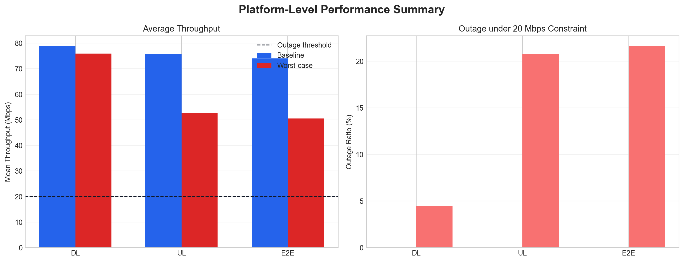
Figure 2. Comparison of mean throughput and outage ratio for the DL, UL, and E2E links under the Baseline and Worst-case scenarios.
From the end-to-end perspective, the Baseline case achieves a mean E2E throughput of 73.99 Mbps with zero outage, whereas the Worst-case scenario reduces the mean E2E throughput to 50.57 Mbps, corresponding to a relative drop of 31.66%, and increases the outage ratio to 21.65%. Meanwhile, the mean E2E delay rises from 37.72 ms to 51.46 ms, indicating that the worst-case condition affects not only link capacity but also the effective path-level transmission cost.
The asymmetry between downlink and uplink is especially revealing. The mean downlink throughput decreases only from 78.97 Mbps to 75.97 Mbps, a drop of 3.80%; however, its 5th-percentile throughput collapses from 58.72 Mbps to 21.25 Mbps and a 4.42% outage ratio appears. This means that the downlink retains considerable average redundancy while its tail risk worsens sharply. By contrast, the mean uplink throughput falls from 75.69 Mbps to 52.62 Mbps, a 30.48% reduction, and the outage ratio reaches 20.73%. The mean uplink SINR also drops from 14.07 dB to 5.58 dB, showing that the satellite receive side becomes the dominant bottleneck under the worst-case interference envelope.
One subtle but important observation is that the mean worst-case downlink SINR is slightly higher than its baseline counterpart. This occurs because the platform can still preserve favorable average link geometry through serving-satellite selection during part of the orbit. Nevertheless, the worst-case downlink minimum SINR drops to -11.18 dB and the minimum throughput becomes 0 Mbps, so the average alone masks the outage windows. This again shows why EMC evaluation cannot rely on mean values only.

6.2 Time-dynamic behavior
Figure 3 presents the throughput time series over one orbital period. In the Baseline case, all three links remain relatively stable and no segment crosses the 20 Mbps outage threshold. In the Worst-case scenario, however, the degradation is concentrated in several windows rather than being uniformly distributed over time.
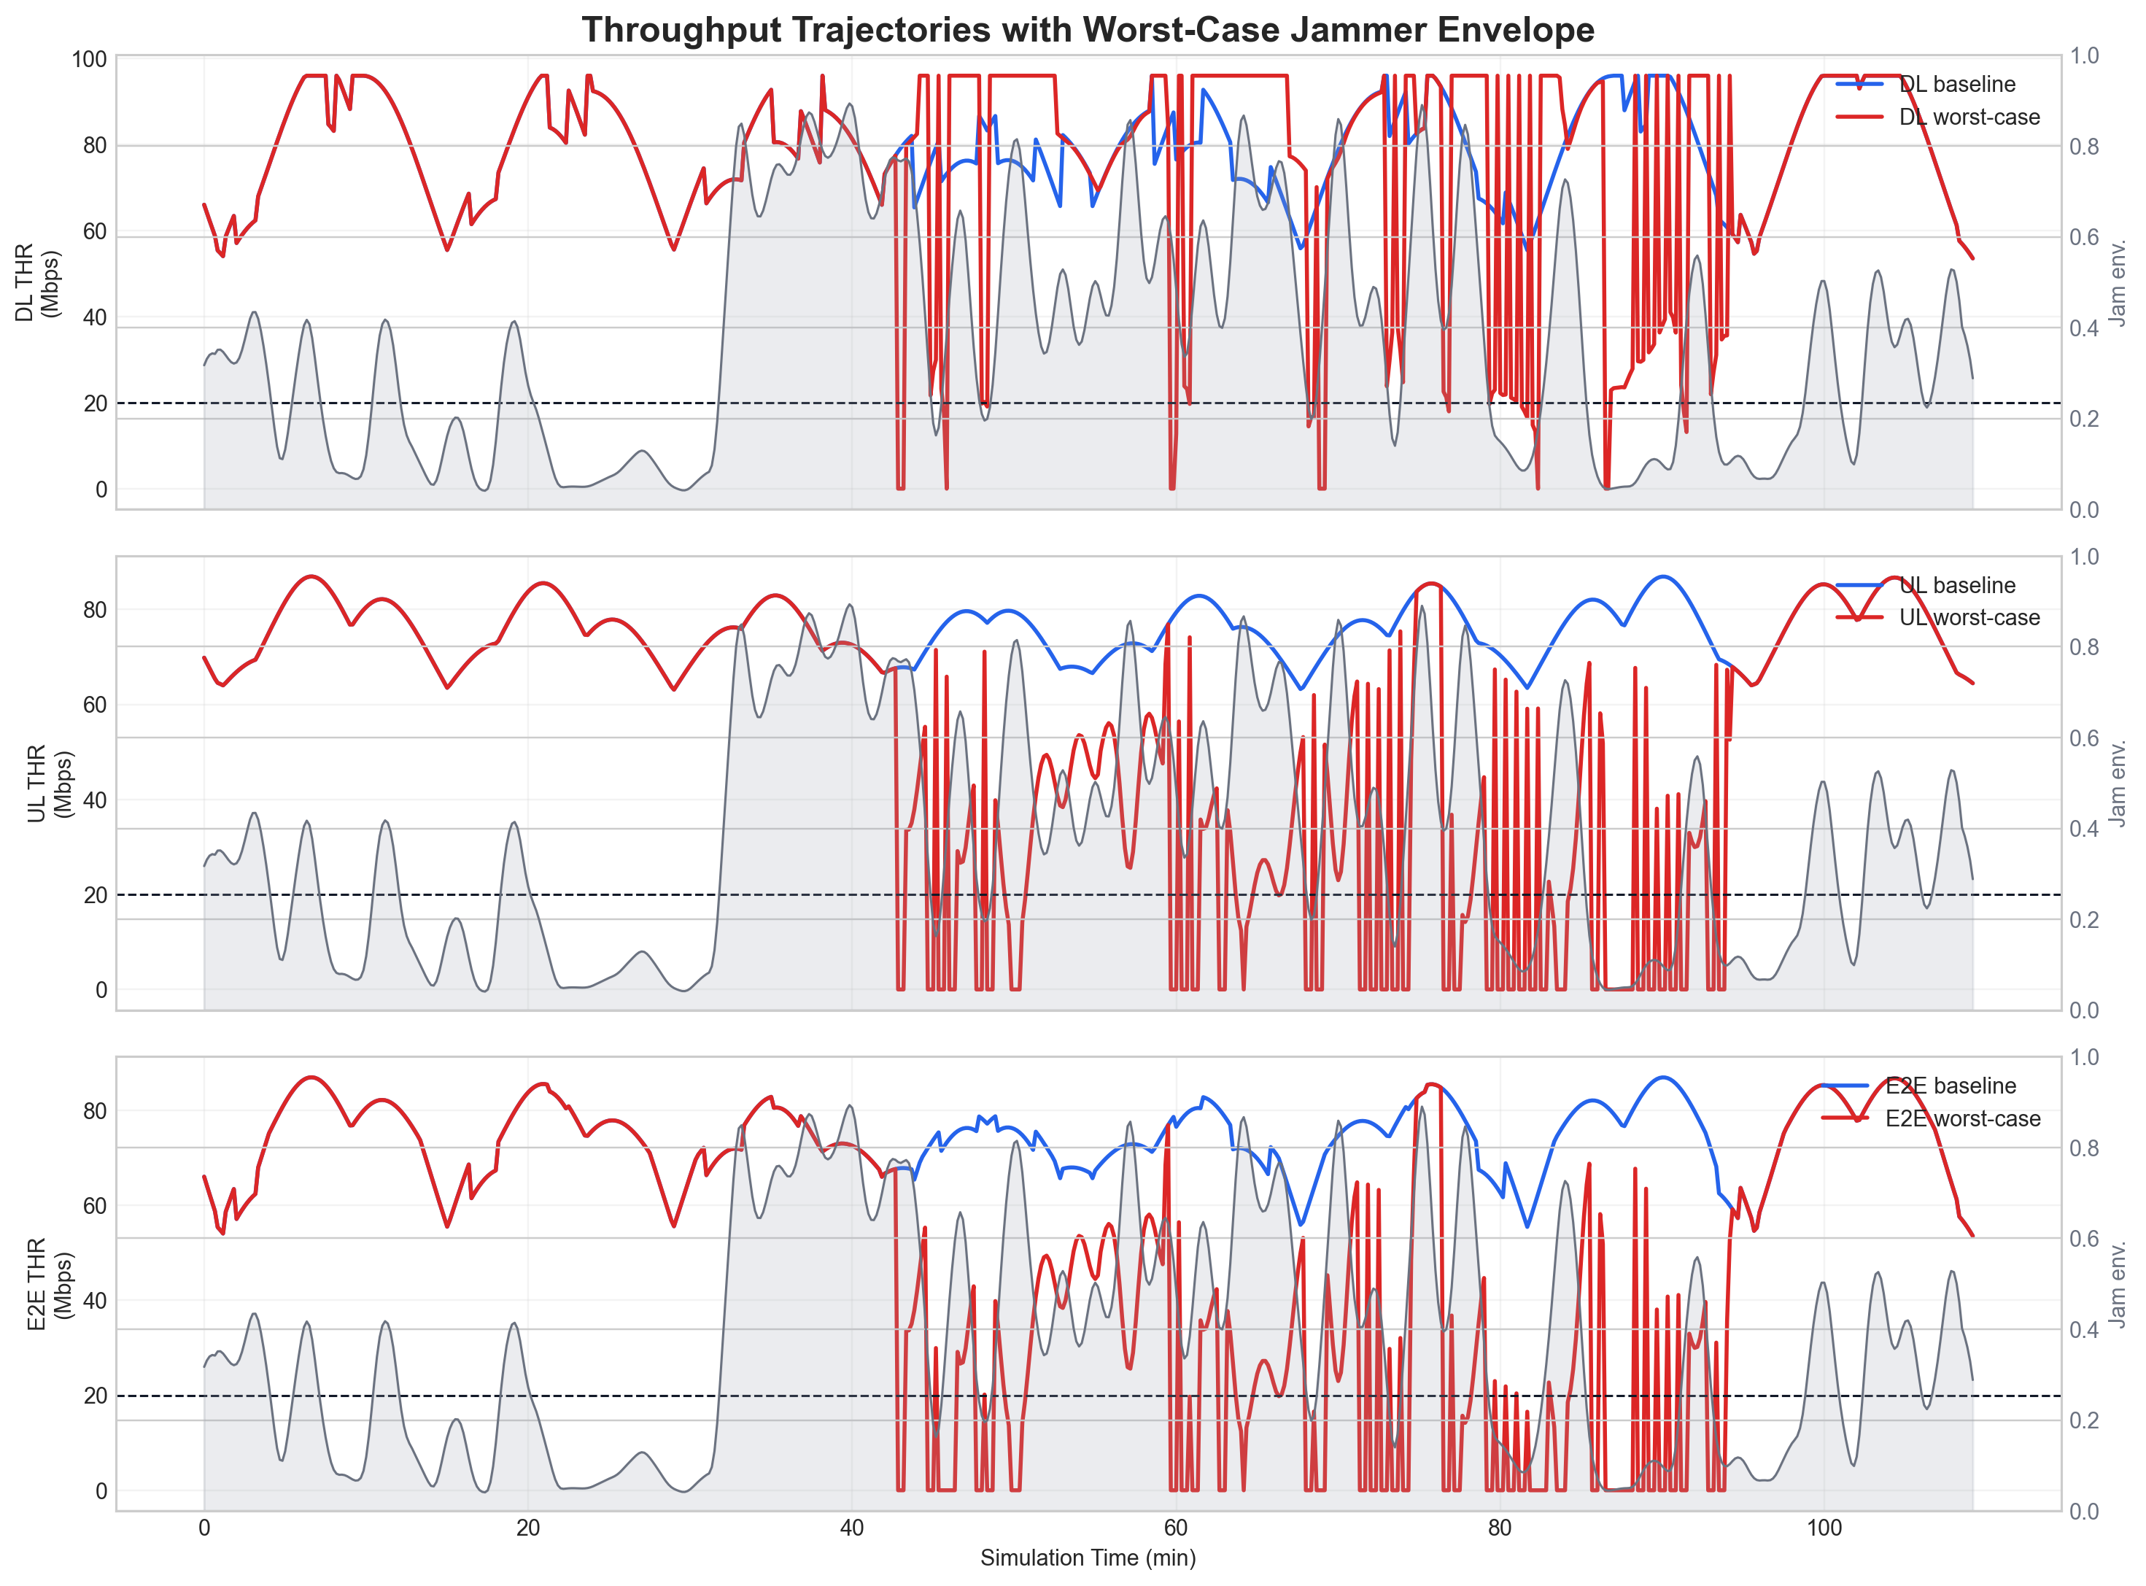
Figure 3. Throughput time series over one orbital period for the Baseline and Worst-case scenarios, together with the worst-case envelope trend.
The E2E curve repeatedly follows the uplink collapse, which is fully consistent with the end-to-end definition THR_E2E = min(THR_DL, THR_UL). In other words, the worst-case envelope does not need to destroy both directions simultaneously; it mainly drives the system into an uplink-dominated bottleneck state. Once the uplink recovers, the E2E throughput also recovers. This has direct implications for laboratory testing: if the goal is to validate resilience under the most harmful conditions, receive-side interference robustness should be prioritized over downlink-only strengthening.

6.3 Power decomposition and interference mechanism
To further explain the performance degradation in the Worst-case scenario, Figure 4 shows the power decomposition into signal, CCI, jammer, and noise terms.
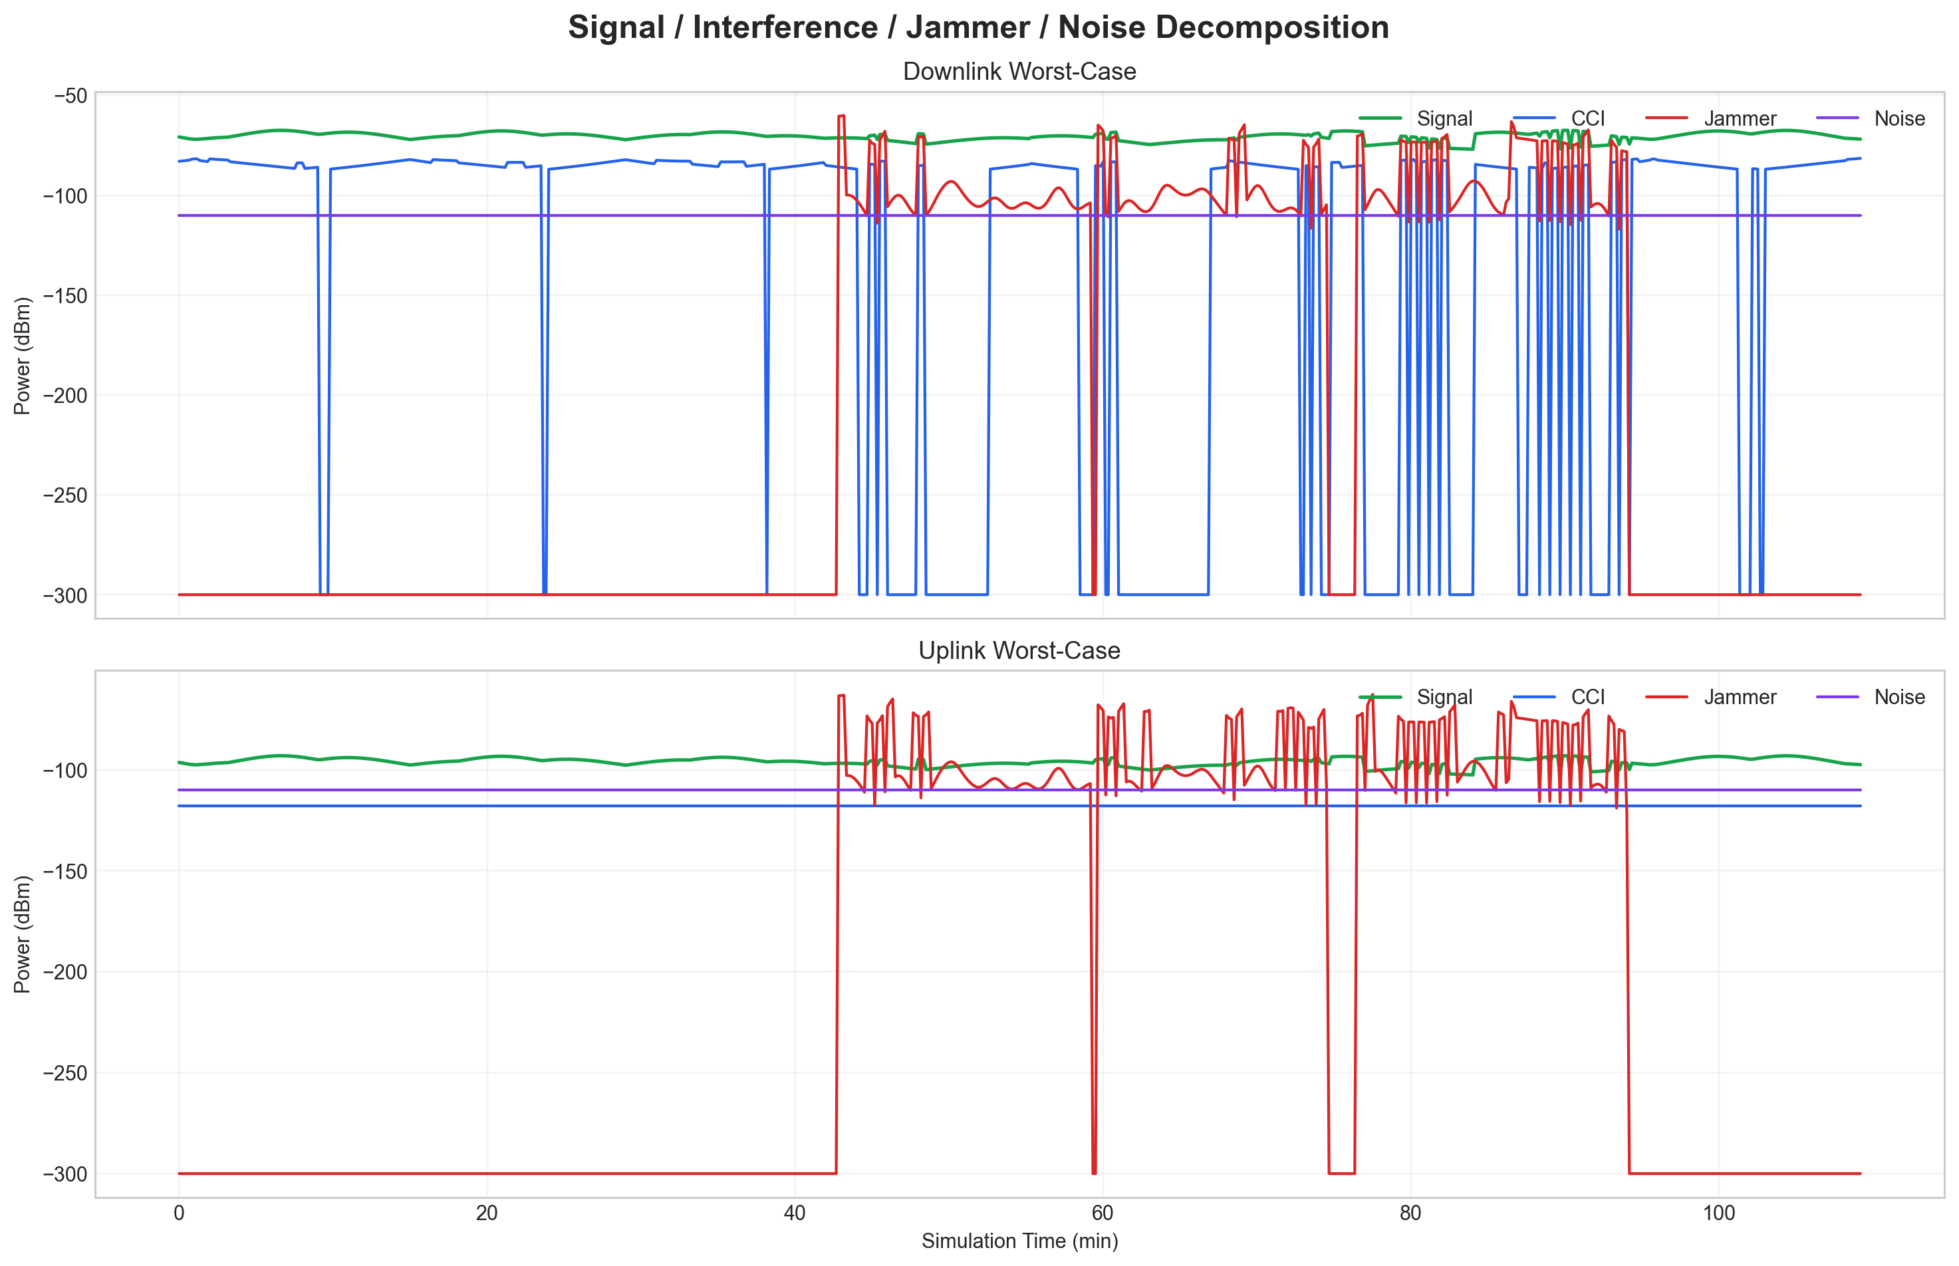
Figure 4. Power decomposition under the Worst-case scenario, including signal, CCI, jammer, and noise terms.
During several outage windows, the jammer aggregate power becomes the dominant disturbance and combines with proxy CCI to suppress SINR. On the downlink, the signal term remains comparatively strong, which explains why the mean throughput stays high in spite of short but deep degradations. On the uplink, by contrast, the signal margin is more limited, so an increase in interference more readily triggers nonlinear BER and BLER growth, which in turn leads to severe throughput collapse and prolonged outages. This interpretation is directionally consistent with recent studies on uplink interference mitigation and robust null shaping.[8]

6.4 Worst-case envelope and outage windows
Figure 5 relates the worst-case jammer envelope to the observed outage windows. The archived engineering outputs show that the mean jammer envelope is about 0.375, its maximum reaches about 0.893, and the time share with jamAgg>0.5 is 30.79%.
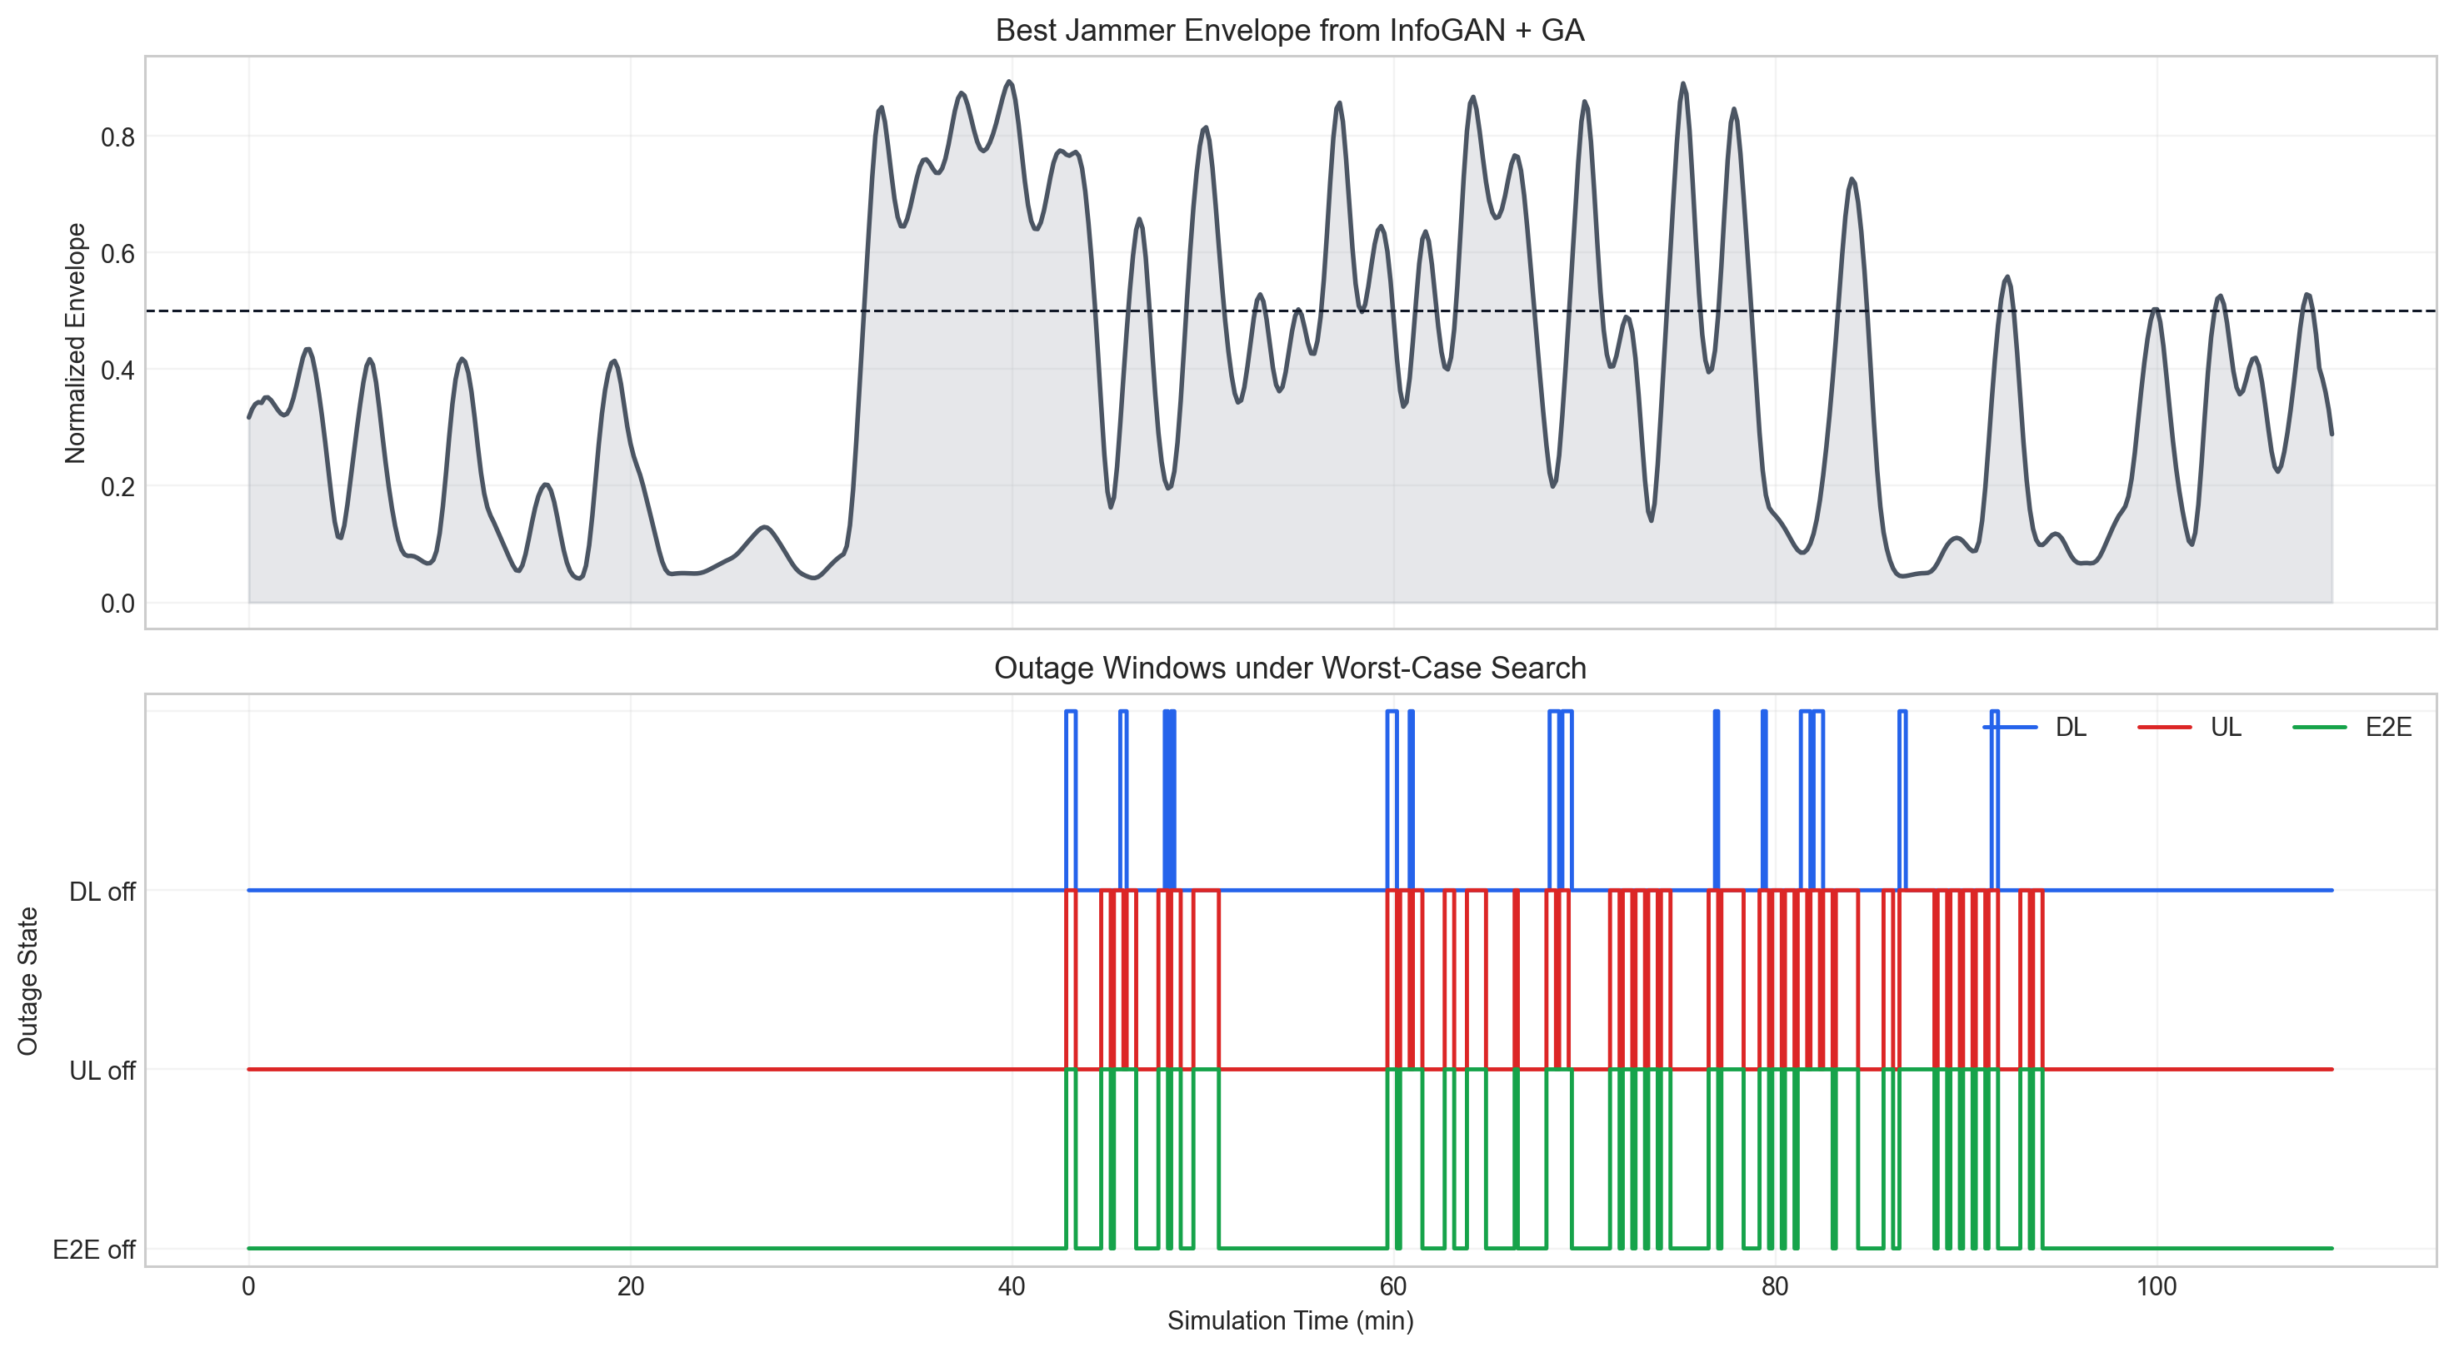
Figure 5. Worst-case jammer envelope and the corresponding outage windows.
Under this envelope, the cumulative E2E outage duration is about 23.67 min. The uplink accounts for about 22.67 min of outage, whereas the downlink accumulates only about 4.83 min. Hence, most end-to-end failures can be traced back to uplink outage episodes rather than simultaneous persistent collapse of both directions. This demonstrates that the worst-case search reveals not just a worse average outcome, but also the temporal organization of system vulnerability.

6.5 Interference-identification visualization
To enhance diagnostic interpretability, Figure 6 presents the normalized confusion matrix of the STFT+LeNet branch. The results indicate strong separability for the tone and pbnj classes, while some confusion remains between the none and mod categories.
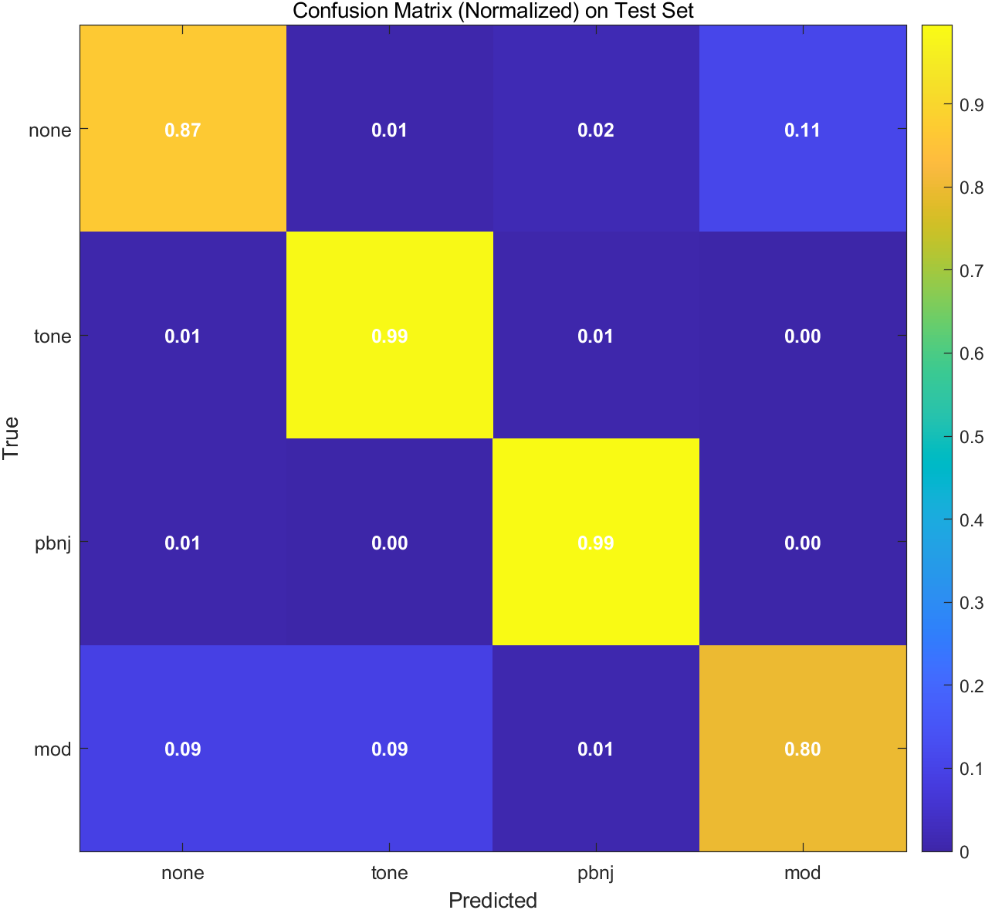
Figure 6. Normalized confusion matrix of the STFT+LeNet auxiliary interference-identification branch on the test set.
This observation suggests that the auxiliary branch already provides meaningful labels for the more salient interference patterns, but it should still be regarded as a diagnostic aid rather than a replacement for the core link solver. In other words, the platform is designed to explain why the link is degrading and what type of interference may dominate, not to claim state-of-the-art classification performance.

7 Discussion

7.1 Strengths of the platform
First, the platform supports joint DL/UL/E2E evaluation and can therefore explain asymmetric degradation together with end-to-end propagation effects. Second, it unifies geometric scenario generation, power precomputation, worst-case search, diagnostic output, and EMC threshold checking within one results chain, reducing the fragmentation often found in multi-script engineering workflows. Third, it produces standardized tables, figures, and summary files that can be inserted directly into design-review or laboratory-preparation documents.

7.2 Limitations
The present platform is fundamentally a system-level power simulation and metric-proxy framework rather than a full waveform-level physical-layer simulator. Therefore, the BER/BLER/throughput mapping remains an engineering approximation. In addition, the reported results are organized from archived V7 outputs and do not yet include confidence intervals from repeated Monte Carlo trials or multiple random seeds. Finally, the STFT+LeNet branch relies on an engineering mapping from power-level sequences to IQ/STFT snapshots, so its labels should be interpreted as diagnostic cues rather than benchmark-grade recognition results.

7.3 Future work
Future extensions can proceed along three directions. First, multi-terminal, multi-gateway, and multi-service models can be introduced to analyze contention and switching behavior. Second, parameter-sensitivity studies and uncertainty quantification can be added to report confidence intervals around worst-case risk. Third, hardware-in-the-loop and EMC chamber experiments can be coupled with the digital platform to form a closed validation loop from digital prototype to laboratory measurement and back.

8 Conclusion
This paper presented a system-level platform for vehicle-mounted LEO satellite communications that integrates scenario modeling, joint DL/UL/E2E simulation, EMC threshold evaluation, InfoGAN+GA worst-case search, and STFT+LeNet-assisted interference diagnosis. In the case study with a 1200 km, 53 deg, 12x8 constellation and six jammers, the baseline E2E mean throughput is 73.99 Mbps, whereas the worst-case scenario reduces it to 50.57 Mbps, a 31.66% drop, and increases the outage ratio from 0% to 21.65%. The uplink is found to be substantially more vulnerable than the downlink. These results demonstrate that the platform can expose the coupling among LEO geometry, EMC constraints, and interference propagation within a unified framework, thereby supporting design studies, parameter sweeps, worst-case pre-assessment, and laboratory validation planning.

Data availability and reproducibility note
The numerical results used in this manuscript come from the archived V7 engineering outputs provided in the project package, including `result_v7.mat`, `summary_v7.txt`, and exported STFT artifacts. When MATLAB R2021a and the required toolboxes are available, the supplied project scripts can reproduce the workflow used in this paper and extend it to broader parameter sweeps.

References
[1] H. Al-Hraishawi, H. Chougrani, S. Kisseleff, E. Lagunas, and S. Chatzinotas, "A Survey on Non-Geostationary Satellite Systems: The Communication Perspective," IEEE Communications Surveys & Tutorials, vol. 25, no. 1, pp. 101-132, 2023, doi: 10.1109/COMST.2022.3197695.
[2] Z. Xiao, Y. He, C. Liang, H. Yao, Z. Sun, and L. Zhu, "LEO satellite access network (LEO-SAN)," China Communications, vol. 20, no. 7, 2023, doi: 10.23919/JCC.2023.10194582.
[3] J. Ma, L. Zhong, and R. Onishi, "LEO Satellite Communication Simulation Framework for Connected Vehicles," in Proceedings of IEEE GLOBECOM, 2023, pp. 6597-6602.
[4] F. Ortiz, E. Lagunas, A. Saifaldawla, M. Jalali, L. Emiliani, and S. Chatzinotas, "Emerging NGSO constellations: spectral coexistence with GSO satellite communication systems," Frontiers in Communications and Networks, vol. 7, Art. no. 1730921, 2026, doi: 10.3389/frcmn.2026.1730921.
[5] A. Pastukh, V. Tikhvinskiy, S. Dymkova, and O. Varlamov, "Challenges of Using the L-Band and S-Band for Direct-to-Cellular Satellite 5G-6G NTN Systems," Technologies, vol. 11, no. 4, Art. no. 110, 2023, doi: 10.3390/technologies11040110.
[6] L. Zhang, Z. Li, and S. Yang, "Evaluating the Influence of Satellite Systems on Terrestrial Networks: Analyzing S-Band Interference," arXiv:2501.05462, 2025.
[7] Z. Yang, F. Tian, J. Jin, and H. Liu, "Rethinking LEO Mega-Constellation Routing to Provide Fast Internet Access Services," Sensors, vol. 23, no. 6, Art. no. 3207, 2023, doi: 10.3390/s23063207.
[8] F. Moya Caceres, A. Al-Hourani, S. Atapattu, and K. Sithamparanathan, "Null-Shaping for Interference Mitigation in LEO Satellites Under Location Uncertainty," arXiv:2510.00816, 2025.
[9] X. Chen, Y. Duan, R. Houthooft, J. Schulman, I. Sutskever, and P. Abbeel, "InfoGAN: Interpretable Representation Learning by Information Maximizing Generative Adversarial Nets," in Advances in Neural Information Processing Systems 29 (NeurIPS), 2016, pp. 2172-2180.
[10] Y. LeCun, L. Bottou, Y. Bengio, and P. Haffner, "Gradient-based learning applied to document recognition," Proceedings of the IEEE, vol. 86, no. 11, pp. 2278-2324, 1998, doi: 10.1109/5.726791.
[11] S. Ujan, N. Navidi, and R. J. Landry, "Hierarchical Classification Method for Radio Frequency Interference Recognition and Characterization in Satcom," Applied Sciences, vol. 10, no. 13, Art. no. 4608, 2020, doi: 10.3390/app10134608.
[12] E. Ozturk, F. Erden, and I. Guvenc, "RF-Based Low-SNR Classification of UAVs Using Convolutional Neural Networks," arXiv:2009.05519, 2020.

