Output Images

1. 3d_scene_optimized_20251224_004332.png
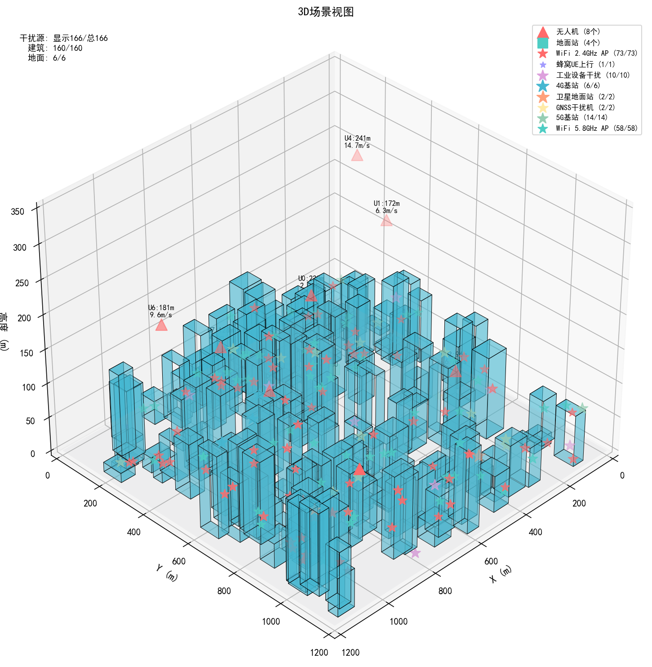

2. communication_analysis_optimized_20251224_004332.png
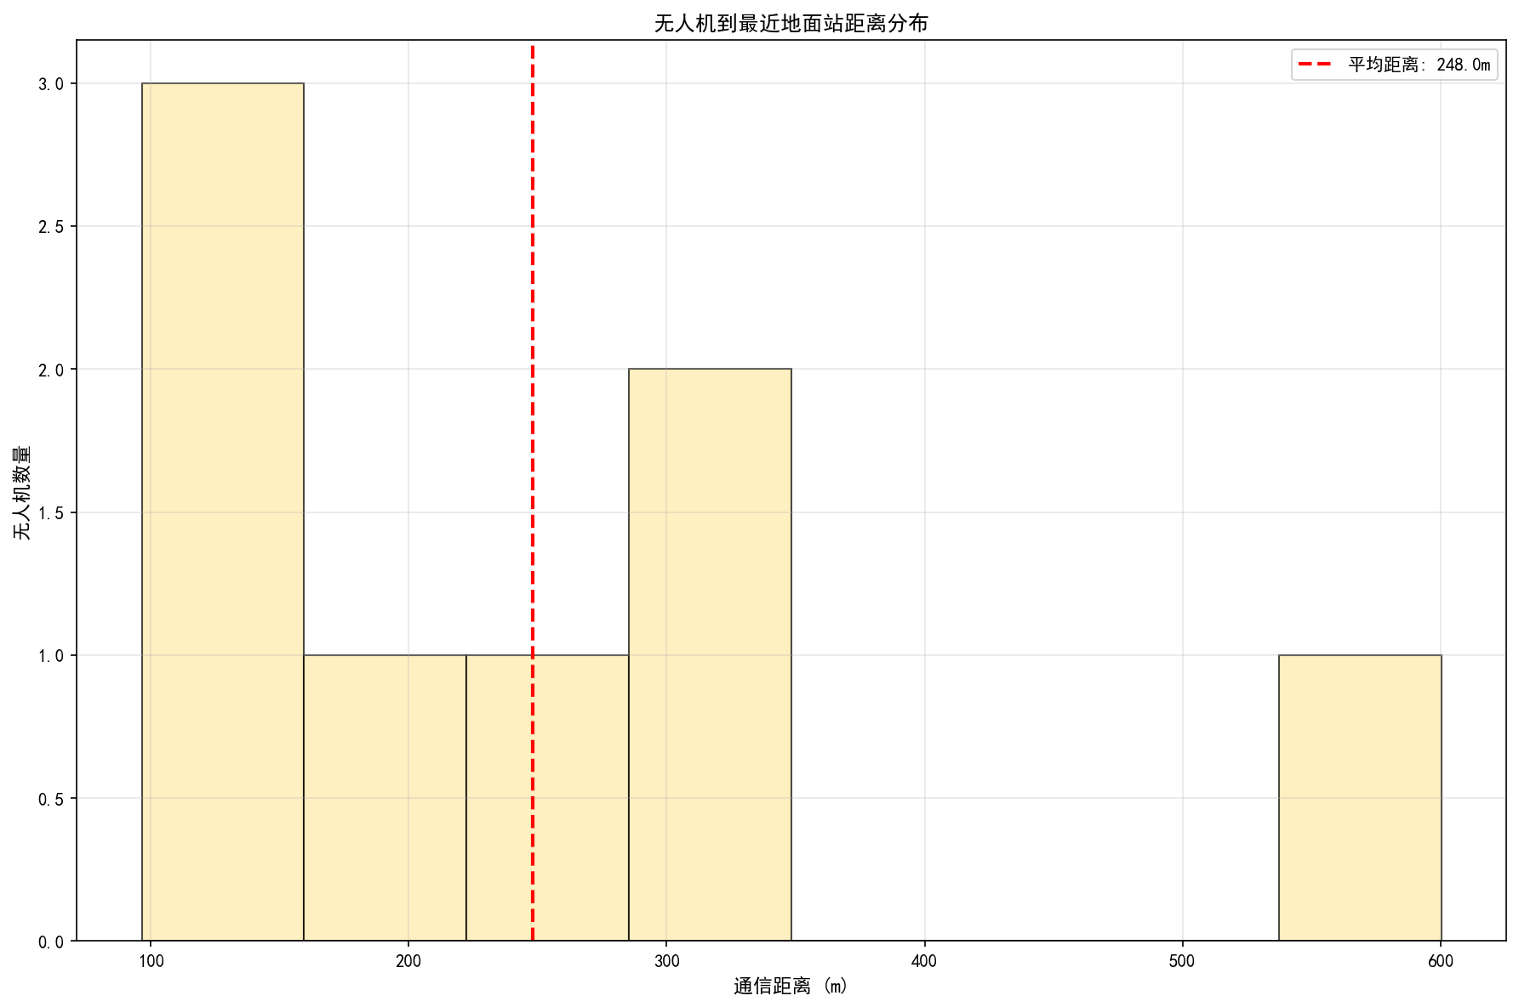

3. height_analysis_optimized_20251224_004332.png
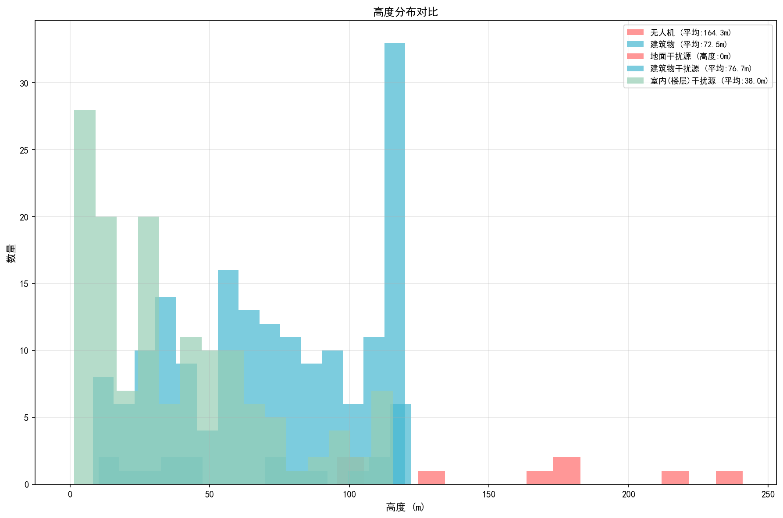

4. interference_dist_optimized_20251224_004332.png
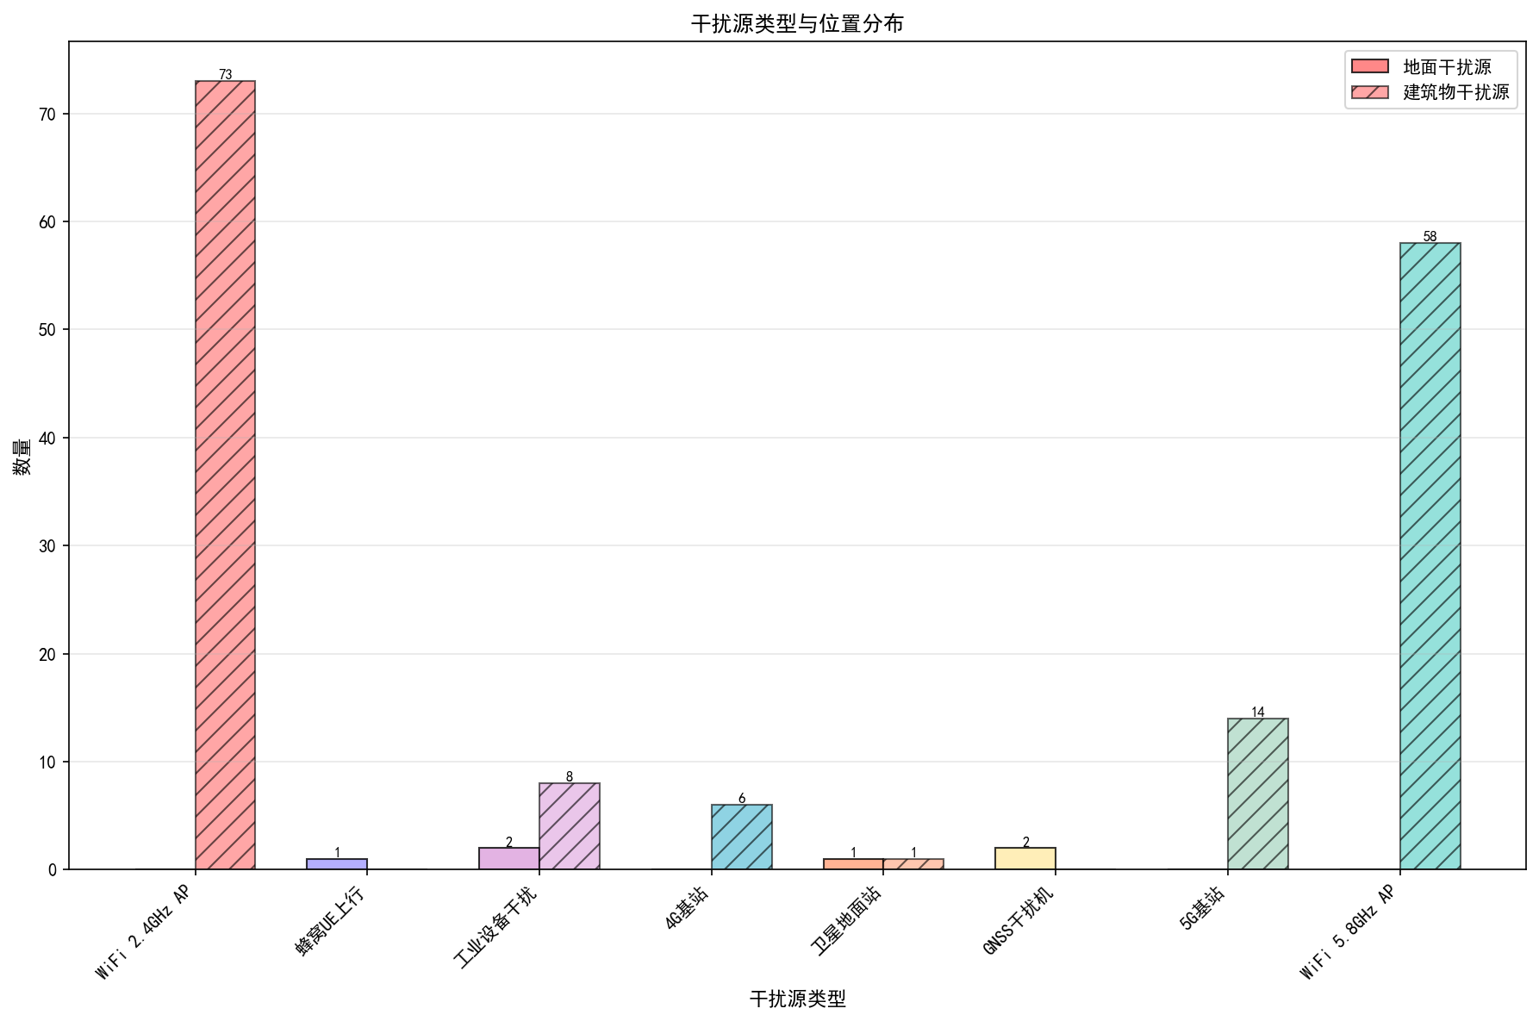

5. interference_location_optimized_20251224_004332.png
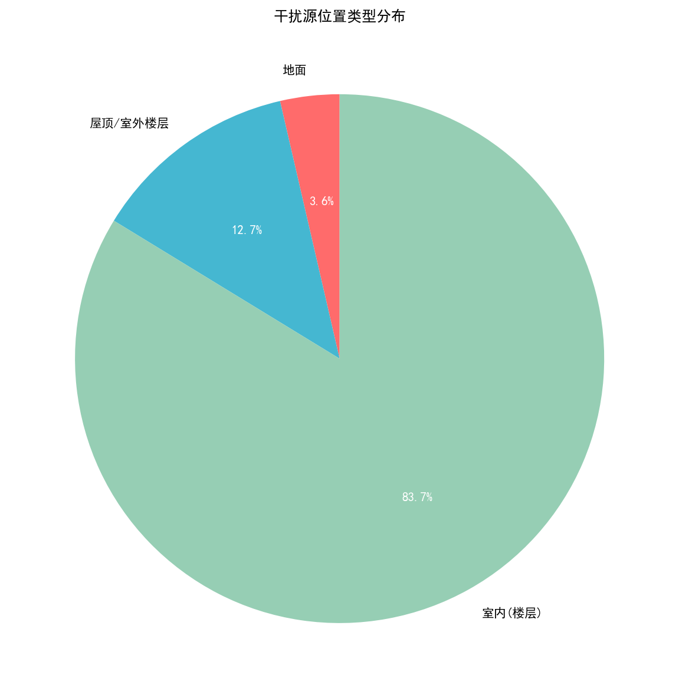

6. scenario_params_optimized_20251224_004332.png
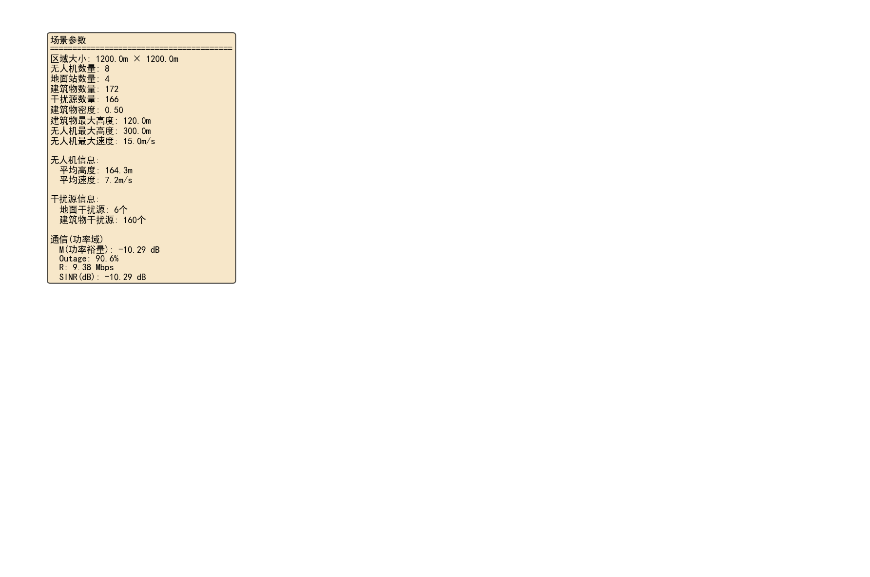

7. side_view_optimized_20251224_004332.png
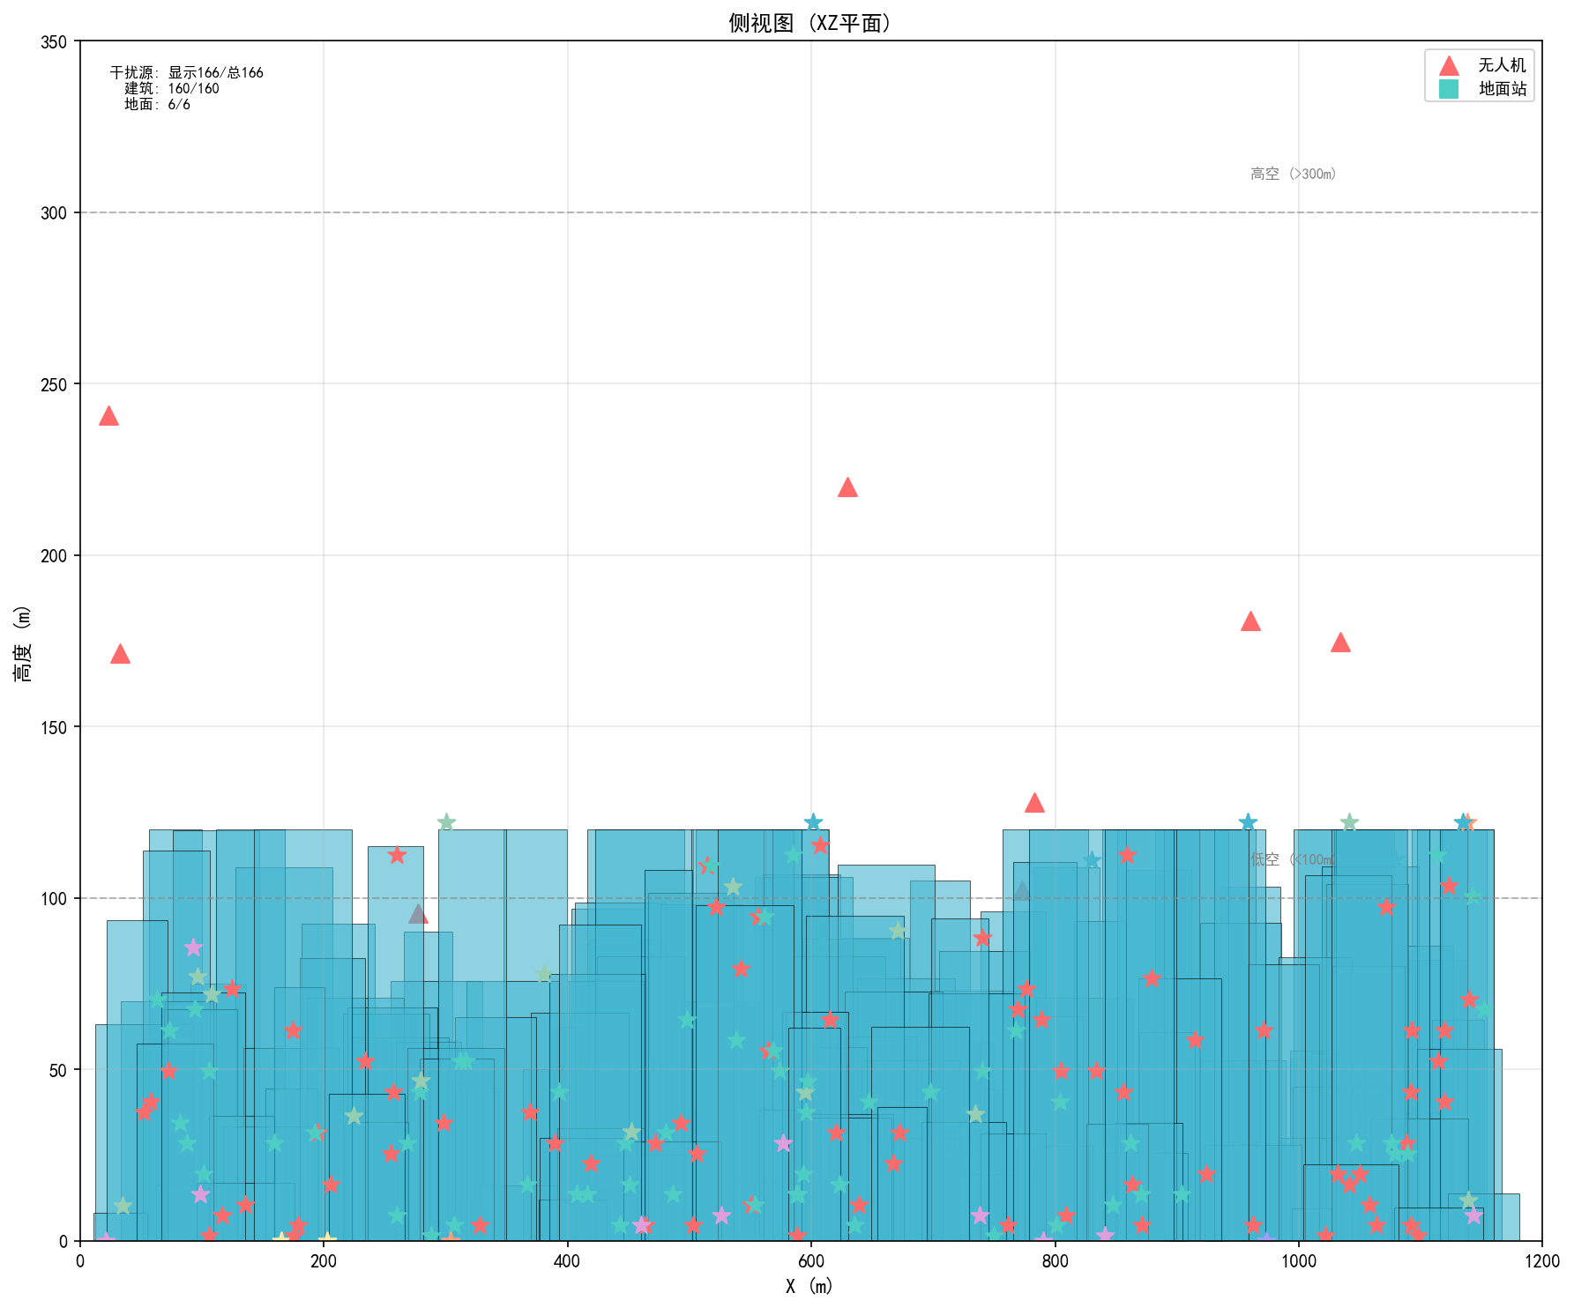

8. top_view_optimized_20251224_004332.png
