Map-Aware Worst-Case Degradation Assessment and Extreme Scenario Generation
for Urban UAV Communications via Genetic Algorithms and Generative Adversarial Networks
Author names omitted for peer review
Manuscript draft prepared from the supplied engineering package and public measurement datasets
Abstract
This paper investigates worst-case communication degradation assessment for urban unmanned aerial vehicle (UAV) links under joint building blockage, heterogeneous coexisting emitters, and high-mobility flight states. Unlike average-coverage studies, the objective is to search for physically plausible configurations that maximize a composite degradation metric and to expand the neighborhood of such boundary cases. A map-aware framework is developed by unifying deterministic segment-building line-of-sight (LoS) checking, when building geometry is available, with a probabilistic fallback based on elevation-dependent air-to-ground (A2G) models. The propagation chain further incorporates ITU-R P.2109 building-entry loss, ITU-R P.1238 indoor loss, spectral coupling, calibrated heterogeneous interferer profiles, a cellular uplink fractional power-control interface, and Nakagami-m moment-matched interference aggregation. On top of the power-domain evaluator, a genetic algorithm (GA) is used to identify high-degradation samples, while a generative adversarial network (GAN) learns the distribution of GA-discovered boundary cases to generate additional extreme scenarios at lower search cost. Using the project outputs provided with this study, pilot results show that the mean composite degradation of GA samples reaches 0.4528, which is 5.70% higher than random scenarios, whereas GAN samples reach 0.4300, only 0.38% above random scenarios. External validation against public 3.6 GHz 5G non-standalone measurements shows that modeled worst regions are substantially more pessimistic than measured trajectories: average SINR drops by 26.77 dB and 23.43 dB, and average throughput decreases by 97.63% and 96.04%, for AERPAW and Dryad, respectively. These results indicate that the proposed framework is better interpreted as a boundary-search and conservative risk-evaluation tool than as a trajectory replay engine.
Keywords: urban UAV communications; air-to-ground propagation; heterogeneous interference; worst-case evaluation; genetic algorithm; generative adversarial network; public measurement alignment
1. Introduction
Cellular-connected UAVs have become a representative scenario for low-altitude digital infrastructure, emergency coverage extension, sensing-assisted networking, and aerial data services. Their communication behavior differs fundamentally from that of conventional terrestrial users because altitude changes the geometric relation to both serving infrastructure and non-serving emitters, often enlarging the LoS footprint and therefore exposing the UAV to stronger inter-cell and cross-technology interference [1], [2].
The literature associated with Yong Zeng established much of the modern analytical foundation for UAV communications. The tutorial in [1] synthesized UAV-ground channel models, antenna considerations, mobility-aware communication design, and cellular-connected UAV interference issues. The energy-efficiency framework in [11] formalized the tradeoff between communication throughput and propulsion expenditure, while the control-oriented 3D trajectory design in [12] moved the field from purely kinematic paths toward smoother and more physically implementable trajectories. These studies collectively motivate the need to evaluate communication quality jointly with mobility and energy variables rather than through isolated signal metrics.
A second foundational line of work originates from Akram Al-Hourani and coauthors. Their A2G path-loss model in [3] and optimal low-altitude platform (LAP) altitude analysis in [4] showed that elevation-angle-dependent LoS statistics and urban morphology can dominate aerial coverage behavior. Later work further generalized urban LoS modeling from empirical formulas to geometry-based formulations [5], [6]. These models remain central to the analysis of UAV links, especially when the problem involves altitude, blockage, and coverage boundaries instead of only average terrestrial service conditions.
At the same time, recent studies have addressed interference mitigation for cellular-connected UAVs [10], robust trajectory planning in the presence of jammers [13], and generative models for wireless channels and environments [15]. However, a gap remains between average-case propagation modeling and worst-case communication degradation assessment under heterogeneous, calibrated interferers embedded in an explicit urban geometry. Existing papers often focus on a single jammer class, a single optimization objective, or average coverage/trajectory improvement. By contrast, safety-oriented system evaluation requires identifying the spatial and spectral boundary where a UAV communication system can fail most severely under plausible joint conditions.
This paper targets that boundary-search problem. Based on the engineering package supplied with this study, we construct a unified framework that links parameterized urban geometry, map-aware visibility analysis, calibrated interferer generation, power-domain degradation computation, GA-based worst-case search, GAN-based extreme-sample expansion, and public-data validation. The manuscript turns the supplied outline and project assets into a formal SCI-style article with an explicit emphasis on how the modeling chain relates to the research threads initiated by Zeng and Al-Hourani.
The main contributions are fourfold. First, we formulate a map-aware urban UAV communication model that uses deterministic line-segment intersection to determine LoS whenever a building map is available, while preserving Al-Hourani-type probabilistic LoS as a fallback for mapless operation. Second, we integrate calibrated heterogeneous interferers, including Wi-Fi, 4G/5G cells, GNSS jammers, industrial emitters, satellite-ground terminals, and cellular uplink users with a retained fractional power-control interface. Third, we build a composite degradation metric that combines power margin, rate, outage tendency, and propulsion-related efficiency into a single optimization target. Fourth, we validate the pessimistic boundary identified by the model against public AERPAW and Dryad measurements and show that the searched worst regions are substantially more fragile than the measured trajectories.
2. Related Work and Research Gap
The existing UAV communication literature can be broadly organized into four strands. The first strand concerns channel characterization and statistical coverage analysis. Representative work includes the tutorial treatments in [1], [2], the elevation-dependent A2G formulations in [3], [4], and later LoS refinements in [5], [6]. These studies provide the analytical ingredients needed to describe how urban morphology and altitude affect link visibility and path loss, but they are not primarily designed to search for physically consistent worst-case scenarios under mixed interferer semantics.
The second strand focuses on mobility, trajectory, and energy optimization. Zeng and Zhang [11] showed that communication performance and propulsion cost must be considered jointly, while [12] introduced a more control-faithful 3D trajectory design for energy-efficient UAV communication. Robust jammer-aware planning was further explored in [13] and related multi-UAV extensions. Nevertheless, most such works optimize a flight policy under a predefined threat model; they do not explicitly learn or generate the broader distribution of extreme communication environments.
The third strand studies cellular interference and coexistence. Aerial-ground interference mitigation in [10] clarified why aerial users can become highly exposed to non-serving cells and how interference-aware network design becomes indispensable. The 3GPP study item on aerial vehicles [9] likewise emphasizes the distinct propagation and interference conditions experienced by UAV user equipment. Yet these works typically retain a network-centric perspective and do not directly address the problem of synthesizing the most adverse urban communication scenes for testing and risk assessment.
The fourth strand concerns data-driven generative modeling. GAN-based wireless channel modeling [15] established the feasibility of learning complex communication distributions from samples rather than relying purely on analytical expressions. However, such models are usually trained on channels or measurements, not on worst-case decision vectors emerging from geometry-aware search. This leaves a methodological opportunity: use an optimizer to find the degradation boundary first, and then use a generator to expand the neighborhood of that boundary in a controllable way.
Accordingly, the research gap addressed here is not another average-coverage model, nor simply another trajectory optimizer. Instead, the key question is how to build an engineering workflow that can (i) preserve physically meaningful geometry and propagation, (ii) accommodate calibrated heterogeneous interferers, (iii) search mixed discrete-continuous worst cases efficiently, and (iv) relate the discovered boundary to public measurements. This combination defines the niche of the present work.
3. System Model and Problem Formulation
3.1 Urban geometry and visibility handling
The study area is a bounded urban region containing UAVs, ground stations, buildings, and multiple categories of interferers. In the default experimental configuration extracted from the supplied project, the area side length is 1200 m, the maximum flight height is 350 m, the building density is 0.45, the maximum building height is 120 m, and the scenario contains six UAVs, four ground stations, and eight controlled interferers. The buildings are represented either by explicit map objects or by a parameterized alpha-beta-gamma city generator that reconstructs three-dimensional urban morphology when a full geographic information system layer is unavailable.
A key implementation detail is that LoS is not always a probabilistic random variable. When building geometry is available, the code determines visibility through deterministic line-segment intersection with building prisms. Only when map information is absent, or when an explicit probabilistic mode is requested, does the framework fall back to an elevation-angle-dependent LoS probability model. This distinction is crucial because it converts the effective path-loss surface from a smooth expected-value function into a piecewise function driven by discrete geometric events.
P_LoS(theta) = 1 / [1 + a exp(-b (theta - a))] | (1)
Equation (1) represents the probabilistic fallback, consistent with the Al-Hourani family of A2G models [3], [4]. In deterministic map-aware mode, the visibility indicator becomes a binary variable chi_LoS in {0,1}, which is obtained by explicit intersection checking instead of probabilistic sampling.
L_A2G = chi_LoS [L_FSPL + eta_LoS] + (1 - chi_LoS) [L_FSPL + eta_NLoS] | (2)
The free-space component is computed at the actual carrier frequency, while eta_LoS and eta_NLoS account for excess losses under LoS and NLoS conditions. The resulting A2G loss inherits the map-aware discreteness of chi_LoS when building geometry is known and reverts to an expected-value model otherwise [3]-[6].
3.2 Heterogeneous interferers and indoor/outdoor propagation
The supplied engineering package does not model interference as a single abstract noise term. Instead, each interferer carries a type, frequency, power range, activity factor, coverage radius, and deployment semantics. The implemented type library includes Wi-Fi at 2.4 and 5.8 GHz, 4G macro cells, calibrated 5G small cells, GNSS jammers, industrial/ISM emitters, Ku-band ground terminals, and cellular uplink users. A practical modeling convention in the code is that the configured power range is interpreted directly as an EIRP-equivalent transmit power in dBm for the link budget.
For indoor or building-entering links, the path-loss chain adds ITU-R P.1238 indoor propagation and ITU-R P.2109 building-entry loss to the basic A2G loss [7], [8]. This allows the same framework to represent not only rooftop or street emitters but also indoor hotspots that become relevant when UAV trajectories pass near or above buildings. Furthermore, the framework includes a spectral coupling factor so that a strong but frequency-separated interferer can have lower effective impact than a weaker co-channel or adjacent-channel emitter.
The cellular uplink interferer class receives special treatment because the code retains a fractional power-control (FPC) interface instead of assigning a fixed transmit-power constant. This is important for future compatibility with dynamic aerial-user scenarios and prevents the uplink interferer from becoming an unjustified free parameter.
P_u = min{ P_max, P_0 + alpha PL_serv + 10 log10(M_RB) + Delta_TF + f(Delta_TPC) } | (3)
Equation (3) is the retained FPC interface used for cellular uplink interferers, consistent with the engineering interpretation of aerial-user power control under 3GPP-inspired settings [9]. In the current package, the closed-loop correction terms are kept as interfaces and default to zero, which means the framework preserves the control structure without overclaiming a full time-evolving TPC simulator.
m_eq = [ sum_i Omega_i ]^2 / sum_i [ Omega_i^2 / m_i ] | (4)
For aggregated interference, each source first contributes a mean power Omega_i in the linear domain after path loss, activity, and spectral coupling. The overall interference can then be approximated through Nakagami-m moment matching using the equivalent parameter in (4), following the general sum-of-Gamma methodology in [16]. This is more expressive than a naive constant-interference assumption because the fading severity can vary across source classes and LoS conditions.
3.3 Power-domain degradation metric
The evaluator used in the supplied project computes the desired signal power, aggregated interference, and thermal noise in a unified power-domain chain. Rather than using a disconnected heuristic score, the degradation metric is derived from the power margin between the received service power and the equivalent interference-plus-noise power. This makes the metric interpretable in link-budget terms and easy to align with SINR, outage, and rate.
M = P_rx - P_IN, P_IN = 10 log10(I + N) | (5)
D_comm = 1 / [1 + exp((M - theta_m) / s_m)] | (6)
Equation (5) defines the power margin M in dB. Equation (6) maps this margin through a logistic transform so that degradation grows rapidly near the failure threshold. Compared with raw SINR alone, the logistic mapping gives the framework better sensitivity around the outage boundary, which is precisely where worst-case search is most valuable.
D_total = [ w_c D_comm + w_e D_speed ] / (w_c + w_e) | (7)
The final objective D_total combines communication degradation D_comm with a speed/energy-related term D_speed derived from a rotorcraft propulsion model. This design follows the broader insight of [11], [12]: unrealistically aggressive or static trajectories should not be rewarded if they only improve one metric while ignoring mobility cost. In the supplied project, the communication term is given higher priority, but the energy component remains essential to prevent physically implausible solutions.
4. GA-GAN Extreme-Scenario Generation Framework
The optimization problem is defined over a mixed decision vector that includes UAV positions, heights, speeds, and interferer-specific variables such as type, power, and semantic location. The objective is to maximize the average composite degradation over the UAV-ground links in a scenario. Because the search space contains both discrete and continuous variables with non-smooth map-induced transitions, gradient-based optimization is not a natural fit.
x* = arg max_{x in X} D_total(x) | (8)
A real-coded GA is therefore used as the primary worst-case search engine. In the supplied pilot configuration, the default settings are 40 independent GA runs, 40 generations per run, and 30 individuals per population. The role of GA is not to solve a textbook convex program but to locate physically meaningful high-degradation boundary points in a complex, irregular decision space [13].
GAN is then used as a secondary generator rather than as a replacement for GA. The generator learns from the normalized high-degradation samples discovered by GA and synthesizes additional candidates in the same decision space. In the current engineering version, the generator is a multilayer perceptron with 128 and 256 hidden units, the discriminator uses 256 and 128 hidden units, the latent dimension is 32, the batch size is 32, and the default training duration is 300 epochs. After generation, the continuous outputs are mapped back to physical ranges and discrete variables are post-processed into valid categories.
This decomposition of roles is conceptually important. GA discovers the boundary; GAN densifies the neighborhood of the discovered boundary. Therefore, the comparison between GA and GAN should not be interpreted as a direct contest between two independent optimizers. The appropriate interpretation is whether GAN can economically expand the set of plausible extreme scenarios after a boundary has been found.
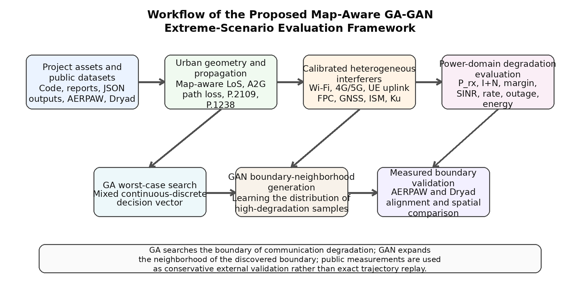
Fig. 1. Workflow of the proposed map-aware GA-GAN extreme-scenario evaluation framework.
5. Experimental Setup and Data Sources
All numerical results in this manuscript were derived from the supplied engineering package, specifically the comparison summary JSON and the public-data corner-case summary JSON that accompany the provided code base. The pilot GA-GAN-random comparison comes from a demo run with limited sample counts, while the external validation uses public 3.6 GHz 5G non-standalone measurement datasets associated with AERPAW and a later Dryad release [17], [18]. The role of the public data is not to provide a perfect digital twin of the environment but to serve as an external consistency check on whether the searched worst regions are meaningfully more fragile than measured trajectories.
Table 1. Default scenario and algorithm parameters used in the supplied project.
Category | Parameter | Default value
Scenario | UAVs / ground stations | 6 / 4
Scenario | Area side length / max altitude | 1200 m / 350 m
Scenario | Max building height / building density | 120 m / 0.45
Scenario | Controlled interferers | 8
GA | Runs / generations / individuals | 40 / 40 / 30
GAN | Epochs / batch size / latent dimension | 300 / 32 / 32
GAN | Generated samples | 20
Random | Random scenarios | 50

The pilot comparison must be interpreted cautiously because only two GA samples and two GAN samples are available in the supplied demo output, versus ten random samples. Consequently, the pilot section below is best understood as evidence of directional validity rather than as a statistically definitive generalization study.
6. Results and Discussion
6.1 Pilot comparison of GA, GAN, and random scenarios
The pilot summary shows that GA achieves the highest mean composite degradation, with an average value of 0.4528, compared with 0.4300 for GAN and 0.4283 for random scenarios. Relative to the random baseline, the GA gain is 5.70%, whereas the GAN gain is only 0.38%. This supports the expected division of labor: direct evolutionary search is still the strongest mechanism for locating the most adverse boundary points in the current small-data regime.
An instructive observation is that the worst communication degradation does not coincide with the strongest average aggregated interference in dBm. The random scenarios exhibit the least negative average interference level (-91.95 dBm), yet they do not produce the worst margins. By contrast, GA produces a more negative average interference level (-94.60 dBm) but the most adverse average margin (-1.1102 dB). This implies that extreme degradation is driven by joint geometry, desired-signal attenuation, blockage, and spectral coupling rather than by raw interferer power alone.
Table 2. Pilot statistical summary of GA, GAN, and random scenarios from the supplied demo output.
Scenario class | Count | Avg. total degradation | Avg. comm. degradation | Avg. interference (dBm) | Avg. margin (dB)
GA | 2 | 0.4528 | 0.6468 | -94.60 | -1.1102
GAN | 2 | 0.4300 | 0.6143 | -93.78 | -0.4535
Random | 10 | 0.4283 | 0.6119 | -91.95 | -0.2917

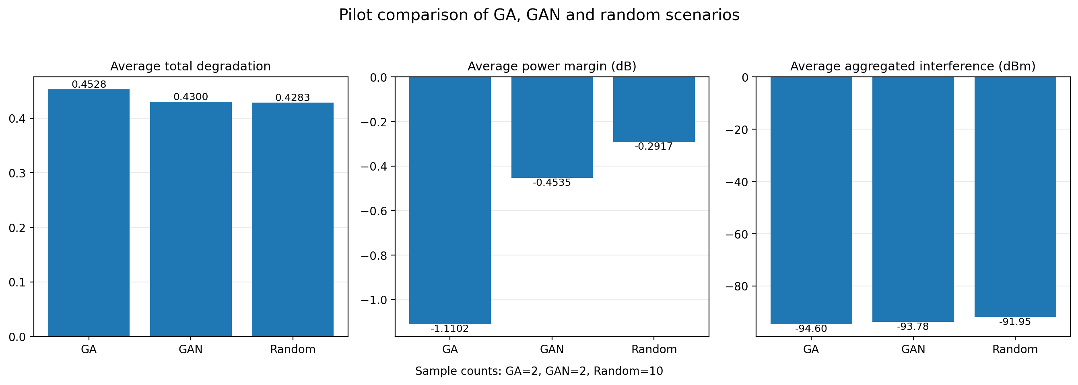
Fig. 2. Pilot comparison of GA, GAN, and random scenarios using the supplied demo summary.
6.2 Public-data validation against AERPAW and Dryad
Validation against the AERPAW dataset shows a pronounced separation between measured trajectories and modeled worst regions. The average SINR of the measured trajectory is 16.05 dB, whereas the modeled worst region falls to -10.72 dB, a reduction of 26.77 dB. The average throughput drops from 562.55 Mbps to 13.32 Mbps, corresponding to a decrease of 97.63%. At the 10 dB threshold, the outage probability grows from 0.384 on the measured trajectory to 1.000 in the modeled worst region.
The same trend holds for the Dryad validation. The mean SINR decreases from 14.69 dB on the measured trajectory to -8.74 dB in the modeled worst region, a difference of 23.43 dB. Mean throughput declines from 507.07 Mbps to 20.06 Mbps, i.e., by 96.04%. Again, the modeled worst region reaches a 10 dB outage probability of 1.000, which is far more pessimistic than the measured trajectory.
Importantly, the modeled worst region should not be read as a mere copy of the empirically worst measured point. Instead, the method identifies a conservatively vulnerable region in the aligned environment that the trajectory did not necessarily traverse. From a testing perspective, this makes the framework useful for bad-point prediction, external route design, and boundary extension beyond what field campaigns have already covered.
Table 3. Public-data validation: measured trajectories, random points, and modeled worst regions.
Dataset | Group | Avg. SINR (dB) | Avg. throughput (Mbps) | Outage at 10 dB
AERPAW | Measured | 16.05 | 562.55 | 0.384
AERPAW | Random | 14.91 | 515.78 | 0.325
AERPAW | Worst region | -10.72 | 13.32 | 1.000
Dryad | Measured | 14.69 | 507.07 | 0.275
Dryad | Random | 14.31 | 497.21 | 0.325
Dryad | Worst region | -8.74 | 20.06 | 1.000

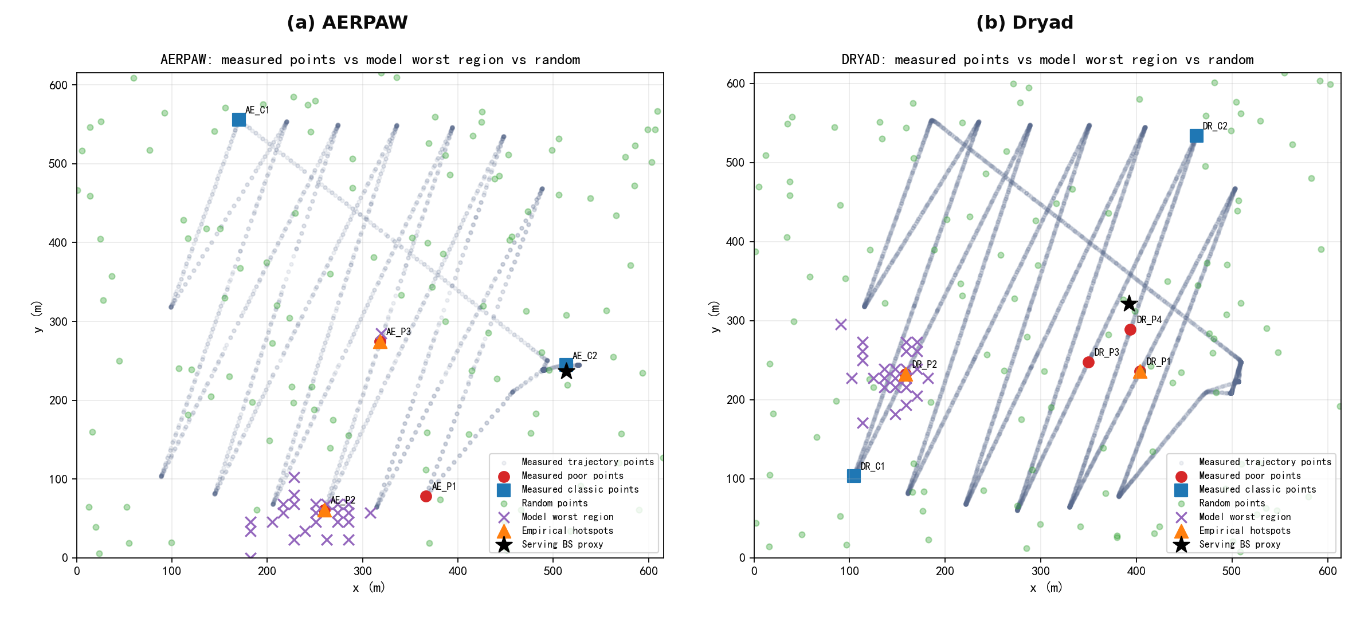
Fig. 3. Spatial alignment between measured points, random points, and modeled worst regions in AERPAW and Dryad.
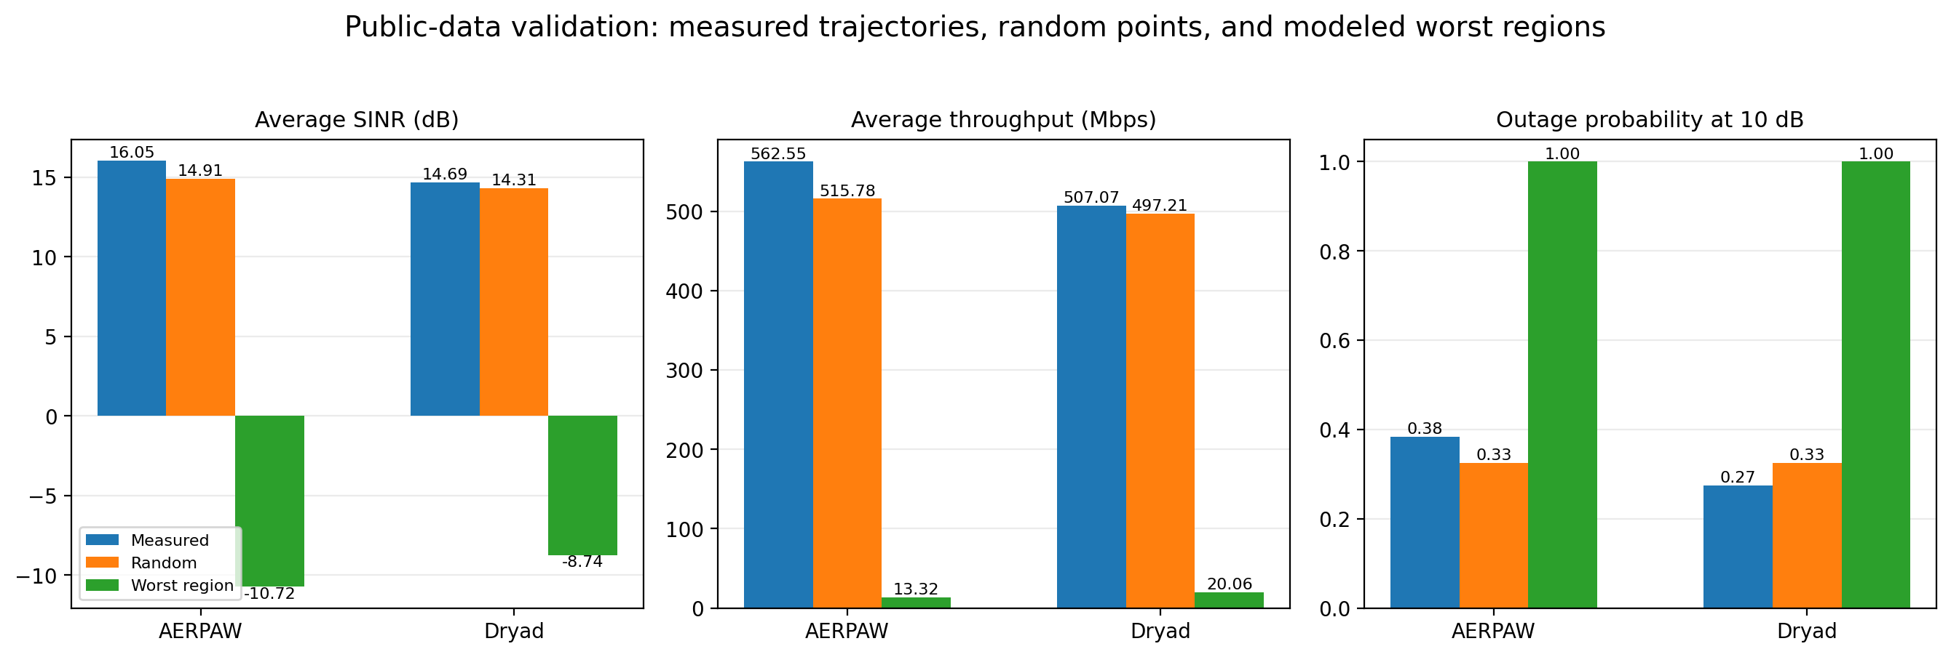
Fig. 4. Quantitative public-data validation across AERPAW and Dryad.
6.3 Discussion
Three insights emerge from the results. First, the degradation boundary is inherently non-monotonic with respect to altitude. Increasing altitude can improve the desired link by clearing blockage, but it can simultaneously expose the UAV to more non-serving emitters. This is exactly why the visibility mechanism must support deterministic map-aware switching when buildings are available; smooth average-probability reasoning alone can hide the discrete transitions that matter most for worst-case search.
Second, calibrated interferer semantics matter. The supplied package distinguishes indoor hotspots, rooftop cells, street-level emitters, and cellular uplink users with different frequency bands, activity factors, and path-loss chains. As a result, a scenario with the highest raw interferer power need not be the one with the worst communication margin. The physically relevant adversarial scene is a coupled geometry-spectrum-activity configuration.
Third, the present GAN results should be interpreted conservatively. Since the pilot training set contains only two GA samples, the generator mostly learns a narrow neighborhood of near-boundary points rather than the boundary itself. Enlarging the high-degradation sample library is therefore an essential next step before stronger distributional claims can be made.
7. Conclusion
This paper transformed the supplied project outline and engineering outputs into a formal SCI-style manuscript on urban UAV communication degradation assessment and extreme-scenario generation. The proposed framework unifies map-aware visibility analysis, heterogeneous interferer calibration, indoor/outdoor propagation, FPC-enabled uplink modeling, Nakagami-m interference aggregation, a power-domain degradation metric, GA-based worst-case search, GAN-based boundary-neighborhood generation, and public-data validation.
Within the supplied pilot results, GA discovers the most adverse scenarios, reaching a mean composite degradation of 0.4528, while GAN provides a first-step approximation to the distribution of high-degradation samples. External validation on AERPAW and Dryad demonstrates that the modeled worst regions are substantially more fragile than measured trajectories, with average SINR reductions of 26.77 dB and 23.43 dB and throughput reductions above 96% in both datasets.
The framework should therefore be interpreted as a conservative risk-boundary discovery tool rather than as a pure fit-to-trajectory model. Future work should expand the GA worst-sample library, calibrate Nakagami parameters and interferer densities from measurements, activate time-varying closed-loop power-control corrections, and integrate higher-fidelity GIS data for more exact geometry-to-measurement alignment.
Data Availability
The numerical tables and derived figures in this manuscript were generated from the supplied project package and its JSON summaries. Public validation relies on the AERPAW/Dryad measurement resources described in [17] and [18].
References
[1] Y. Zeng, Q. Wu, and R. Zhang, "Accessing From the Sky: A Tutorial on UAV Communications for 5G and Beyond," Proceedings of the IEEE, vol. 107, no. 12, pp. 2327-2375, 2019.
[2] M. Mozaffari, W. Saad, M. Bennis, Y.-H. Nam, and M. Debbah, "A Tutorial on UAVs for Wireless Networks: Applications, Challenges, and Open Problems," IEEE Communications Surveys & Tutorials, vol. 21, no. 3, pp. 2334-2360, 2019.
[3] A. Al-Hourani, S. Kandeepan, and A. Jamalipour, "Modeling Air-to-Ground Path Loss for Low Altitude Platforms in Urban Environments," in Proc. IEEE Global Communications Conference (GLOBECOM), 2014, pp. 2898-2904.
[4] A. Al-Hourani, S. Kandeepan, and S. Lardner, "Optimal LAP Altitude for Maximum Coverage," IEEE Wireless Communications Letters, vol. 3, no. 6, pp. 569-572, 2014.
[5] A. Al-Hourani, "On the Probability of Line-of-Sight in Urban Environments," IEEE Wireless Communications Letters, vol. 9, no. 8, pp. 1178-1181, 2020.
[6] A. Saboor, E. Vinogradov, Z. Cui, A. Al-Hourani, and S. Pollin, "A Geometry-Based Modelling Approach for the Line-of-Sight Probability in UAV Communications," IEEE Open Journal of the Communications Society, vol. 5, pp. 364-378, 2024.
[7] ITU-R Recommendation P.2109-2, "Prediction of building entry loss," 2023.
[8] ITU-R Recommendation P.1238-13, "Propagation data and prediction methods for the planning of indoor radiocommunication systems and radio local area networks in the frequency range from 300 MHz to 450 GHz," 2025.
[9] 3GPP TR 36.777, "Enhanced LTE Support for Aerial Vehicles," Release 15, 2017.
[10] W. Mei and R. Zhang, "Aerial-Ground Interference Mitigation for Cellular-Connected UAV," IEEE Wireless Communications, vol. 28, no. 1, pp. 167-173, 2021.
[11] Y. Zeng and R. Zhang, "Energy-Efficient UAV Communication With Trajectory Optimization," IEEE Transactions on Wireless Communications, vol. 16, no. 6, pp. 3747-3760, 2017.
[12] B. Li, Q. Li, Y. Zeng, Y. Rong, and R. Zhang, "3D Trajectory Optimization for Energy-Efficient UAV Communication: A Control Design Perspective," IEEE Transactions on Wireless Communications, vol. 21, no. 6, pp. 4579-4593, 2022.
[13] L. Zhou, X. Zhao, X. Guan, E. Song, X. Zeng, and Q. Shi, "Robust Trajectory Planning for UAV Communication Systems in the Presence of Jammers," Chinese Journal of Aeronautics, vol. 35, no. 10, pp. 265-274, 2022.
[14] I. Goodfellow, J. Pouget-Abadie, M. Mirza, B. Xu, D. Warde-Farley, S. Ozair, A. Courville, and Y. Bengio, "Generative Adversarial Nets," in Advances in Neural Information Processing Systems, 2014, pp. 2672-2680.
[15] Y. Yang, Y. Li, W. Zhang, F. Qin, P. Zhu, and C.-X. Wang, "Generative-Adversarial-Network-Based Wireless Channel Modeling: Challenges and Opportunities," IEEE Communications Magazine, vol. 57, no. 3, pp. 22-27, 2019.
[16] I. S. Ansari, F. Yilmaz, M.-S. Alouini, and O. Kucur, "New Results on the Sum of Gamma Random Variates With Application to the Performance of Wireless Communication Systems over Nakagami-m Fading Channels," Transactions on Emerging Telecommunications Technologies, vol. 28, no. 1, e2912, 2017.
[17] R. Asokan, O. Ozdemir, I. Guvenc, and M. L. Sichitiu, "Aerial RF and Throughput Measurements on a Non-Standalone 5G Wireless Network," in IEEE International Symposium on Dynamic Spectrum Access Networks (DySPAN), 2024, pp. 120-123.
[18] R. Asokan, A. H. F. Raouf, O. Ozdemir, I. Guvenc, and M. L. Sichitiu, "Ericsson 5G NSA network RF and throughput measurements on AERPAW network," Dryad, 2025.
[19] D. Lee, S. J. Maeng, O. Ozdemir, M. B. Pandian, and I. Guvenc, "Reliability of Wi-Fi, LTE, and 5G-Based UAV RC Links in ISM Bands: Uplink Interference Asymmetry Analysis and HARQ Design," IEEE Open Journal of the Communications Society, vol. 7, pp. 386-406, 2026.

