Power-Domain Worst-Case Degradation Assessment for Urban UAV Communications
Map-Aware Propagation, CLPC-Aligned Heterogeneous Interference, Nakagami-m Aggregate Analysis, and GA-GAN Boundary Search
Author names omitted for review

Abstract
Urban UAV links are fundamentally different from terrestrial links because altitude simultaneously changes the desired A2G path, the visibility to non-serving emitters, and the propagation semantics of indoor, rooftop, street-level, and user-side interferers. Most existing studies emphasize average coverage, path-loss fitting, or trajectory optimization, whereas worst-case communication degradation under coupled geometry, interference, and power-control effects remains insufficiently characterized. This paper develops a formal evaluation framework for urban UAV communication degradation that is centered on the worst vulnerable boundary rather than on average performance. The proposed model combines parameterized urban morphology, deterministic map-aware line-of-sight (LoS) judgment when building geometry is available, and probabilistic LoS as a fallback reference. Interference is represented as a union of controlled sources and a Poisson background field, with semantic projection to valid indoor, rooftop, and street placements, ITU-R P.1238/P.2109 penetration terms, AP/BS-side time-load closed-loop power-control (CLPC) approximation, a retained UE uplink fractional power-control interface, spectral coupling, and activity factors. To avoid both the over-smoothing of mean-only aggregation and the instability of per-link random sampling, the aggregate interference is modeled by moment-matched Nakagami-m/Gamma statistics. A power-domain margin is then mapped through a logistic degradation function and combined with propulsion-power-induced mobility degradation. On a CLPC-Nakagami configuration with 6 UAVs, 4 stations, a 1200 m x 1200 m urban region, and 8 controlled interferers, the genetic algorithm (GA) achieves a mean total degradation of 0.4225, exceeding random search by 19.9%, while reducing the mean power margin to -0.61 dB. In contrast, the GAN generator reaches 0.2309 under the current sample library and behaves primarily as a boundary-neighborhood generator rather than as a worst-boundary finder. A further observation is that the GAN set exhibits 4.96 dB stronger average interference than GA, but still preserves a 6.22 dB higher mean margin, confirming that worst communication states cannot be inferred from interference power alone. When aligned with AERPAW and Dryad 3.6 GHz measurements, the optimized worst regions reduce mean SINR by 26.77 dB and 23.43 dB, and reduce mean throughput by 97.63% and 96.04%, respectively, relative to measured trajectories. These results show that the proposed method identifies conservative vulnerability boundaries beyond measured routes and offers an engineering-faithful basis for risk-oriented UAV communication assessment.
Keywords: urban UAV communications; worst-case performance assessment; map-aware propagation; heterogeneous interference; closed-loop power control; Nakagami-m fading; genetic algorithm
1. Introduction
Low-altitude unmanned aerial vehicles (UAVs) are becoming part of public-safety networking, emergency backhaul, aerial sensing, and 5G/6G integrated communication systems. In these settings, the central engineering question is no longer limited to whether a UAV link is available on average. What matters in practice is how far the system can be pushed toward a vulnerable operating boundary when terrain, buildings, heterogeneous emitters, user load, and flight state evolve jointly. This question is especially relevant for urban UAVs, because the same height increase that improves visibility to a serving station may also expose the UAV to stronger rooftop cells, indoor Wi-Fi leakage, street-side jammers, and uplink emitters [1]-[3].
The analytical foundation of UAV communication modeling has been shaped by the studies of Yong Zeng and collaborators, which clarified the roles of altitude, three-dimensional geometry, aerial-ground interference, and propulsion-aware optimization [1]-[3], [11]. In parallel, Akram Al-Hourani and coauthors established the now classical air-to-ground path-loss and coverage-altitude relations that are still widely used as a probabilistic baseline for LoS modeling [4], [5]. These works explain why UAV links cannot be treated as a trivial extension of terrestrial cellular links. However, they do not by themselves provide an engineering workflow for identifying the worst degradation boundary in a dense urban coexistence environment.
A second strand of literature focuses on coexistence and measurement. Interference mitigation for cellular-connected UAVs has shown that aerial users may be affected by a much wider set of non-serving cells than ground users [10]. Measurement campaigns on 5G and UAV remote-control links have further revealed strong asymmetry between downlink robustness and uplink vulnerability, together with environment-dependent throughput tails [13], [15]. Yet measurement alone cannot search an unobserved vulnerable boundary, and many simulation studies still rely on homogeneous interferers, fixed transmit powers, or mean-only path-loss abstractions.
The present work addresses that gap through a unified power-domain evaluation framework. Four contributions distinguish the proposed study. First, it formulates an urban UAV communication model in which LoS is determined by deterministic segment-building intersection whenever a city map exists, while the Al-Hourani-style probabilistic LoS law is retained only as a fallback reference. Second, it builds a calibrated heterogeneous interference engine that combines controlled interferers with a Poisson background field, semantic placement projection, indoor/building-entry losses, AP/BS time-load CLPC approximation, and a UE uplink FPC interface. Third, it derives a power-domain degradation metric based on received signal power, moment-matched Nakagami aggregate interference, thermal noise, and propulsion-power-aware flight degradation. Fourth, it couples this evaluator to GA-based worst-boundary search and GAN-based adverse-sample densification, and validates the resulting worst regions against AERPAW and Dryad measurements. The resulting framework is intended for conservative vulnerability assessment rather than for average-coverage reporting.
2. Assessment Characteristics, Research Gap, and Design Principles
The key distinction between UAV communication degradation assessment and conventional terrestrial coverage analysis is that the altitude variable does not act on only one link. It simultaneously changes the serving path, the interference geometry, the visibility state, and the power-control regime of different emitter classes. Therefore, the degradation objective is generally non-monotone, non-convex, and piecewise smooth. This section formalizes that observation and explains why existing simplifications are insufficient for worst-case evaluation.
Table 1. Main limitations of common UAV communication evaluation practices and the design choices adopted in this work.
Typical practice | Main limitation | Design in this work
Average or probabilistic A2G loss only | Smooths away local shadow boundaries | Deterministic map-aware visibility; probabilistic LoS only as fallback
Homogeneous interference temperature | Cannot distinguish rooftop, indoor, street, or uplink semantics | Type-calibrated heterogeneous sources plus PPP background
Fixed interferer transmit powers | Misses time-of-day and user-load dependence | AP/BS time-load CLPC approximation and UE uplink FPC interface
Mean-only interference aggregation | Under-represents outage-relevant tails | Moment-matched Nakagami-m/Gamma aggregate interference
Interference-only or outage-only score | Cannot separate weak-signal and strong-interference mechanisms | Power-margin-based composite degradation objective

Let h denote the UAV altitude and let Omega_i(h) be the linear-domain contribution of interferer i after path loss, spectral coupling, and activity scaling. For a fixed visibility state, Omega_i(h) varies continuously with altitude. However, when the UAV crosses a roofline or becomes newly visible to a rooftop or indoor source, the binary visibility indicator changes abruptly. Hence the aggregate interference is not a single smooth function of altitude; it is a piecewise function whose dominant terms may switch with height.
Proposition 1 (non-monotonic altitude response). Under map-aware visibility and heterogeneous interference, the power margin M(h) is generally non-monotone with respect to UAV altitude. For a fixed visibility pattern, dOmega_i/dh = -(ln 10 / 10) Omega_i(h) dL_i/dh, where dL_i/dh contains geometry-dependent terms proportional to (h - h_i) / r_i^2 and source-specific height factors. Because serving and interfering nodes occupy different heights and semantics, the signs of dL_i/dh are not aligned across links. At visibility transition heights, the indicator chi_i(h) changes discontinuously, producing abrupt loss-state switching. Therefore, neither the desired power nor the aggregate interference preserves monotonicity across altitude, and the resulting margin M(h) = P_rx(h) - 10 log10(I(h) + N) is non-monotone in general.
This proposition is the reason the evaluation target of the present study is the worst degradation boundary instead of the mean link budget. A method that only fits average A2G path loss may reproduce overall trend lines, but it will not preserve the local geometry-driven vulnerability that appears when the serving link is still partially blocked while one or more dominant interferers already enjoy improved visibility. Likewise, a model that tracks only the strongest interference power may miss cases where degradation is primarily caused by desired-link collapse rather than by absolute interference dominance. The proposed power-domain metric is designed precisely to preserve that distinction.
3. Map-Aware System and Interference Model
Consider an urban scenario containing a set of UAVs U, a set of serving stations S, a building set B, a controlled interferer set I_c used for boundary search, and a background interferer set I_b generated from class-dependent Poisson point processes. Urban morphology follows the commonly used alpha-beta-gamma parameterization, where alpha denotes building-area fraction, beta denotes building density per square kilometer, and gamma controls the height scale [4], [5]. For any transmitter a and receiver b, the three-dimensional distance is written as
r_ab = sqrt( ||q_a - q_b||_2^2 + (h_a - h_b)^2 ) | (1)
When building geometry is available, visibility is not sampled from a probability law. Instead, it is determined by a deterministic segment-building intersection test, namely
chi_ab = 1, if segment(a,b) is not blocked by any building in B; 0, otherwise | (2)
If no map is available, the engine falls back to an elevation-angle-dependent probabilistic law inspired by Al-Hourani [4], [5],
P_LoS(theta) = 1 / (1 + a_env exp[-b_env (theta - a_env)]) | (3)
Accordingly, the mean propagation loss of the desired or interfering link is expressed in a unified componentized form as
L_ab = FSPL(r_ab, f) + chi_ab eta_LoS + (1 - chi_ab) eta_NLoS + L_in + L_BEL + L_h | (4)
where L_in denotes indoor loss based on ITU-R P.1238, L_BEL denotes building-entry loss based on ITU-R P.2109, and L_h is a source-type-dependent height factor. This expression is intentionally componentized. It preserves the physical distinction between rooftop emitters, indoor access points, and ground-level devices instead of collapsing all sources into a single empirical attenuation law.
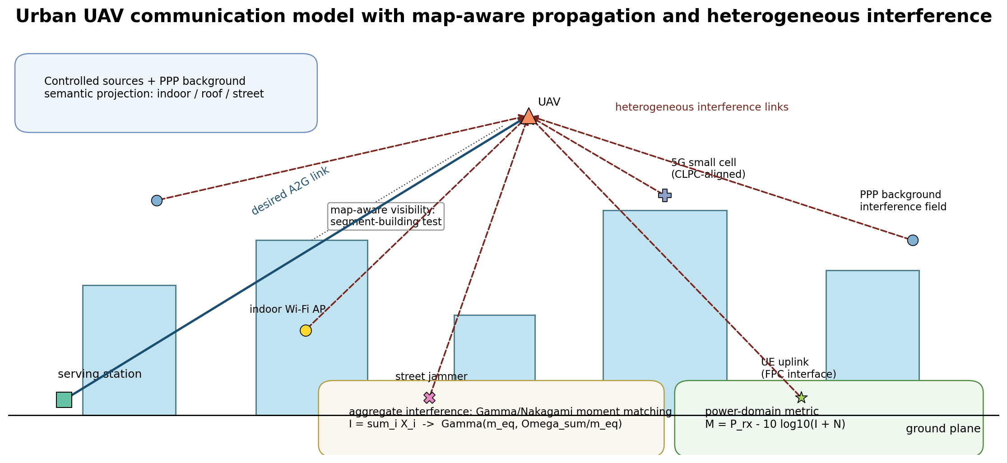
Fig. 2. Urban UAV system schematic with map-aware propagation and heterogeneous interferers.
The heterogeneous interference engine distinguishes Wi-Fi at 2.4/5.8 GHz, 4G cells, 5G small cells, GNSS jammers, industrial/ISM devices, Ku-band terminals, and cellular uplink users. Each class carries a carrier frequency, a calibrated transmit-power range, an activity model, a coverage radius, and an allowed semantic placement set. A projection operator enforces semantic validity, for example, placing Wi-Fi primarily indoors, small cells on rooftops or poles, and jammers on the street layer. The background field of class k is modeled by Phi_k ~ PPP(lambda_k), whereas I_c remains explicitly controllable by the optimizer. The total interferer set is I = I_c union I_b.
Omega_i = a_i eta_f(Delta f_i) 10^((P_i - L_i)/10) | (5)
Equation (5) gives the mean linear-domain contribution of interferer i, where a_i is the activity factor and eta_f(Delta f_i) is the spectral coupling term. This form matters because a high-power but spectrally offset interferer may contribute less than a moderate-power cochannel emitter. The model therefore preserves both power and spectrum semantics in a single expression.
To capture time-varying urban interference without introducing a full radio resource management simulator, the AP/BS-side transmit power follows a CLPC-aligned approximation. Let rho_base(t) be the hour-dependent traffic-profile load and rho_user = N_users / C be the instantaneous user-load ratio. The effective load is
rho_eff = (1 - alpha_c) rho_base(t) + alpha_c rho_user | (6)
For each AP/BS class c, let tau_s and tau_f be the sleep and full-power thresholds, and let P_min^(c) = xi_c P_max^(c). The transmit power is updated by a three-state law,
P_tx^(c) = P_min^(c), rho_eff <= tau_s; P_min^(c) + ((rho_eff - tau_s)/(tau_f - tau_s))(P_max^(c)-P_min^(c)), tau_s < rho_eff < tau_f; P_max^(c), rho_eff >= tau_f | (7)
The uplink user class is treated differently. Instead of assigning a static power value, the engine retains a 3GPP-inspired fractional power-control interface,
P_u = min( P_max, P_0 + epsilon L_serv + 10 log10(M_RB) + Delta_TF + f(Delta TPC) ) | (8)
where L_serv is represented by a calibrated serving-path proxy, epsilon is the fractional compensation factor, and the closed-loop correction term f(Delta TPC) is retained as an interface even when its default value is zero. This separation is important: AP/BS CLPC models time-load behavior of access infrastructure, whereas the UE uplink interface models path-loss-sensitive user-side emission.
The aggregate interference is not formed by deterministic linear summation alone. If each per-source power term is approximated by an independent Gamma variate X_i ~ Gamma(m_i, Omega_i / m_i), then E[X_i] = Omega_i and Var[X_i] = Omega_i^2 / m_i. The sum I = sum_i X_i is replaced by an equivalent Gamma law matched on the first two moments [12],
Omega_sum = sum_i Omega_i, m_eq = Omega_sum^2 / sum_i (Omega_i^2 / m_i) | (9)
I ~ Gamma( m_eq, Omega_sum / m_eq ) | (10)
This step has two advantages. First, it introduces a controllable fading severity beyond the Rayleigh case m = 1. Second, it reduces optimization noise compared with independent per-source random sampling while still preserving outage-relevant variability. In expectation mode, the evaluator uses Omega_sum directly; in sample mode, it draws from the equivalent Gamma law with deterministic seeding for repeatability.
4. Power-Domain Degradation Algorithm and Analysis
The goal of the evaluator is not to maximize interference power by itself. Instead, it computes a complete power-domain chain at the UAV receiver, including desired signal power, aggregate interference, thermal noise, resulting margin, achievable rate, outage state, and flight-efficiency penalty. This design avoids the ambiguity that arises when a scenario shows strong interference but an even stronger serving link. The receiver-side effective interference-plus-noise power is
P_IN = 10 log10( I + N ) | (11)
where I is in milliwatts after the Nakagami aggregate model and N is the thermal noise plus receiver noise figure in the same linear domain. The desired-link received power is obtained from the unified path-loss model and optional small-scale fading, and the power margin is defined by
M = P_rx - P_IN | (12)
The corresponding linear-domain SINR and Shannon upper-bound rate are
gamma = 10^(M/10), R = B log2(1 + gamma) | (13)
Instead of using a hard outage indicator as the optimization target, the communication degradation is mapped through a bounded logistic function centered at the engineering threshold theta,
D_comm(M) = 1 / (1 + exp((M - theta)/s)) | (14)
This choice is deliberate. A binary outage metric is too discontinuous for stable search, whereas a raw SINR or rate objective over-emphasizes high-quality regions that are irrelevant to vulnerability discovery. The logistic map is monotone, smooth, and threshold-aware: it is nearly flat in clearly safe or clearly failed regions, but most sensitive exactly where the communication state is about to collapse. In the present configuration, theta = 0 dB and s = 3 dB.
To prevent the optimizer from producing physically implausible high-degradation scenarios by merely driving UAV speed to arbitrary extremes, a mobility-energy term is constructed from the rotary-wing propulsion-power law [11], [14]. In compact form, P_bp(v) = P_0(1 + 3v^2/U_tip^2) denotes the blade-profile component and P_ind(v) = P_i sqrt( sqrt(1 + v^4/(4v_0^4)) - v^2/(2v_0^2) ) denotes the induced-power component,
P_prop(v) = P_bp(v) + P_ind(v) + 0.5 d_0 rho s A v^3 | (15)
D_mob(v) = 1 - P_hover / P_prop(v), P_hover = P_0 + P_i | (16)
The final per-UAV objective is a weighted composite
D_total = (w_c D_comm + w_v D_mob) / (w_c + w_v) | (17)
with default weights w_c = 0.7 and w_v = 0.3. Communication reliability remains dominant, but the optimization is discouraged from selecting only unrealistic flight states. For a candidate scenario x with N_U UAVs, the score passed to the optimizer is the mean composite degradation
F(x) = (1 / N_U) sum_{u=1}^{N_U} D_total^(u)(x) | (18)
The evaluator is traceable at every step: each candidate can be decomposed into P_rx, I, N, P_IN, M, SINR, rate, and mobility penalty. This is a major engineering advantage over black-box risk scores. It also explains why the proposed method can distinguish between two superficially similar scenarios: one may have stronger absolute interference, whereas the other is more harmful because its serving path has collapsed after a geometry change.
Algorithm 1. Scenario evaluation and degradation scoring
Input: urban parameters, buildings B, stations S, candidate vector x, CLPC/FPC parameters, Nakagami parameters.
1: decode UAV states and controlled interferers from x; project each source to a valid semantic placement.
2: generate PPP background interferers by class and append them to the controlled source set.
3: calibrate AP/BS powers with the CLPC approximation; calibrate cellular uplink powers with the FPC interface.
4: for each UAV, compute desired-link path loss and received power using map-aware visibility.
5: compute per-source Omega_i after path loss, spectral coupling, activity, and penetration losses.
6: form aggregate interference by Nakagami/Gamma moment matching and obtain I and P_IN.
7: compute margin M, SINR, rate, outage, D_comm, D_mob, and D_total.
8: return F(x) = mean_u D_total^(u)(x) together with all intermediate metrics.
Algorithmic summary of the proposed evaluation chain.
The computational bottleneck lies in repeated LoS checking and interference accumulation. With grid-accelerated building queries, visibility testing avoids exhaustive intersection checks against the full building set. For a fixed candidate, the evaluation cost is approximately linear in the number of active interferers per UAV. Consequently, the total search cost is dominated by O(N_pop N_gen C_eval) for GA, where C_eval is the cost of one scenario evaluation. This structure is compatible with engineering-scale repeated search and is much more transparent than an end-to-end learned surrogate trained without physics constraints.
5. Boundary Search via GA and GAN
The candidate vector contains continuous UAV coordinates, altitudes, and speeds, together with mixed discrete-continuous interferer variables such as type, power, semantic placement, and location. Because the objective contains discrete visibility switching, semantic projection, piecewise CLPC states, and stochastic-yet-repeatable Nakagami sampling, it is not suitable for gradient-based optimization. A real-coded GA is therefore used as the primary worst-boundary search engine.
The role of GAN is different. The generator is trained on high-degradation samples discovered by GA after normalization and filtering. It does not replace GA as a global optimizer; instead, it learns the neighborhood geometry of already discovered adverse scenarios and generates additional candidates around that boundary. This division of labor is essential. GA is responsible for discovery, while GAN is responsible for local boundary densification and sample library expansion. Under a limited training set, GAN should not be expected to outperform the search engine that provided its adverse examples.
Figure 1 summarizes the complete method chain, from literature-grounded modeling assumptions to city generation, interference calibration, power-domain KPI extraction, and measurement-aligned validation. The important point is that every optimization step is tied to a physically interpretable metric and that the same evaluator is reused for simulation and for measurement-aligned corner-case analysis.
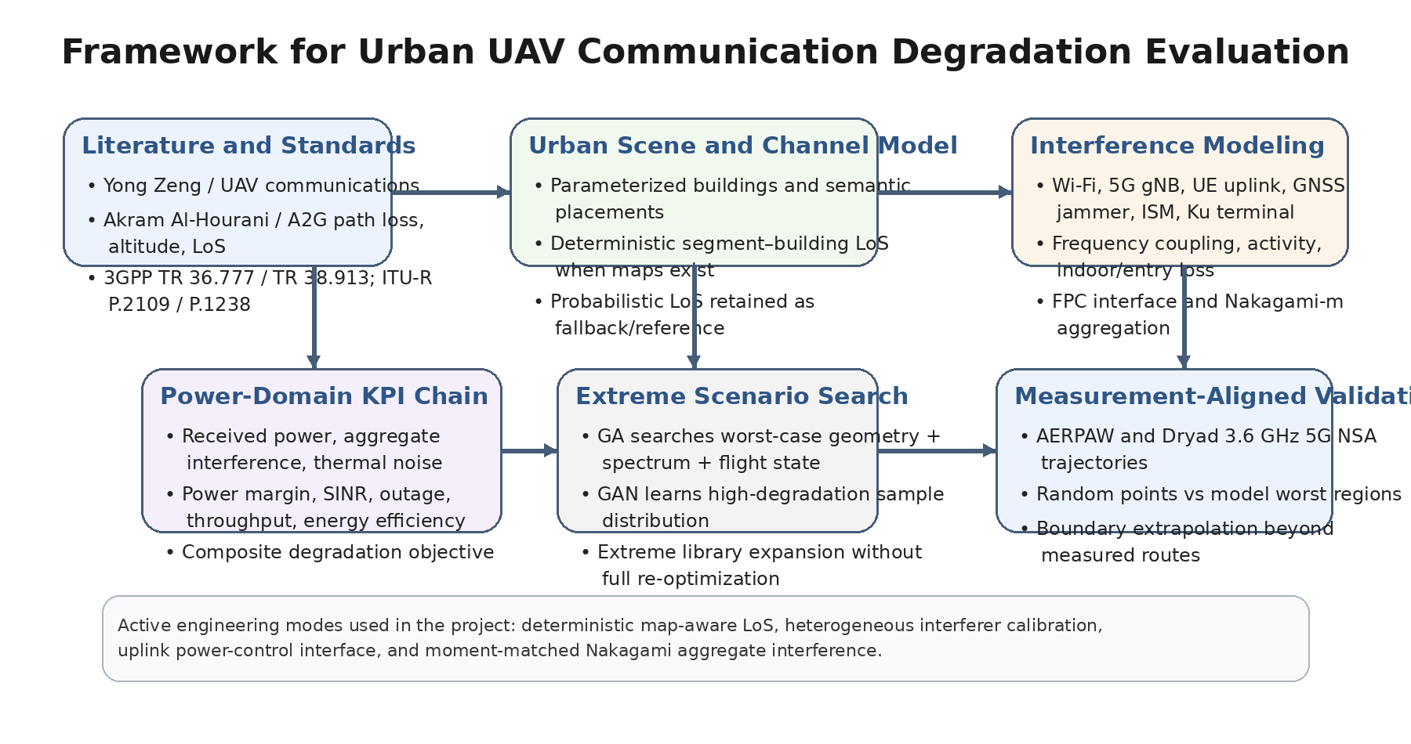
Fig. 1. Overall workflow of the proposed urban UAV communication degradation evaluation framework.
6. Experimental Results
The main configuration used for quantitative evaluation contains 6 UAVs, 4 ground stations, a 1200 m x 1200 m urban region, 8 controlled interferers, deterministic-if-map visibility, enabled PPP background interference, CLPC enabled at hour 19.0, CLPC blending alpha 0.65, sleep/full thresholds 0.12/0.88, and sample-mode Nakagami aggregation. The default margin threshold is 0 dB and the logistic slope is 3 dB. Table 2 lists the principal scenario settings.
Table 2. Principal simulation parameters for the CLPC-Nakagami evaluation setting.
Parameter | Value
Number of UAVs / stations | 6 / 4
Urban area size | 1200 m x 1200 m
Maximum UAV altitude | 350 m
Building coverage / density / height scale | alpha=0.45, beta=120 km^-2, gamma=40 m
Maximum building height | 120 m
Controlled interferers | 8
CLPC configuration | enabled, hour=19.0, alpha_c=0.65, tau_s=0.12, tau_f=0.88
Background interference | enabled
Visibility mode | deterministic_if_map
Aggregate interference model | Nakagami-m, sample mode
Degradation threshold / slope | theta=0 dB, s=3 dB

Table 3. Statistical comparison of GA, GAN, and random search under the CLPC-Nakagami configuration.
Method | Samples | Mean total deg. | Mean comm. deg. | Avg. interference (dBm) | Avg. margin (dB)
GA | 4 | 0.4225 | 0.6036 | -105.43 | -0.61
GAN | 6 | 0.2309 | 0.3298 | -100.47 | 5.61
Random | 20 | 0.3523 | 0.5034 | -104.05 | 2.53

Table 3 shows that GA produces the most adverse scenarios in the current configuration. Its mean total degradation is 0.4225, which is 19.9% higher than random search and is accompanied by a negative average margin of -0.61 dB. This result confirms that the search objective indeed discovers boundary states in which the receiver operates near or below the communication threshold. The outcome is also consistent with the outage curves, where GA dominates the low-margin regime across thresholds.
A particularly important observation is that worst degradation does not coincide with the strongest average interference power. The GAN set exhibits a stronger mean aggregate interference (-100.47 dBm) than both GA (-105.43 dBm) and random search (-104.05 dBm), yet its average margin remains 5.61 dB. In other words, a scenario can carry more interference power and still be less harmful if the serving link remains strong. This is exactly why the proposed method optimizes the power margin instead of optimizing interference power alone. Figure 2 and Figure 3 visualize this distinction from complementary perspectives.
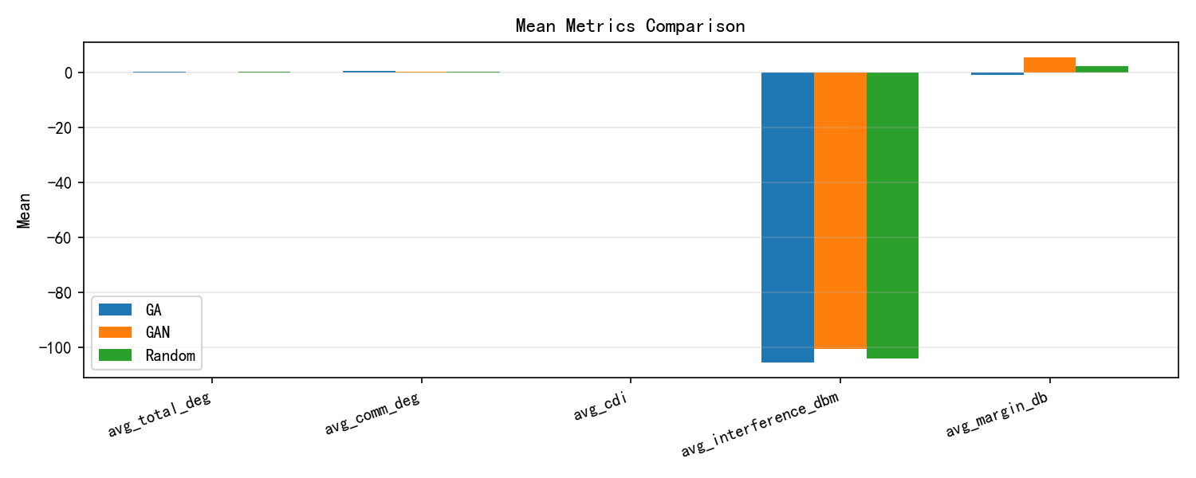
Fig. 2. Comparison of mean total degradation, communication degradation, interference power, and margin for GA, GAN, and random scenarios.
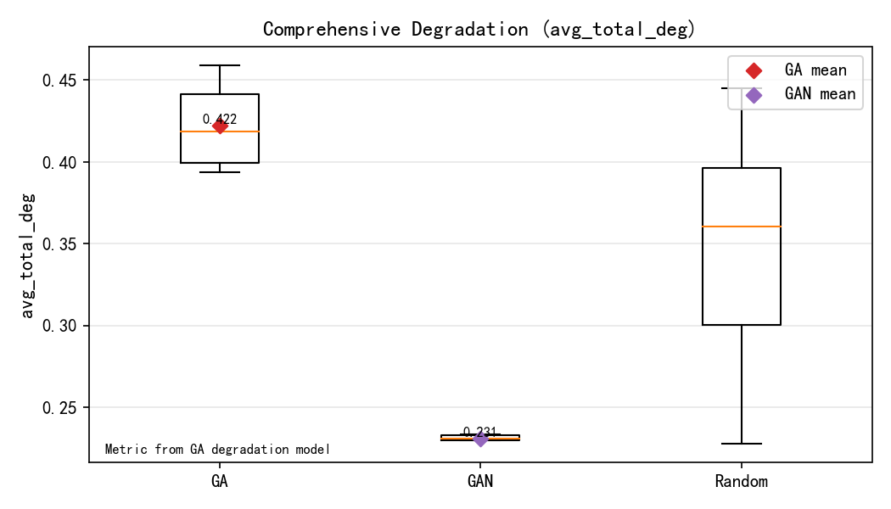
Fig. 3. Distributional overview of the composite degradation under GA, GAN, and random search.
The GAN results should be interpreted cautiously. Under the present sample library, GAN behaves as a boundary-neighborhood generator rather than as a boundary finder. Its degradation statistics are more concentrated and clearly lower than those of GA. This does not invalidate the generator; instead, it confirms the intended division of labor discussed in Section 5. A larger adverse library and stronger training diversity are expected to make the GAN samples approach the discovered boundary more closely.
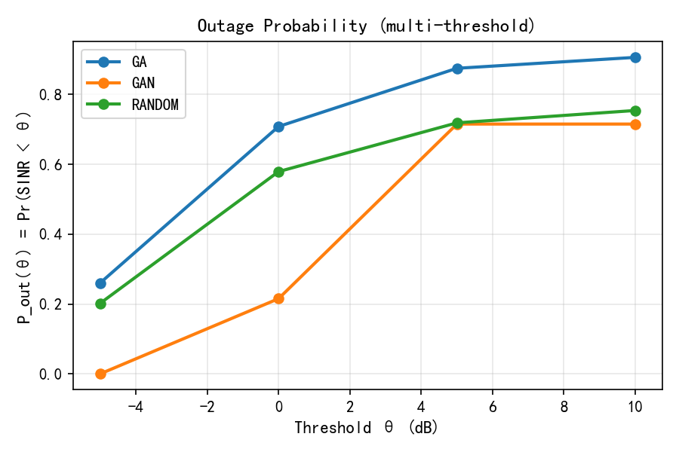
Fig. 4. Outage probability trends for GA, GAN, and random scenarios under multiple margin thresholds.
Validation against public measurements further clarifies the meaning of the optimized worst region. The comparison is not intended to copy the empirically worst sample on a measured trajectory. Rather, it asks whether the model can identify a conservative region that is more fragile than the observed route while remaining consistent with the aligned environment. Table 4 summarizes the results.
Table 4. Measurement-aligned comparison for AERPAW and Dryad at 3.6 GHz.
Dataset | Group | Mean SINR (dB) | Mean throughput (Mbps) | Outage @10 dB
AERPAW | Measured trajectory | 16.05 | 562.55 | 0.384
AERPAW | Random points | 14.91 | 515.78 | 0.325
AERPAW | Model worst region | -10.72 | 13.32 | 1.000
Dryad | Measured trajectory | 14.69 | 507.07 | 0.275
Dryad | Random points | 14.31 | 497.21 | 0.325
Dryad | Model worst region | -8.74 | 20.06 | 1.000

For AERPAW, the modeled worst region lowers the mean SINR from 16.05 dB on the measured trajectory to -10.72 dB, a gap of 26.77 dB, while the mean throughput collapses from 562.55 Mbps to 13.32 Mbps, corresponding to a 97.63% reduction. For Dryad, the mean SINR decreases from 14.69 dB to -8.74 dB, a 23.43 dB gap, and the mean throughput decreases from 507.07 Mbps to 20.06 Mbps, a 96.04% reduction. In both datasets, the worst region also drives the outage probability at 10 dB to 1.0, which is far more severe than the measured or random baselines.
These results support the interpretation of the method as a conservative vulnerability-boundary finder. It identifies where the urban scene can become more fragile than what was actually traversed by the measured route. Such an ability is valuable for mission planning, safety evaluation, and stress testing of UAV communication policies because it goes beyond route replay and explores latent but physically plausible weak regions.
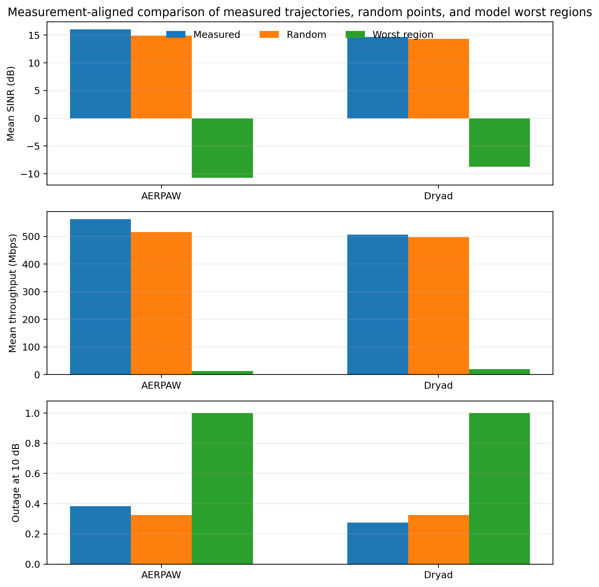
Fig. 5. Measurement-aligned comparison of measured trajectories, random points, and model worst regions for AERPAW and Dryad.
7. Discussion and Limitations
The main advantage of the proposed framework is not only that it searches for strong interference scenarios, but that it preserves an end-to-end causal chain from urban geometry to degradation outcome. This chain allows one to explain why a given candidate is harmful: whether the cause is a serving-link collapse, a new rooftop interferer entering LoS, a CLPC-driven power rise during busy hours, an indoor leakage path with favorable spectral coupling, or a mobility-induced efficiency penalty. Such traceability is indispensable when the goal is engineering diagnosis rather than black-box scoring.
At the same time, several limits should be stated explicitly. The AP/BS CLPC mechanism is a time-load approximation rather than a full network-level closed-loop scheduler. The UE uplink term retains the closed-loop correction interface f(Delta TPC), but the default correction value is not yet a measured temporal sequence. The Nakagami parameters remain engineering configuration values rather than externally regressed field parameters for each source class. Finally, the current GAN library is still modest and should therefore be interpreted as a neighborhood generator built on top of GA-discovered adverse samples. These limits do not undermine the methodological contribution, but they define the proper scope of current claims.
8. Conclusion
This paper presented a formal SCI-style study on worst-case degradation assessment for urban UAV communications. The central argument is that urban UAV vulnerability cannot be captured by average coverage or by interference power alone. Because altitude changes both desired and interfering geometry, because visibility switches discretely in map-aware settings, and because emitter power depends on semantics and load, the relevant object of study is the vulnerable boundary of the power margin rather than a single mean path-loss curve.
To that end, the paper developed a unified method chain that combines deterministic map-aware propagation, heterogeneous interferer calibration, AP/BS CLPC approximation, UE uplink FPC interface, Nakagami-m aggregate interference, a power-domain logistic degradation metric, and GA-GAN boundary search. The quantitative results show that GA consistently finds more adverse scenarios than random search under the CLPC-Nakagami configuration, while measurement-aligned studies on AERPAW and Dryad confirm that the modeled worst region can be much more fragile than the observed trajectory. The proposed framework therefore provides a rigorous basis for conservative urban UAV communication evaluation and offers a clear path toward future extensions with richer closed-loop traces, field-calibrated fading parameters, and larger adverse-scenario libraries.
References
[1] Y. Zeng, R. Zhang, and T. J. Lim, "Wireless communications with unmanned aerial vehicles: Opportunities and challenges," IEEE Communications Magazine, vol. 54, no. 5, pp. 36-42, 2016.
[2] Y. Zeng, Q. Wu, and R. Zhang, "Accessing from the sky: A tutorial on UAV communications for 5G and beyond," Proceedings of the IEEE, vol. 107, no. 12, pp. 2327-2375, 2019.
[3] Y. Zeng, J. Lyu, and R. Zhang, "Cellular-connected UAV: Potential, challenges, and promising technologies," IEEE Wireless Communications, vol. 26, no. 1, pp. 120-127, 2019.
[4] A. Al-Hourani, S. Kandeepan, and A. Jamalipour, "Modeling air-to-ground path loss for low altitude platforms in urban environments," in Proc. IEEE GLOBECOM, 2014, pp. 2898-2904.
[5] A. Al-Hourani, S. Kandeepan, and S. Lardner, "Optimal LAP altitude for maximum coverage," IEEE Wireless Communications Letters, vol. 3, no. 6, pp. 569-572, 2014.
[6] M. Mozaffari, W. Saad, M. Bennis, Y.-H. Nam, and M. Debbah, "A tutorial on UAVs for wireless networks: Applications, challenges, and open problems," IEEE Communications Surveys & Tutorials, vol. 21, no. 3, pp. 2334-2360, 2019.
[7] 3GPP TR 36.777, "Enhanced LTE support for aerial vehicles," Release 15, 2017.
[8] ITU-R Recommendation P.1238-13, "Propagation data and prediction methods for the planning of indoor radiocommunication systems and radio local area networks," 2025.
[9] ITU-R Recommendation P.2109-2, "Prediction of building entry loss," 2023.
[10] W. Mei and R. Zhang, "Aerial-ground interference mitigation for cellular-connected UAV," IEEE Wireless Communications, vol. 28, no. 1, pp. 167-173, 2021.
[11] Y. Zeng and R. Zhang, "Energy-efficient UAV communication with trajectory optimization," IEEE Transactions on Wireless Communications, vol. 16, no. 6, pp. 3747-3760, 2017.
[12] I. S. Ansari, F. Yilmaz, M.-S. Alouini, and O. Kucur, "New results on the sum of Gamma random variates with application to the performance of wireless communication systems over Nakagami-m fading channels," Transactions on Emerging Telecommunications Technologies, vol. 28, no. 1, e2912, 2017.
[13] R. Asokan, O. Ozdemir, I. Guvenc, and M. L. Sichitiu, "Aerial RF and throughput measurements on a non-standalone 5G wireless network," in Proc. IEEE, 2024.
[14] G. Auer et al., "How much energy is needed to run a wireless network?," IEEE Wireless Communications, vol. 18, no. 5, pp. 40-49, 2011.
[15] D. Lee, S. J. Maeng, O. Ozdemir, M. B. Pandian, and I. Guvenc, "Reliability of Wi-Fi, LTE, and 5G-based UAV RC links: Uplink interference asymmetry analysis and HARQ design," 2024.

