Plugin *UserTakeOver*

Documentation

¨

|  |  |
| --- | --- |
| Date of Release: | 21.11.2014 |
| Document-Version: | 1.0 |
| Plugin-Version | 1.0.0 and above |
| Author: | Martin Studer, studer + raimann ag |

|  |  |  |
| --- | --- | --- |
| Version | Author | Changes |
| 1.0 | Martin Studer | Created |

Table of contents

1 Introduction 4

2 Installation 5

2.1 Create the Plugin Directory 5

2.2 Get the Plugin from GitHub 5

# Introduction

The UserTakeOver-Plugin gives you the possibility to take over the view of another ILIAS User.

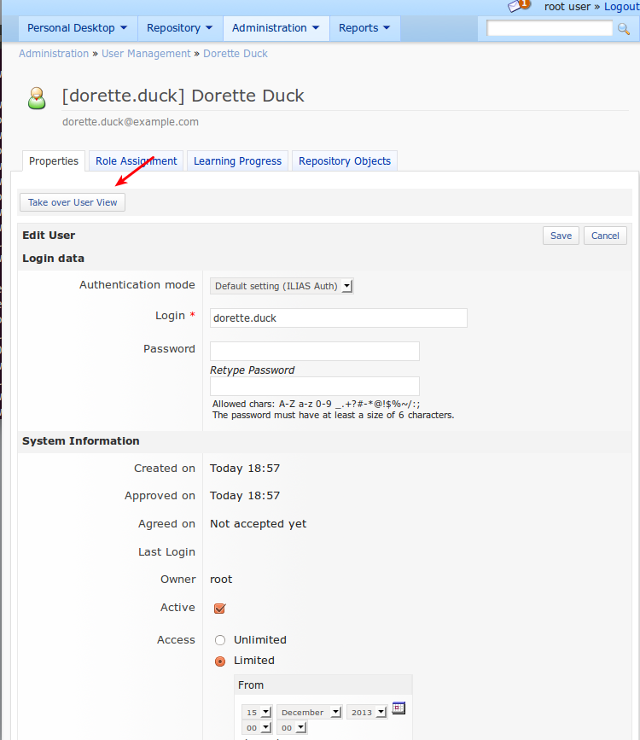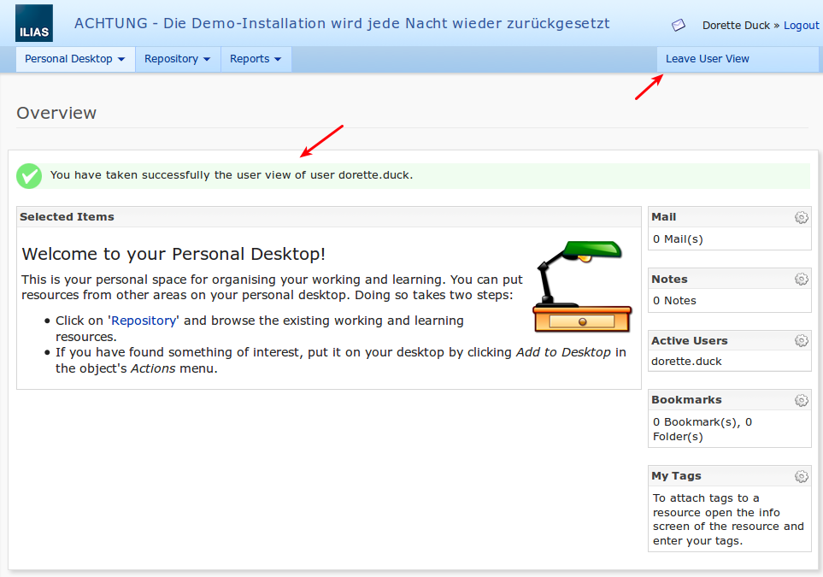

# Installation

## Create the Plugin Directory

[ILIAS-WWW]/Customizing/global/plugins/Services/UIComponent/UserInterfaceHook

## Get the Plugin from GitHub

The project can be found on github: https://github.com/studer-raimann/UserTakeOver

git clone <https://github.com/studer-raimann/UserTakeOver.git> UserTakeOver

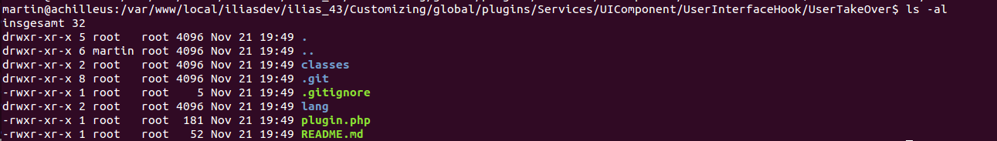Abbildung 1: Example Directory Structure