Computer programming

Final Project

Report

I.E.S. San Vicente
San Vicente del Raspeig (Alicante)
2017/2018

Teachers:
José Ignacio Cabanes / Ignacio Iborra

Student:
Guillermo Pastor Pastor

-= Note: all the texts included here are just an example
of the way that the report should look when finished
Each student must replace these texts with
the ones corresponding to their projects =-

1. Introduction
Project name
Trello Like App

Made by
Guillermo Pastor

Short description of the project
This is a "Trello Like App" an app that will help people to control and manage their projects. It is an app made in Windows Forms

2. Functionality of the project
After entering the program, a welcome screen will be displayed, where the user can choose between:

- Create projects.
- View projects.
- Edit projects.
- Credits Screen or F.A.Q button.
- Quit the game.

If the user chooses to create a project, she / he will be asked about the name of the project and the boss that is In charge of that project, then who the programmers are, it will ask to enter a project name, after that you can enter subtasks of that project, like classes or functions and who is the one in charge of making that part.

If option two is selected, the user can see the projects that are in the process of being made, then he can select one of them, and see its subtasks

If option three is selected, the user will be able to edit the active projects, in case of faults, or need to add more subtasks.

3. Screen prototype
The game screen will look like this:
Approximate view of my project
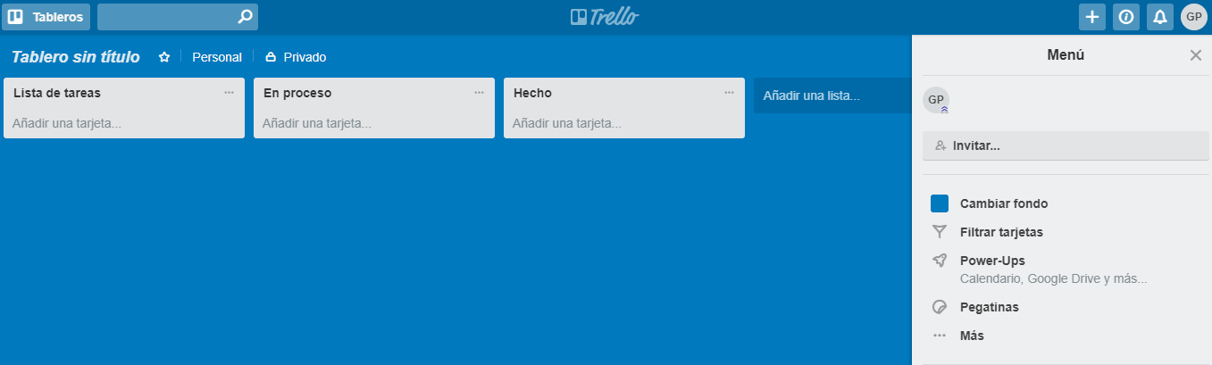

4. Analysis

4a. Requisites
Requisite | Date achieved
The program will allow the user to create a project.
The program will allow the user to add subtasks to the project.
The program will allow the user to add the boss of that project and its programmers.
The program will allow the user to add and see the dates in which the project should end.
The program will allow the user to look at other projects and archive them in case they are finished.
The program will allow the user to edit the active projects in case that the user can make some changes, to the project
The program will start with a welcome screen.
The intro screen will allow the user to enter a Credits screen which will display data about the programmer and version of the program.
The program will use windows forms
(...)

4b. Basic pseudocode

4c. Classes diagram
(…)

5. Initial planning and expected deliveries

5a. Expected deliveries
- Version 1: Main menu with it options. (can’t be used yet)
- Version 2: First option / tab in the menu, create a project and add the workers. (no subtasks added yet)
- Version 3: Be able to add subtasks to projects.
- Version 4: Second Option / tab in the menu, look at the projects already made.
- Version 5: Third option / tab in the menu, edit the projects already made.
- Version 6: Tab in the menu, with a calendar in which you can see the deadlines of the projects.
- Version 7: Class Employee, save employees, and refresh button
- Version 8: Calendar, and see the deadlines in bold.
- Version 9: Alert of the deadlines in one week or less.
- Version 10:
- Version 11:
- Version 12:
- Version 13:
- Version 14:
- Version 15:

5b. Real deliveries
- Version 1 (May 14): As expected: First option / tab in the menu, create a project and add the workers. (no subtasks added yet)
- Version 4 (May 17): Created class SubTasks and methods for save in local file. Created class non-functional Employees. Created Events for save in local file SubTasks.
- Version 5 (May 18): Class Employee, save employees, and refresh button.
- Version 6 (May 21): Added a calendar to see deadlines, in bold.
- Version 7 (May 22): Alert of the deadlines in one week or less.
- Version 8 (May 23):

6. File formats

6a. Plain files format
The projects are saved in to a custom text file with the extension .tla, which contains the name of the project in one line, the boss of that project, a short description, the start and end date of that project, and the subtasks if you add them to the project,
Example:
Project Name: Hola
Project Manager: Brandon Blasco
Short Description: asd
Start Date: 21/05/2018
End Date: 21/05/2018
---- ñaa43?
----Sara Abad
----asdasda

7. Problems found and solutions

8. Improvements or restrictions to the starting design

9. Screenshots of the final project

10. Source code of the final project

