StudentShield: Machine Learning-Based Emotional Distress Detection and Bullying Reporting System with Automated Parental Alerts for Junior High School Students at Saint Vincent Blessed School of Manila

A Capstone Project
presented to the Faculty of the
School of Arts, Science and Technology
National Teachers College
Quiapo, Manila

In Partial Fulfillment of the
Requirements for the Degree of
Bachelor of Science in Information Technology

By
Enriquez, Justin Altamia
Melgarejo, John Carlo
Meneses, Vonn Christian Miel
Ramos, John Cris
Urayanza, Ashley Princess

May 2026
APPROVAL SHEET FOR TITLE DEFENSE

This Capstone Project entitled StudentShield: Machine Learning-Based Emotional Distress Detection and Bullying Reporting System with Automated Parental Alerts for Junior High School Students at Saint Vincent Blessed School of Manila
was prepared and submitted by:

Enriquez, Justin Altamia
Melgarejo, John Carlo
Meneses, Vonn Christian Miel
Ramos, John Cris
Urayanza, Ashley Princess

has been approved by the REVIEW COMMITTEE as partial fulfillment of the requirements for the subject Capstone Project

Mr. Edward James V. Grageda
Adviser

REVIEW COMMITTEE

Mrs. Rodessa Bunag Mr. Joshua Pacer
Panelist 1 Panelist 2

Accepted and approved by:
Carlito L. Cunanan, MIT
Information Technology Department

Liezel L. Aguilar, MACDDS
School of Arts, Sciences and Technology

APPROVAL SHEET FOR PRE - ORAL DEFENSE

This Capstone Project entitled StudentShield: Machine Learning-Based Emotional Distress Detection and Bullying Reporting System with Automated Parental Alerts for Junior High School Students at Saint Vincent Blessed School of Manila
was prepared and submitted by:

Enriquez, Justin Altamia
Melgarejo, John Carlo
Meneses, Vonn Christian Miel
Ramos, John Cris
Urayanza, Ashley Princess

has been approved by the REVIEW COMMITTEE as partial fulfillment of the requirements for the subject Capstone Project.

Mr. Edward James V. Grageda
Adviser

REVIEW COMMITTEE
Panelist 1 Panelist 2
Panelist Panelist
Panelist
Panelist Chair

Accepted and approved by:
Carlito L. Cunanan, MIT
Information Technology Department

Liezel L. Aguilar, MACDDS
School of Arts, Sciences and Technology
TABLE OF CONTENTS

CHAPTER 1. INTRODUCTION 7
Project Purpose 8
Project Description 9
Objective of the Study 9
General Objective of the Study 9
Specific Objectives of the Study 10
Significance of the Study 10
Scope and Delimitations of the Study 12
Scope 12
Limitations 13
Review of Related Literature 14
Technical Background 32
Conceptual Framework 33
Definition of Terms 36

CHAPTER II. METHODOLOGY 39
Design of Software, System, Product or Process 39
Software Architecture 39
Data Flow Diagram 40
Software Development Life Cycle 42
System Flowchart 46
Entity Relationship Diagram 49
Use Case Diagram 51
Requirements Analysis 53
Requirements Documentation 56
Statistical Treatment of data 67
Data Gathering Technique 68
Setting of the Study 68
Subject of the Study 69
Sampling Technique 69

LIST OF FIGURES
Figure 1. Conceptual framework 33
Figure 2. Software Architecture 38
Figure 3. DFD Level 0 39
Figure 4. DFD Level 1 40
Figure 5. Software Development Life Cycle - Agile Model 42
Figure 6. Super Admin Flowchart of StudentShield System 45
Figure 7. Counselors Flowchart of StudentShield System 46
Figure 8. Students Flowchart of StudentShield System 47
Figure 9. Entity Relationship Diagram 48
Figure 10. Use Case Diagram 50
Figure 11. Implementation Plan using Gantt Chart 64

LIST OF TABLES
Table 1: Test Case Scenario for Authentication Module 60
Table 2: Test Case Scenario for Vent Log Module 61
Table 3: Test Case Scenario for Bully Report Module 61
Table 4: Test Case Scenario for Dashboard and Case Management Module 62
Table 5: Test Case Scenario for User Management Module 63
Table 6: Test Case Scenario for Audit Log Module 63
Table 7: Mean Interpretation 70
Table 8: Standard Deviation Interpretation 71

CHAPTER I. INTRODUCTION
Today’s students grow up in the age where their surroundings are determined primarily by technological connectivity. With the introduction of technology into life, people have gained the chance to get information promptly. The fact that every student and teacher live in the world of screens makes the communication style between them change drastically. Nevertheless, this transition to digital communication has also caused various issues, like cyberbullying, harassment, and even concealed emotional problems.
To handle these modern issues, modern means should be used. Given that most of the student interaction is conducted via electronic devices, technologies should be used actively to prevent any harmful actions. Using technologies will make it possible to trace bullying or other risky behavior of students with the help of software applications rather than only relying on traditional control measures. In case when the administration uses sophisticated monitoring methods, it will be able to track all digital communications and get immediate alerts regarding any critical behavior of the student.
In an effort to enable schools such as St. Vincent Blessed School of Manila (SVBSM) to effectively identify and mitigate risks in students, the developers came up with StudentShield, which is a complete solution that helps mitigate the effects of peer victimization both socially and psychologically. Unlike the conventional way of dealing with student risks where the user is always expected to constantly keep on checking the dashboard, StudentShield incorporates a module for sending emails automatically whenever there is a risk through the use of the Simple Mail Transfer Protocol (SMTP).

Project Purpose
The primary goal of StudentShield is to enable SVBSM to gain access to a reliable and fully automated system of detection and prevention of cyberbullying and behavioral risks that will facilitate identification and addressing cyberbullying in real-time. This has been achieved by integrating technological solutions and the requirements of the guidance and student affairs departments due to the integration of NLP.
In case there is no central monitoring system present at an educational facility, several issues arise when it comes to tracking student behavior and preventing it before it turns out to be very dangerous. That is why the key elements underlying the development of StudentShield are as follows:

- Proactive Risk Detection: Switching to proactive detection using NLP algorithms to detect the earliest warning signs from student communications.
- Priority Action: Implementing a classification system to classify all incidents according to Low, Medium, High, and Critical criteria and provide immediate help to students belonging to the latter. Enabling the SVBSM administration to take actions aimed at improving the wellbeing of their students on the basis of trend data and monitoring.
- Trend Analytics & Monitoring: Leveraging trend data to identify patterns in student wellbeing and empowering the administration with data-driven decision making.

Project Description
The advocates seek to implement a machine learning solution to monitor and manage risks that can enhance the safety of the students in the SVBSM environment; it is known as StudentShield. The machine learning solution proposed for this study utilizes a hybrid model where the PHP CodeIgniter 4 will be used as a web-based user interface for administration, and the Python FastAPI framework for performing the machine learning computations.
In this model, the analysis of the texts with natural language processing allows us to classify the emotion level into four different risk categories: low, medium, high, and critical. Such an analysis can generate instant alerts to the concerned people, especially to the guidance counselor when there is a critical behavioural risk identified. Hence, this will allow the StudentShield to provide real-time notifications to the concerned party regarding the threat to students' safety. Data privacy and security was a major concern in the design of the machine learning model because the data involved are private information about students.

Objective of the Study

General Objective of the Study
The general goal of this study involves designing an NLP-driven intervention system (StudentShield) that will be used for automating the process of identifying bullying cases, assessing behavioral risks, and ensuring proactive administrative intervention in cases of bullying at SVBSM.

Specific Objectives of the Study
- To create a "Safe Space" web platform where SVBSM Junior High School students will have the possibility to report their emotional outbursts, as well as formally file a case of bullying unidentified, with an option to add photos and videos to support their claim.
- To implement a Predictive Risk Classification Architecture (with mDeBERTa-v3, GoEmotions classifier, and FAISS recurrence model) that analyzes text-based data inputs and detects psychological distress indicators to predict the likelihood of risk escalations, apart from the normal risk categories of Low, Medium, High, and facCritical.
- To integrate a behavioral trajectory tracking module that will track student's behavior for 14 days to identify any patterns of deterioration in behavioral risks and warn the administration.
- To create a real-time Alerting System with SMS alerts via a local SMS Gateway, as well as email alerting for notifying parents and school administrators at once whenever critical incidents arise.
- To verify the accuracy of the AI danger flags through an official pilot test with the SVBSM administration to assure legal compliance, and to assess the system's accuracy and data privacy by imposing AES-256 encryption for secure data processing.
- To develop an integrated online video conferencing module that enables guidance counselors to conduct secure, real-time virtual consultations with students directly within the StudentShield platform.

Significance of the Study

The proposed study would provide a tremendous enhancement to the way the student wellbeing at Saint Vincent Blessed School of Manila is maintained. The traditional environment would focus on solving disciplinary and wellness problems reactively after they have become publicly known. StudentShield would reverse such a process by providing the institution with a proactive technology-based approach, making sure that the intervention during "Golden Hour" would take place.
The Client / Organization (Saint Vincent Blessed School of Manila)
The proposed research would provide SVBSM with an up-to-date instrument for dealing with the problem of decentralized report management. Now that the school can count on a centralized procedure, it would be able to avoid unnecessary paper work and verbal notifications of any kind. This will give an opportunity to the administration to better use their guidance staff.
End Users (Students and Guidance Counselors)
StudentShield offers students a safe space to share their thoughts without feeling immediately judged by all but assured there is help available should anything happen. Students can express themselves in a conditional anonymous manner and vent what they want without fear since the system knows their identity. It acts like an automated assistance counselor for the guidance counselors in filtering through several vents and focusing on High and Critical cases thereby minimizing the daily work of counselors.
The Parents
Parents are also the weakest link in the security of schools due to the fact that they are also the last to know about any issues that may arise involving their children. The solution to that is to give the students an instant response system. If the issue is life-threatening or aggressively violent in nature, then the NLP engine automatically sends an alert to the parent. Thus, the parent would be notified instantly about the situation which needs immediate intervention both at home and at school. Parents can receive automated emails and get a real-time notification regarding the psychological state of the child and cyber-bullying.
The School / Institution
SVBSM has demonstrated its dedication to digital security through its use of Student Shield in that it will move away from the old and vulnerable record systems and adopt a new and efficient system that is compliant with data privacy laws in the country..
The Proponents
One of the key lessons learned during this whole process was dealing with the difficulties of combining various web technologies for developing a system that can link a PHP and CodeIgniter web application with a Python and FastAPI microservice. The team members also learned how to integrate APIs, use AES-256 data encryption, and route notifications in real time.
Future Researchers
This project presents a case study on how to implement transformers' capabilities in practical settings. Future research could base their studies on this model, for instance, by improving the NLP engine for different dialects, among other options.

Scope and Delimitations of the Study

Scope
- Creating a safe "Safe Space" web application that will provide SVBSM Junior High School students an anonymous means to vent their emotions and report incidents of bullying using photos and videos.
- Implementing a predictive risk classification architecture consisting of multiple layers (mDeBERTa-v3, GoEmotions multi-label classifier, and FAISS recurrence model) that examines text inputs for signs of psychological distress and predicts probabilities of future risks, along with risk classifications (Low, Medium, High, and Critical).
- Implementing a trajectory tracker that uses (FAISS) to capture the student's last 14 days' behavioral trends.
- Installing a dashboard with an administrative counselor that has features to send instant SMS notifications via the Local SMS Gateway and email alert to alert parents and other relevant stakeholders.
- Implementation of a secure database architecture utilizing AES-256 encryption for student entries and a web-based dashboard for counselors to monitor system-generated risk flags.
- The StudentShield platform strictly sticks to Republic Act 10173 or Data Privacy Act of 2012. In light of implementing this software among junior high school students at SVBSM, it must be noted that terms of service as well as the Guardian Consent model should be applied. Consequently, user registration, mood tracking, and notification for parents must be suspended until guardian consent is secured.
- The system includes an online video conferencing feature limited to one-on-one sessions between a student and a designated guidance counselor, conducted within the platform for confidential consultation purposes.

Limitations
- It is not a diagnostic tool for mental illnesses; it is not a prescription for treatment; it is not a replacement for the services of a professional guide counselor.
- Live chat and interactive dialogue are not supported.
- The algorithm behind the machine learning model works on traditional CPUs. While enough for the needs of SVBSM, it is less efficient than graphics cards that other global platforms employ
- The budget for this project was inadequate to increase its capacity to accommodate hundreds, let alone thousands, of users simultaneously from several colleges.
- Internet connection is required at all times to use this service.

Review of Related Literature
A Review On Deep-Learning-Based Cyberbullying Detection. Future Internet
In line with Hasan et al. (2023), the deep learning model, including the convolutional neural network, recurrent neural network, and transformers, has been used for cyberbullying detection in social media platforms. In accordance with their study, BERT and its variations consistently outperform other methods in distinguishing aggressiveness that does not include any slurs.
The researchers correlate this with the current investigation because the StudentShield should be capable of detecting the usage of language even without any explicit terms. Thus, this will require analyzing the entire context of the students' conversation.
Hasan et al. (2023) were the source of inspiration for the proponents regarding the development of the system using the transformer model, which is more complicated than the keyword and rule-based models.
BERT-Based Ensemble Learning for Multi-Aspect Hate Speech Detection
The proposed combination by Mazari et al. (2023) of the pre-trained BERT with Bidirectional LSTM and Bidirectional GRU neural networks for multiclass detection resulted in an ROC-AUC performance of 98.63%. Instead of classifying the text content based on a general binary label like "toxic/not toxic," their model classified them into different categories such as "threat," "insult," and "identity hate."
These researchers relate this technique to the present research in that they both need to categorize the vents of the students not based on only two classes but multiple risk factors such as threats and emotional expression. Following their work, the proponents got the idea of separating the vent into its threat and emotional dimensions, giving counselors a clear view of the risks involved.
Natural Language Processing Applied to Mental Illness Detection
As reported by Zhang, T., Schoene, A.M., Ji, S. et al. (2022), natural language processing algorithms have the capacity to identify signs of depression, anxiety, and suicide risk using non-clinical text such as tweets and postings on forums. According to the authors' findings, pre-trained models pick up on emotional cues that cannot be easily detected using traditional questionnaires and that are frequently ignored by younger individuals in favor of expressing them through digital platforms. In addition to this, it was highlighted that pre-trained models lack accuracy when dealing with language patterns not commonly included in the training set.
It is related to the current study as the StudentShield application analyzes text written in "Taglish" and slang used in English that are absent in the usual English dataset for training language models.
Based on the results of Zhang et al. 's research, the researchers came up with the idea of analyzing the performance of the Go Emotions model when exposed to "Taglish" data obtained from SVBSM students.
DeBERTaV3: Improving DeBERTa with ELECTRA-Style Pre-Training
(He et al., 2021) have proposed DeBERTaV3, which is an improved Transformer model, using replaced token detection during training rather than masked language modeling. This is the model train that scores higher and faster than BERT and RoBERTa, and requires less computation resources in text classification task. Its benchmarks demonstrated that they can get to the top of the SuperGLUE leaderboard with nothing particularly expensive like GPU clusters.
The proponents connect it to this current study as it does not require data center hardware for the analysis engine, but on traditional server machines. The school requires to have a reliable solution that provides high accuracy and low cost, which are critical in maintaining the speed of the system in providing alerts in real time.
The proponents decided on relying on the results of He and the group's research and chose to use DeBERTaV3 as the base Transformer model for the threat detection engine in StudentShield, given the speed of a typical school internet that limits the computations that can be carried out.
Detection of Hate Speech using BERT and Hate Speech Word Embedding with Deep Model
As per Saleh et al. (2023), the training of BERT model along with customized word embeddings generated from the annotated hate speech data sets made the machine able to identify those forms of toxicity that do not often occur in the generic training set. The difference in terms of F1-score was more significant for the tweets that contained covert hatred, where sarcasm or euphemism made it difficult to understand what the tweet means.
This is related to the present study by the proponents since the students of Filipino Junior High School from SVBSM utilize English, Filipino, and street language that has never been seen before in the language model. Thus, there should be some fine-tuning of the model to recognize the coded language. The inspiration for such an approach to developing the classification engine comes from the study by Saleh et al. (2023).
Editorial: Bullying and cyberbullying: their nature and impact on psychological wellbeing
This book explores bullying and Cyberbullying from diverse perspectives, including its frequency, context, and repercussions. According to Fermani et al. (2023), here are some of the issues that do not arise with traditional bullying but come up in cyberbullying: once a message has been put up, it will remain visible for an indefinite amount of time, thus creating a vast audience base, and perpetrators can quickly assume anonymity. The studies conducted by Stuart have shown that the repercussions faced by students who encounter both types of bullying were much worse than those suffered by victims of either form of harassment alone.
It is assumed by the advocates that the data collected through StudentShield through two separate pathways: Safe Space digital venting and the official Bullying Report Module is equivalent to the current research findings. Both sources enable guidance counselors to determine whether the target child suffers from multiple avenues.
Based on Smith's research, the advocates have opted to develop the platform with capabilities to document both informal and formal data about the bullied victim's emotions and incidents.
BERT-based Ensemble Approaches for Hate Speech Detection
Mnassri et al. (2022) point out that stacking multiple BERT-based models and then voting on the results decreases false positives in hate speech detection. According to their research conducted at the IEEE Global Communications Conference, there is no BERT configuration that prevails in all cases of hate speech. Therefore, multiple configurations can ensure safer prediction.
It connects to the proposed research since in an educational institution, even one false alert may completely break the student's faith in the system. The StudentShield system should find a balance between false positives and the actual danger.
Taking into account the findings of Mnassri et al. (2022), the proponents came up with the idea of testing students' text against two models, namely mDeBERTa-v3 for detecting the danger and Go Emotions for emotion analysis, and then combining the results as a second opinion.

Policy Guidance on AI for Children
According to UNICEF (2021), there are nine criteria that the AI systems should satisfy to be considered fair and transparent while ensuring that the information provided is protected by the relevant policies. Also, the system should have human oversight since the use of the technology will directly affect minors.
These associations, therefore, suggest that the technology should be used as an addition to the processes done by teachers, just like what has been suggested by the researchers in this paper. They warn against the automation of the counseling process, which might lead to more harm than good for the students involved.
The proposal, therefore, to develop the proposed model using UNICEF's recommendations, which suggest the use of the 'human-in-the-loop' strategy to score the risk level and alert the students; however, no message will be sent to their parents or the counselor unless somebody is held accountable for their next move.
Understanding The Influence Of Cyberbullying Among High School Students In Philippine Public Schools In The Post-Pandemic Era
Realized that there needs to be a structured reporting system in Philippine schools today which is why recent studies focused on this. Buguina and Buguina (2023) studied the experience of cyberbullying during the period of the post-pandemic in high schools and found that some victims are reluctant to report the cyberbullying and hence do not have secure reporting avenues.
Their research identified some key aspects of how cyberbullying has a devastating impact on pupils' wellbeing and academic achievement. We take a step forward to have an encrypted confidential reporting module, with StudentShield, directly addressing this gap. The system helps students to speak up without fear of exposure, and the guidance office will discuss with the students so that pal’s bullying doesn't escalate.
Understanding Bullying in Philippine Education: Impacts and Opportunities for Change
This is an insightful awareness-raising session on Bullying in Philippine Education and what opportunities for change exist. The Communications and Communications (2025) indicates that the prevalence of bullying among Filipino students is well above the OECD average with nearly one in three students experiencing one or more types of bullying. An absence of tools for digital monitoring is cited as a factor in why schools are not able to intervene in bullying early enough.
The proponents refer to this study as a response to the missing institutional gap EDCOM 2 had identified, as StudentShield has emerged as a product to fill that role. The system provides SVBSM with a monitoring system that can detect the characteristics of harassment in student text and alerts them in time, before the damage is already done.
The proponents based on EDCOM 2 report came with an idea to create an early-warning platform, which involves the ability of utilizing machine learning for identifying detrimental patterns in student works the early warning platform that EDCOM 2 stated that Philippine schools should implement.
Revised Implementing Rules And Regulations Of Republic Act No. 4 10627, Otherwise Known As The Anti-Bullying Act Of 2013
The Department of Education (2025) has clarified in the updated implementing rules on the Anti-Bullying Act of 2013 that Cyberbullying, which happens outside the school environment and Online Harassment are covered. The updated guidelines include asking schools to implement digital tools to assist with the process of identifying and documenting bullying incidents and reduce the amount of manual work involved.
The proponents link it to the present study as providing a legal framework for DepEd's directive for implementing a digital monitoring platform, the use of which is given legal backing by the proponents. The school has this policy to explain to parents and students why it collects and processes student vents via StudentShield.
The proponents innovatively conceived the system to be used as a compliance tool to enable the school to fulfil its obligation under RA 10627 in that the system will automatically log, timestamp, and automatically classify all such incidents flagged.
Emergency Alert and Warning Systems and Their Impact on Sustainable Disaster Preparedness and Awareness in the Philippines: A SEM–ANN Analysis
Saflor and Kudhal (2026) argue that a text message can be sent as soon as possible and will be delivered without a single fail without requiring a broadband connection, thus the advantage that in the Philippines, it has a speedier delivery and better reliability compared to email or app Push notifications. SMS emerged as the most reliable channel for alerting as the nation has an almost universal phone ownership with a still rigid internet connectivity.
Recent studies indicate the current study on the grounds that the StudentShield must provide the parents with the essential alerts without any delay, even in regions with weak Wi-Fi connections. Relying solely on online messaging is insufficiently reliable for critical alerts.
The idea of the proponents originated from the findings of Saflor and Kudhal (2026) that SMS is the most prevalent way of notifying parents with critical-risk alerts, provided the critical-risk alerts are in plain text and are sent to parents by the the Local SMS Gateway when the AI engine determines that a vent is life-threatening.
Anonymous Reporting Systems for School-Based Violence Prevention: A Systematic Review
Anonymous reporting systems for school-based violence prevention, Emma Messman, Justin Heinze, and Marc Zimmerman (2022) conduct a study to measure the effectiveness of the use of confidential information channels in schools. In the article, the proponents examine the extent to which digital tip lines and anonymous reporting platforms make students disclose information without exposing their identity.
The proponents' study centers on anonymity as a means of breaking the code of silence among the student population. Messman et al. (2022) argue that the fear of retaliation from peers and stigma deter students from reporting cases of bullying. From the proponents' study, it is evident that the assurance of anonymity reduces psychological barriers, leading to more disclosures, although the data is unverified, and needs triaging behind the scenes.
The study above is very relevant to your study since it addresses the implementation of the policy you have discussed. Specifically, under the Philippines' Anti-Bullying Act (RA 10627), all public schools are required to provide anonymous reporting platforms and cannot punish any student without concrete evidence. Messman et al.'s findings are significant since they support your study by demonstrating that although anonymity reveals bullying, data management processes are important.
Mental Health Program Implementation of Local Universities and Colleges (LUCs) in Zambales: Basis for Action Plan Development
Ebro and Mantillas (2024) explore the occurrence and types of peer victimization among students in Philippine public secondary schools. The researcher identifies different types of abuse, which include physical abuse, verbal abuse, social abuse, and cyberbullying, in order to create a local framework that can assist school administrators and educators in dealing with such acts of hostility committed by students.
This research is related to study since it explains how national policies against bullying are implemented in the school setting. As reported by Ebro and Mantillas (2024), the anonymous reporting of bullying among juniors in public schools has been legislated as a part of Republic Act No. 10627. Importantly, it is noted that the schools are not allowed to take any disciplinary measures against perpetrators on the basis of anonymous reports only.
Nevertheless, the use of anonymity proves to be effective in increasing the number of reports submitted by victims and witnesses; however, anonymity poses challenges in terms of investigations since each case must be verified. This research is validated by the study conducted by Ebro and Mantillas (2024) since it shows that schools require data management frameworks that can facilitate their work with such cases.

Review of Related Studies
Multi-Level Severity and Risk Classification in Text-Based Cyberbullying and Distress Detection
According to Malam et al. (2020), traditional binary classification models that merely label text as "bullying" or "non-bullying" fail to provide actionable context for institutional intervention. In their study, machine learning classifiers were trained to categorize text into four distinct severity levels (None, Low, Medium, and High), demonstrating that multi-level severity scoring allows responders to differentiate routine insults from high-harm threats. Complementing this, EMNLP Findings (2022) and Fodeh et al. (2022) applied natural language processing to stratify text-based psychological distress into four risk tiers (Low, Moderate/Medium, High, and Critical/Severe). Their research highlighted that isolating a dedicated Critical tier is essential for identifying emergency scenarios such as explicit self-harm or severe harassment that necessitate immediate escalation and intervention.
StudentShield adopts this exact multi-level risk architecture by mapping analyzed student entries into four structured risk bands: Low (1%–30%), Medium (31%–60%), High (61%–85%), and Critical (86%–100%). By combining sentiment analysis, emotion classification, and heuristic rule triggers, StudentShield ensures that low-level venting is logged appropriately, while entries reaching the Critical threshold automatically trigger real-time SMS and email alerts to parents and guidance counselors for prompt intervention.
Protect: A Hybrid Deep Learning Model For Proactive Detection Of Cyberbullying On Social Media
According to Harshitha et al. (2024), the novel hybrid system referred to as “ProTect” incorporates the use of a random forest model for feature selection combined with CNN to detect cyberbullying on Twitter and Instagram platforms. The approach focuses on finding the middle ground in terms of achieving high accuracy and speed, recognizing the potential adverse consequences resulting from slow detection times due to the possibility of the harm already being done.
This is significant for the present paper since, like StudentShield, StudentVent detection involves quick categorization and can happen in less than a second. If the process takes too long in real-life circumstances, it may be too late by the time an alert is issued.
Inspired by the results reported in the aforementioned paper, the present study implements a similar fast text classification solution using a microservice architecture built on FastAPI.
A Multitask Framework for Sentiment, Emotion and Sarcasm aware Cyberbullying Detection from Multi-modal Code-Mixed Memes
According to Maity et al. (2022), there is the possibility to consider multitasking through which cyberbullying will be considered using different dimensions like sentiment, emotion, and sarcasm. After the training of an algorithm, it is possible to make use of the emotions and produce scores that will help determine the extent to which cyberbullying occurs within the conversations.
There is some relevance of the concept to the present research since StudentShield does not have to consider whether the cases of cyberbullying are occurring or not. It is important that the guidance counselor dealing with several students can tell the difference between what is urgent and what is not urgent. With regard to Maity et al. (2022), it will be relevant for the authors to consider incorporating the process of calculating the risk of emotional percentage ranging from 0 to 100.
Deep Learning in Sentiment Analysis: Recent Architectures
Abdullah and Ahmet (2022) argue that machine learning can assist the school administration in predicting which students will exhibit behavioral challenges before such issues develop. The study by Singh and Kumari involved applying a number of algorithms to historical data from schools and established that predictive analytics could effectively single out the students at risk provided that enough information about their past behavior was taken into account.
The proponents relate it to the present study because StudentShield should be preventative rather than reactionary. Therefore, the technology should detect the signs of deteriorating mental state prior to a crisis taking place, not just react after something went wrong. It was due to the findings of Abdullah and Ahmet (2022), that the proponents came up with the idea of producing weekly reports about the "Mental Health Trajectory" within a particular institution and detecting certain trends such as mass negative psychological reactions during exams.
Robust Hate Speech Detection in Social Media: A Cross-Dataset Empirical Evaluation
As per Antypas and Camacho-Collados (2023), whereas all Transformer architectures surpassed conventional machine learning approaches in terms of accuracy in detecting toxic language, those which had been fine-tuned on relevant datasets demonstrated a significantly higher accuracy rate. The relationship between the proponents' ideas and this study consists in StudentShield processing informal text written by students rather than news stories or Wikipedia entries. To detect what students write to each other online, the models must be trained on the social media-like texts.
It was the result obtained by Antypas and Camacho-Collados (2023) that became the inspiration for choosing the models previously exposed to social media-like texts for the current application and capable of understanding informal language, abbreviations, and emojis used by SVBSM members.
Tracking Emotional Shifts During Story Reception: The Relationship Between Narrative Structure and Affective Responses
However, as explained by Schmidt et al. (2023), through vector representation and the analysis of new vectors relative to past data, it becomes possible for a system to recognize gradual emotional deterioration that cannot be detected using single post analysis.
This approach was adopted in their research because detecting the progression of the user's mood over time is necessary. For example, the student may submit several posts that, while being mildly negative, do not raise any alarms alone, but are indicative of dangerous development.
From the described study, the proponents derived the concept of employing FAISS (Facebook AI Similarity Search), which will involve transforming each vent to a mathematical vector and comparing it to the previous 14 days' worth of vectors from the student, issuing an alert upon discovering a "worsening trend".
Different Interactions With Appearance-Focused Social Media Content And Adolescents’ Body Dissatisfaction: A Within-Person Perspective
As mentioned by Schreurs and Vandenbosch (2022), students would be more comfortable being open to sharing their thoughts if the interface uses conversational, non-judgmental language and if there is an understanding that a person, rather than a computer, will read the chat conversation.
The proponents find this principle applicable to their research as it will be necessary for the "Safe Space" portal to have an inviting interface to encourage the usage of the platform by the students. The portal must be user-friendly enough not to scare off any students from using the platform.
It was from the study conducted by Schreurs and Vandenbosch (2022) that the proponents derived the concept of developing the "Safe Space" portal to ensure that the interface is made inviting, and at the same time, inform the students that their conversations will be read by counselors if deemed necessary by the system.
A Deep Neural Network Model for the Detection and Classification of Emotions from Textual Content
Based on the results of Asghar et al. (2022), there are NLP screening tools that may be able to spot high-school students suffering from emotional distress, based on their writing assignments. In their study, they found out that the screening tool was equally effective compared to clinical screening methods used by medical professionals. They advised that the tools should be used as a "first-pass" filter for schools.
The proponents have connected this to the current study since their product, the StudentShield, is precisely designed according to this concept. This is done in such a way that the AI engine serves only as a digital "first-responder," but not as a substitute for a counselor. It works by screening vents for any potential problem cases that are referred to the human counselor for a final decision. This is why the proponents decided to use this approach after learning about it through the research of Asghar et al. (2022)
Ensuring safety in digital spaces: Detecting code-mixed hate speech in social media posts
Roy and Kumar (2025) findings reveal that hate speech models perform poorly when used for classification of code-switched text messages in which users use two or more languages to form a single sentence. The models classified many toxic tweets as neutral tweets due to code-switching. Multilingual Transformers performed better, although they had to be fine-tuned on the code-switched examples in the target language pair.
The supporters associated their concept with the current research based on the fact that Filipino students enrolled in SVBSM tend to use both English and Filipino words in a sentence ("Taglish"). The software cannot allow such a case where it misses out a threat since it was posted in half Tagalog and half English sentences.
The proponents got their motivation from Roy and Kumar study for choosing the use of mDeBERTA-V3 (multilingual Transformer) as a threat detection model for code switching issues.
Sentiment Analysis of Students’ Experiences during Online Learning in a State University in the Philippines
As stated in Santiago et al. (2023), their online sentiment analysis system utilized to guide the counseling offices in Cavite province involved capturing short messages from the students through simple NLP and classifying these messages based on the prevailing mood conveyed. The transition from traditional pen-and-paper process saved the counselors more time while making it easy to detect if there is a downward trend in the students' mood during a certain period of weeks.
The proponents are inspired by this study since StudentShield improves the concept in question and applies sophisticated approaches in detecting the nuances in mixed-language messages, which were beyond the capabilities of Santiago et al. (2023) tool.
From the previous study, the proponents have been inspired to introduce some elements that were not considered previously – specifically, SMS notification systems that inform the parents of the concerned students if their emotions score reaches the critical level.
Empathy, Cyberbullying, And Cybervictimization Among Filipino Adolescents
Based on the findings of Shannen et al. (2021), more than half of the students surveyed in the population of Metro Manila were victims of cyberbullying in the previous semester and had experienced high levels of anxiety during the tests as opposed to the normal population. Moreover, Shannen et al. (2021) have shown that more than half of the victims failed to report their situation to school officials.
From the introduction, it is clear that the current study aligns with Shannen et al. (2021) study since reporting cyberbullying is an essential requirement when designing and developing StudentShield. In order to encourage the victims to come out and make their reports, there should be a private reporting avenue because most victims do not want to approach the guidance offices.
In light of the above findings, it would be appropriate if a private reporting avenue is set up by the proponents where victims can vent their grievances without embarrassment in person.
Views of Parents on Digital Parenting Competencies
According to Soylemez (2023), most Filipino parents lack adequate technological knowledge and resources to prevent their kids from potential dangers in the cyber world. Parents relied heavily on non-technical measures to find solutions to the problem and preferred imposing time restrictions over monitoring software. The current study sheds light on the importance of the technology in schools for cooperation between schools and parents.
This particular group of proponents is relevant to this study because they relate the findings to the existing scenario and suggest that StudentShield must contact parents regardless of their technological competencies. The notification system must be able to function successfully even among parents without smartphones and Internet connections.
According to the findings reported by Soylemez (2023), the proponents suggest sending automated messages in clear language through SMS to inform the parents about their children’s condition.
Awareness And Implementation Of The Anti-Bullying Law Among Secondary Schools In Northeastern Cagayan
According to Pinera et al. (2022), although RA 10627 is very strict legislation, there have already been numerous cases in Central Luzon wherein many schools are overwhelmed with the documentation process since it is being manually documented. Reports are being piled up inside cabinets, and there have been instances wherein the procedures were not even consistently followed. They recommended automating the documentation process whenever possible.
The researchers have identified the relevance of this background to their study because SVBSM is experiencing the same compliance problem as stated above. The amount of paperwork needed in the guidance office should have been done using an electronic system.
With this information from Pinera et al. (2022), the researchers proposed developing a StudentShield software application that would automate the entire documentation process of all cases that the school should have documented.
Digital Literacy And Cybersecurity In Higher Education: The Unseen Power Of Academic Librarians
According to Baharuddin et al. (2025), it was observed that while the students could readily detect the presence of physical bullying, the same did not hold true for cyberbullying. It was noted that instances of cyberbullying which involved exclusion from discussions, passive-aggressive remarks, and anonymous insults were generally seen as a simple joke.
In light of the above finding, it is essential to take into consideration this study for the development of StudentShield, since the main objective of this software is to assist in bridging the knowledge gap amongst the students of SVBSM. If the students do not possess the capacity to identify instances of cyberbullying on their own, then it would become essential to ensure that such instances are detected by the software.
Based on the results of Baharuddin et al., it is proposed by the developers of StudentShield to develop a common standard classification system for all messages in order to use "High Risk" as the reference point.
Online Counselling Among Filipinos: Do Internet-Related Variables Matter?
In accordance with the statements of Tuliao and Velasquez (2021), the students of a private university located in Metro Manila were more open to talking about topics such as issues related to family problems, emotional issues, and conflicts with peers when using an online counseling system than when going to personal counseling sessions. The key point was not convenience, but the degree of privacy of information revealed during consultations.
The discussed literature review can be connected to the present research because, according to the authors, for the proper functioning of the "Safe Space" function, it is crucial that students believe in its effectiveness and are sure that their statements are not included into their academic file.
Given the findings presented by Bernardo et al., the decision was made to keep the "Safe Space" tool separated from all other systems in which information related to students' grades and absences is kept track of.
Improving Large-scale Language Models and Resources for Filipino
As Cruz and Cheng (2022) note, transfer learning that uses fine-tuning of pre-trained models on the basis of a language with many available resources (English) and adapts them to the use of the Filipino language, which is resource-poor, is highly useful. According to the results obtained by Cruz and Cheng, multilingual BERT models, which were fine-tuned for the Filipino language, considerably outperformed those trained on a small data set from scratch.
The present study discusses the aforementioned hypothesis through the prism of application to StudentShield, where the algorithm operates with texts in Taglish language, which combines English and Filipino languages. It means that the development of a model based only on the Filipino language cannot be considered feasible due to lack of training data.
Taking into consideration Cruz and Cheng's experience, the researchers offer to apply the approach of using a pre-trained multilingual transformer (mDeBERTa-v3), which is able to identify language patterns in the sentence, in order to analyze Taglish texts produced by SVBSM students.

Technical Background
The StudentShield project follows the concept of decoupling, where the application is made up of two different parts, namely, a web application and machine learning analysis. The separation was aimed at ensuring that there would be no crashes in the submission process for the students. Decoupling was implemented to ensure that the machine learning algorithm had sufficient computing power to analyze multiple texts simultaneously. This is particularly relevant during busy periods such as exams when the number of students increases drastically.
- Front-End Student and Administration Portal: The application uses standard HTML5, standard JavaScript, and Tailwind CSS in the frontend. The mentioned above web technologies have been chosen to use because they provide a way to keep the system simple enough to allow fast loading of its pages and navigation by students.
- Back-End Application Logic (PHP): Routing, session handling, and other business logic components were created using CodeIgniter 4 (PHP 8.1) since the chosen software ensures a high level of security, including protection from SQL injection and CSRF attacks that are vital factors while building the website for minors.
- Database (SQL): MySQL 8.0 is used as a main relational database. According to the Data Privacy Act of 2012, any sensitive emotional text data and user submissions are encrypted using PHP.
- Machine Learning Analysis Engine (Python): The Machine Learning Analysis Engine is built using Python with FastAPI and incorporates a FAISS (Facebook AI Similarity Search) Vector Store to analyze and track student risk history and behavioral trajectories over time.
- Advanced Language Models: Distress detection and emotional classification in this paper employs the use of mDeBERTa-v3 together with the 28-class GoEmotions multilabel classifier. The transformers were chosen due to their proven strength in processing the kind of multilingual, Taglish, and gen Z type of informal language commonly spoken by junior high school students. Using mDeBERTa’s understanding of the Taglish language and GoEmotions’ advanced multilabel classifier, it will be possible to detect the psychological states contained in informal student responses. For the fine-tuning process, a dataset that is built on text submission of the students from SVBSM Junior High School will be used to analyze the linguistic structure and emotional tone in all of the 28 emotions. At least 300 labeled text data sets will be gathered based on validation done by the guidance counselors in the school, with data augmentation applied to ensure at least 1,000 samples for the training process.
- Vectorized Trajectory Tracking: The system uses FAISS (Facebook AI Similarity Search) to vectorize the submissions for trajectory analysis. With this ability, StudentShield compares the student’s last submission against the last two weeks of submissions to detect emotional changes in the state.
- Layer of Deployment and Notification: The deployment of all components of StudentShield occurs via Docker containers. Parents and counselors are notified about potential issues through Local SMS Gateway and SMTP.

Conceptual Framework
The study follows the Input-Process-Output (IPO) model, adapted to reflect the real-time nature of digital school safety interventions. This framework shows how subjective student emotions are transformed into objective administrative data.
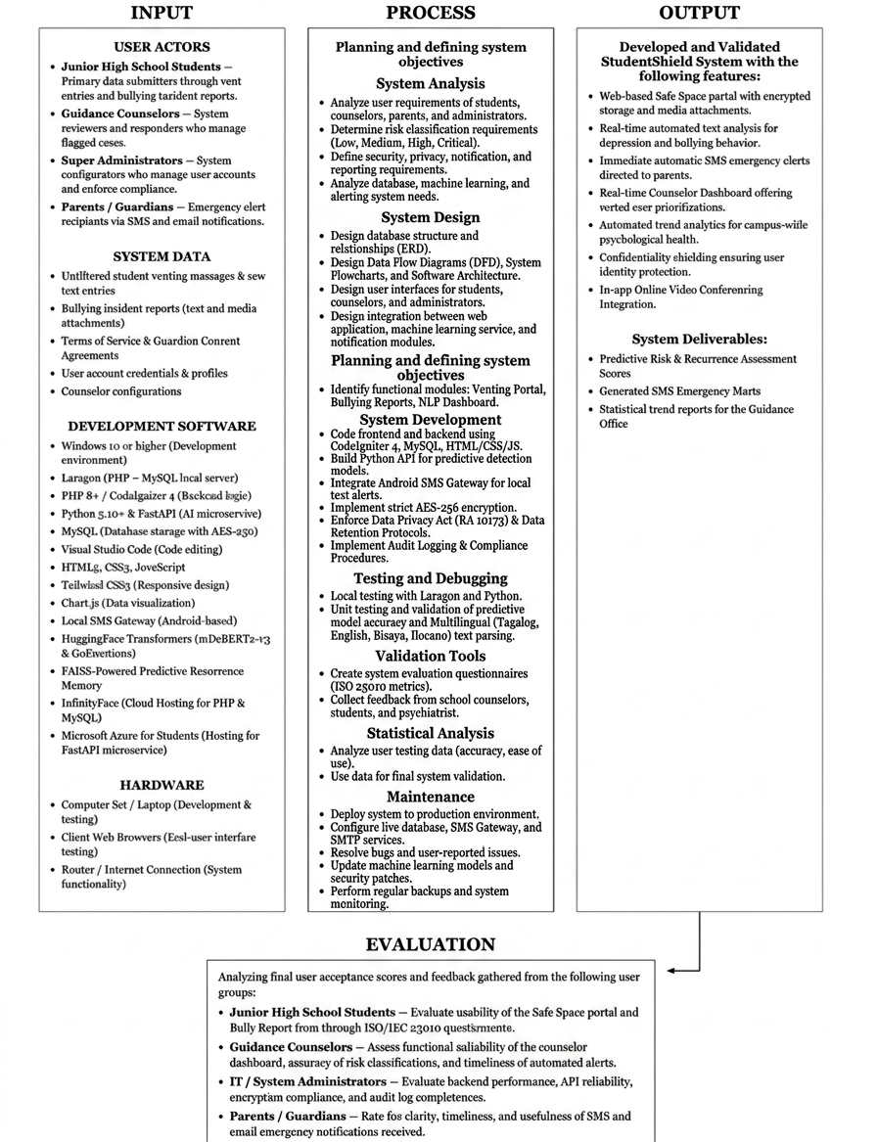
Figure 1. Conceptual framework

Input
The system supports various primary inputs required for creating and running the StudentShield application. They include the following User Actors: Junior High School Students, Guidance Counselors, Super Administrators, and Parents/Guardians.
- System Data: Unfiltered student venting messages, raw text entries, formal bullying incident reports (including media attachments), user credentials, counselor configurations, and formal Terms of Service & Guardian Consent Agreements.
- Development Software: The entire technology stack comprises the use of PHP 8 and CodeIgniter 4 as backend technologies; Python and FastAPI to build the predictive microservice, HuggingFace transformers such as mDeBERTa-v3 model for prediction of threat levels and GoEmotions model for predicting multi-label emotions; and FAISS-Powered Predictive Recurrence Memory. The rest include MySQL for AES-256 Encryption of Data Storage; Local SMS Gateway for Emergency Routing and InfinityFree/Microsoft Azure Cloud Hosting Platform.
- Hardware: Standard computer sets, client web browsers, and active internet connections serving as the physical tools for both system development and end-user testing.
Process
The Process is an overview of the activities involved during the creation, implementation, testing, and continuous improvement of the StudentShield system. This begins with the Planning and Objective Formulation phase, which entails identifying the institutional need for bullying and emotional distress intervention and defining important modules such as the Safe Space Portal, Bullying Report Module, NLP Dashboard, and Alerting System.
The System Analysis phase focuses on gathering and analyzing the requirements of students, counselors, parents, and administrators. During this phase, the researchers determine the system’s risk classification requirements (Low, Medium, High, and Critical), security and privacy requirements, reporting mechanisms, notification workflows, database requirements, and machine learning functionalities.
The System Design phase involves designing the overall structure of StudentShield. This includes the creation of the Entity Relationship Diagram (ERD), Data Flow Diagrams (DFD), software architecture, system flowcharts, user interfaces, database relationships, and the integration design between the web application, machine learning engine, and notification modules.
In the System Development phase, the developers are tasked with developing the web interface, developing the Python API for the predictive models, integrating the SMS Gateway, implementing AES-256 encryption, and ensuring adherence to the Data Privacy Act (RA 10173), Data Retention Protocols, and Audit Compliance Procedures.
The Testing and Debugging phase involves verifying system functionality, validating predictive model performance, testing notification delivery mechanisms, checking encryption and security controls, and evaluating the accuracy of predictive models in different languages, including Tagalog, English, Bisaya, and Ilocano.
Validation Tools such as ISO 25010 evaluation questionnaires and feedback from target users are utilized to assess system quality, usability, reliability, and functional suitability. Statistical Analysis is then conducted to evaluate system performance, user acceptance, and predictive model effectiveness.
Finally, the Maintenance phase ensures the continued reliability and security of the deployed system through production deployment, database and notification service configuration, security updates, backups, bug fixes, machine learning model improvements, and ongoing user support.

Output
Output represents the final phase in the process of finalizing the deliverables of the project. Deliverables include the fully-fledged StudentShield system that consists of an encrypted Safe Space Website, predictive emotion analysis tools for detecting bullying and depression, In-app Online Video Conferencing Integration, and Confidentiality Shielding, among others. Additionally, the system generates Predictive Risk and Recurrence Assessment Scores, automatic SMS and email alerts sent to parents in case of emergencies, and campus-wide trends based on the Counselor Dashboard analysis.

Evaluation
Evaluation of the system will be carried out in the form of feedback from the project itself. It is to be conducted through the analysis of final ratings given by the users and feedback collected from the four types of users, namely Junior High School students (usability aspect); Guidance Counselors (functional suitability and prediction ability); IT Administrators (audit compliance and reliability); and parents (timeliness of alerts).

Definition of Terms
Cyberbullying - Intimidation, harassment, or threat towards a person through electronic communications (Oxford Dictionary, 2020). In StudentShield, it refers to the use of digital means and/or aggression formally reported through the "Bullying Report" Module by SVBSM students.
Data Privacy Act (DPA of 2012 / RA 10173) - Philippine law that protects privacy rights of private and sensitive personal information (National Privacy Commission). It forms the legislative basis of how data is collected, stored, encrypted, and used in the system.
Encryption - A process in which information is converted into code to prevent any unauthorized access to it (Kaspersky, 2021). In the system, student reports and vents are encrypted before they are placed in the MySQL database to protect their confidentiality.
FAISS (Facebook AI Similarity Search) - Library for efficient similarity search and clustering of dense vectors (Johnson et al., 2017). It helps StudentShield determine whether there are similarities in current student submission and previous ones in order to identify a pattern of emotional deterioration over time.
Machine Learning - Subfield of artificial intelligence that enables computers to learn from experience and adapt without being explicitly programmed (Mitchell, 1997). Machine learning is the main element in the development of a system to recognize patterns of bullying and emotional distress in Taglish text submissions. Microservice - An architectural method for developing a single application as a suite of small running services (Fowler, 2014). A way of building software where different parts run independently. In the StudentShield system, the AI engine works independently from the primary website to maintain the overall system efficiency during text analysis.
Natural Language Processing (NLP) - Artificial intelligence subdomain aimed at analyzing, generating, and understanding language in humans (IBM, 2021). In the StudentShield system, it serves to help analyze non-formal student text submissions, which contain a significant amount of slang and informal expressions.
StudentShield - Name under which the integrated platform is sold to Saint Vincent Blessed School of Manila. It combines students' sentiment analysis with parents' automated SMS notifications.
Transformer - Neural network architecture that uses the attention mechanism to establish word-to-word and word-to-sentence connections (Vaswani et al., 2017). In this context, transformers will contribute to improving the understanding of the context of meanings of student vents.
Vent - To let off steam; to vent one's feelings (Merriam-Webster, 2023). The text entry was produced by a student in the "Safe Space" module and aimed at venting their emotions.
Terms of Service (ToS) - Referred to as the legal document describing the responsibilities of the users, system boundaries, information handling procedures, and interaction guidelines for students and administrators using the StudentShield website application.

StudentShield Risk Classification Engine - The StudentShield Risk Classification Engine is a four-stage sys
tem that monitors and scores student distress text into four severity bands (Low, Medium, High, or Critical). It begins by calculating a Base Score using a weighted mix of machine learning models that detect toxic or distressed text, negative emotions, and semantic similarity to crisis phrases. Next, it applies Heuristics boosts including an exponential compound multiplier if it flags specific indicators like hopelessness, masked depression, or isolation. For immediate safety, Hard Overrides can instantly bypass the scoring to force a High or Critical rating for explicit self-harm, violence, or final planning, while safely downgrading genuine sarcasm. Finally, it uses Historical Tracking (FAISS) over a 14-day window to escalate a student's risk level if it detects a worsening emotional trajectory or chronic, repeating distress incidents.

Stage | Metric / Category | Weight / Adjustment | Description & Impact
1. Base Score | Distress Confidence | 35% Base Weight | ML Confidence score from fine-tuned mdeberta-v3-base model recognizing toxic/distressed text.
 | Negative Emotion | 35% Base Weight | ML Confidence score from Go Emotion recognizing sadness, fear, grief, etc.
 | Semantic Similarity | 30% Base Weight | Vector similarity to known crisis anchor phrases
2. Heuristics | Hopelessness | +15% Boost | Language indicating a lack of future anticipation (e.g., "no point in trying").
 | Masked Depression | +14% Boost | Signals of hiding true emotions (e.g., "smiling outside, hurting inside").
 | Emotional / Social / Self-Worth | +12% Boost (Each) | Detected isolation, feelings of worthlessness, or general emotional distress.
 | Distortion / Venting / Relationship | +10% Boost (Each) | Cognitive distortions ("always/never"), extreme venting, or relationship breakups.
 | Compound Multiplier | +15% per extra signal | Escalates risk exponentially if ≥ 2 distress indicators are found concurrently.
3. Hard Overrides | Explicit Suicide / Self-Harm | CRITICAL (≥86%) | Direct threats of self-harm. Instantly overrides base scores to CRITICAL.
 | Sexual Harassment /Assault | CRITICAL (≥86%) | Mentions of abuse or harassment. Instantly overrides to CRITICAL.
 | Semantic Match (≥ 88%) | CRITICAL (≥86%) | AI detects a highly accurate semantic match to fatalistic crisis patterns.
 | Physical Violence / Bullying | HIGH (61-85%) | Physical threats or bullying. Automatically flagged as HIGH risk.
 | Finality / Preparation | HIGH (61-85%) | Planning signals (e.g., "giving my stuff away", "ready to go").
 | Masked Depression | HIGH (61-85%) | High clinical concern for students silently suffering.
 | Sarcasm & Joke Detection | Downgrade 1-2 Levels | Gen-Z slang / sarcasm (e.g., "I'm dead lol") safely downgrades the risk severity.
4. Historical (FAISS) | Escalating Trajectory | Escalate to HIGH | System detects a statistically worsening mathematical slope over a 14-day window.
 | Chronic Distress | Escalate to CRITICAL | 3 or more HIGH/CRITICAL incidents recorded for the same student within 14 days.

Figure 2: StudentShield Metrics

Final Score Output Bands
- LOW: 1% - 30%
- MEDIUM: 31% - 60%
- HIGH: 61% - 85%
- CRITICAL: 86% - 100%

CHAPTER II. METHODOLOGY

Design of Software, System, Product or Process
The main goal of StudentShield's design was to maintain that the system is always fast and responsive even when students submit long messages. To do this, we decided to split the system between a machine learning engine and a web interface. Because of its unique design, the website for students or counselors won't be slowed down by the challenging process of text analysis. Each feature of the system was chosen to support a secure and stable environment for the benefit of students.

Software Architecture
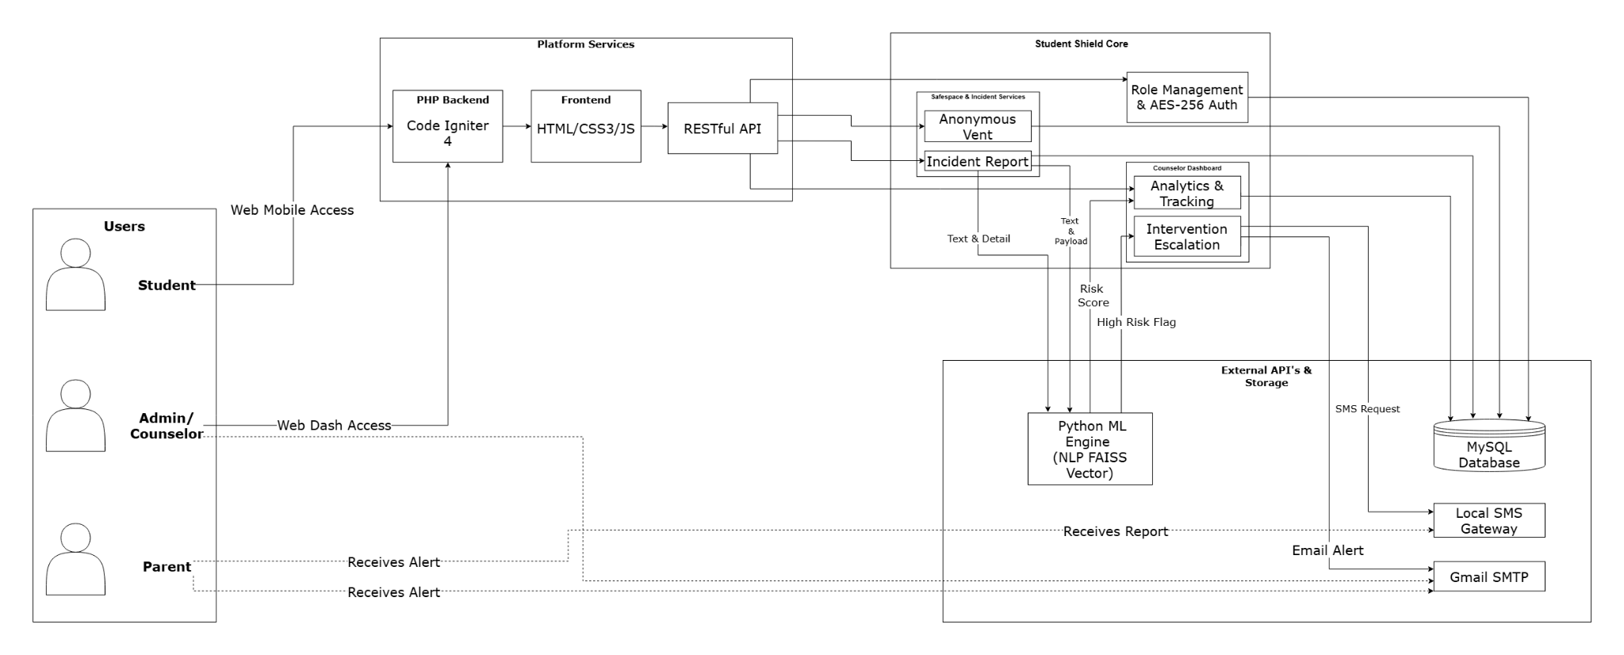

Figure 2. Software Architecture
The diagram highlights a student safety system that calls for three primary user roles: students, administrators (or school counselors), and parents. Besides administrators or counselors having access to a dashboard where they can review complaints, analyze behavior, and settle the problem, students can also make an conditional anonymous complaint through the website or app. Data is kept in a MySQL database, and the back-end handles roles, user authentication, and simple service calls. In addition, it uses NLP/machine learning capabilities for risk assessment purposes and integration with third-party applications like email and SMS notifications. The FastAPI ML Engine, along with its FAISS vector memory, is packaged as a Docker container and deployed directly to Hugging Face Spaces, functioning as an isolated microservice.

Data Flow Diagram
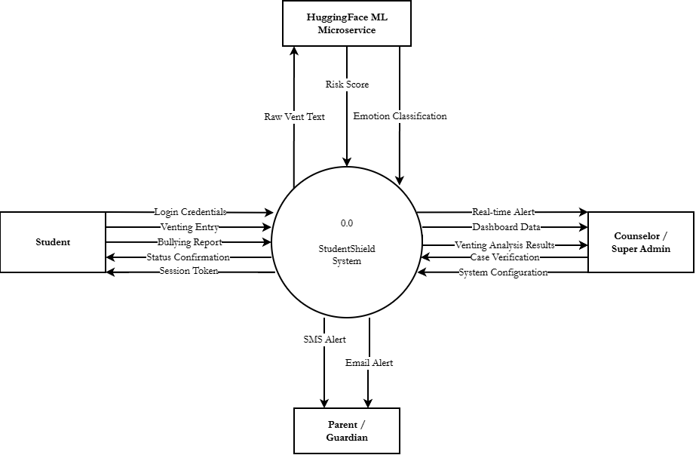Figure 3. DFD Level 0
Based on the Level 0 Data Flow Diagram, StudentShield is seen as the key system that serves as the communication channel between the student, counselor, or super admin, parent, or guardian, and the HuggingFace ML microservice. The students are able to enter their login credentials to log in and submit their venting logs and reports of any bullying they encounter. As input to the system, the output from the system is the session token and confirmation of status as a way of letting the student know that the action was processed. The FastAPI ML Engine, along with its FAISS vector memory, is packaged as a Docker container and deployed directly to Hugging Face Spaces, functioning as an isolated microservice.

The system passes on the vent text to the HuggingFace ML microservice, which outputs the risk score and emotion class, helping the system to detect cases that might need attention. The system generates notifications and dashboard information to be sent to the counselors or super admins while at the same time the counselors and super admins provide case verification and system configurations to the system. Where there are cases of potential danger, the parent or guardian receives SMS and email notifications.
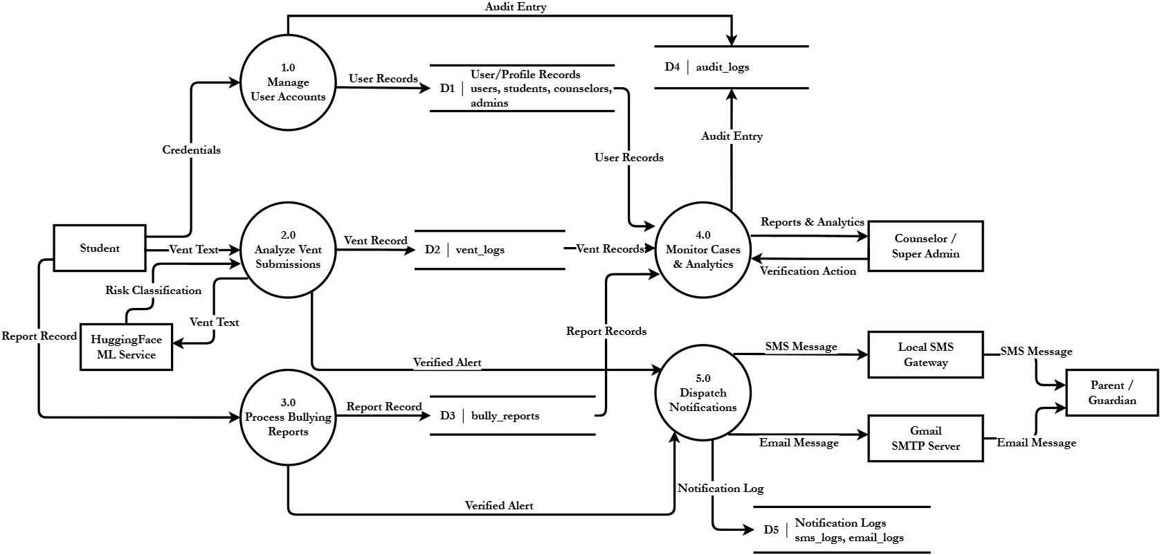

Figure 4. DFD Level 1
While the Context Diagram presents StudentShield as one system, DFD Level 1 reveals what happens inside the system. The process consists of the following: Manage User Accounts, Analyze Vent Submissions, Process Bullying Reports, Monitor Cases & Analytics, and Dispatch Notifications. Manage User Accounts verifies the user's credentials in the User/Profile Records repository, containing users, students, counselors, and admins. All the significant events related to the management process are recorded in Audit Logs.

If a student sends their vent, the system sends it to the HuggingFace ML Service, which generates a classification based on risks associated with the event. Afterward, the event is stored in vent_logs, and a confirmed alert is generated if necessary. Bullying reports are processed in the Process Bullying Reports process and stored in bully_reports. The Monitor Cases and Analytics process permits the counselor and the super admin to view user records, vent records, and reports. All their actions are saved. In the end, notifications are dispatched via the Local SMS Gateway and Gmail SMTP Server. All the messages are stored in sms_logs and email_logs. The FastAPI ML Engine, along with its FAISS vector memory, is packaged as a Docker container and deployed directly to Hugging Face Spaces, functioning as an isolated microservice.

Software Development Life Cycle
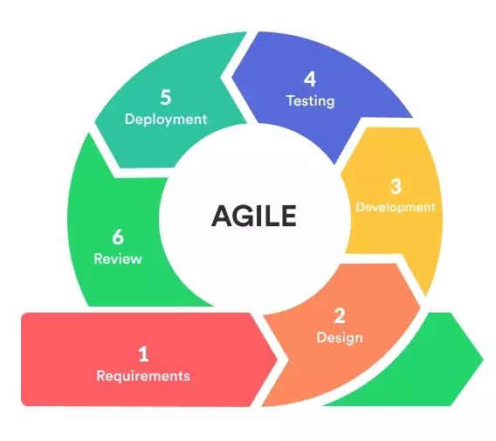

Figure 5. Software Development Life Cycle - Agile Model
The choice of implementing the development of StudentShield using the Agile-Iterative approach was made by us. It was the most appropriate choice for us as we had known beforehand that we were going to make many modifications to our machine learning algorithms after analyzing them with Filipino student language data. With this approach, we can make a small segment of the system and modify it accordingly.
- Planning
Firstly, the researchers establish what problem this study is intended to solve when developing the research plan. In the school setting, there was no established procedure for identifying cases of bullying, problems of students, and any other issues that would need assistance. This provides a basis for the purpose of StudentShield. The system was developed to assist the parents and counselors in getting real-time information, identifying the issues from the text, and creating a safe platform where the students can vent their feelings. This is the stage at which the system components were introduced.
- System Analysis
The researchers analyzed the needs of the system based on the needs of the users during the process of system analysis. It was necessary to establish the way in which the system would analyze the texts in order to establish possible levels of threats, the way in which counselors will view the reports and the way in which the students will report bullying and venting messages. Database architecture, user privileges, encryption of sensitive information, implementation of machine learning and warning systems were some of the technical needs that were analyzed.
- System Design
During the system design phase, the StudentShield structure was carefully designed. The researchers developed the database structure, arranged the fundamental components of the system, and determined the relationships between the most essential parts. Also, counselors' and students' user interfaces were created with ease of use and procedure simplicity in mind. As well, the interface between the web application and machine learning service was highlighted, especially with the topic of notification management, risk assessment, and text classification. Process flowcharts, architecture diagrams, and entity-relationship diagrams were one of the design outputs used as deployment tools.
- Development
Using the Agile methodology, system development has been carried out in manageable iterations, each iteration on a different feature:
- Iteration 1: Fundamental Web Functionalities (Login, Vent Submission, Bullying Reports)
- Iteration 2: Integration of Machine Learning (text analysis of hugging faces)
- Iteration 3: Security and Alerts (Local SMS Gateway, Audit Logging, and Encryption)
PHP (CodeIgniter 4) and MySQL were used for the backend, while Tailwind CSS and JavaScript were used for the frontend. The Local SMS Gateway for text alerts, SMTP for email OTPs, and ApexCharts for data visualization were added tools.
- Testing
Based on the system requirements, every important feature will be carefully reviewed. The researchers will make certain that:
- Every essential feature, including database storage and one-time password authentication, is verified.
- Slang, Taglish, and the Filipino language are all accurately interpreted by the machine learning module.
- In emergency scenarios, the automatic local SMS gateway and SMTP alerting function well.
- Maintenance
The following step would involve putting the prototype to use in the real world using the production server, environment variables, and API (Local SMS Gateway & SMTP). This would be followed by maintenance process, which will ensure the integrity of both security and functionality of the application. There would be the following events:
- Setting up the live database and uploading the CodeIgniter 4 system
- Defining the Counselors' and Super Admins' initial roles and permissions
- Resolving user concerns or logical mistakes
- Modifying the machine learning model to better predict students' language use
- Security updates and system backups

System Flowchart
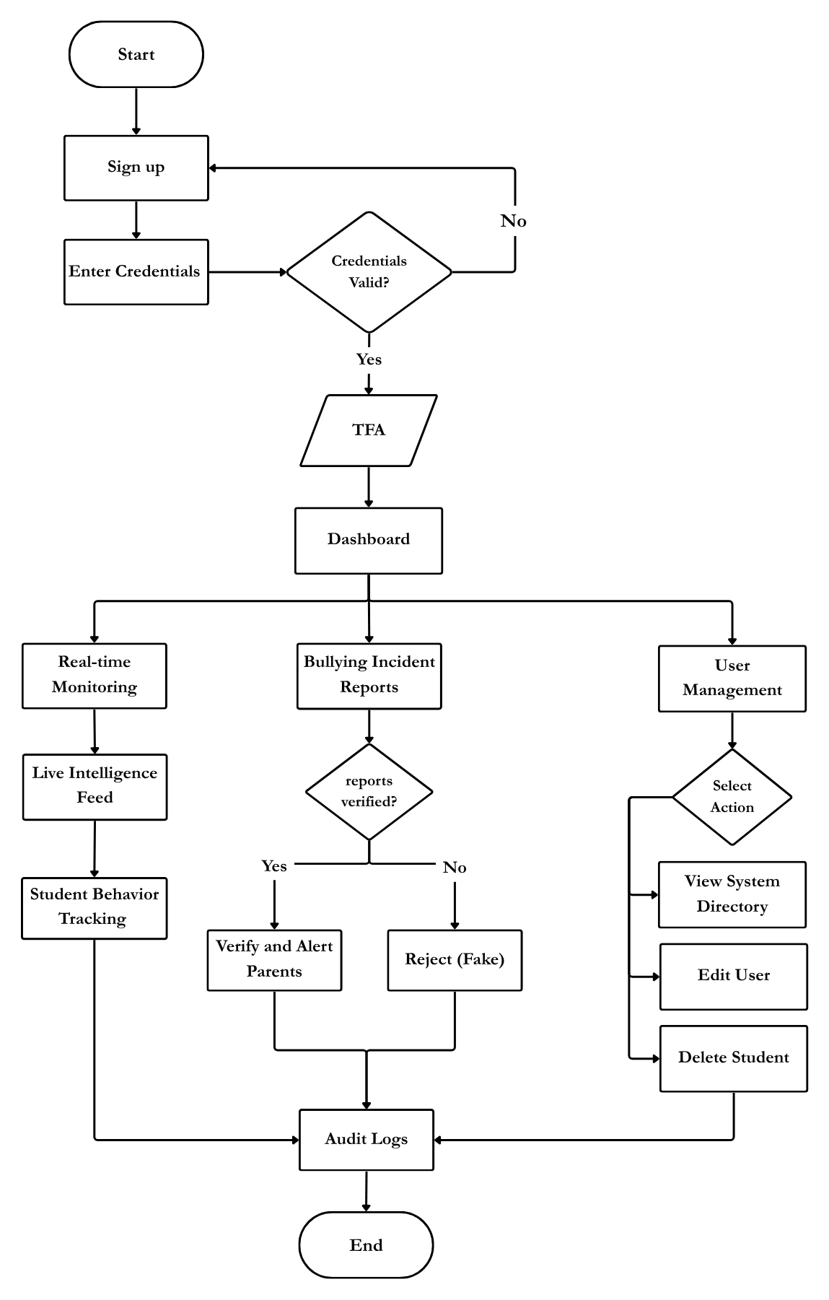

Figure 6. Super Admin Flowchart of StudentShield System
The super admin workflow is the process of managing the system using the verification and administration process. The process involves the need to provide a password and an email for one to log into the system. Once the submission is made successfully, the system initiates the two factor authentication process in order to verify the identity of the administrator. The system offers the real time monitoring of intelligence flows, incident reports, and delivery status of alerts. The user administration features include viewing system databases, creating user account, editing and deleting users' profile among others.
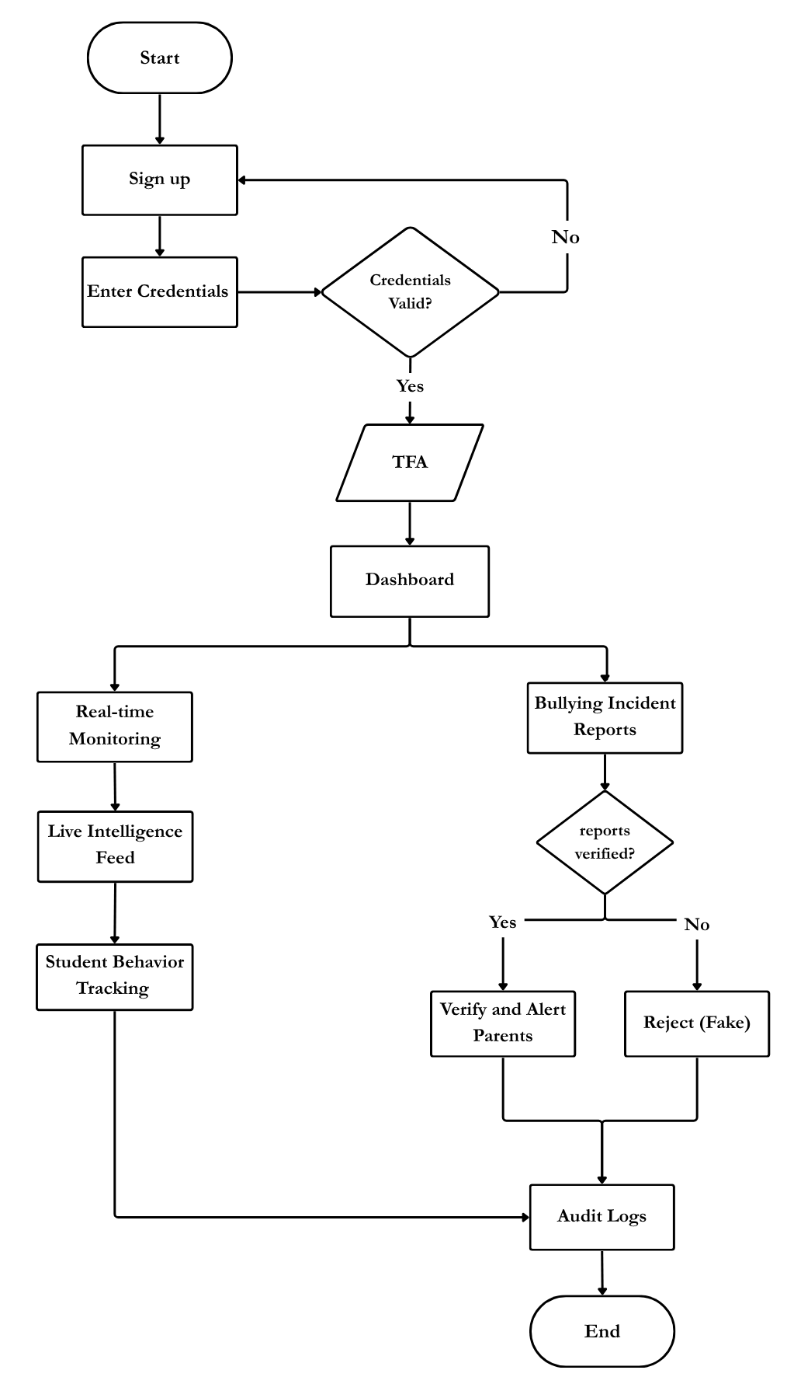
Figure 7. Counselors Flowchart of StudentShield System
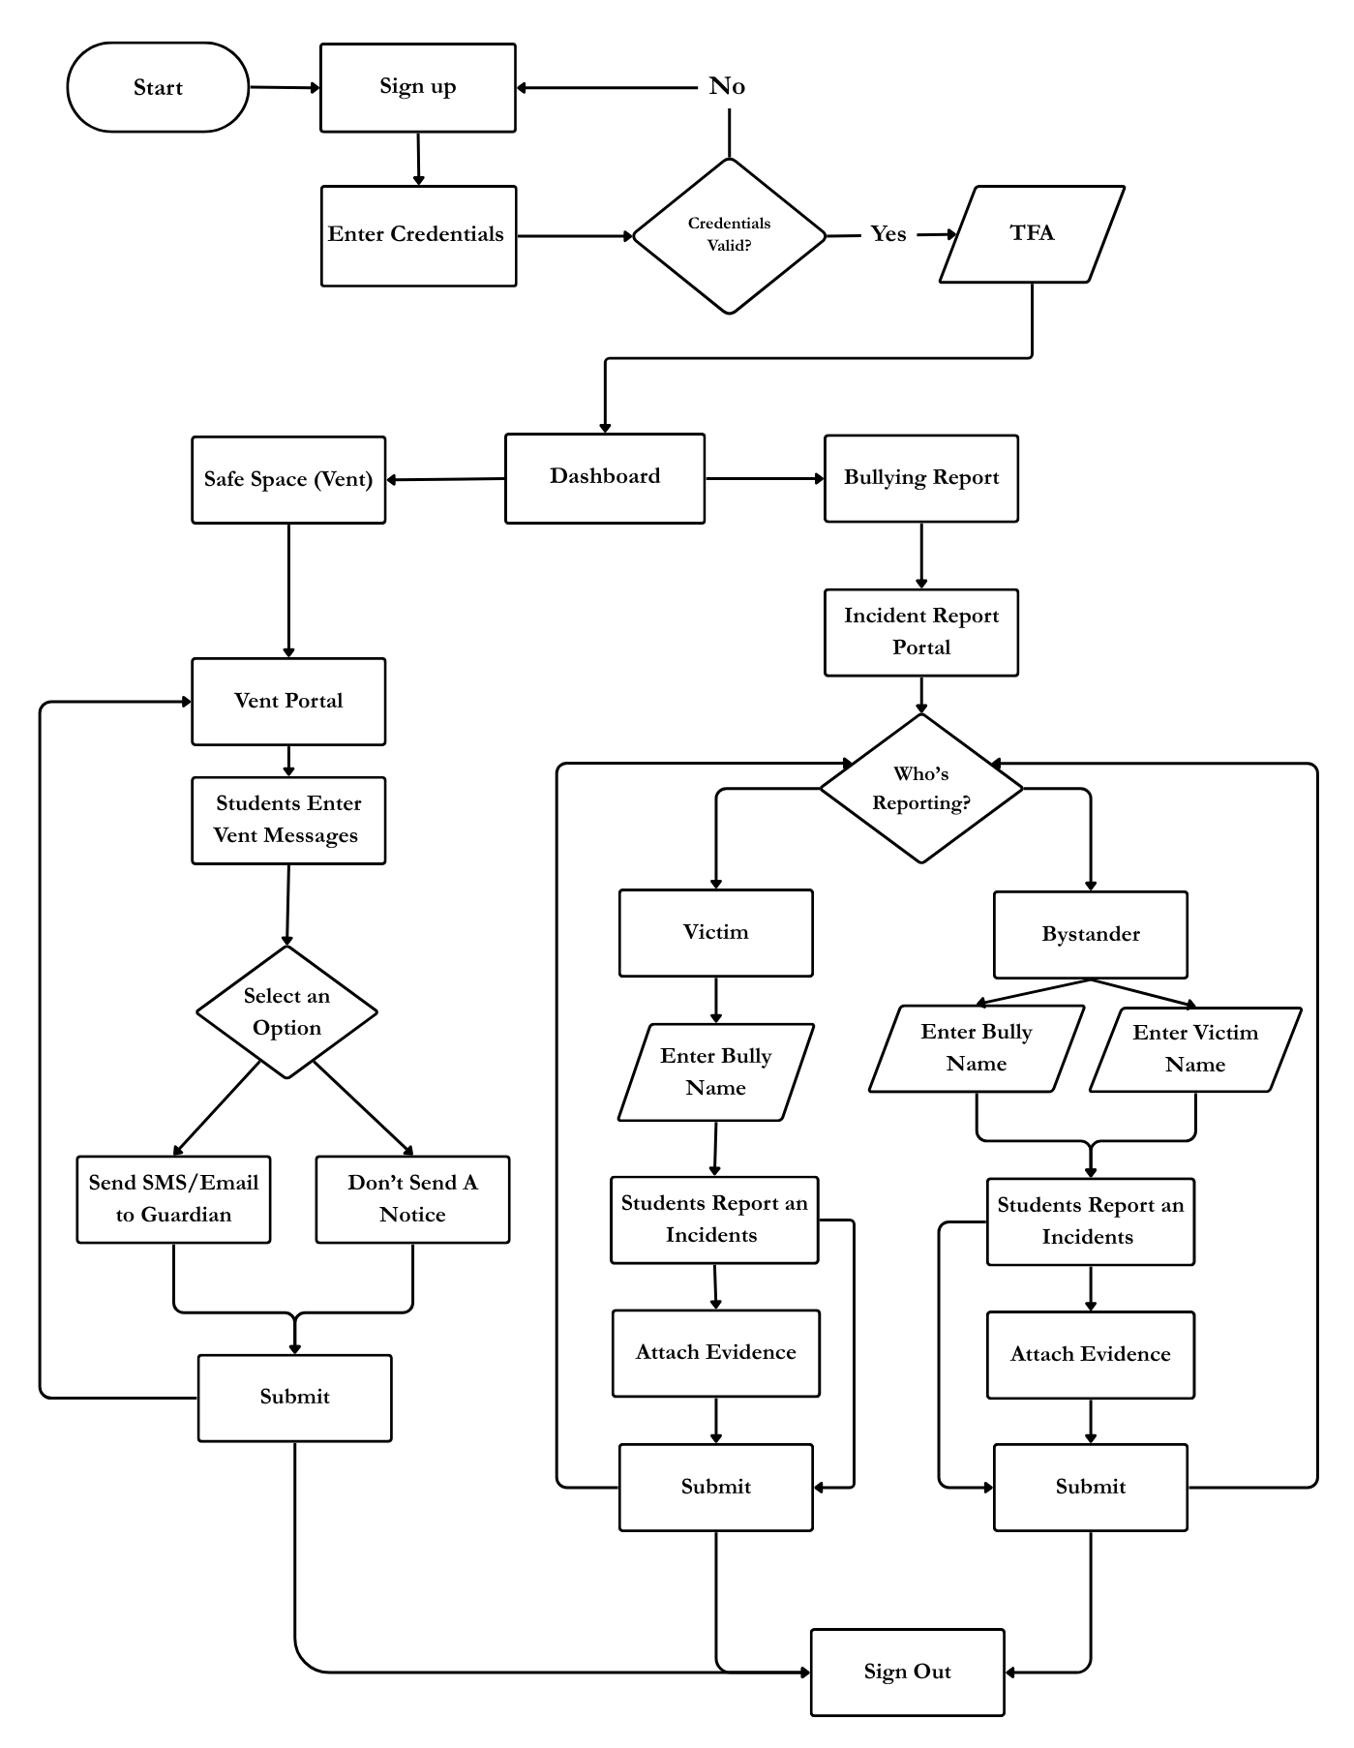
Methodology used by the counselor is intended for observation as well as response. Entry into the system is done through secure log-in and use of two-factor authentication. The main work area will be dashboard overview where real-time monitoring will take precedence. In this case, the system collects data from the database in order to display real-time intelligence feed, bullying incidents reports, and alerts. This enables continuous monitoring of the learning environment. At the end of the process, the user logs out of the system.

Figure 8. Students Flowchart of StudentShield System
The student process offers a full range of tools that enable one to communicate their feelings and report any incidents. After going through the process of safe sign-in, there are two main options available. With the Safe Space model, one can post messages regarding their emotions. This tool enables one to decide whether they wish to contact a guardian or keep the record anonymous. The use of an organized gateway makes it possible for the person to identify themselves as victims or spectators in the incident. Depending on this, certain information will be entered such as the names of the victims or bullies involved. Attachments will then be uploaded to the database.

Entity Relationship Diagram
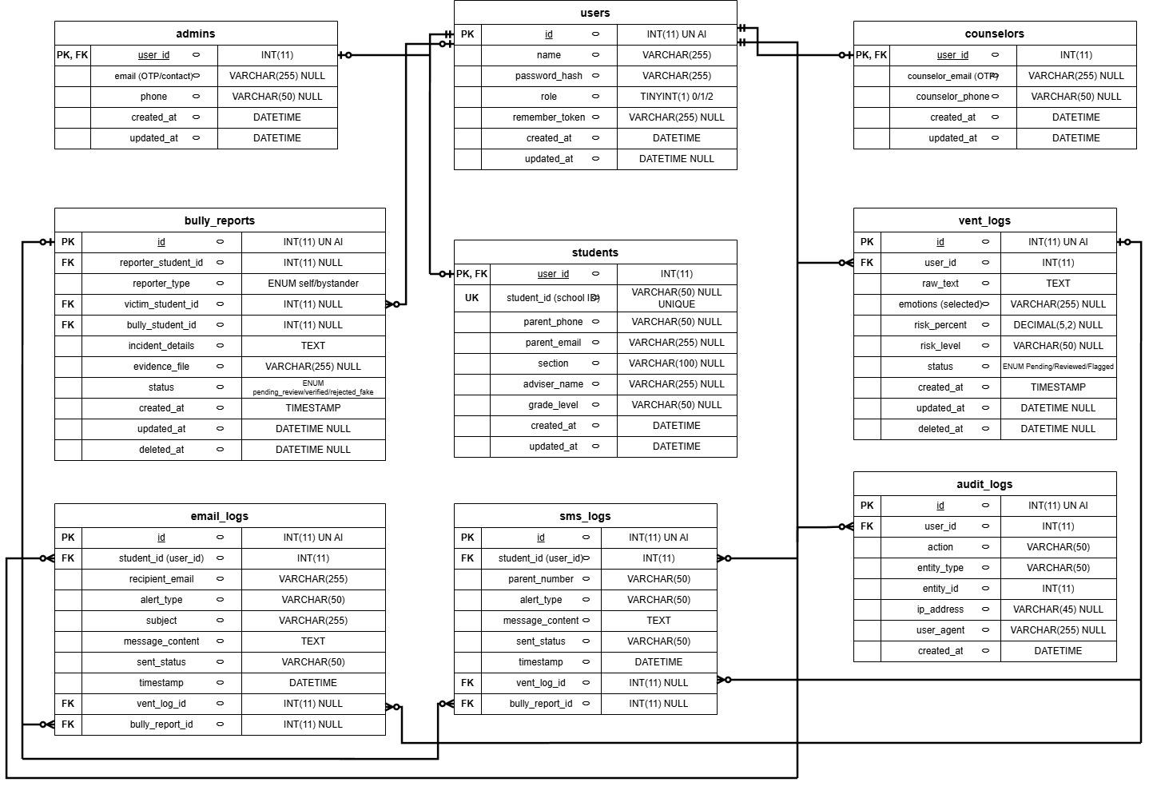

Figure 9. Entity Relationship Diagram
The key in the users table is the main primary key in the database. The `id` attribute in the table is auto-incremented and creates a unique record for all users registered in the system. The `id` can also be seen as the common key that will be used by other associated tables.
- users : The primary key `id` in the `users` table is auto-assigned to all registered users
- students: In this table, the `user_id` acts as both the primary and the foreign key. Another `id` attribute is not required because there exists a direct mapping between each student profile and their user account.
- counselors: This table is similar to the students table with the `user_id` acting as both the primary key and the foreign key linking the counselor's profile to their corresponding user account.
- admins: This table also uses the same principle where the `user_id` links the admin's profile to their respective user account.
- vent_logs: In this table, the primary key is the `id` because more than one vent log can be submitted by one user. The `user_id` here acts as the foreign key.
- bully_reports: Its primary key is `id`. There are three foreign keys present in it, which include `reporter_student_id`, `victim_student_id`, and `bully_student_id`. All three keys refer to `users.id`, and these keys are null because not all the names will be known.
- audit_logs: The primary key of this table is `id`. There is a foreign key in this table as well, and that is `user_id`.
- sms_logs and email_logs: Both of these tables have `id` as their primary key. In these tables, `student_id` refers to `users.id`.
In conclusion, the tables of profile data of students, counselors, and admin have `user_id` as the primary and foreign key of `users` as well as one-to-one relationships. But in the case of logs and reports tables, they have their respective primary keys and foreign keys as well.

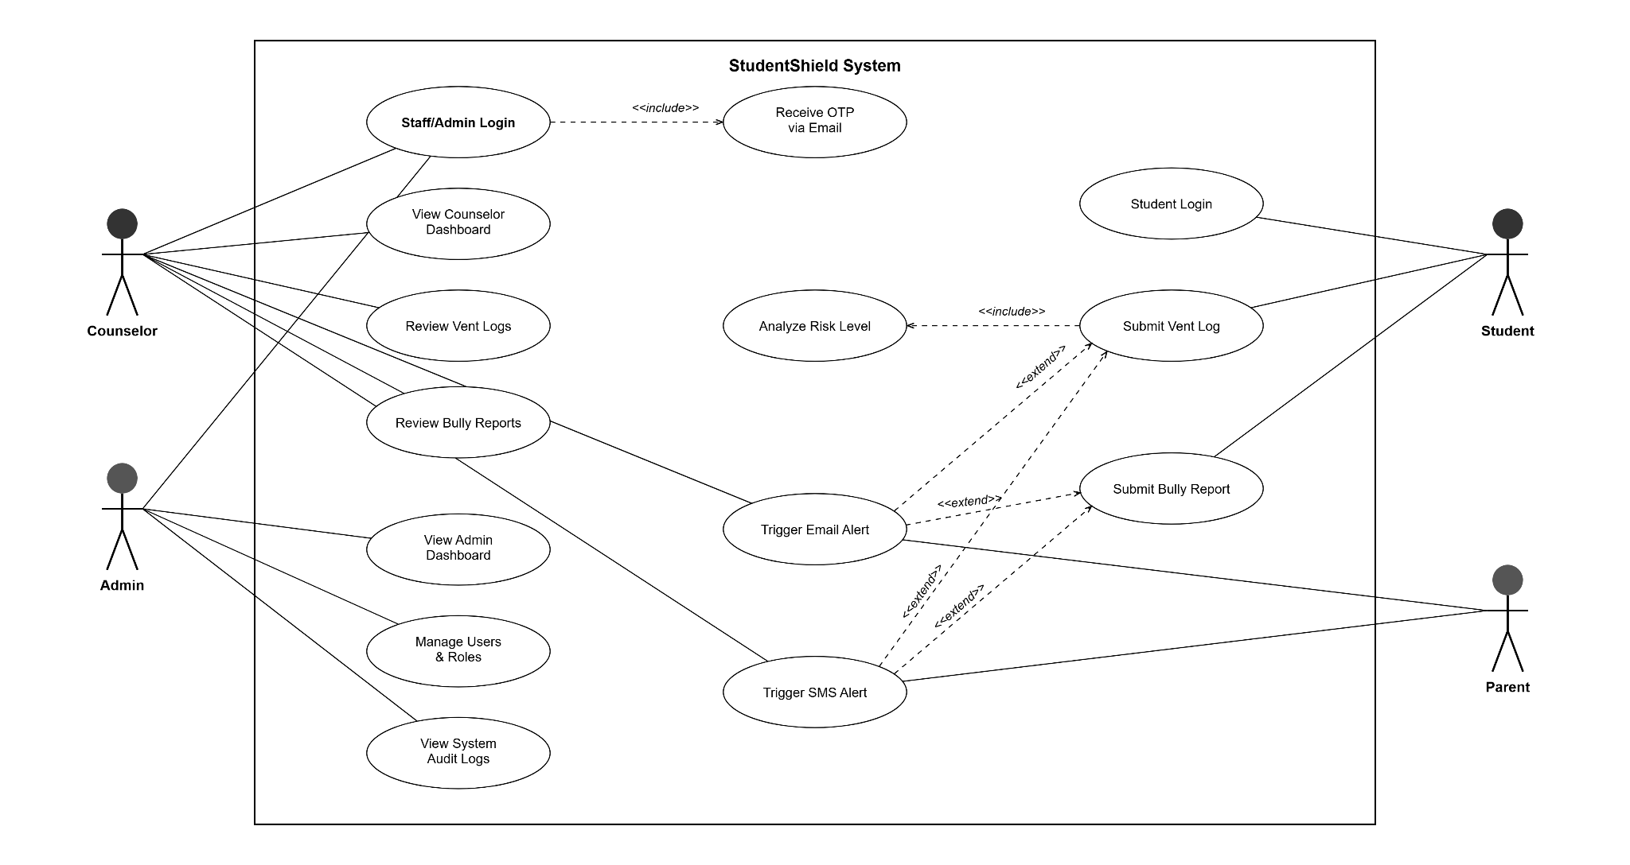
Use Case Diagram

Figure 10. Use Case Diagram
Figure 10 indicates how students, parents, counselors, and admins work with the reporting and notification functionalities of StudentShield.
Key Figures
- Student: The main user who checks in to report incidents of bullying or create encrypted diary entries.
- Counselor: School employees who check vent logs and look into bullying reports after logging in over a secure OTP gateway. When a student is flagged, they are the first to receive emergency emails and SMS alerts.
- Super Admin: Uses the same OTP gateway to log in as well. They manage the system's audit logs, manage user accounts, and give a roles. They don't get direct alerts.
- Parent: A passive actor who gets automated email and SMS alerts when the machine learning classifies their child's vent log as critical risk.
Use Cases
- Staff/Admin Login: This portal is used to authenticate counselors and administrators. Before providing access, an email-based OTP verification step is required.
- Student Login: Students can log in separately and more easily with just their name and password. OTP is not necessary.
- Submit Vent Log: Students write encrypted journal entries. The machine learning risk analyzer, which rates the text and determines a risk level (Low, Medium, High, or Critical), is automatically called for each submission.
- Bully Report Submission: Students submit an encrypted incident report on bullying. The counselor office is instantly notified by email and SMS upon submission so they can look into it.
- View Counselor Dashboard / Review Vent Logs / Review Bully Reports: Counselor-side features for reading decrypted entries and managing active cases.
- View Admin Dashboard / Manage Users & Roles / View System Audit Logs: Admin-side operate for account management and compliance tracking.
- Trigger Email Alert / Trigger SMS Alert: Automated system replies that only extend from the submission use cases. The system emails and contacts the student's parent if a vent log receives a Critical score. The counselor office receives an instant email and SMS after filing a bully report. They work based on the backend and are not triggered through manual action by any of the actors.
In the diagram provided below, you can see actions performed automatically by the system and those which have to be carried out manually by the user. The main reason for choosing this method is because all bully reports are instantly sent directly to the counselor's phone who must give approval first.

Requirements Analysis
1. Software Requirements
This is the software used for development, testing, and deployment of the StudentShield Web Application.
Development Tools and Frameworks:
- Frontend Development
  - HTML 5
  - CSS 3
  - Tailwind CSS (CDN)
  - Chart.js (risk distribution pie chart)
  - ApexCharts (vent trend area chart, student risk timeline)
  - JavaScript (Fetch API for AJAX)
- Backend Development
  - PHP 8.1+ (CodeIgniter 4 Framework)
  - MySQL (via Laragon local server)
  - Hugging Face Inference API (ML-based risk analysis)
  - Local SMS Gateway (for automated SMS alerts to parents and counselors)
  - Gmail SMTP (for OTP delivery, parent email alerts, and counselor notifications)
- Security and Authentication
  - AES-256 Encryption (OpenSSL, for encrypting vent logs and incident reports at rest)
  - Bcrypt Password Hashing (for storing user credentials)
  - Email-based One-Time Password (OTP) verification for staff and admin logins
  - Anti-spam rate limiting (30-second cooldown on vents, 120-second cooldown on bully reports) to prevent Local SMS Gateway credit abuse
  - Trusted Device Cookies (optional OTP bypass for remembered machines)
2. Hardware Requirements
This is the physical resource that will be required in developing, testing, and deploying the application.
Development Environment:
- Developer Machines (for coding and testing):
  - Processor: Minimum: Intel Core i3 / AMD Ryzen 3.
  - RAM: 4 GB minimum; 8 GB recommended to handle Laragon, the browser, a code editor, and the local SMS gateway app running at the same time.
  - Storage: Minimum: 128 GB SSD; Recommended: 256 GB SSD for the codebase, database files, and dependencies.
  - Graphics: Integrated graphics (Intel HD or AMD Radeon Vega) are enough. No GPU-heavy tasks are required.
  - Operating System: Windows 10 or later (Laragon is Windows-native).
3. SMS Gateway Device:
Android Phone: Any Android 8.0+ device with an active SIM card and mobile data or Wi-Fi. This phone runs the local SMS gateway app that receives REST API calls from the server and sends actual text messages to parents.
Testing Devices:
- Devices for Testing:
  - Computer: Laptop or desktop with a modern browser for testing the full dashboard layout and responsiveness.
  - Mobile Device: Any smartphone for testing the student-facing pages (vent form, bully report form) on small screens.
  - Test Network: All devices must be on the same local network (Wi-Fi) so the web server can reach the Android SMS gateway.

Requirements Documentation
Functional Requirements
Role-Based Access Control
- The system assigns three user roles: Student (role 0), Counselor (role 1), and Super Admin (role 2), each with different access levels.
- Students can only access the student dashboard, the vent form, and the bully report form.
- Counselors can view all vent logs, review bully reports, verify or reject incidents, and view student risk profiles.
- Super Admins can do everything Counselors can, plus manage user accounts, assign roles, and view system audit logs.
- User management is locked to Super Admin only (role 2). The code explicitly blocks Counselors from accessing it.
Account Management
- Admin and Counselor accounts are pre-seeded or created by the Super Admin through the user management panel.
- Student accounts are created by the Super Admin, who provides the student's name, student ID, section, adviser name, parent phone, parent email, and password.
- Student IDs are mandatory for student accounts. Section and adviser name are also required.
- Counselors and Super Admins log in with name and password, followed by a mandatory email-based OTP (6-digit code, 5-minute expiry).
- Students log in with name and password only. No OTP is required.
- Passwords are stored as bcrypt hashes. Legacy plaintext passwords are silently auto-upgraded on first login.
- There is no password reset feature. If a user forgets their password, the Super Admin resets it manually through user management.
- Super Admin generates profiles (Student and Parent information) which start out as "Pending Consent".
- The first login requires accepting the Terms of Service (ToS) by opening a form.
- Students must check off the box that he or she has submitted a signed Guardian Consent document before access can be granted.
Vent Log Submission and AI Risk Analysis
- Students write personal journal entries through an encrypted submission form.
- Each submission is sent to a custom ML model hosted on Hugging Face Spaces that scores the text and returns a risk level: Low, Medium, High, or Critical.
- If the ML service is offline or times out (15 seconds), a local keyword-based fallback engine activates. This engine uses Filipino and English distress keywords with built-in Gen-Z sarcasm detection (e.g., "kms after math exam" is downgraded because it matches both a crisis keyword and an academic context marker).
- All vent text is encrypted with AES-256 before being saved to the database.
- If the risk level is Critical, the system automatically sends an SMS and email to the student's registered parent.
- If the student checks "hide from parents" (domestic abuse precaution), parent alerts are suppressed and the counselor receives an emergency override notification instead.
- A static and clearly visible privacy notice is placed immediately below the “Submit” button to ensure that students are aware of how their data will be handled.
- This privacy notice informs students that their responses are securely stored by means of standard AES-256 encryption at rest, ensuring no data leaks occur.
- Students are advised that their responses stay confidential unless they pose a “Critical” safety risk, in which case their parents or legal guardians will receive an instant SMS and email notification.
- Should a case of domestic abuse be confirmed, the emergency alert will be directed not to the parents but directly to the school counselor.
Bully Report Submission (Two-Stage Alert Pipeline)
- Students file encrypted bullying incident reports, identifying whether they are the victim or reporting for someone else.
- The system resolves typed names to database user IDs using strict single-match lookups to prevent wrong-parent notification errors.
- Stage 1 (Immediate): Upon submission, the counselor office gets an SMS and email alert so they can investigate. No parent alerts are sent yet.
- Stage 2 (Counselor Verification): The counselor reviews the report on the dashboard and can click "Verify & Alert Parents," which fires automated SMS and email alerts to both the victim's parent and the bully's parent. Alternatively, the counselor can reject the report as fake, which blocks all parent alerts. They can also undo a decision to reset the report back to pending review.
Dashboard and Case Management
- Counselors see all active vent logs with decrypted text, risk scores, student names, sections, and adviser information.
- The dashboard displays a risk distribution pie chart (Chart.js) and a vent trend area chart (ApexCharts) that update in real time via AJAX polling.
- Counselors can mark entries as Resolved, soft-delete (archive) them, restore archived entries, or perform bulk operations on multiple entries at once.
- Counselors can click on any student name to open a full student profile that displays the student's information, their risk timeline graph (ApexCharts), all their vent history, and any bully report involvement.
- The Admin dashboard provides user management (create, edit, delete), role assignment, and a full system audit log.
- The Super Admin cannot demote or delete their own account (self-protection guard).
- For making real-time interventions possible remotely, there is a direct video conference integration on the Counselor Dashboard. Once a critical-risk-scored student or a student with frequent risk occurrences is found, a counseling session can be arranged and a video conference link can be created and sent to the concerned student’s dashboard for conducting the session.
- Counselors shall be able to generate a Case Summary Report for individual students.
- The report shall display the student's risk assessment history, highest recorded risk level, detected emotional indicators, bullying report statistics, notification history, counselor interventions, and current case status.
- The report shall serve as a centralized documentation record for counseling sessions, parent consultations, investigations, and intervention planning.
- The system shall allow counselors to view and export the report to pdf for record-keeping purposes.
Automated Notifications
- SMS alerts are sent through the Local SMS Gateway using app key and secret credentials stored in the .env configuration file.
- Email alerts are sent through Gmail SMTP using credentials stored in the .env file.
- A cooldown timer prevents alert fatigue by blocking duplicate notifications to the same parent within a set time window.
- Alert logs are written to a JSON file and viewable from the dashboard.
Audit Logging
- Every administrative action (resolve, archive, restore, bulk delete, verify, reject, undo, create user, update user, delete user) is logged to the audit_logs table with the acting user's ID, IP address, user agent string, and timestamp.
Data Retention Policy
- Student records, vent logs, bullying reports, and notification logs shall remain active only while the student is officially enrolled in the institution.
- In cases of graduation or official transfer to another school, all associated records shall be retained for thirty (30) days to allow completion of pending administrative and counseling processes.
- After the 30-day retention period, the student's records shall be permanently deleted from the system database in accordance with the Data Privacy Act of 2012 (RA 10173).
- Students who temporarily discontinue their studies, take a leave of absence, or become inactive shall not have their records deleted. Instead, their accounts shall be archived and marked as inactive.
- Archived records shall remain encrypted and inaccessible to unauthorized users while stored within the system.
- If the student re-enrolls in the institution, the archived account and records may be reactivated by authorized personnel to ensure continuity of counseling and case management services.
- Access to retained and archived records shall be limited to authorized school personnel through role-based access controls.

Non-Functional Requirements
Performance
- Vent submissions process and save within 2–3 seconds, including the round-trip to the Hugging Face ML API.
- If the ML service times out (15-second limit), the local keyword fallback returns a risk score instantly.
- Dashboard data refreshes via AJAX polling without requiring a full page reload.
Availability
- High availability is ensured by deploying the core web application on InfinityFree Production Hosting. To maintain absolute reliability and sub-second response times if the Hugging Face Space is sleeping or offline, CodeIgniter 4 implements a native PHP fallback function (localKeywordFallback()) to evaluate student risk status locally without downtime.
- Availability
Security
- All sensitive text (vent content, incident details) is encrypted at rest using AES-256 via CodeIgniter's built-in encryption library.
- User passwords are hashed with bcrypt. Plaintext passwords are never stored after first use.
- Staff logins require a 6-digit OTP sent via email, with a strict 5-minute expiration.
- Form submissions are rate-limited (30s for vents, 120s for bully reports) to prevent spam and gateway abuse.
- The user management panel is access-controlled to Super Admin only. Counselors are explicitly blocked.
- Under the requirements of the Data Privacy Act of 2012, the system must implement an automatic retention process for records. There should be no indefinite storage of any extremely sensitive information such as emotional trajectory data and unedited text logs, which should be automatically deleted or anonymized after the end of the school year.
Usability
- The interface is built with Tailwind CSS and is responsive across desktop and mobile devices.
- Students can submit a vent in 2 steps: type their entry and click submit.
- The counselor dashboard loads all active cases in a single scrollable view with no pagination required.

Development and Pre-Testing procedures
This section documents the testing process to be followed, guided by the design specifications and functional requirements listed above.

Table 1: Test Case Scenario for Authentication Module
Test Case | Test Scenario | Testing Status
Authentication Module | Can a student log in with a valid name and password? | Passed or Failed
 | Does the system reject invalid student credentials? | Passed or Failed
 | Can a counselor log in and receive an OTP email? | Passed or Failed
 | Can a super admin log in and receive an OTP email? | Passed or Failed
 | Does the system reject an expired or incorrect OTP? | Passed or Failed
 | Does the trusted device cookie bypass OTP on the next login? | Passed or Failed
 | Are legacy plaintext passwords auto-upgraded to bcrypt on first login? | Passed or Failed

Table 2: Test Case Scenario for Vent Log Module
Test Case | Test Scenario | Testing Status
Vent Log Module | Can a student submit a vent entry successfully? | Passed or Failed
 | Is the vent text encrypted with AES-256 before being saved? | Passed or Failed
 | Does the Hugging Face ML API return a valid risk level? | Passed or Failed
 | Does the local keyword fallback activate when the ML API is offline? | Passed or Failed
 | Does the sarcasm detector correctly downgrade "kms after math exam" to Medium? | Passed or Failed
 | Does the system send an SMS to the parent when risk is Critical? | Passed or Failed
 | Does the system send an email to the parent when risk is Critical? | Passed or Failed
 | Does the "hide from parents" toggle suppress parent alerts and notify the counselor instead? | Passed or Failed
 | Does the rate limiter block a second submission within 30 seconds? | Passed or Failed

Table 3: Test Case Scenario for Bully Report Module
Test Case | Test Scenario | Testing Status
Bully Report Module | Can a student submit a report for themselves (self)? | Passed or Failed
 | Can a student submit a report on behalf of someone else? | Passed or Failed
 | Are incident details encrypted before being saved? | Passed or Failed
 | Does the counselor receive an SMS alert after submission (Stage 1)? | Passed or Failed
 | Does the counselor receive an email alert after submission (Stage 1)? | Passed or Failed
 | Does "Verify & Alert Parents" send SMS and email to both the victim's and bully's parents (Stage 2)? | Passed or Failed
 | Does "Reject as Fake" block all parent alerts? | Passed or Failed
 | Does "Undo" reset the report back to pending review? | Passed or Failed
 | Does the rate limiter block a second report within 120 seconds? | Passed or Failed

Table 4: Test Case Scenario for Dashboard and Case Management Module
Test Case | Test Scenario | Testing Status
Dashboard Module | Can the counselor view all active vent logs with decrypted text? | Passed or Failed
 | Does the risk pie chart display correct distribution counts? | Passed or Failed
 | Does the vent trend area chart update via AJAX? | Passed or Failed
 | Can the counselor mark a vent entry as Resolved? | Passed or Failed
 | Can the counselor archive (soft-delete) a vent entry? | Passed or Failed
 | Can the counselor restore an archived vent entry? | Passed or Failed
 | Can the counselor bulk-delete or bulk-restore multiple entries? | Passed or Failed
 | Can the counselor click a student name to view their full risk timeline and profile? | Passed or Failed

Table 5: Test Case Scenario for User Management Module
Test Case | Test Scenario | Testing Status
User Management Module | Can the super admin create a new student with all required fields (name, student ID, section, adviser)? | Passed or Failed
 | Can the super admin create a new counselor or admin account? | Passed or Failed
 | Can the super admin edit an existing user's information? | Passed or Failed
 | Can the super admin delete a user account? | Passed or Failed
 | Is a counselor blocked from accessing the user management page? | Passed or Failed
 | Is the super admin prevented from demoting or deleting their own account? | Passed or Failed

Table 6: Test Case Scenario for Audit Log Module
Test Case | Test Scenario | Testing Status
Audit Log Module | Does the system log every resolve, archive, restore, and verify action? | Passed or Failed
 | Does each log entry record the correct user ID, IP address, user agent, and timestamp? | Passed or Failed
 | Can the admin view the full audit trail from the dashboard? | Passed or Failed
 | Are alert logs (SMS/Email history) viewable from the dashboard? | Passed or Failed

Implementation Plan (Infrastructure/ Deployment)
Activity | FEBRUARY - MAY
Planning Phase | Month 1 | Month 2 | Month 3 | Month 4 | Month 5 | Month 6 | Month 7 | Month 8 | Month 9 | Month 10
Defining the Problem
Confirming Project Feasibility
Producing the Project Schedule
Chapter 1, 2, 3, 4
Title Defense
Prototype Defense
Analysis Phase
Interview in target Beneficiary
Consulting Mental Health Pro
Determining System Requirement
Determining User Requirement
Recommending Solutions
Designing DFD, CFD, ERD
Design Phase
Determining the Programming Tools
Designing the Database
Designing the System Interface
Designing ML System Control
Implementation Phase
Revision of Document
Coding
Testing and Verifying System
Mock Defense / Final Checking
Final Proposal Defense

Figure 11. Implementation Plan using Gantt Chart
The StudentShield system takes a three-layered cloud-based design that helps avoid machine learning latency issues while concentrating on reducing data security concerns and cost. It involves deployment of web application, machine learning service and emergency alert systems.
The proposed deployment will see students and counselors use a CodeIgniter 4 PHP-applications running on InfinityFree. This Hosting Company takes care of the Web server and the MySQL Database. Passwords will be hash-coded, audit records will be kept, plus vent submissions will be encrypted. It is set to be encrypted using AES-256 encryption from the set up prior to adding any raw text or bullying report. This will ensure that those without authorization to access the database will only be able to see random lengths of strings. This process will be done when updating a web application: push updates directly to web application via FTP, and clear system caches. The Hosting is free and for this reason, during the project phase is an opportunity for the project to be hosted at low cost provided that during the Test phase the code does not impose any restrictions on the type of Hosting used. If the school decides to expand the budget, or more users are needed for the system, the user can host the application and database for a fee at a different host (HostGator, AWS, DigitalOcean, etc.) and connect it to the custom domain name; the program need not be altered.
The machine power will play a significant role in the machine learning features allowing to run models (in the case of the machine learning features this will be Mdeberta, Go Emotions and the FAISS vector memory). As a result, the machine learning service employs a distinct entry and exit points as compared to the web app. The ML Engine is a containerized Python service built with FastAPI, running inside a Docker Container hosted on Hugging Face Spaces. The environment is stable and updates are easier thanks to running the service within a Docker container. Using Python scripts, the deployment is automated, whereby the older versions of the containers are removed to save disk space, other containers are zipped and transferred via SFTP, and the models are pushed into a Docker container via Hugging Face. However, on restarts, regardless of whether they are intentional or not, the API will continue to function. Last but not least, the system is interfaced with the device for the emergency notification purposes. For these regular email alerts which it transmits to parents and counselors via the Gmail SMTP protocol with an app password. If it is an emergency, the webapplication will send messages to the mobile phone, that will also be running an application for SMS-gateway within the local network. This phone will read the numbers out loud, and will text the parents/counsellors right away.
The implementation plan is a timeline of 10 months for the construction, deployment and testing of StudentShield. There are five phases of the project: Planning, System Coding, Debugging, System testing and user Acceptance Testing. During the three phases, each of the three key areas (Web app, ML service, automated alerts) are given a focus to ensure they operate in a coordinated system before the system goes live.

Statistical Treatment of Data
For assessing the efficiency, usability, and technology performance of StudentShield, an established process for gathering and analyzing data will be employed. The method for analysis is that of a mixed-method, wherein the researcher employs both qualitative and quantitative measures. Analysis of quantitative data gathered through evaluation of users will be accomplished through descriptive statistics. Additionally, in order to outline the methodology for measuring the effectiveness of the model during the next phase of implementation of the system, standard text classification measures are listed to assess the machine learning model's efficiency in future operation.

Data Gathering Technique
For an efficient evaluation of the StudentShield prototype, the following data collection techniques will be used by the researchers in assessing the design and usability of the prototype. The first approach that will be applied is the Questionnaire/Survey. This will require the utilization of ISO 25010 quality criteria when assessing the functionality, reliability, usability, and efficiency of the prototype. The second approach that will be applied is the Interview. The qualitative information will be gathered through this approach concerning the alerting functionalities of the prototype for the school staff members. The third approach that will be employed is the Observation. The usability of the mockup of the dashboard and the report form will be evaluated using this method by means of guided testing. Finally, the Document review approach will be adopted in order to determine whether the data fields and workflow of the prototype match those of the school guidance counseling manuals and paper forms.

Setting of the Study
The site or location wherein the research was conducted consists of the Saint Vincent Blessed School of Manila (SVBSM). This is the official Name of the organization that was partnered for the conduct of the experiment. Its Address / location is 732 Instruccion St., Sampaloc, Manila, 1000 Metro Manila. The Type of organization is a private learning institution that caters to the needs of junior high school students. The Number of employees/users in the organization includes those in the guidance counseling office and IT department that ensure the welfare of the junior high school students. The description of the environment where the system was applied or tested includes the selection of SVBSM as the main site of research because it was the client. The school administration collaborated with the researchers to come up with an incident reporting system that caters to their real-life problems.

Subject of the Study
The main subjects of the study in the prototype evaluation phase are categorized into three different user groups. These include all of the following groups involved in making the StudentShield work:
The Student Body: These would be the main users of the software that would use the "Vent" module and the incident reporting tool. The involvement of these users in the testing phase of the prototype would be essential to measure the usability, navigation, and security of the interaction with the system.
Guidance Counselors and Responders: These user categories will receive notifications for all incidents and will respond accordingly. Their participation in prototype evaluation is important for testing the administrative dashboard’s functionality and ease of navigation.
IT and System Administrators: These users are responsible for technical support operations on the platform. Their participation in prototype evaluation is important for assessing the system architecture, user experience flow, and compliance with data privacy requirements.

Sampling Technique
Non-probability sampling will be used in sampling respondents for prototype testing, namely purposive sampling. Purposive sampling is appropriate in the given case due to the fact that the project is in the prototype phase of development and the main goal of the research will be the receipt of quality feedback from potential users.

Purposive sampling will allow selecting those respondents who will correspond to the target characteristics of end-users. In particular, among the selected respondents, there should be guidance counselors that will work with the dashboard, technical security specialists, and some representatives from the student council who represent students.

Statistical Treatment of Data
The data acquired through the questionnaire is analyzed based on the statistical formula. In doing this, we can determine the average sentiment and the variance of opinions in the test population.
Frequency and Percentage
Frequency counts and percentages break down the demographic profile of the participants.
The formula for the percentage is as follows:
Formula: P = (f / n) × 100
Where:
- P = percentage
- f = frequency
- n = total number of respondents
Weighted Mean
The weighted mean is computed to determine the measure of central tendency of each criterion. The weighted mean provides an estimate of how the system is rated by users. The formula for the weighted mean is as follows:
Formula: WM = (Σfx) / n
Where:
- f = frequency
- x = assigned weight of each scale point (1 to 5)
- n = total number of respondents
The interpretation of the mean scores was based on the following scale:
Weighted Mean Range | Interpretation
4.21 - 5.00 | Strongly Agree (Excellent)
3.41 - 4.20 | Agree (Good)
2.61 - 3.40 | Neutral (Fair)
1.81 - 2.60 | Disagree (Poor)
1.00 - 1.80 | Strongly Disagree (Very Poor)

Table 7: Mean Interpretation
Standard Deviation
Whereas the mean is an estimate of the average rating, the standard deviation measures agreement. Low standard deviation suggests that there was agreement among the participants, whereas high standard deviation suggests disagreement.
The formula for the standard deviation is as follows:
Formula: SD = √[ Σf(x - x̄)² / n ]
Where:
- f = frequency of each rating
- x = assigned weight of each scale point (1 to 5)
- x̄ = mean of the distribution
- n = total number of respondents
The interpretation of the standard deviation was based on the following scale:
Standard Deviation Range | Interpretation
2.00 and above | Very High Variability
1.50 - 1.99 | High Variability
1.00 - 1.49 | Moderate Variability
0.50 - 0.99 | Low Variability
0.00 - 0.49 | Very Low Variability

Table 8: Standard Deviation Interpretation
This statistical analysis gives an objective means of evaluating the user's acceptance of the system and overall system quality.

Confusion Matrix Metrics
Once the machine learning model undergoes full-scale testing with simulated datasets, the following standard classification metrics will be used to measure its diagnostic reliability:
- Accuracy = (TP + TN) / Total
- Precision = TP / (TP + FP)
- Recall = TP / (TP + FN)
- F1-Score = 2 × (Precision × Recall) / (Precision + Recall)
TP stands for true positive, TN stands for true negative, FP stands for false positive, and FN stands for false negative. These metrics will be used to examine the accuracy of the model in identifying potential threats in students' writing.

REFERENCES

Abdullah, T., & Ahmet, A. (2022). Deep learning in Sentiment Analysis: Recent architectures. ACM Computing Surveys, 55(8), 1–37. https://doi.org/10.1145/3548772
Antypas, D., & Camacho-Collados, J. (2023). Robust Hate Speech Detection in Social Media: A Cross-Dataset Empirical Evaluation. ACL Anthology, 231–242. https://doi.org/10.18653/v1/2023.woah-1.25
Asghar, M. Z., Lajis, A., Alam, M. M., Rahmat, M. K., Nasir, H. M., Ahmad, H., Al-Rakhami, M. S., Al-Amri, A., & Albogamy, F. R. (2022). A Deep Neural Network Model for the Detection and Classification of Emotions from Textual Content. Complexity, 2022(1). https://doi.org/10.1155/2022/8221121
Baharuddin, M. F., Jalil, A., Amin, Z. M., Rahmad, F., & Shuhidan, S. M. (2025). Digital literacy and cybersecurity in higher education: the unseen power of academic librarians. International Journal of Evaluation and Research in Education (IJERE), 14(6), 4404. https://doi.org/10.11591/ijere.v14i6.34916
Buguina, L. A., & Buguina, E. C. (2023). Understanding the influence of cyberbullying among high school students in Philippine public schools in the Post-Pandemic era. International Journal of Multidisciplinary Applied Business and Education Research, 4(6), 1849–1857. https://doi.org/10.11594/ijmaber.04.06.10
Communications, E. 2., & Communications, E. 2. (2025, May 22). Understanding Bullying in Philippine Education: Impacts and Opportunities for change. EDCOM 2. https://edcom2.gov.ph/publications/understanding-bullying-in-philippine-education-impacts-and-opportunities-for-change/
Cruz, J. C. B., & Cheng, C. (2022, June 1). Improving large-scale language models and resources for Filipino. ACL Anthology. https://aclanthology.org/2022.lrec-1.703/
Ebro, E. D., & Mantillas, C. C. (2024). Mental Health Program Implementation of Local Universities and Colleges (LUCs) in Zambales: Basis for Action Plan development. International Journal of Multidisciplinary Applied Business and Education Research, 5(8), 3127–3141. https://doi.org/10.11594/ijmaber.05.08.16
Faro, A., Tejada, J., & Al-Delaimy, W. (2025). Severity Classification of anxiety and depression using Generalized Anxiety Disorder scale and Patient Health Questionnaire: National Cross-Sectional Study applying Classification and Regression Tree models. JMIR Public Health and Surveillance, 11, e72591. https://doi.org/10.2196/72591
Fermani, A., Del Moral, G., & Canestrari, C. (2023). Editorial: Bullying and cyberbullying: their nature and impact on psychological wellbeing. Frontiers in Psychology, 14, 1265031. https://doi.org/10.3389/fpsyg.2023.1265031
Harshitha, T. N., Prabu, M., Suganya, E., Sountharrajan, S., Bavirisetti, D. P., Gadde, N., & Uppu, L. S. (2024). ProTect: a hybrid deep learning model for proactive detection of cyberbullying on social media. Frontiers in Artificial Intelligence, 7, 1269366. https://doi.org/10.3389/frai.2024.1269366
Hasan, M. T., Hossain, M. a. E., Mukta, M. S. H., Akter, A., Ahmed, M., & Islam, S. (2023). A review on Deep-Learning-Based Cyberbullying Detection. Future Internet, 15(5), 179. https://doi.org/10.3390/fi15050179
He, P., Gao, J., & Chen, W. (2021, November 18). DeBERTaV3: Improving DeBERTa using ELECTRA-Style Pre-Training with Gradient-Disentangled Embedding Sharing. arXiv.org. https://arxiv.org/abs/2111.09543
Maity, K., Jha, P., Saha, S., & Bhattacharyya, P. (2022). A Multitask Framework for Sentiment, Emotion and Sarcasm aware Cyberbullying Detection from Multi-modal Code-Mixed Memes. Proceedings of the 45th International ACM SIGIR Conference on Research and Development in Information Retrieval, 1739–1749. https://doi.org/10.1145/3477495.3531925
Mazari, A. C., Boudoukhani, N., & Djeffal, A. (2023). BERT-based ensemble learning for multi-aspect hate speech detection. Cluster Computing, 27(1), 325–339. https://doi.org/10.1007/s10586-022-03956-x
Messman, E., Heinze, J., Hsieh, H., Hockley, N., Pomerantz, N., Grodzinski, A., Scott, B., Goldstein, N., & Zimmerman, M. (2022). Anonymous Reporting Systems for School-Based Violence Prevention: A Systematic Review. Health Education & Behavior, 51(1), 62–70. https://doi.org/10.1177/10901981211073734
Mnassri, K., Rajapaksha, P., Farahbakhsh, R., & Crespi, N. (2022, September 14). BERT-based Ensemble Approaches for Hate Speech Detection. arXiv.org. https://arxiv.org/abs/2209.06505
Philippines. (2025). Revised Implementing Rules And Regulations Of Republic Act No. 10627, Otherwise Known As The Anti-Bullying Act Of 2013. https://www.deped.gov.ph/wp-content/uploads/Anti-bullying-IRR-Clean-version-as-of-25-March-2025_1.pdf
Pinera, J. B., Mercado, M. T. M., Seguritan, L. C. L., & Malazzab, O. E. (2022). AWARENESS AND IMPLEMENTATION OF THE ANTI-BULLYING LAW AMONG SECONDARY SCHOOLS IN NORTHEASTERN CAGAYAN. International Journal of Advanced Research, 10(03), 891–898. https://doi.org/10.21474/ijar01/14467
Roy, P. K., & Kumar, A. (2025). Ensuring safety in digital spaces: Detecting code-mixed hate speech in social media posts. Data & Knowledge Engineering, 156, 102409. https://doi.org/10.1016/j.datak.2025.102409
Saflor, C. S. R., & Kudhal, K. (2026). Emergency alert and warning systems and their impact on sustainable disaster preparedness and awareness in the Philippines: a SEM–ANN analysis. Sustainability, 18(7), 3590. https://doi.org/10.3390/su18073590
Saleh, H., Alhothali, A., & Moria, K. (2023). Detection of Hate Speech using BERT and Hate Speech Word Embedding with Deep Model. Applied Artificial Intelligence, 37(1). https://doi.org/10.1080/08839514.2023.2166719
Santiago, C., Jr, Centeno, Z. J., Ulanday, M. L., & Cahapin, E. (2023). Sentiment Analysis of Students’ Experiences during Online Learning in a State University in the Philippines. International Journal of Computing Sciences Research, 7, 1287–1305. https://doi.org/10.25147/ijcsr.2017.001.1.102
Schmidt, M. C. R., Winkler, J. R., Appel, M., & Richter, T. (2023). Tracking emotional shifts during story reception: the relationship between narrative structure and affective responses. Scientific Study of Literature, 12(1), 17–39. https://doi.org/10.61645/ssol.177
Schreurs, L., & Vandenbosch, L. (2022). Different interactions with appearance-focused social media content and adolescents’ body dissatisfaction: A within-person perspective. Computers in Human Behavior, 135, 107364. https://doi.org/10.1016/j.chb.2022.107364
Shannen, T., Kim, S., & Lee, J. (2021a). Empathy, cyberbullying, and cybervictimization among Filipino adolescents. Child Health Nursing Research, 27(1), 65–74. https://doi.org/10.4094/chnr.2021.27.1.65
Soylemez, N. H. (2023). Views of parents on digital parenting competencies. International Journal on Social and Education Sciences, 5(3), 452–474. https://doi.org/10.46328/ijonses.500
Tuliao, A. P., & Velasquez, P. a. E. (2016). Online counselling among Filipinos: do Internet-related variables matter? Asia Pacific Journal of Counselling and Psychotherapy, 8(1), 53–65. https://doi.org/10.1080/21507686.2016.1260613
UNICEF. (2021). Policy guidance on AI for children (2.0).
https://www.unicef.org/innocenti/media/1341/file/UNICEF-Global-Insight-policy-guidance-AI-children-2.0-2021.pdf
EMNLP Findings. (2022). Towards intention understanding in suicidal risk assessment with natural language processing. Findings of the Association for Computational Linguistics: EMNLP 2022, 297. https://aclanthology.org/2022.findings-emnlp.297.pdf
Fodeh, S., & colleagues. (2022). Detection of depression and suicide risk based on text using machine learning and NLP. Frontiers in Psychiatry / PMC, PMC9170939. https://pmc.ncbi.nlm.nih.gov/articles/PMC9170939/
Malam, A., & colleagues. (2020). Cyberbullying severity detection: A machine learning approach. PLOS ONE, 15(10), e0240924. https://pmc.ncbi.nlm.nih.gov/articles/PMC7591033/

