When validating the CSS, you will get the following error. I’ve done extensive research, and this is how you’re supposed to do the operations.

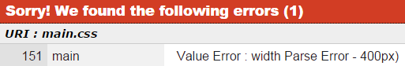

These are just some ways in which I was trying to manipulate the properties of CSS, which work. These are note publicly defined yet, and therefor they are unknown.

