Conmunis Conquest
(Working Title)
Game Pitch

Table of Contents
- Foreword
  - Working Title?
  - Goals of the project
- Story
- Characters
- Class system
  - Abilities
  - Levels
  - Equipment
- Level/Environment design
- Game-play
- Art
- Sound and Music
- User Interface/Game controls
- Math
  - AI
  - Manipulatable physical world
  - Celestial Bodies
  - Procedural generation of
    - Maps
    - NPC Ships
    - NPC Inventories
    - Celestial Bodies
    - Evolution of NPC Trade routes, Technologies and Territories.
- Free-to-play marketing model
- Why not kick-starter?
- Why so serious? (share distribution on launch day)

(Ctrl + Left-click to follow hyperlinks.)
      - Foreword
1.A Working title?
Why ‘Conmunis Conquest’? ‘Conmunis’ is latin for: common, collective, general, social, public, universal. Allowing for several play on-words with ‘Common Conquest’, ‘Collective Conquest’, ‘Social Conquest’ and ‘Universal Conquest’. All while offering unique brand identity, with only 223 google results for the two term search, ‘Conmunis Conquest’.
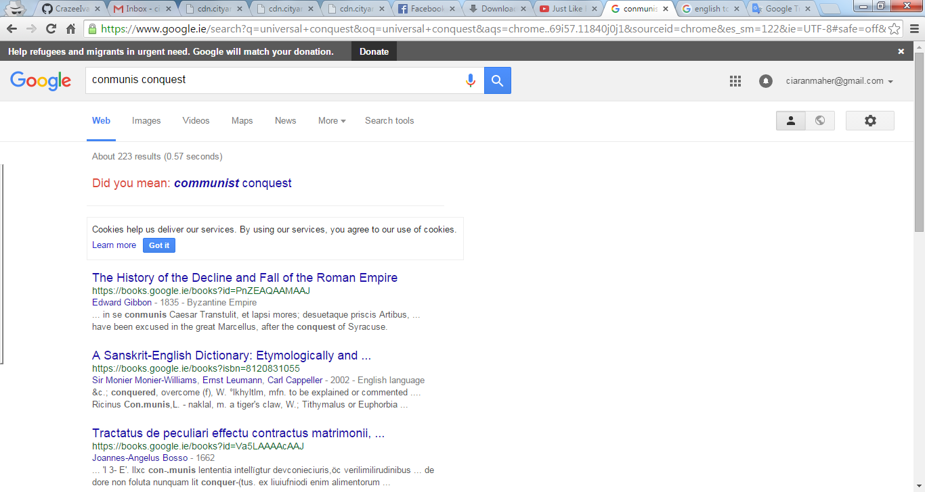

1.B Goals of the project
To create a game that provides intuitive and simple game-play on a micro level with a deep class system, procedural item generation and simulated physics across a massive sandbox universe. The complex class system layers a multi-role class system into a single character while still giving the player the ability to divide their “characters” into individual, specialised units. It is this system, combined with a universal economy that requires the harvesting, transportation and protection of both common and rare materials; that offers dozens of avenues of sand-boxesque game-play.
It is intended that this goal be met with the additional primary goal of creating a rich experience which being based on recent research, engages the player in areas of cognitive reasoning, memory and multi-tasking. This objective should come with the obvious implication that the game be approachable by gamers of all ages and backgrounds. The primary goals can thus be summarised as the following:
- Intuitive game-play and menus
- Simple but enthralling story elements
- Fun, vibrant and concise arcade action
- Immediate sound and visual feedback to all skills when used, when effective and when ineffective
- Procedural item generation
- Multi-class system
- Mothership allows universal class availability and increased customisability
- Single character/account system
- Immense world
- Physics based universe containing an evolving environment based on mathematical models
- Promote development of cognitive thinking, maths, fine motor control, memory and multi-tasking
- Playable with controller or mouse/keyboard
- Robust cross platform support with local and internet listen or dedicated servers.
- Scalable world
- Exciting and ruthless PvP/PvE encounters
- Evolves from a random seed

      - Story
2.A Work in Progress
Open to massive inputs here, but three player factions is proposed with varying levels of NPC punishments for same faction PvP, depending on the chosen faction. This would result in an easy, intermediate and difficult faction choices.
It is proposed that themes and history from Ciarán Maher’s ‘Quantum Conludium’ be used for filler i.e. take any three fantasy races and put them on separate planets until they discovered space travel and began fighting each other.

      - Characters
WiP
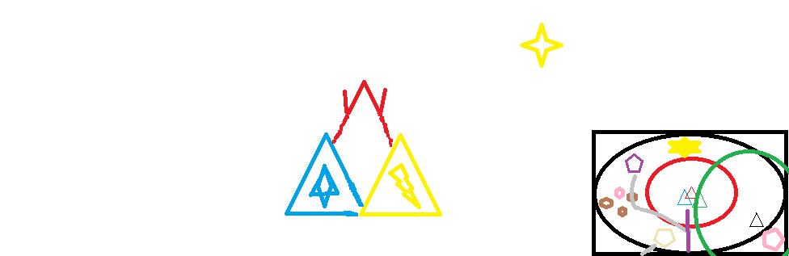

All characters in the game consist of several core ships with varying abilities customised by the player, or in the case of NPCs; randomly.
Characters are all connected via the mother-ship and can communicate and co-operate with one another. Additionally, an experienced player can set-up ambushes, scout ahead, corner prey or setup flanking manoeuvres. Finally, simple tasks such as deliveries, mining and scouting can be automated.
Players begin the game as a simple mother-ship with poor speed, manoeuvrability, mining and construction tools. The first objectives are to create support ships but there is no questing or otherwise handholding. Areas are dangerous and NPCs are ruthless. Predatory players can also attack them with varying difficulty, depending on their starting faction.
NPCs provide services and sales but ultimately players must craft their entire compliment of ships, each of which represents a uniquely designed class answerable only to the player. Skills and stats are heavily affected by the items players have crafted or scavenged from other players and NPCs.

      - Class system

Each player must choose two starting classes from a pool of greater than 4 total classes. There is the potential to add downloadable content/free-to-play content in the form of new classes; provided it does not pose as a pay-gate to free-to-play players.
Chosen classes represent the base skills of the mother-ship, as well as potential future upgrades which are achievable with later resources.
A player may craft a new ship of any class, provided they have available resources near an active production facility. This may vary from the mother-ship, to specialised ships to planetary bases and spacestations.
Everything is destructible, repairable and harvestable/salvageable.
Abilities
Abilities is still largely depending on what we can do and then what we can imagine. I would propose things from shields, missiles, lasers, turrets, drones, evasive manoeuvres, to the more wacky; black-hole cannons, moon catapults and star-throwers.
Levels
Unknown. In a universe sandbox game, with infinite scalability, do you need levels?
Equipment
Unknown. Research new types of ‘stat algorithm’ to randomly generate new types of engines, shields, weapons, etc?

      - Level/Environment design
Anthony save me!
Massive open world. Reproducible from an algorithm and our database. Procedurally generated in real-time, with as low overheads as possible.

      - Game-play
What wouldn’t you do?

      - Art
“ I choose you, Barry!”
- Simple visuals as possible, associate simple geometric shapes with particular class or roles. Similar or the same radar silhouette.
Weapon/equipment load-out should be communicated as efficiently as possible from simply looking at a unit in the world.
Friendly, inviting environment; let players and the NPCs do the intimidating.
Simple, clean interface using logical associations of menus. As little text as possible, but plenty of stats. Overlay tutorials but try to avoid complex stat system to make this redundant.
      - Sound and Music
Usshkush and Kevin, a match made in heaven?
- To the beat of ‘unts, unts, unts’

Good music is hard to come by, but super-critical. Sound as a whole also needs to be another medium that provides the player with feedback. If it helps, consider information an instrument.
Music must also be creating memories and associations with what’s going on in terms of game-play, teaching the player to associate a musical pattern to danger or rewards.
      - User Interface/Game controls
Ideally, playable on a controller or keyboard/mouse combination. If it can be played on controller it can ultimately be played on a smartphone.
Switch between ships, simple controls for each ship with cross ship similarity to make taking on new ships, simple and effective.

      - Math
AI
Procedural generation of
Maps
NPC Ships
NPC Inventories
Celestial Bodies
Evolution of NPC Trade routes, Technologies and Territories.
Manipulatable physical world
Celestial Bodies

      - Free-to-play marketing model

      - Why not kick-starter?

      - Why so serious? (share distribution on launch day)

