# **web operations team**



APPLICATION FOR WEBOPS Coordinator

## Indian Institute of Technology

**MADRAS**



My website: https://crazy-co.github.io/Insti-Webops/

Alternate Link: https://tinyurl.com/instiwebops

Name: Khushdev Yogi

Roll No: CE21B070

Contact: 8209958781

Email: [ce21b070@smail.iitm.ac.in](mailto:ce21b070@smail.iitm.ac.in)

“

“

Do what I love,

Love what I do.

* *****What relevant programming language or frameworks are you comfortable with? State your credentials and any experience in development, internship, passion projects, open source collaborations.. We’d love to hear it all!*
* I have started coding after getting admitted into most prestigious college “IITM” and now I am very much comfortable with C and C++.
* I love to make websites and have good knowledge of HTML, CSS and working to learn JavaScript.
* I would like to mention here that I have learned GIT Bash and now familiar with GitHub UI.
* No prior experience in development, but I have made some small scale projects for my own learning. I had made a website which have some important links of IITM websites all at one page with my grade-card in form of a table.
* *Why are you applying for this position and what qualities make you the right person for this?*
* I have decent knowledge of HTML and CSS. I found it very interesting while developing websites for engaging myself in my leisure time. And now, I am in search of refinement of this skill and to join a team with people having interest alike to me.
* I have good sense of designing, so because of this I consider myself a good designer and frontend is all about making website clean and good looking.
* I am very much familiar with MS Office software, which can be helpful for our team when we need to make Application or Pdfs or Presentation for Insti.
* I like to spend my spare time with computer and trying new things.
* I also have interest in cyber security back from my school days.
* WebDev is one of the most demanding skill in today’s world. I  
  want to be a part of Developers community and Insti WebOps  
  will lead me to this path straight away.
* *What improvements can you suggest in the current websites made by the institute WebOps team?*
* ****In Fresher’s website, details in Alumni Insight is not completely responsive.
* In Fresher’s website, text content written should be justified and I have noticed that many paragraphs are written in italics which is not a good practice according to the rules of typography. Content should be presented in simple format and some keywords can be italics to emphasize upon them.
* Concept of Story of You website is very good, all it need is good quality of background images which can make it easier to read.
* *****How would you rate your willingness to learn new stuff? What methods do you use to learn something new?*
* I would rate **9/10** my willingness to learn new stuff. Because sometimes I feel that my habit will impact inversely in long-run.
* I am pretty good at learning part, I devote my maximum time in learning new skills, even if I had to do it overnight.
* I don’t feel pushed when I invest my time in non-productive work. And I can work even in dozing situation if I feels that it is a productive work and will aid my skill-set.
* Mostly when I start anything new, I give much efforts on that without looking at time. During night while sleeping in my bed (Not daily), I put my earphones and start some videos on YouTube/Learn Vern/Coursera to start learning and then sleep at some random time.
* Currently, I watch C programming topics, Cyber forensics course and Websites making tutorials to see how other works on real-time websites and designs.
* *****What are the things you feel Insti WebOps lacks & how would you improve that?*
* Insti WebOps team is very good and creative as I have gone through their websites, some graphics and content designer can be added in team so that it will make a perfect team.
* Knowledge of typography, text alignment, color contrast and graphics designing will be good for presenting contents in more readable format.
* *Describe projects that you've worked on previously or are working on currently. You can include details about the design/architectural decisions you had to make and why you made them, any challenges you faced and how you overcame them. Abandoned projects are fine too (maybe you can write about the lessons you learnt from them).*
* I was working on a website to contain all important links of IITM needed to be saved.
* My above website is not completed by me as it is very hard to resume back anything. We usually start things and stop working on them and move on to start something new.
* I learned that we should not start new things till we complete the ongoing task.
* *****Mention your current PORs. Also mention the PORs for which you have currently applied. How much time can you devote to working in the WebOps team? Also mention references (if any).*
* Besides my academics, I have only 1 POR i.e. IAR WebOps, and now I want to join Insti WebOps also to make my Resume stronger and get opportunity to work as WebOps Core next year. It will help me in building my future in Web Development field.
* I also have plans to apply for OnIP Shaastra coordinator.
* I can devote 2-3 hours while working for Insti Webops team, but time may vary as it depends on the workload we have at that particular time.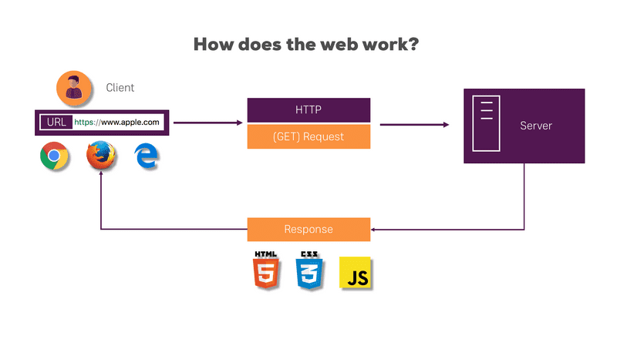*******HOW DOES THE WEB WORKS?*
* Client enters a URL in web browser. [Client Request]
* The browser goes to DNS server, and finds the real address (website’s IP address) of the website linked with that URL.
* Web browser finds the server using that IP address.
* Server search in its database and send data in series of small data-packets in raw form (i.e. HTML, CSS, JS). [Server Response]
* Now the browser assembles the data packets into a complete webpage and display it on client’s PC.

##### WHY ME?

* I am very hardworking and have lot of commitment towards my work. I’ll do the work assigned to me with utmost sincerity.
* I have ability to learn and grab new things quickly.
* I have a habit that I don’t stop and relax until my work is done and I love this.
* I like to help others, so I will not restrict myself to only my team but will also help other Insti teams as well.
* Other than programming and web development, I am familiar with Filmora, Kinemaster, MS Office, Photo Editing, AutoCAD, Fusion 360 and some other softwares knowledge.
* I’m calm and patient. Even in critical situations I don’t panic and looks for solution keeping myself tranquil and keeping the team members motivated.
* I always try hard to finish the assigned tasks to me before the given deadlines.