Autonomous Reconfiguration of Modular Satellite Components

MOdular Spacecraft Assembly and Reconfiguration (MOSAR) is a ground-based demonstrator of heterogeneous modular spacecraft. It utilises a robotic arm and universal docking adapters to allow any module to be attached to any other and transfer power, heat and controls. Reconfiguration of the MOSAR demonstrator is currently manual; commands will be carried out in simulation software by hand, these movements will then be sent to the arm for it to carry out. This does not utilise nor demonstrate the true potential of the system, my project mission has been to fill this gap.
MOSAR is in the minority of modular robotics because it is a heterogeneous system whereas most researched systems are homogeneous. Heterogeneous systems present unique problems for reconfiguration as some modules are not interchangeable and therefore module placement becomes essential in arrangement.
In searching for solutions I came across an algorithm called Melt Sort Grow that was purposefully written for heterogeneous modular robotics. It represents each module as a node in a tree which allows it to take advantage of Breadth First Search (BFS) for searching and path finding. The process of reconfiguration is broken down into the 3 steps:
Melt
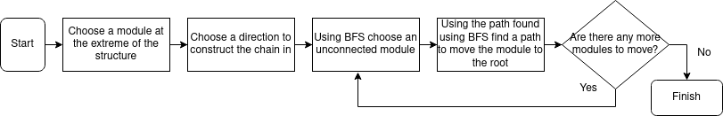

Sort
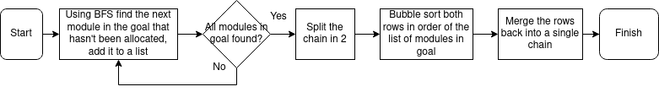

Grow
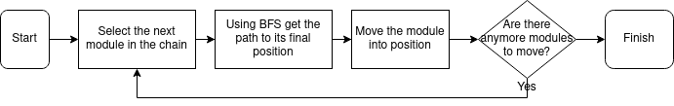

The algorithm as it was presented modelled the module movement as sliding cubes, simplifying simulation and easily translating into movements made by a robotic arm. The path begins as a list of modules returned by BFS, these are then converted into those modules’ real world positions, and then only the extremities of the path are taken and used to move the module. This ensures the module passes around the outside of the structure without traveling too far away from it.
There were features missing from the original algorithm that would prove useful for its real world use; some of these I was able to implement. One of these was orientation, as the MOSAR modules are cubes their rotations are restricted to 90°. To implement it I stored each module's orientation as quaternions which allow for modules to be in any orientation and avoid gimbal lock. Implementing orientation was especially essential as some modules may have to preserve certain orientations even when moving. I then added features that allow the modules to be different sizes; this should also prove useful for real world use.
There are many improvements and features that could be added, such as: optimisation for arm movements, (allowing for jumping gaps in the structure and moving in diagonals), identifying and moving groups of cubes (in the microgravity environment moving multiple modules would be both possible and more efficient in certain situations), rewriting as to distribute computation (to truly take advantage of modular robotics computation should be distributed). There are also several improvements that could be made to improve testing in the morse simulator: allowing structures to be loaded into the environment, to create and code an arm, and add grouping of modules without any one being the parent.

