**EXPERIMENT – 4**

**Write a Perl program that computes the circumference of a circle with a radius of 12.5 units.**

**Code:**

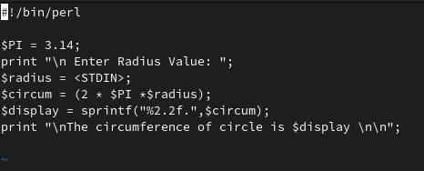

**Output:**

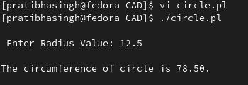

**Write a Perl program to take in two numbers and prints out the result of the two numbers multiplied.**

**Code:**

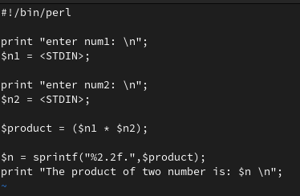

**Output:**

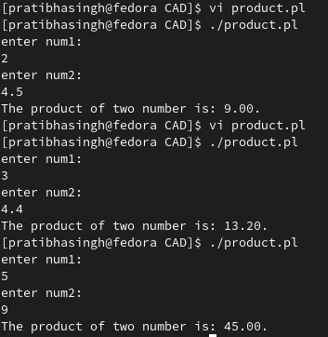

**Write a Perl program that reads in a string and a number, and then prints out the string the number of times requested.**

**Code:**

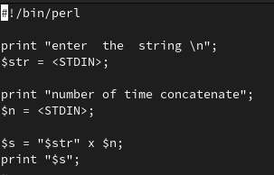

**Output:**

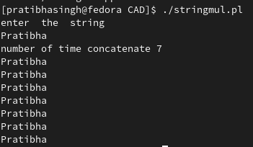

**Write a Perl program that prints the cube of a number.**

**Code**:

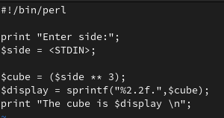

**Output:**

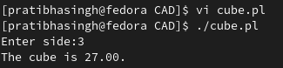

**Write a code to explore String operators.**

**Code:**

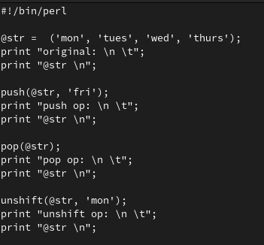

**Output:**

