**Experiment-1**

**Objective:** Introduction to data types and arrays.

1. Write the SystemVerilog code to:
2. Declare a 2-state array, my_array, that holds four 12-bit values
3. Initialize my_array so that:

my_array[0] = 12'h012

my_array[1] = 12’h345

my_array[2] = 12'h678

my_array[3] = 12’h9AB

1. Traverse my_array and print out bits [5:4] of each 12-bit element
2. With a for loop
3. With a foreach loop
4. Write the SystemVerilog code to:
5. Declare a 2-state two dimensional array, array_2d (4 rows and 3 columns), that holds 12 integer values.
6. Initialize my_array so that:

array_2d[0][0] = 0

array_2d[0][1] = 1

array_2d[0][2] = 2

array_2d[1][0] = 3

array_2d[1][1] = 4

array_2d[1][2] = 5

array_2d[2][0] = 6

array_2d[2][1] = 7

array_2d[2][2] = 8

array_2d[3][0] = 19

array_2d[3][1] = 20

array_2d[3][2] = 21

1. Print out the values stored in array_2d and verify them with initialized values. Hint: use foreach loop.

**Code 1:**

module test1;

bit [11:0] my_array[4]; // Declared a 2-state array that hold 12bit values

initial begin

// initialise my_array with the given values

    my_array='{12'h012, 12'h345, 12'h678, 12'h9AB};

// Traverse my_array and print out bits [5:4] of each 12-bit element

//using for loop

    $display("\n Using For loop");

    for(int i=0; i<$size(my_array); i++) begin

        $displayh("my_array(%0d)=%b,%b",i,my_array[i], my_array[i][5:4]);

    end

    //using foreach loop

    $display("\n Using Foreach loop");

    foreach(my_array[i]) begin

      $displayh("my_array(%0d)=%b,%b",i,my_array[i], my_array[i][5:4]);

    end

    $display("\n Adding 4 to the values");

    $display("\n Using For loop");

    for(int i=0; i<$size(my_array); i++) begin

      my_array[i] +=4;

      $displayh("my_array(%0d)=%b,%b",i,my_array[i]);

    End

    my_array='{12'h012, 12'h345, 12'h678, 12'h9AB};

    $display("\n Using Foreach");

    foreach(my_array[i]) begin

      my_array[i] +=4;

      $displayh("my_array(%0d)=%b,%b",i,my_array[i]);

    end

  end

endmodule

**Output 1:**

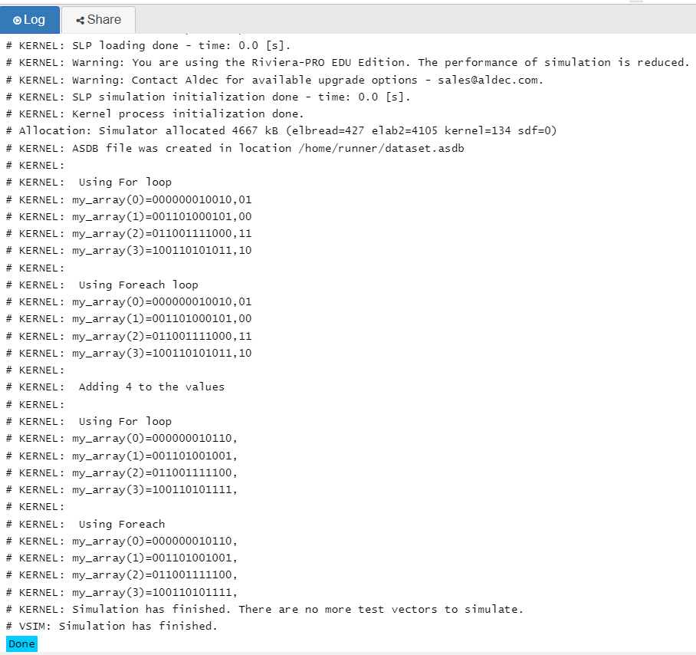

**Code 2:**

module test2;

int array_2d[4][3]='{'{0,1,2},'{3,4,5}, '{6,7,8}, '{9,10,11}};

  initial begin

    // array_2d='{'{0,1,2},'{3,4,5}, '{6,7,8}, '{19,20,21}};

    foreach(array_2d[i,j])

      $display("array_2d[%0d][%0d]=%d",i,j,array_2d[i][j]);

  end

endmodule

**Output 2:**

