**Experiment-1: 4x1 Multiplexer**

**Objective:**

To design a 4x1 Multiplexer and write a simple test bench for it. The test bench should generate stimulus to completely verify the functionality of the design under test with delay of 20ns.

**Theory:**

Multiplexer is a combinational circuit that has maximum of 2n data inputs, 'n' selection lines and single output line. One of these data inputs will be connected to the output based on the values of selection lines such that, each combination will select only one data input.

**Design Code:**

module mux41(input a, b, c, d, s0, s1, output y);

assign y=((~(s0))&(~(s1))&a)||((~(s0))&s1&b)||(s0&(~(s1))&c)||(s0&s1&d);

endmodule

**Testbench Code:**

module tb;

    // Inputs

    reg a; b; c; d; s0; s1;

    // Outputs

    wire y;

    // Instantiate the Unit Under Test (UUT)

    mux41 uut (.a(a), .b(b), .c(c), .d(d), .s0(s0), .s1(s1), .y(y));

    initial begin

        // Initialize Inputs

        a = 0; b = 0; c = 0; d = 1; s0 = 0; s1 = 0;

        #20;

        a = 0; b = 0; c = 0; d = 1; s0 = 0; s1 = 1;

        #20;

        a = 0; b = 0; c = 0; d = 1; s0 = 1; s1 = 0;

        #20;

        a = 0; b = 0; c = 0; d = 1; s0 = 1; s1 = 1;

        end

initial begin

$monitor ($time , "a=%b, b=%b, c=%b, s0=%b, S1=%b", a,b,c,s0,s1);

End

endmodule

**RTL Schematic:**

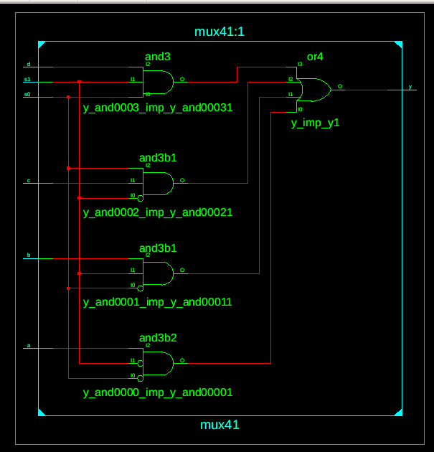

**Simulation Result:**

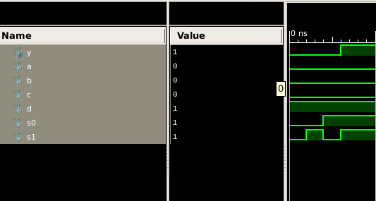

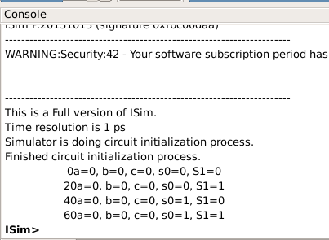

**Result:**

The simulation output and the RTL diagram is observed and found to be correct.