**ASSIGNMENT-1**

Write Different Programs in ARM assembly language to Set/Reset the flag register and apply all the conditional code suitable to perform the specific task.

**Conditional Codes**

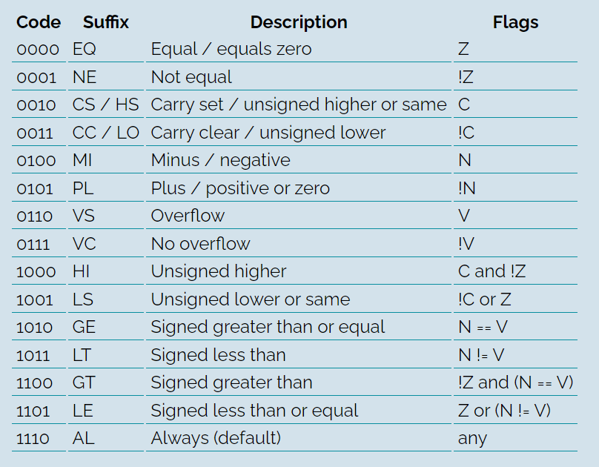

Here R0 register is taken as counter for counting the loops execution and other registers are used for compare and arithmetic operations to set and reset the flags.

**CODE**

 AREA PROGRAM, CODE, READONLY

 ENTRY

MAIN

     MOV R0, #1

     MOV R1, #2

     MOV R2, R1

     CMP R1, R2

     BEQ LOOP1 ; EQUAL

LOOP6

     ADD R0,R0,#1

     LDR R1, =0X70FFFFFF

     LDR R2, =0X3FFFFFFF

     ADDS R2, R1, R2

     BVS LOOP7 ; OVERFLOW

LOOP1

     ADD R0, R0, #1

     MOV R1, #1

     MOV R2, #2

     CMP R1, R2

     BNE LOOP2 ; NOT EQUAL

LOOP4

     ADD R0,R0,#1

     MOV R1, #1

     MOV R2, #3

     SUBS R1, R1, R2

     BMI LOOP5 ; MINUS

LOOP3

     ADD R0,R0,#1

     LDR R1, =0x00001000

     ADDS R1, R1, R1

     BCC LOOP4 ; CARRY CLEAR

LOOP2

     ADD R0, R0, #1

     LDR R1, =0xFFFFFFFF

     ADDS R1, R1, R1

     BCS LOOP3 ; CARRY SET

LOOP5

     ADD R0,R0,#1

     MOV R1, #5

     MOV R2, #2

     SUBS R1, R1, R2

     BPL LOOP6 ; POSITIVE

LOOP9

     ADD R0,R0,#1

     MOV R1, #1

     MOV R2, #2

     CMP R2, R1

     BGT LOOP10 ; GREATER THAN

LOOP8

     ADD R0, R0, #1

     MOV R1, #1

     MOV R2, #2

     CMP R1, R2

     BLT LOOP9 ; LESS THAN

LOOP12

     ADD R0,R0,#1

     CMP R1 , R2

     BLS LOOP13 ;UNSIGNED LOWER OR SAME

LOOP11

     ADD R0,R0,#1

     CMP R1, R2

     BLE LOOP12 ; less or equal

LOOP10

     ADD R0, R0, #1

     MOV R1, R2

     BGE LOOP11 ; GREATER OR EQUAL

LOOP14

     ADD R0,R0,#1

     BAL LOOP20 ; ALWAYS

LOOP13

     ADD R0,R0,#1

     LDR R1,=0XFFFF0000

     MOV R2,R1

     ADDS R1, R1, R2

     BHI LOOP14 ; UNSIGNED HIGHER

LOOP7

     ADD R0,R0,#1

     LDR R1, =0X00001000

     LDR R2, =0x00000000

     ADDS R1, R1, R2

     BVC LOOP8 ; NO OVERFLOW

LOOP20 B LOOP20

 END

**REGISTER OUTPUT**

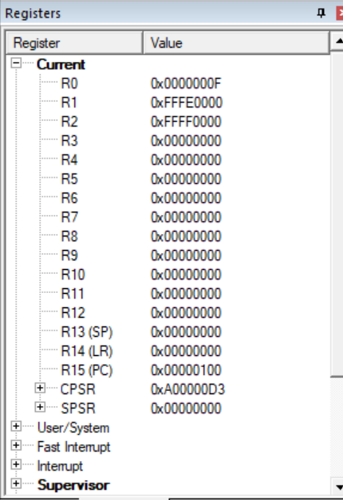

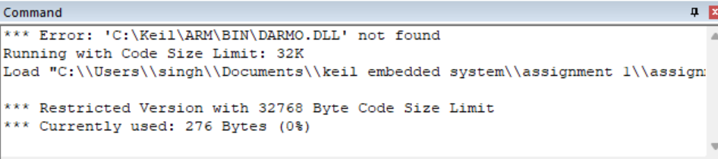

**RESULT:**

Successfully executed the program to Set/Reset the flag register and applied all the conditional code suitable to perform the specific task. The outputs of registers are as expected.