Problem2

(a)

We set c3=34, and we set two set of initial conditions:

(x1=-1.50, y1 = 0.00, z1 = 2.00) and (x2=1.50, y2 = 0.00, z2 = -2.00)

Now we observe two sets of periodic orbits

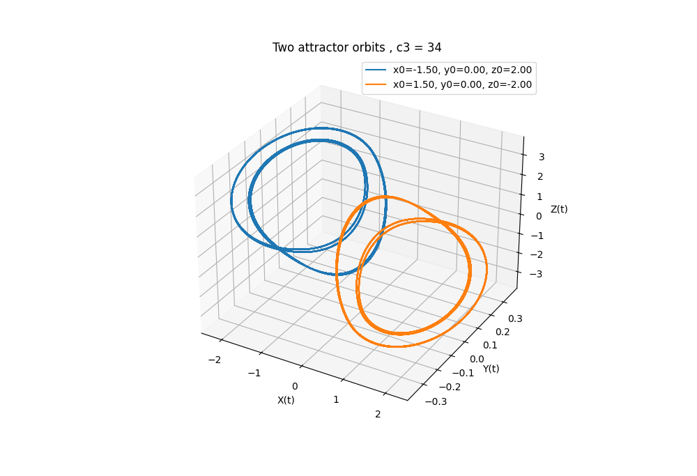

(b)

C3=34, we have period 4 solution.

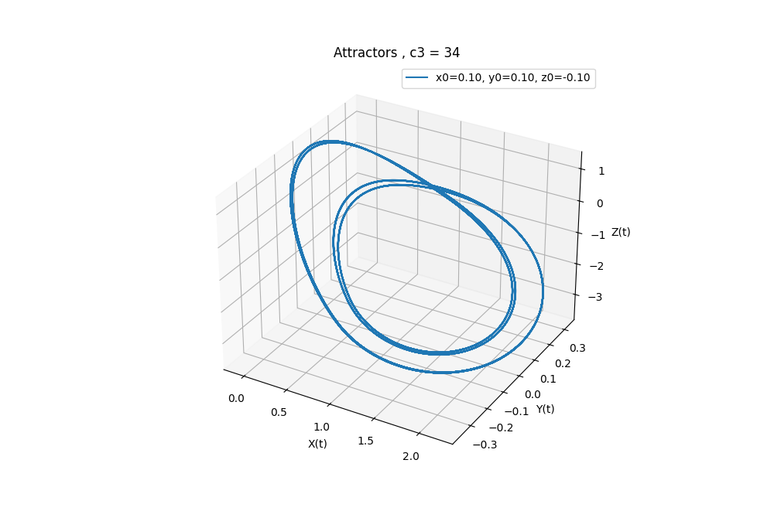

C3 = 35, we have period 2 solution

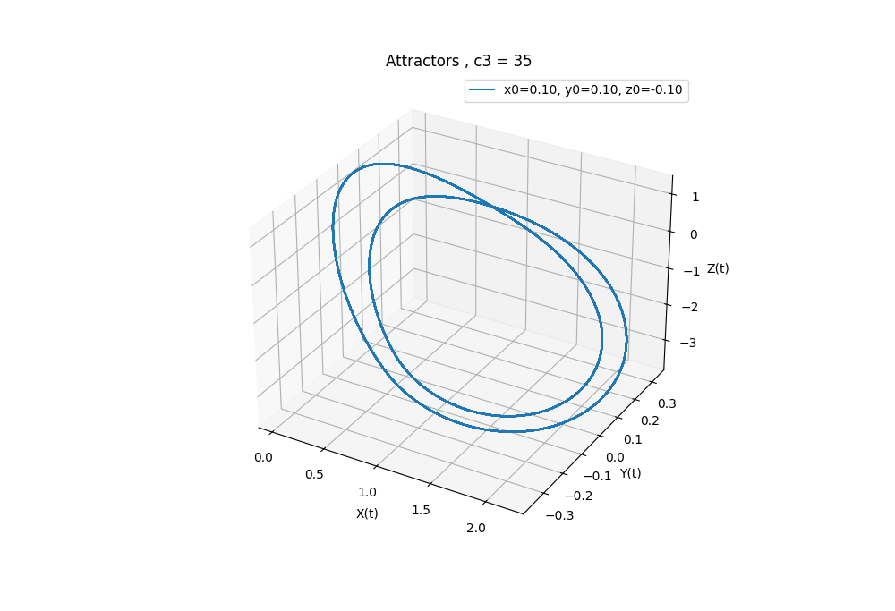

(c) At c3 = 25.58, we can see a chaotic attractor

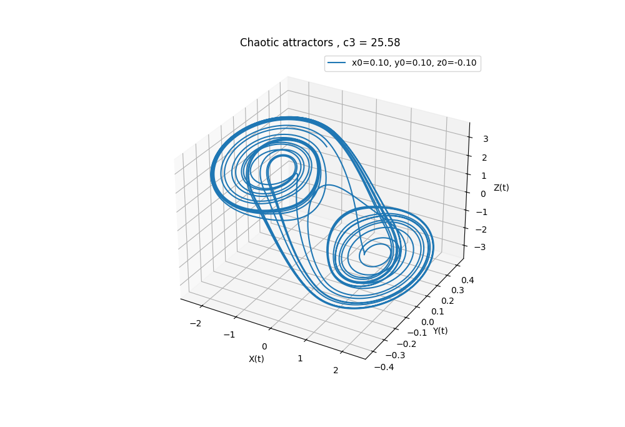

(d)

If we set coupled coefficient c=0.15, we have two uncorrelated attractors

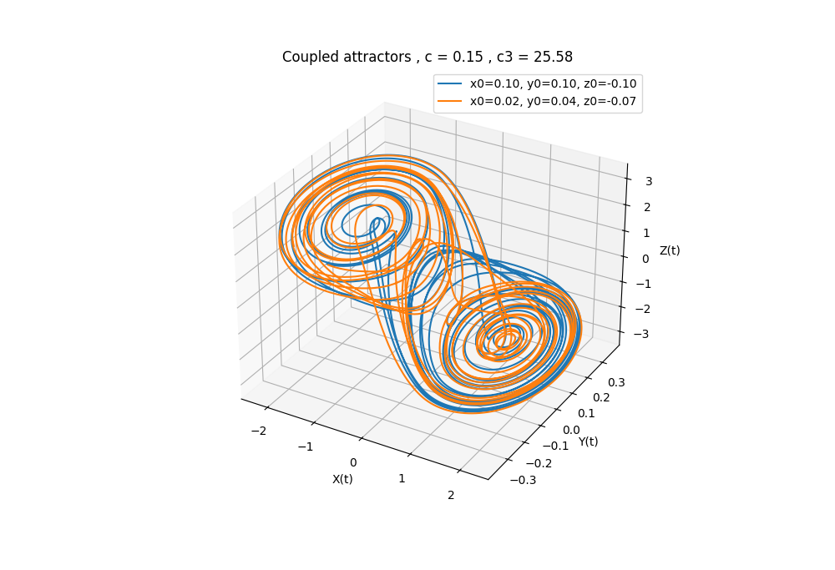

However, if c=0.3, the two attractor orbits start to synchronize (orbits overlap)

