Problem 1 Plotting

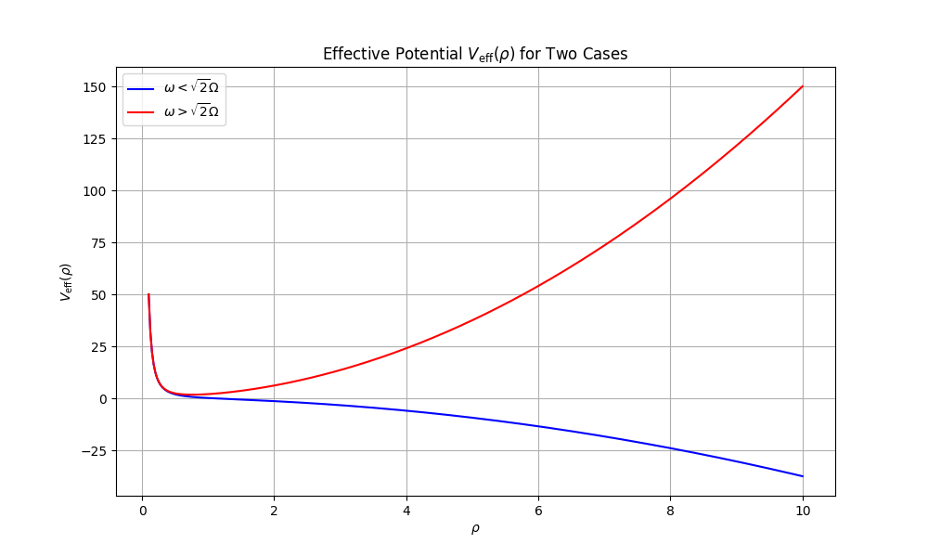

We can see clearly that in the case of $ω>\sqrt{2} Ω$, there is a local minimum in the effective potential, so it can form an efficient trap.

On the other hand, for $ω<\sqrt{2} Ω$, there is not a local minimum in the effective potential, so it cannot form an efficient trap.