Fast Engine Startup — Baseline: Where Does Startup Time Go?
Setup: Qwen/Qwen3-30B-A3B-Instruct-2507 (BF16, 61 GB), SGLang v0.5.20 (lmsysorg/sglang:v0.5.20, torch 2.13 / CUDA 13), TP=2 on 2× H100 80GB HBM3 (Modal, driver 580.95), weights on a Modal v2 volume. Vanilla sglang.launch_server with no startup flags.
Method: One Modal container launches the engine twice in a row (baseline.py, run 20260923-184715).
- Cold (run 1): fresh container. Empty page cache, empty JIT caches, and image files not yet fetched.
- Warm (run 2): same container right after run 1. Everything above is cached.
Phase boundaries come from SGLang's own log lines, timestamped as each line arrives. "Ready" means /health returned 200 and one /generate request succeeded. GPU utilization and memory were sampled every 0.5 s.
Caveat: this is n=1 per condition. The numbers show where time goes, but they are not yet tight enough to quote precisely. Repeat runs are listed under next steps.

Headline
 | Cold | Warm | Cold − Warm
Container start (call → function running) | 13.9 s | —
Process spawn → serving first request | 237.0 s | 89.7 s | 147.3 s
End to end | ~251 s

Nearly two-thirds of cold startup (147 s of 237 s) disappears when caches are warm. Most of the gap is fixable by preparing things before the GPU is attached, not by making SGLang itself faster.
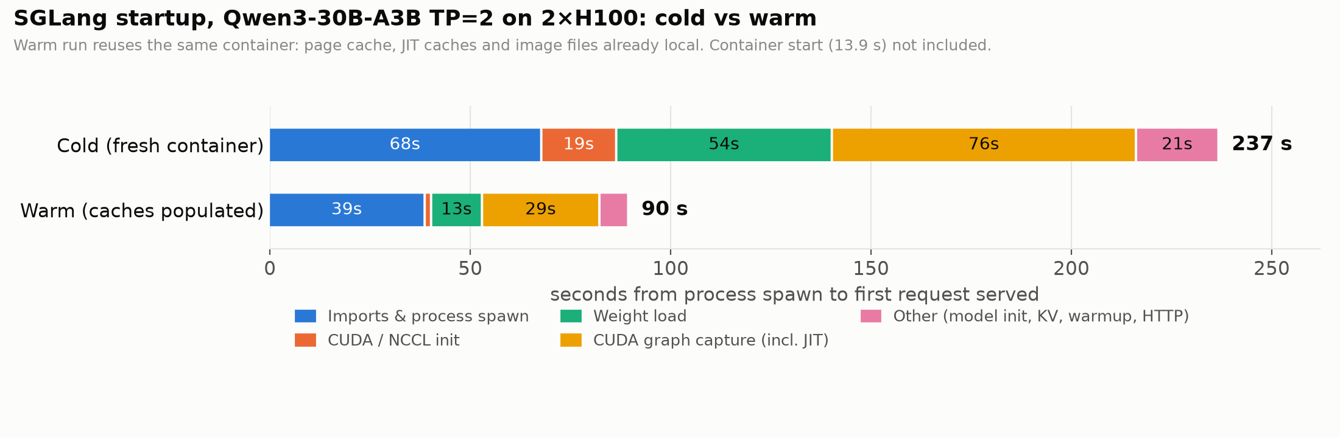

Phase breakdown (seconds)
Phase | Cold | Warm | Δ | What it is
Spawn → server_args logged | 45.8 | 18.8 | 27.0 | Python + torch + sglang imports in the launcher; the cold run also fetches image files lazily
→ Init torch distributed begin | 22.2 | 20.1 | 2.1 | Spawning the TP worker processes, which re-import torch/sglang
Distributed / NCCL init | 18.7 | 0.8 | 17.9 | NCCL + CUDA context setup; cold includes first load of CUDA/NCCL libraries
→ Load weight begin | 6.1 | 2.0 | 4.1 | Model construction
Weight load | 53.8 | 12.8 | 41.0 | 61 GB from the volume (28.65 GB per GPU). Cold ≈ 1.1 GB/s; warm is served from page cache
KV cache allocation | 2.4 | 2.0 | 0.4 | 777k tokens, 35.6 GB K+V per GPU
Prefill CUDA graph capture | 62.6 | 20.0 | 42.6 | "Breakable" piecewise graphs over 58 token counts (4 … 8192); cold includes Triton JIT for the MoE kernels
Decode CUDA graph capture | 13.3 | 9.3 | 4.0 | Full graphs over batch sizes 1 … 256+
Scheduler → Uvicorn up | 1.3 | 0.6
Server warmup request | 8.8 | 1.2 | 7.6 | SGLang's built-in warmup /generate
Health + first request | 1.1 | 1.0 |  | The first user request takes 70–80 ms once ready

SGLang's own Engine startup timings line agrees with these numbers: load_weight=53.77, cuda_graph prefill=62.59 / decode=13.32 cold.

GPU time wasted during startup
During the cold launch, the 2 GPUs were reserved (and billed) for the whole 237 s:
- GPU memory was held for 167 s.
- Any kernel activity at all showed up in only ~50 s of samples (~21%).
- During weight loading, the GPUs showed activity in only 22 of 54 s. They mostly wait on storage.
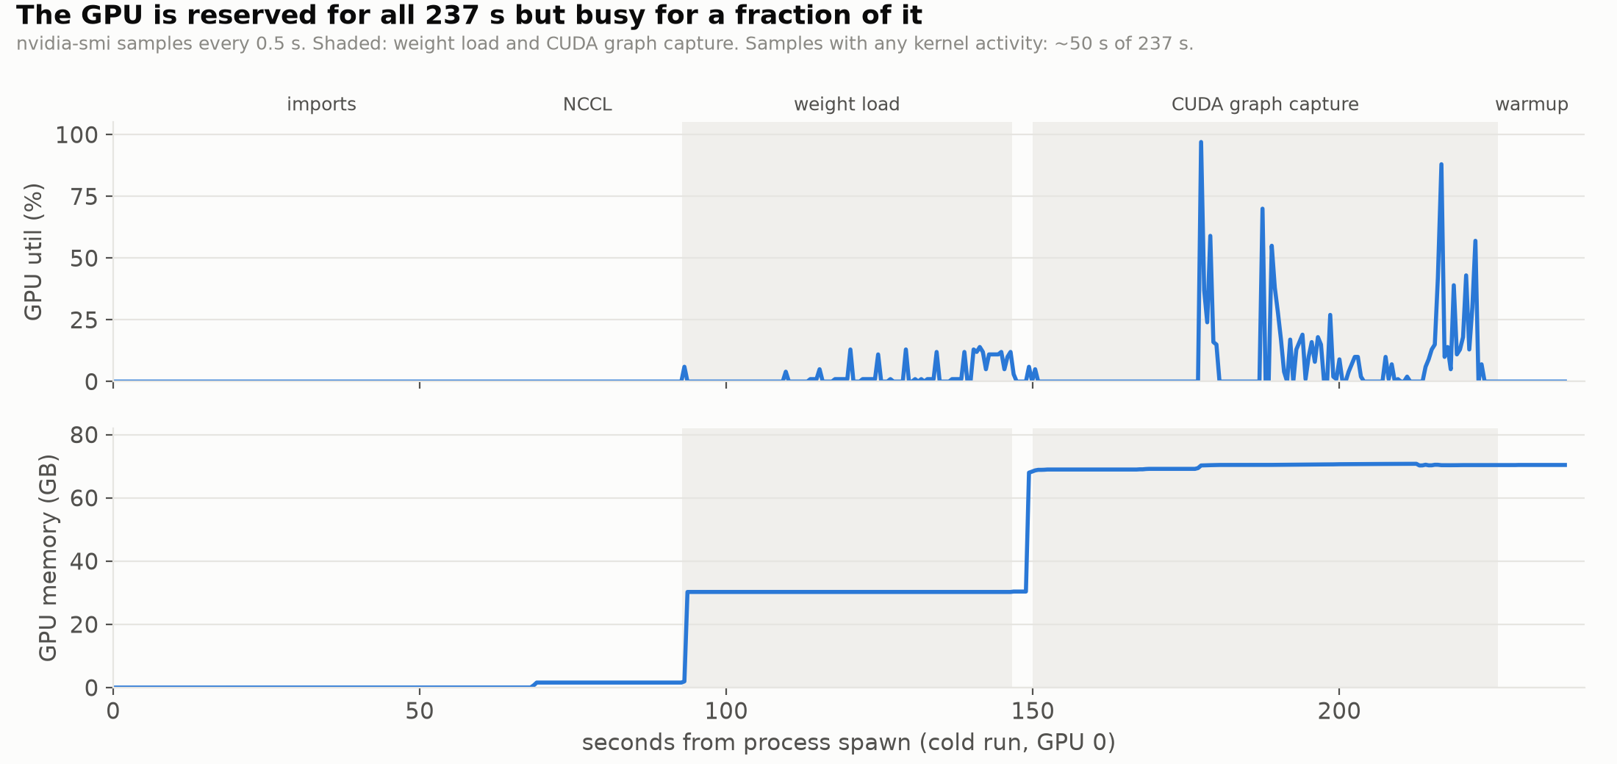
The timeline also shows the first ~27 s of CUDA graph capture (150–177 s) with 0% GPU utilization. That's Triton JIT-compiling the MoE kernels on the CPU while both GPUs wait, which matches the 42.6 s cold/warm gap in prefill capture.
This is coarse (nvidia-smi utilization.gpu counts any kernel in the sample window), but the conclusion holds: most of cold startup is CPU, I/O and compile work that doesn't need the GPU. That supports moving preparation onto CPU workers before the GPU is attached.

What this says about where to go deeper
Ranked by recoverable time, with the approach each points to:
- Weight loading: ~41 s recoverable (cold 53.8 → warm 12.8). Reading from the volume is the bottleneck, not the host-to-GPU copy. Candidates:
- Pre-stage weights to local NVMe or /dev/shm on a CPU worker before GPUs attach.
- Parallel/streaming loaders already in this SGLang build: --load-format fastsafetensors and runai_streamer.
- For the "A serving, B starting" scenario: --load-format remote_instance, which pulls weights GPU-to-GPU from the serving replica (NIXL is installed).
Trade-offs: local disk or RAM per node, and the load that remote transfer puts on the serving replica.
- CUDA graph capture: ~43 s JIT + ~29 s capture.
- The cold/warm gap (42.6 s on prefill graphs) is compile work. Persisting JIT/compiler caches across containers, keyed by model, TP, GPU type and SGLang version, should recover most of it.
- Open question: after run 1, ~/.cache held only 20 MB (~/.cache/sglang), so the Triton/Inductor caches must live somewhere I haven't found yet. Locating them comes first.
- The remaining ~29 s warm is capture itself, over 58 prefill sizes plus the decode batch sizes. Capturing fewer sizes (--cuda-graph-max-bs, custom lists) or capturing lazily trades startup time for latency on uncaptured shapes.
- Process start and imports: ~68 s cold / ~39 s warm before any model work.
- Three Python processes (launcher + 2 TP workers) each import torch and sglang.
- The cold premium (~27 s) comes from lazy image loading.
- Candidates: Modal memory snapshots, pre-warming the image, or a pre-imported engine process started on CPU before GPU attach.
- NCCL/CUDA init: ~18 s cold, ~1 s warm. Most likely first-time library loading from the image, so it should shrink alongside item 3.
- Built-in warmup: 8.8 s cold. Mostly JIT on the first real forward pass, so it should shrink with item 2.
A rough ceiling: if everything that differs between cold and warm were prepared ahead of time, startup would approach ~90 s. Getting below that means capturing fewer graphs, restoring from a snapshot, or reducing import cost.

Next steps
- Repeat cold and warm runs (n≥3) to get variance. Add a second cold container to confirm how much of the cost is per-container versus per-launch.
- Find where the JIT artifacts are written; persist them to the volume and re-measure the cold start.
- Weight-loading sweep, measured on cold containers: default vs. fastsafetensors vs. runai_streamer vs. pre-staged local NVMe / /dev/shm.
- Graph capture sweep: default vs. reduced batch-size lists vs. --disable-cuda-graph, including decode throughput and latency after startup so the trade-off is visible.
- 4×H100 scenario: A (GPUs 0–1) serving while B (GPUs 2–3) starts with remote_instance loading from A. Measure B's startup and A's latency impact.

Reproduce
uv run modal run tmp/experiments/setup_env.py::download_model # once, CPU only
uv run modal run tmp/experiments/baseline.py --runs 2 # ~6 min on 2×H100
Raw logs, gpu.csv and summary.json are in results/20260923-184715/ (and on the fes-results volume).

