CASA0018: Deep Learning for Sensor Networks 25/26

Exposure Expert - Final Report

Name: Haoyu.Hu
Student ID: 25037784
https://github.com/CrazyEpi/CASA0018-ExposureMaster/tree/main
Abstract
This project presents "Exposure Expert," a machine learning mobile application assisting instant photographers in determining exposure settings. Built on a lightweight MobileNetV2 model, the system was trained on a custom dataset simulating various exposure values (EV) via TensorFlow, achieving 79.1% validation accuracy. A Flutter android app was developed to deploy the model. It features a real-time capture and feedback loop, providing exposure suggestions and vibration alerts to inform users of lighting conditions. This balances computational efficiency for real-time deployment with robust predictive performance across varied lighting environments.
- Introduction
Analog photography, especially instant-film photography, has become increasingly popular in the past decade for its unique aesthetic. However, unlike digital systems, film are expensive and offer no real-time preview. Exposure errors often cause film and financial waste. While traditional light meters provide numerical data, they often fail to give intuitive advice for beginners.
This project aims to develop a machine learning solution that senses the ambience, performs local inference, and provides physical responses to users. The main challenge is deploying this system on computationally limited devices like smartphones, which requires careful optimization to maintain acceptable inference latency (Chen and Ran, 2019).
The proposed system includes a custom dataset, a training program, and a mobile application. The complete dataset consists of 8,407 images across 1,065 samples, which comes from three parts, the SICE dataset, a self-built image collection, and a modified WIDER Face dataset adapted for exposure simulation. Then a transfer-learning network based on MobileNetV2 is used for training. Finally, the generated model file will be used in the mobile application to conduct an exposure inference.
- Methodology
  - Data Acquisition and Labeling
A robust dataset is the foundation of this project, and for this project, a composite dataset was designed to maximize the image diversity, while trying to mimic the characteristics of instant film with digital images. Specifically, images with different exposures are labeled according to their exposure status (Under, Normal, or Over Exposure). By training on the dataset, it is expected that the model will be able to learn to distinguish images with different exposure conditions.
The dataset consists of 8,407 images from three sources, and then engineered for this task.
The first part is the SICE dataset (Cai, Gu and Zhang, 2018), providing high-quality multi-exposure sequences of various scenes. This is the foundation of the whole dataset, and the following parts are built with the same format as the SICE dataset. Each SICE sample contains an odd number of images; the median file represents optimal normal exposure (0 EV), while smaller and larger numbers represent under- and over-exposed images, respectively.
The second part consists of a random sampling of personal photographs taken by me over the past few years. The photo selection contains mainly landscape photography and street photography taken in multiple countries, ensuring the diversity of the dataset. These images were originally captured in Nikon RAW (NEF) format, providing a wider dynamic range. A custom Python script was developed to process the 16-bit linear RGB data and to generate 6 pictures out of one, from -3EV to 3EV. Exposure was mathematically simulated by the following equation before applying Gamma 2.2 correction:
$$I_{shifted}=I_{linear}×2^{EV_shift}$$
The third part was designed to strengthen portrait-related performance, as the previous parts contained few portraits. Therefore, a random sampled subset of the WIDER Face dataset (Yang et al., 2016) was introduced into the project. Specifically, 157 samples were randomly extracted from the original dataset's 32,203 portrait images. However, since JPEG images are non-linear data, an inverse gamma decoding was first applied to approximate the linear RGB space. The exposure shift was then simulated using the following simplified formula before re-encoding back to the standard sRGB space:
$$I_{shifted}={\left(I_{jpeg}^{2.2}×2^{EV_shift}\right)}^{\frac{1}{2.2}}$$
Due to the inherent dynamic range limitations of JPEG images, this mathematical transformation serves as an approximation. By applying it to the WIDER Face subset, 4 synthetic exposure variations are generated per original sample.
  - Preprocessing and Augmentation
After the dataset was loaded, the images were resized to 224 x 224 pixels for the model input. Then all the 0EV images were augmented by a slight EV shift. This is to reduce influence by the exposure difference caused by the auto exposure system in cameras when the images were taken. Finally, the "Normal" class comprises -1, 0, and +1 EV images, while lower and higher exposures form the "Under" and "Over" classes, respectively.
  - Neural Network Architecture
MobileNetV2 (Sandler et al., 2018) was selected as the backbone for since it was developed for mobile processors, which are likely to demonstrate a higher level of efficiency and accuracy. Training was conducted in two stages with a 40% dropout to improve robustness. The model was trained in 120 epochs, 70 in stage 1, and 50 in stage 2. A cosine decay scheduler controlled the learning rate in Stage 1, while a lower rate (1e-6) was applied in Stage 2. Since normal samples outnumbered the others, class weighting was applied to balance the three categories. In Stage 1, the backbone was frozen to train the classification head. In Stage 2, the top 20 layers were unfrozen for fine-tuning. During stage 2, all Batch Normalization (BN) layers were locked to prevent the learning outcome being corrupted by our relatively smaller dataset (Ioffe and Szegedy, 2015), resulting in a more stable convergence.
  - App Development and Model Implementation
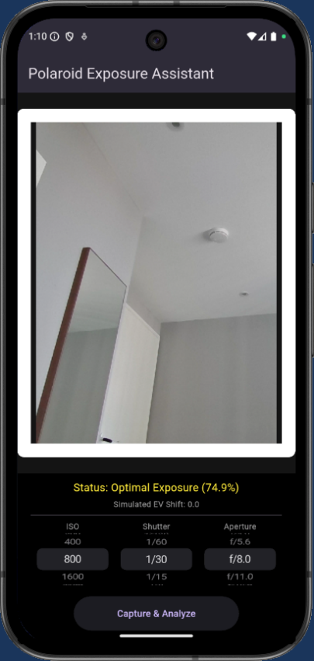
Fig 1, Exposure Expert Interface
The application was built using Flutter to facilitate cross-platform deployment, the design is shown as Fig.1. The model was converted to .tflite format with weight quantization (Jacob et al., 2018), reducing its size to approximately 4MB. This allows for relatively fast inferences, which is crucial for a real-time photography tool. The functionality of the app is relatively straightforward, the app will first load the TensorFlow lite model, then capture a real-time frame from the device’s camera. The default setting is to mimic the characteristics of Polaroid 600 instant film, and Fujifilm Instax instant film series. For further customization, the bottom control dials allow users to fine-tune exposure, ensuring compatibility with a wider range of film styles. Thus, the app is ready to make an inference, and the inference result will appear under the viewfinder with a vibration cue. A "Normal" classification triggers a short vibration pulse, indicating optimal shooting conditions. Conversely, "Under" or "Over" classifications result in a heavy double-pulse warning. This physical response allows a clearer exposure feedback, trying to build up a better human-computer interaction. Moreover, the graphical user interface was specifically designed to bridge the gap between digital and analog experiences. A digital viewfinder with an instant-film-style frame was implemented to give users a realistic sense of the final instant photo's composition. This ensures the user experience of the app aligns with the process of taking actual instant film.
- Results and Evaluation
  - Accuracy and Loss Curves
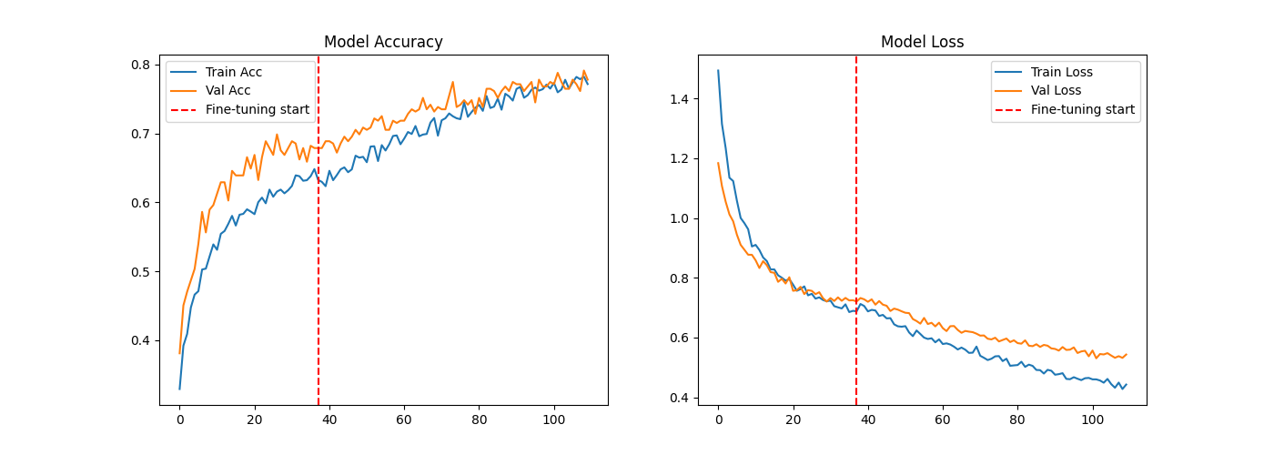
Fig 2, Accuracy and Loss Curves of the Trained Model
Shown as Fig.2, stage one training successfully pushed training accuracy to approximately 60%, and validation accuracy to around 70%. With fine-tuning in stage 2, the both training and validation accuracy slowly but steadily climbed to 79.1%. The loss curve exhibited a similar, stable trend. These curves indicate successful convergence, suggesting the 0.4 Dropout rate mitigated overfitting. Noticeably, validation accuracy remained higher than training accuracy across most epochs. This may because of the dropout layers and data augmentations weakened the actual classification ability during training.
  - Confusion Matrix
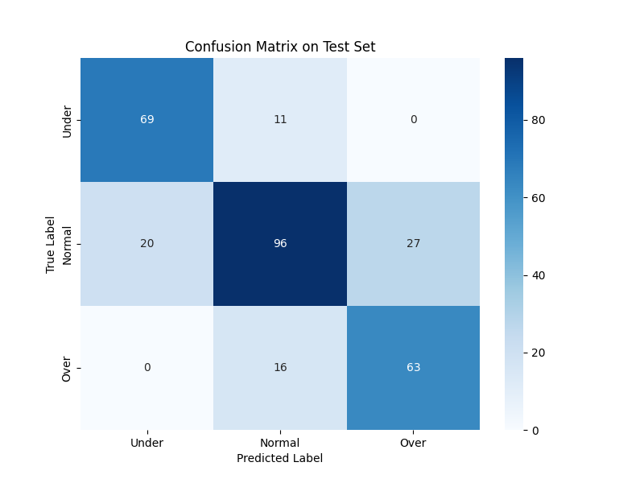
Fig 3, Confusion Matrix on Test Set
The confusion matrix shown in Fig.3 demonstrates that the model has never confused underexposure with overexposure. The primary error was misclassifying "Normal" as "Overexposed" (27 samples). Actually, this bias is likely to benefit the final result, since films has a better highlight performance than shadows.
- Project Reflection
Reflecting on this project, building an exposure assistant provided profound lessons in edge computing. While data engineering and training were manageable, deploying the model under strict latency constraints proved challenging. Furthermore, controlling the smartphone camera's ISO, shutter speed, and aperture presented a major obstacle. The Flutter package restricts direct hardware manipulation across different operating systems. To solve this, I developed a software-based simulation approach, adjusting the overall exposure compensation to mathematically mimic changes in the mentioned three elements related to exposure. Moreover, experiences in combining different machine learning techniques also gave me a better understanding of how to organically integrate methods rather than just stacking them.
- Conclusion and Future Works
This project demonstrates a complete Edge AI development and deployment workflow. By fine-tuning MobileNetV2 on a custom dataset, the system senses ambient light and makes local inferences, reaching 79.1% validation accuracy. Using the smartphone's vibration motor as a haptic actuator provides real-time physical feedback to users.
For future improvements, the dataset could be significantly enhanced. Instead of simulated EV shifts, future data collection could use actual light meters as ground truth in diverse outdoor environments. Finally, conducting broader user testing with beginner photographers would yield valuable feedback on the effectiveness of multiple designs, such as the haptic feedback, ensuring the application truly achieves its goal of making analog photography more accessible and cost-effective.

Reference List
Cai, J., Gu, S. and Zhang, L. (2018) ‘Learning a Deep Single Image Contrast Enhancer from Multi-Exposure Images’, IEEE Transactions on Image Processing, 27(4), pp. 2049–2062. Available at: https://doi.org/10.1109/TIP.2018.2794218.
Chen, J. and Ran, X. (2019) ‘Deep Learning With Edge Computing: A Review’, Proceedings of the IEEE, 107(8), pp. 1655–1674. Available at: https://doi.org/10.1109/JPROC.2019.2921977.
Ioffe, S. and Szegedy, C. (2015) ‘Batch Normalization: Accelerating Deep Network Training by Reducing Internal Covariate Shift’, arXiv [cs.LG] [Preprint]. Available at: http://arxiv.org/abs/1502.03167.
Jacob, B. et al. (2017) ‘Quantization and Training of Neural Networks for Efficient Integer-Arithmetic-Only Inference’, arXiv [cs.LG] [Preprint]. Available at: http://arxiv.org/abs/1712.05877.
Sandler, M. et al. (2019) ‘MobileNetV2: Inverted Residuals and Linear Bottlenecks’, arXiv [cs.CV] [Preprint]. Available at: http://arxiv.org/abs/1801.04381.
Yang, S. et al. (2015) ‘WIDER FACE: A Face Detection Benchmark’, arXiv [cs.CV] [Preprint]. Available at: http://arxiv.org/abs/1511.06523.

