**REQUIREMENTS**

**SmartParking app**

We are going to develop an app - SmartParking - that harnesses to show real-time location and guidance information from each site our sensors and devices are installed in.the App will guide you to the nearest parking slot available and gives the user a message if the parking lot is completely occupied.

**Map**

Parking is often the first and last thing a customer experiences when visiting cities and businesses.

By showing them via our App the available parking choices and relative occupancy levels at your Parking lot.Our user-friendly, embeddable Map does this by providing user with

a real-time map visualisation of your parking site. Information can include occupancy levels as well as details of parking options.It uses intelligent data gathered through vehicle

detection sensors, which is then processed by Raspberry pi to be fed into your App..

We enable this module by using **Google Maps Api** for navigating the user to the nearest parking slot.

**IR SENSORS**

Smart Parking’s in-ground sensors monitor individual parking spaces and relay

occupancy status to our Raspberry Pi,by connecting the Data pin of the IR Sensor to GPIO23 i.e. Physical Pin 16 of the Raspberry Pi. which inturn can be controlled by blynk App. allowing real-time information of parking events to be viewed on multiple devices.

**Raspberry Pi camera**

Cameras placed at entry and exit points performs the continuous monitoring of detection of cars and counting the number of cars entering and exiting.Once the count reaches the count equal to number of slots in the parking lot the user will get a message about the complete occupancy of the parking lot.

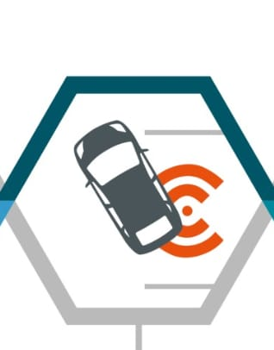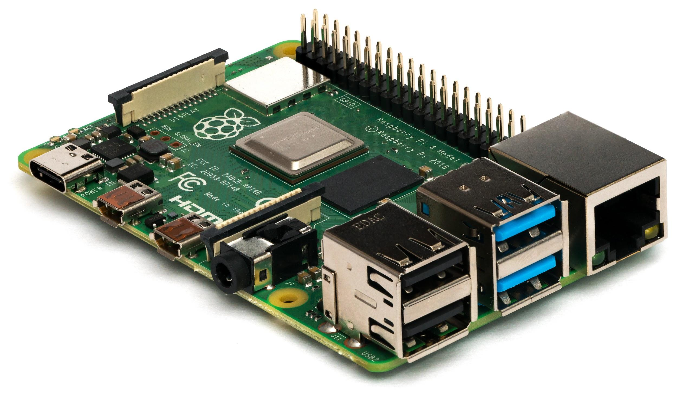 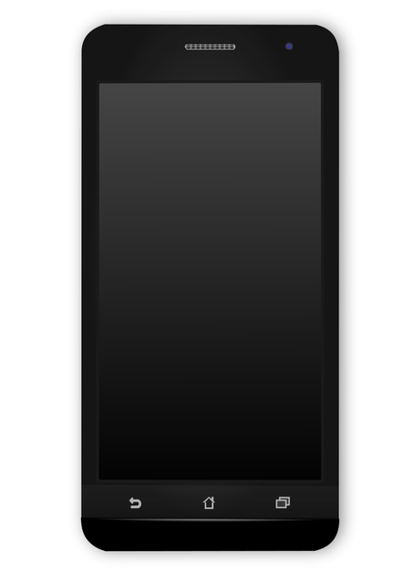

IR Sensors Raspberry pi Android App