Cubefeild recreation:

Individual project proposal

CMPT 370

Thomas Williamson

I have an interest in creating video games and especially 3d environments, Cubefeild was one of the common pastimes in my elementary school, over all Cubefield while offering a full playable game is actually relatively simple only requiring simple 3d shapes, movement, random generation, and simple user inputs.

For my final project I essentially want to recreate the standard forward motion block dodging game cube field I may change the graphics slightly, add shading, change background or add textures

The general methods are

Add a time or a distance counter with high score keeper visible in one edge or corner of the view box

Create a 3d environment with a player shape (likely texture mapped and or sphere) (3d object) that sits in the center low section of the view. one point perspective, Directional light- Phong shading, and texture mapped sky box. Chart, bubble chart

The user will be able to use “a” “d” or the “<-” “->” arrow keys in order to move the camera and the player object along the x axis to avoid the oncoming objects

If player object collides with one of the oncoming objects all objects stop, counter stops, and game ends.

implement game over screen containing restart button.

Reference:

Block dodge type game “cubefield”

https://www.crazygames.com/game/cubefield

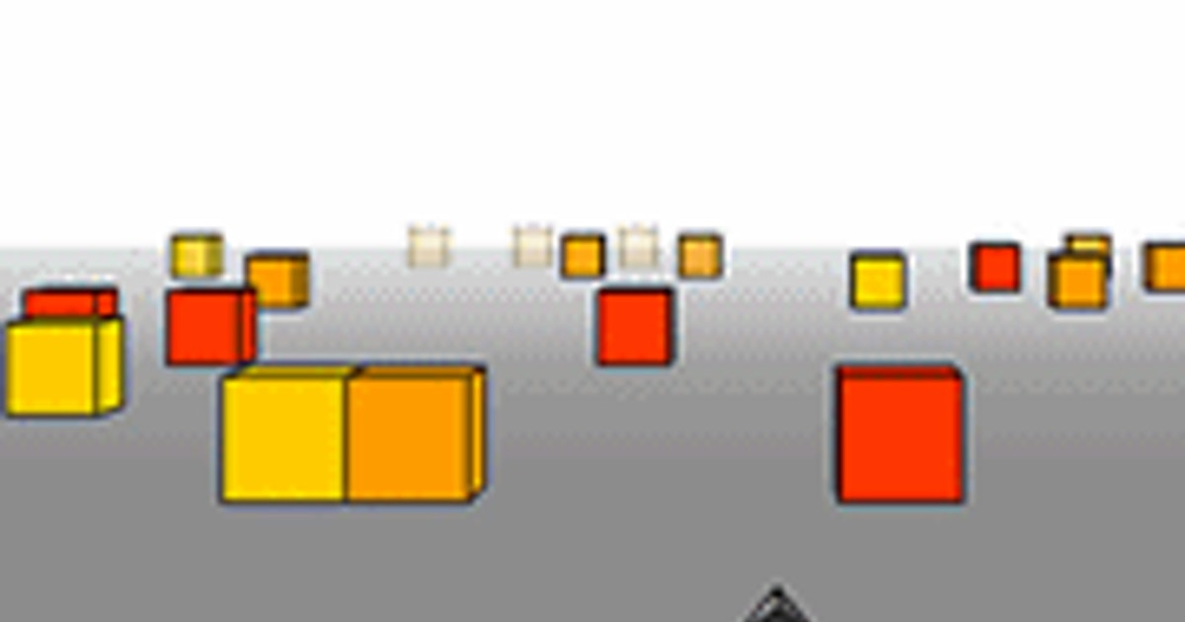

Run game

https://www.coolmathgames.com/0-run-2

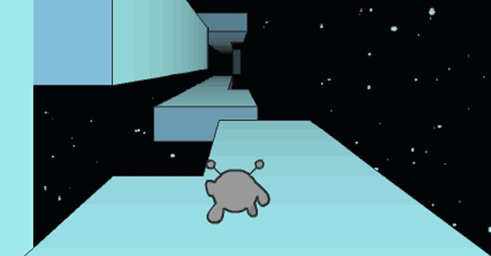

Making a Sky box to change background: <https://www.youtube.com/watch?v=cp-H_6VODko&t=33s&ab_channel=RedStapler>

<https://webglfundamentals.org/webgl/lessons/webgl-skybox.html>

lighting: <https://developer.mozilla.org/en-US/docs/Web/API/WebGL_API/Tutorial/Lighting_in_WebGL>

Phong shading:  <https://en.wikipedia.org/wiki/Phong_shading>

Object instancing: <https://webglfundamentals.org/webgl/lessons/webgl-instanced-drawing.html>

Perspective: <https://webglfundamentals.org/webgl/lessons/webgl-3d-perspective.html>