Tutorial first xor:

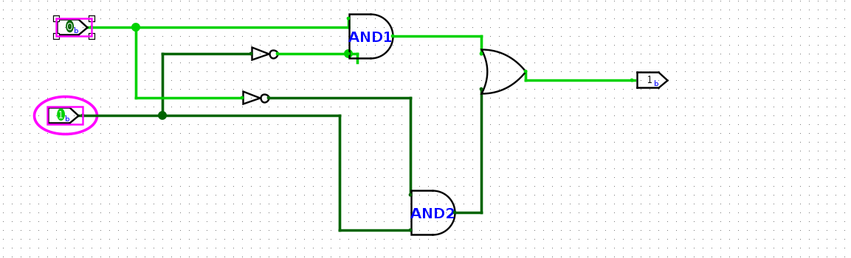

Lab 01:

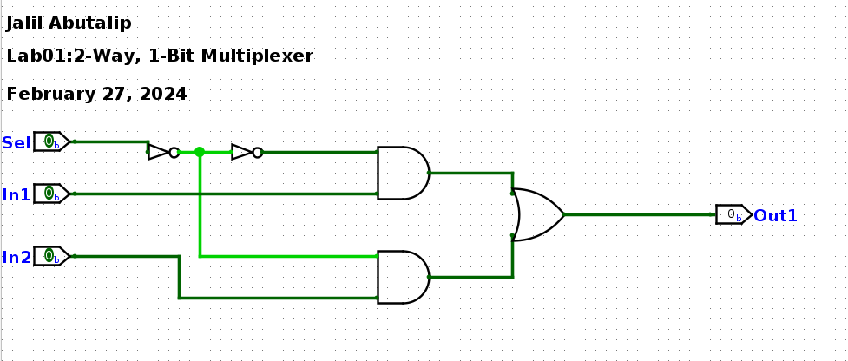

comment: Need to find a way to align text prperly, the distance between lines of text is different

